ADS INTEGRATION DOCUMENTATION :

Everything is done for you :

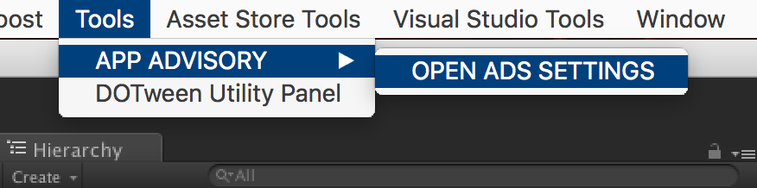

And Select the networks you want (don’t forget to get the SDKs if needed) :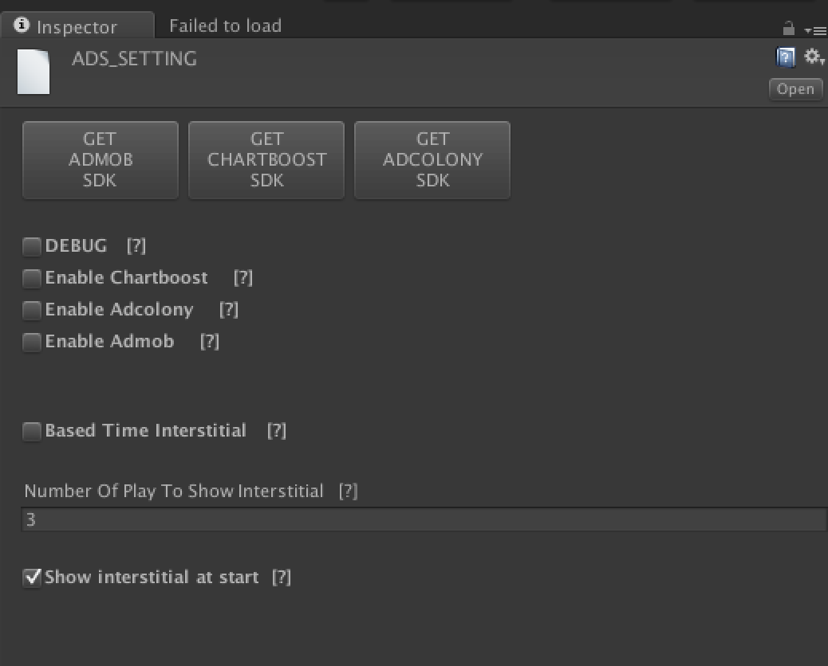

For Unity Ads, please visit my website :

<https://appadvisory.zendesk.com/hc/en-us>

You should have a GameObject named « AdsInit » in the hierarchy view :

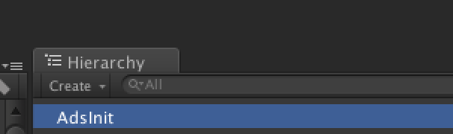

If not, please do a right click on the hierarchy view and :

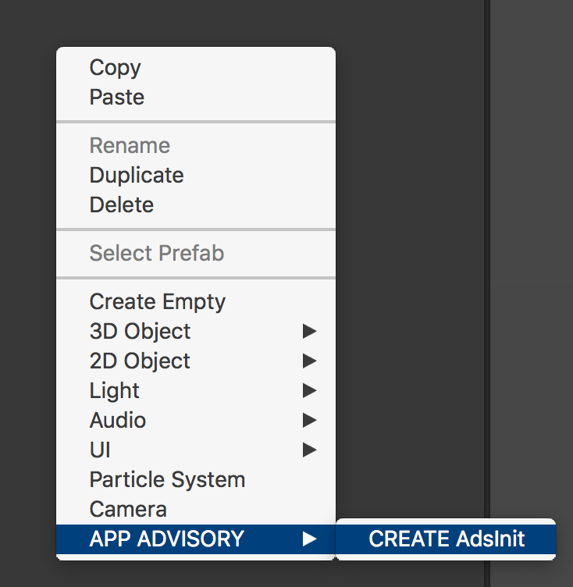

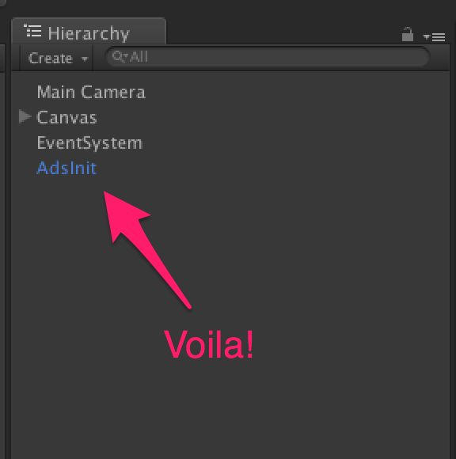

How to check :

* If an interstitial is available ?

*AdsManager.instance.IsReadyInterstitial()*

Return a boolean : true if ready, false if not.

* If a video ad is available ?

*AdsManager.instance.IsReadyVideoAds()*

Return a boolean : true if ready, false if not.

* If a rewarded video is available ?

*AdsManager.instance.IsReadyRewardedVideo()*

Return a boolean : true if ready, false if not.

How to show :

* An interstitial ?

*AdsManager.instance.ShowInterstitial()*

* A video ad?

*AdsManager.instance.ShowVideoAds()*

* A rewarded video?

*AdsManager.instance.ShowRewardedVideo( () => {*

*If(success)*

*{*

*//give a reward to the player*

*}*

*else*

*{*

*//the player do not complete the video*

*}*

*})*

OR

*AdsManager.instance.ShowRewardedVideo(Method) ;*

And the method called is like this :

*Void Method(bool success)*

*{*

*If(success)*

*{*

*//give a reward to the player*

*}*

*else*

*{*

*//the player do not complete the video*

*}*

*}*

Thanks !

Our other assets : <http://u3d.as/9cs>

Contact : [contact@app-advisory.com](mailto:contact@app-advisory.com)