**Software Requirements Specification**

for

**LeapMotion-vJoy Driver**

*Version 1.1*

Prepared by

Red Panda Inc.

Shawn Hardwick

Richard L. Jones

# Overall description

## Product functions

LeapMotion-vJoy Driver provides an interface between the LeapMotion controller and vJoy virtual controller device for Windows. The driver currently supports the x-axis and two button control through the use of hand gestures. The user is able to roll their hand left or right to manipulate the joystick’s x-axis. They will also be able to accelerate and decelerate the car by opening and closing their hand respectively. This allows the user to control the basic functions of a controller with basic hand motions. This interface has a very specific use case in mind by primarily working for a racing game, but can be expanded by allocating more work into the product.

User characteristics

General User- Users should be able to use the LeapMotion-vJoy Driver to control a racing simulator that is able to use Direct Input. Users should be able to steer, accelerate, and brake the car using the LeapMotion.

Software Developers – Developers will be able to expand this code to work with games other than racing simulators; they will be able to use vJoy documentation, LeapMotion documentation and this software to build a driver that can be used for any video game that uses Direct Input.

# External interface requirements

## Installation

Step 1: Install the vJoystick driver from <http://vjoystick.sourceforge.net/site/index.php/download-a-install> and follow prompted instructions. (During installation you will be prompted to restart your computer so that you may enter Test Mode. Test Mode is needed to use the vJoystick and LeapMotion-vJoydriver. You can remove your computer out of Test Mode by uninstalling the vJoystick driver.)

Step 2: Make sure that your LeapMotion is plugged into your machine and the drivers are installed correctly.

Step 3: Run LeapMotion-vJoy driver and watch the magic happen.

## User interfaces

Proper output when the LeapMotion device and vJoy controller are properly installed and connected:

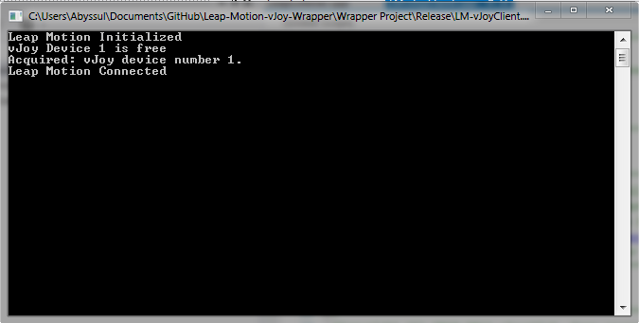

Error output when the Leap Motion device is not connected:

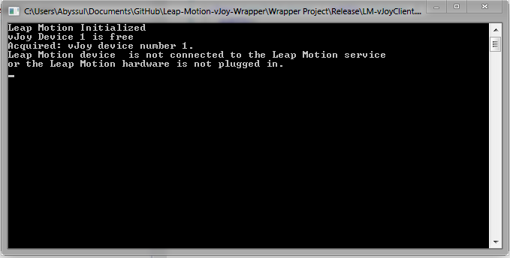

Error output when vJoy driver is not properly installed:

