CVS N/A Analysis

The purpose of this is analysis is to review all CVS attributes to determine new values.

The Strategy: [Link](https://docs.google.com/spreadsheets/d/1Ll-enXIWWWkw4x7GE9N-Y9qLkH5q0NvO0uoDTHmJLuI/edit#gid=1741695204)

**Absorbency**

* Total number of SKUs: 1166
* Number of N/A values: 397
* Difficult call outs for this attribute but we can reduce the N/A count

**Antiseptic Type**

* Total number of SKUs: 8
* Number of N/A values: 8

**Benefit**

* Total number of SKUs: 11993
* Number of N/A values: 2707
* Difficult call outs
* Reinforcing current values and adding proposed values could reduce n/a values by 700 SKUs
* Proposed Values:
  + Cleansing Skin
  + Restoring Capability (This could go under repairing but we need to update the GL)

List of values:

(color.?correcting)|(curling)|(dermatologis.{0,20}tested)|(exfoliating)|(firming)|(hydrating)|(lengthen)|(matt)|(repair)|(restor.{10})|(smooth)|(volumiz)|(washable)|(water.?proof)|(cleanse?i?n?g?.?skin)|(fresh.?feeling)|(dry.?clean)|(hand.?wash)|(machine.?washable)|(non.?iron)

**Concern**

* Total number of SKUs: 65000
* Number of N/A values: 21300
* This attribute has 172 current values
* Reinforcing current values and adding proposed values could reduce n/a values by 3000 SKUs.
* We may have to remap the buckets for the 172 values.
* Proposed Values:
  + Eyebrow Concern (misshapen eyebrows, uneven eyebrows, clumpy eyebrows, etc)
  + Anti-Fragrance (including anti scent)
  + Free Radicals

List of values I searched with: (acne)|(anti.?aging)|(anti.?bacterial)|(anti.?.{10})|(calluses)|(cellulite)|(clump)|(split.?end)|(color.?protection)|(dandruff)|(crow.?feet)|(wrinkle)|(circles)|(puffy.?skin)|(dry.?skin)|(oily)|(excess.?oil)|(flakes)|(free.?radical)|(frizz)|(.{10}damage.{10)|(ingrown.{10})|(.{10}eyebrow.{10})|(scar)|(.{10}irritation.{10})|(sensitive)|(weight loss)|(teething)|(sunburn)|(vegan)|(vegitarian)|(testosterone)| (skin.?tone)|(STD)|(\bSTI\b)|(sleep)

**Days of Treatment**

* Total number of SKUs: 33
* Number of N/A values: 16
* There are two values that are written out “Use at minimum four times per day, then as needed” so we might update the guidelines but this attribute only has 33 SKUs

**Fit**

* Total number of SKUs: 108
* Number of N/A values: 35

**Form**

* Total number of SKUs 48000
* There are 56 current values
* Number of N/A values: 450
* Proposed Values:
  + Bath Tissue

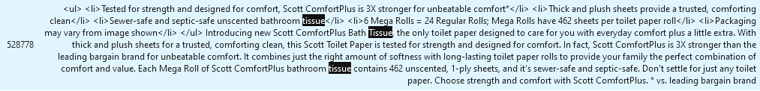

**Gauge**

* Total number of SKUs: 95
* Number of N/A values: 88
* Bucket: Home Diagnostics Accessories
* Difficult callout but did not see any values

**Gender**

* Total number of SKUs: 41000
* Number of N/A values: 1

**Height**

* Total number of SKUs: 1
* Number of N/A values: 1

**Homeopathic**

* Total number of SKUs: 531
* Number of N/A values: 12
* Matches: 4

**Image View**

* Total number of SKUs: 0
* Number of N/A values: 0

**Key Ingredient**

* Total number of SKUs 21500
* Number of N/A values: 11629
* Reinforcing current values and adding proposed values could reduce n/a values by 2800 SKUs
* This attribute can be very tricky
* Proposed Values:
  + Ginko Biloba
  + Pumpkin Seed Oil
  + Ginseng
  + Siberian Eleuthero





List of values:

(Ginkgo Biloba)|(Pumpkin Seed Oil)|(Ginseng)|(Siberian eleuthero)|(Cinnulin)|(zinc)|(tioconazole)|(tea tree oil)|(shea butter)|(protein)|(probiotics)|(prebiotics)|(pramoxine)|(potassium)|(peroxide)| (pantothenic)|(niacin)|(miconazol)|(magnesium)|(iron)|(ibuprofen)|(hydroco)|(fluride)|(fiber)|(fexofenda)|(essential.?oil)|(enzyme)|(electrol)|(coconut)|(clotrimazole)|(cetirizine)|(CBD)|(calcium)|(caffe)|(biotin)|(benzoca)|(baking soda)|(antioxidant)|(aloe)|(acetami)

**Length**

* Total number of SKUs: 1009
* Number of N/A values: 474

**Life Stage**

* Total number of SKUs: 50,000
* Number of N/A values: 388

**Makeup Finish**

* Total number of SKUs: 7623
* Number of N/A values: 1026
* Reinforcing current values could reduce n/a values by 5 SKUs

**Material**

* Total number of SKUs: 6664
* Number of N/A values: 6000
* There are a lot of call outs for this attribute and I don’t know why the curators missed these.

**Metabolism Support**

* Total number of SKUs: 5626
* Number of N/A values: 5330
* Reinforcing current values and adding proposed values will reduce n/a values by 8 SKUs
* This attribute has a lot of N/A values
* Proposed Values:
  + DMG

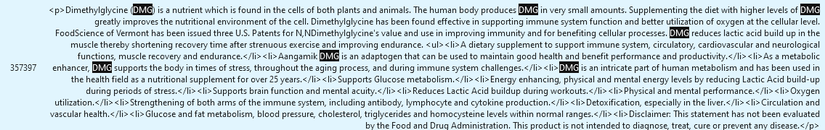

**Nasal Sinus Respiratory**

* Total number of SKUs: 1204
* Number of N/A values: 61
* Number of matches reinforcing current values 12

**Occasions**

* Total number of SKUs: 2773
* Number of N/A values: 1797
* Reinforcing current values and adding proposed values will reduce n/a values by 174 SKUs
* Proposed Values:
  + Anniversary
  + Birthday
  + Wedding
  + Christmas
  + Independence Day
  + Birth/Newborn/Baby
  + These are not called out explicitly but it might be good to include them: Mother’s Day, Father’s Day, Juneteenth, Graduation, Bachelor/Bachelorette Party

**Pack Type**

* Number of N/A values: 88

**Primary Flavor**

* Total number of SKUs: 15683
* Number of N/A values: 6701
* The syntax on this attribute is too complex to estimate how many SKUs can be curated
* Proposed Values:
  + Apple cider vinegar
  + Cranberries (Would this be fruit?)

 



**Product Type**

* Total number of SKUs: 71096
* Number of N/A values: 318
* There are 1614 values

**Protein Content**

* Total number of SKUs: 6072
* Number of N/A values: 4743
* This is a range of the amount of mg of protein in a product. It’s a tough call out but I don’t see any SKUs.

**Protein Type**

* Total number of SKUs: 5521
* Number of N/A values: 4643
* The syntax is too difficult to determine how many N/A values we can reduce these SKUs by.
* Proposed Values:
  + Dairy-Based

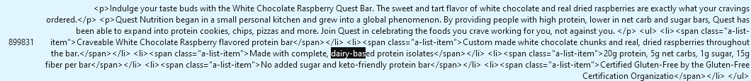

**Quantity**

* Total number of SKUs: 54035
* Number of N/A values: 146

**Scent**

* Total number of SKUs: 22548
* Number of N/A values: 5085
* Reinforcing current values and adding proposed values will reduce n/a values by 1200 SKUs
* Proposed Values:
  + Lightly Scented
  + Unscented

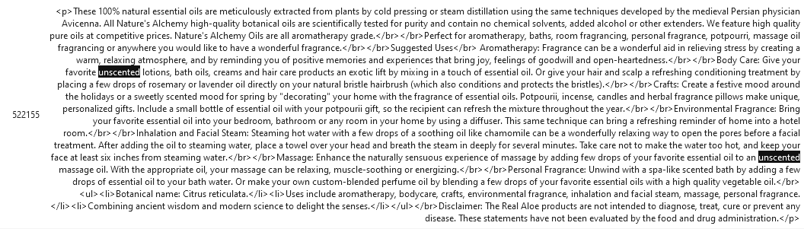

* + Signature Scent

**Search Product Type**

* Total number of SKUs: 1157
* Number of N/A values: 213

**Size**

* Total number of SKUs:1157
* Number of N/A values: 467
* Reinforcing current values will reduce the n/a values by 19 SKUs

**Skin Type**

* Total number of SKUs: 8264
* Number of N/A values: 4535
* Reinforcing current values and adding proposed values will reduce n/a values by 1100 SKUs
* Proposed Values
  + Acne-This should be under oily skin but should we update the GL?



* + Wrinkles



* + Sagging skin



* + Firm skin



* + Moisture (we can include this under dry skin but we should update the GL)



* + Dead skin (We could possibly get rid of this one)



* + Dirty Skin



**SPF**

* Total number of SKUs: 4734
* Number of N/A values: 4676
* This is a range of numbers for the SPF of sunscreen
* Reinforcing current values will reduce the n/a values by 300 SKUs.
* High number of N/ values

**Symptom**

* Total number of SKUs: 20771
* Number of N/A values: 16214
* Reinforcing current values and adding proposed values will reduce n/a values by 7000 SKUs
* Proposed values
  + Organ Function (including lung, kidney, prostate, liver, etc.)



* + Bone Issues (including calcium deficiency)



* + Blood and Cardiovascular Issues

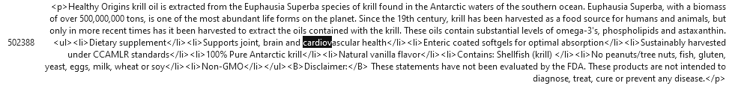

* + Menopause-Already have PMS?



* + Vitamin Deficiency (including nutrient deficiency)

* + Electrolyte and hydration deficiency

* + Stamina



* + Muscle problems (including Neuromuscular health, muscle tissue, weak muscles, muscle health, muscle pain, sprained muscles, etc.)

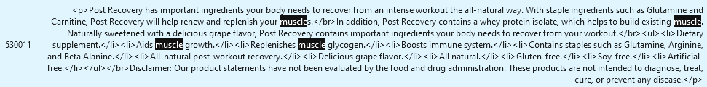

**Thickness:**

* Total number of SKUs: 953
* Number of N/A values: 388
* Very few call outs for new values and reinforcing current values does not reduce the n/a values