Title: Transfer learning/ fine tuning our own models in domain driven specific use cases for clients

Github: <https://github.com/ShawnKyzer/expert-system-gpt>

Example Output:

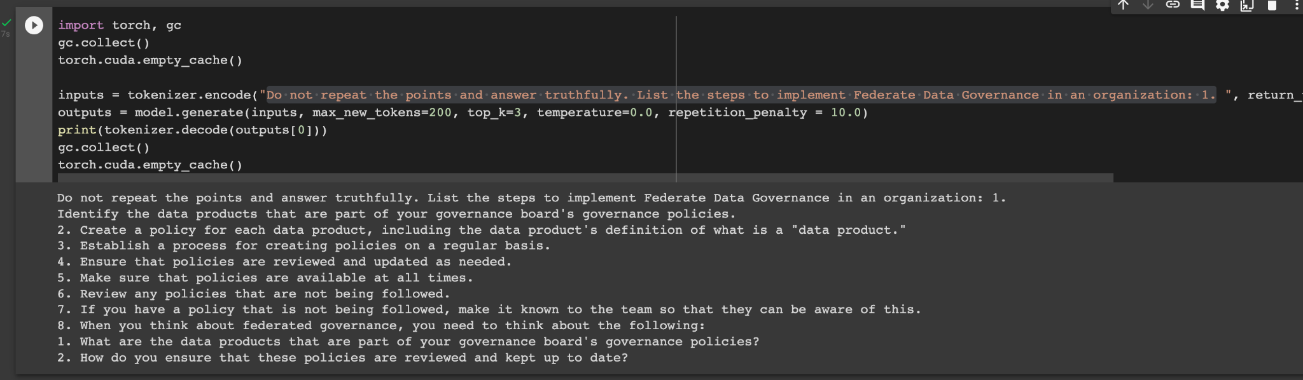

(Custom Fine-Tuned LLM)

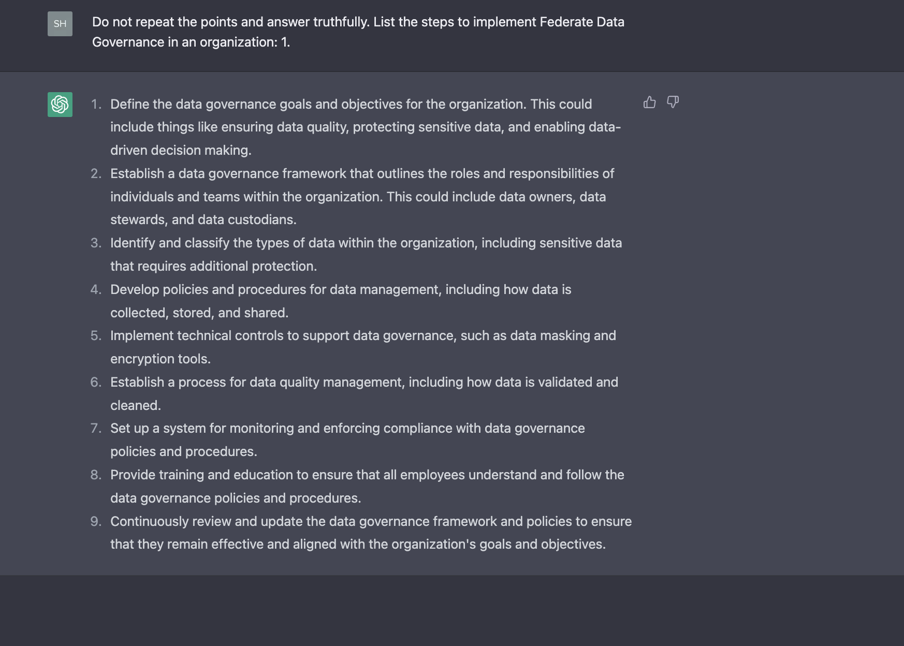

(Above From OpenAI ChatGPT)

Document Search:

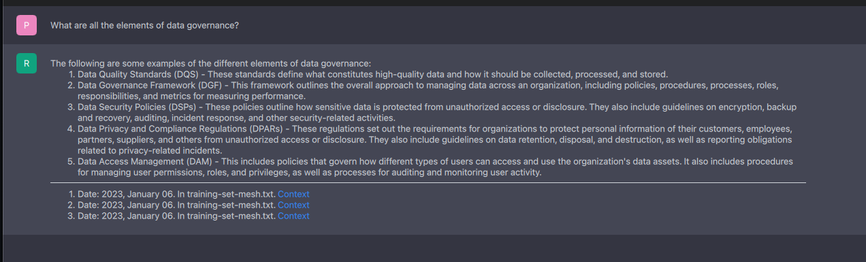

Useful Links:

* Open LLM Leaderboard - <https://huggingface.co/spaces/HuggingFaceH4/open_llm_leaderboard>
* LangChain - <https://python.langchain.com/>
* Private GPT - <https://github.com/imartinez/privateGPT>
* GPT 4 All - <https://github.com/nomic-ai/gpt4all>
* <https://www.nbcnews.com/tech/tech-news/leaked-google-engineer-memo-warns-big-tech-lose-ai-race-little-guys-rcna83146>
* <https://github.com/bentoml/OpenLLM>

Presentation Link

* <https://odsc.com/speakers/turbocharge-your-data-analytics-plane-with-ai/>