|  |
| --- |
|  |
| Innovate |
| Employee Directory |
|  |
| **Shawn Kyzer** |
| **10/5/15** |

[Type the abstract of the document here. The abstract is typically a short summary of the contents of the document. Type the abstract of the document here. The abstract is typically a short summary of the contents of the document.]

Table of Contents

[To update the table of contents, right click the message below and select Update Field (F9 on PC, ⌥⌘U on Mac).]

**No table of contents entries found.**

1. Pages
   1. Page Tree

Home  
 EmployeessListView_Random  
 EmployeesListView_Deparment_Sorted_First  
 EmployeeView  
 EmployeeViewConfirmModal  
 EmployeeEditFormView  
 EmployeeNewFormView

* 1. Home
     1. User Interface

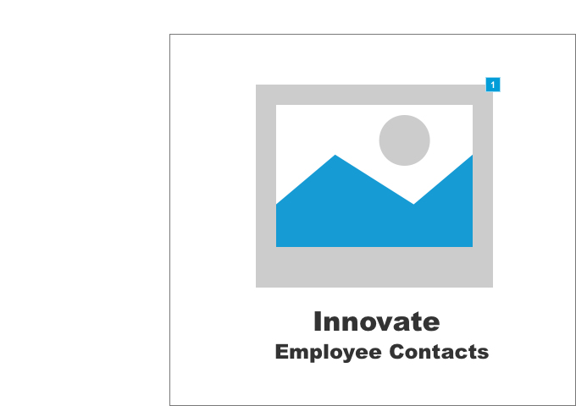

* + 1. Widget Table

|  |  |
| --- | --- |
| Footnote | Interactions |
| 1 | OnClick:  Case 1:  Open EmployeessListView_Random in Current Window |

* 1. EmployeessListView_Random
     1. User Interface

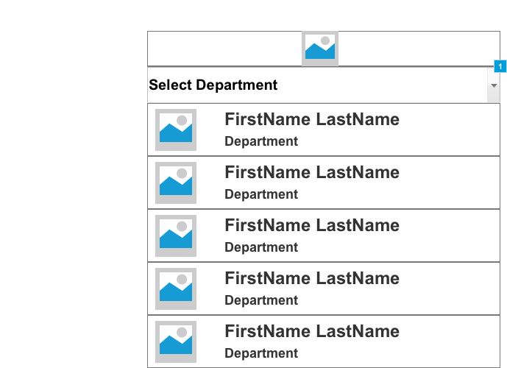

* + 1. Widget Table

|  |  |  |
| --- | --- | --- |
| Footnote | Name | Interactions |
| 1 | Department | OnSelectionChange:  Case 1:  Open EmployeesListView_Deparment_Sorted_First in Parent Frame |

* 1. EmployeesListView_Deparment_Sorted_First
     1. User Interface

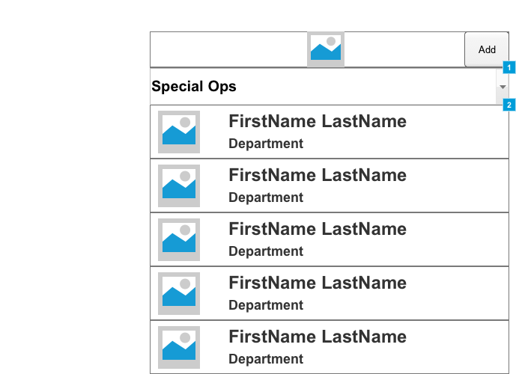

* + 1. Widget Table

|  |  |  |
| --- | --- | --- |
| Footnote | Name | Interactions |
| 1 | Department | OnSelectionChange:  Case 1:  Open EmployeesListView_Deparment_Sorted_First in Parent Frame |
| 2 |  | OnClick:  Case 1:  Open EmployeeEditFormView in Current Window |

* 1. EmployeeView
     1. User Interface

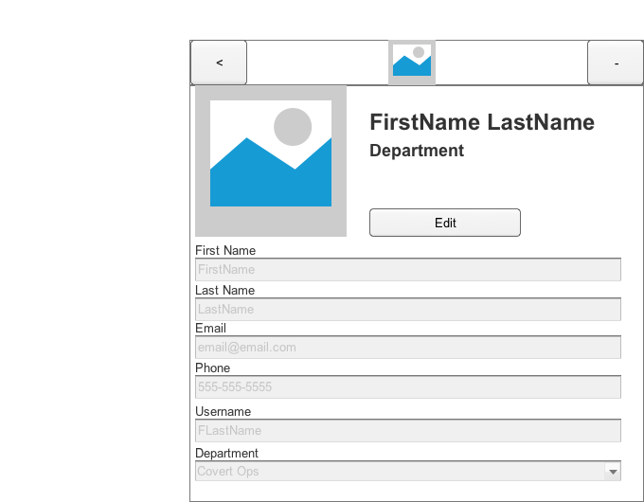

* 1. EmployeeViewConfirmModal
     1. User Interface

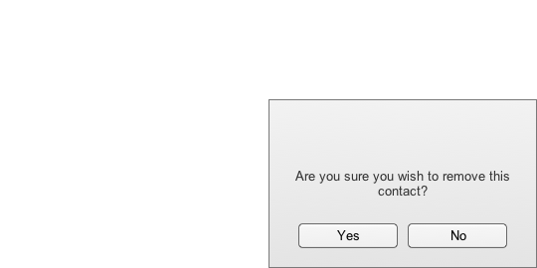

* 1. EmployeeEditFormView
     1. User Interface

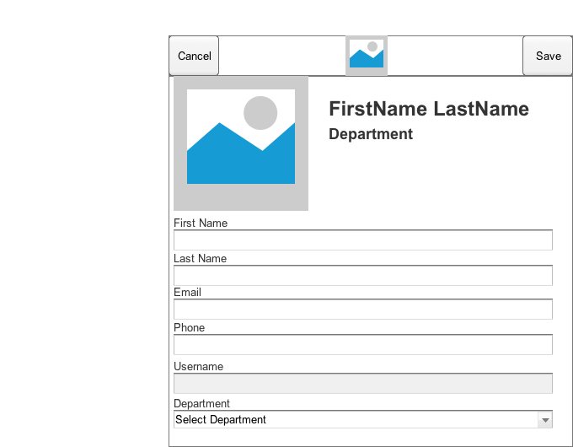

* 1. EmployeeNewFormView
     1. User Interface



1. Masters
   1. Master List

Header

* 1. Header
     1. User Interface

