CS425 MP4 Report

Taipeng Liu(taipeng2) & Xiang Li(xiangl14)

**2. Measurement**

Application: wordcount

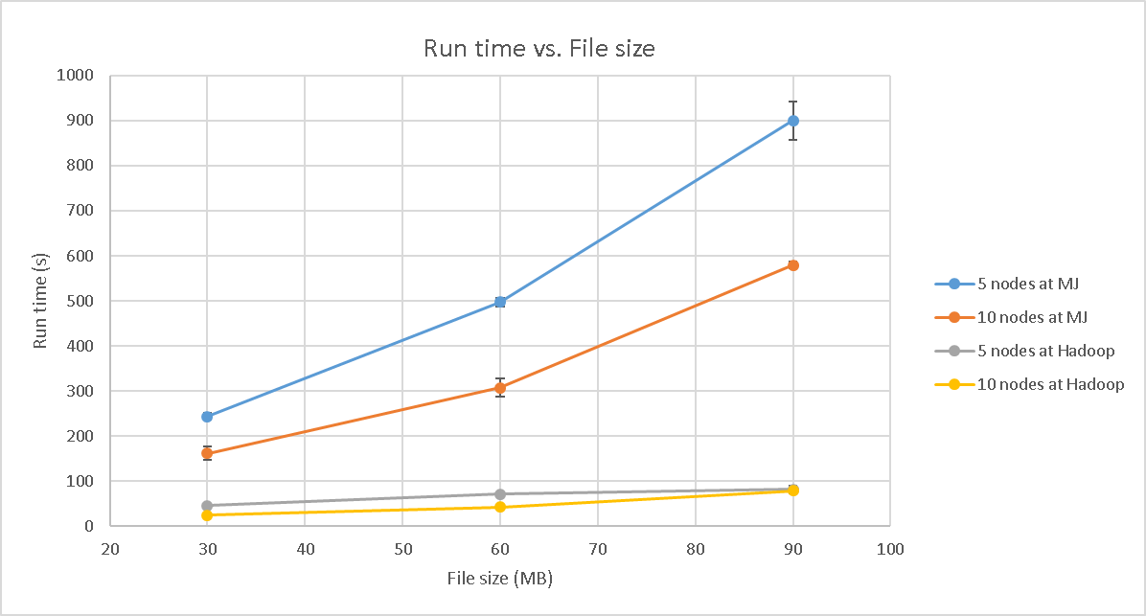

Application: reverse web link

