Single-player: (0:18)
To play in Single-player mode, select “Singleplayer” from the main menu
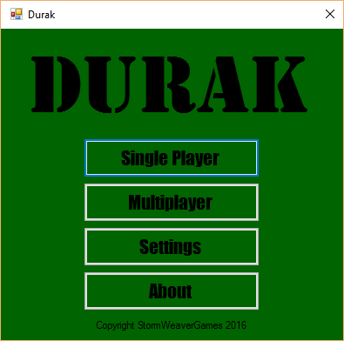
This will bring you into the lobby, where you can add bot players and choose your game options.
