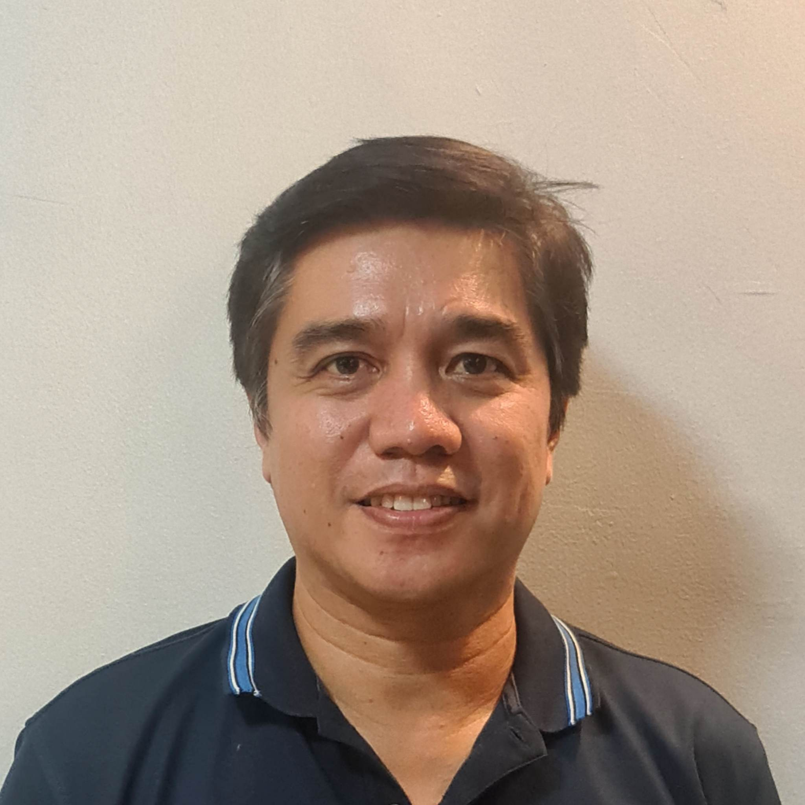Almeda, Marlo Ross J.

|  |
| --- |
| **Contact Details**  Present Address : Philippines  Address : B3 L48 Saturn St. Maria Aurora Subd., San Pedro, Laguna, Philippines, Laguna,  4023, Southern Tagalog, Philippines  Telephone No. : 63-2-8473870  Mobile No. : 09178730020  Skype ID. : mja24almeda  Email : [erozek1234@gmail.com](mailto:erozek1234@gmail.com) / marlo_almeda@yahoo.com |
| **Personal Particulars**  Age : 53 years old  Date of Birth : 24 March 1970  Nationality : Philippines  Gender : Male  Marital Status : Married  Passport No. : EC4855674 |
| **Educational Background**  Field of Study : Engineering (Aviation/Aeronautics/Astronautics)  Major : BS Aircraft Technology  Institute/University : PATTS College of Aeronautics, Philippines  Graduated : 1994 |
| **Experiences**  **Experience level**  Company Name : Vienna Hotel/Coron Palawan  Position Title : Hotel Operation Manager.  Specialization : Hotel Management/Tourism Services  Industry : Hotel / Hospitality Duration : Oct 2018 – May 15 2021  Oversee the entire day-to-day operations.  Operations include human resources, housekeeping, security, public relation, food  services, sales and finance.    Handles effectively with Customer, bosses and staff.  Assist department heads.    Handles hiring new employees and training of staff.  Creating work schedules and policies and procedures.  **Employment History**  Company Name : Savoy Hotel Boracay Pre-Opening / Megaworld  Position Title : Assistant Front office manager.  Specialization : Hotel Management/Tourism Services  Industry : Hotel / Hospitality Duration : January 2017 – July 2017  Responsible for overseeing all areas of operations related to the guest service experience for front  desk, reservation , PBX, and guest services.  Maintains standard of services as directed by the front office manager.  Reviews VIP reservations, amenity orders, resumes for in coming and in-house guests, and the suite  book to ensure proper handling of guest and groups.  Must have coordination skills as it pertains to determining time, place, and sequence of  operations and actions.  Communicating with customers and employees, and preparing written reports of room availability  and revenue generated.  Maintain contact with reservation service regarding requests for suites and other accommodations.    **Employment History**  Company Name : Resort World Manila/Remington Hotel  Position Title : Duty Manager  Specialization : Hotel Management/Tourism Services  Industry : Hotel / Hospitality  Duration : Oct 2012 – March 2, 2015  Work Description :  Supervises the proper performance of duties by all front office staff to achieve optimum level of occupancy for the hotel.  Inspect rooms assigned to VIP guests from time to time and ensures that all guests are properly accommodated.  Assists in maintaining smooth relationship between management and guests by resolving problems arising from guest complaints, attending to their requests or inquiries and ensuring the prompt, efficient and courteous service is provided to guests.  Reviews daily list, room availability, forecast and night reports. Prepare such reports as may be required by Management.  Maintains and sustains guest profile. Ensures that all guests are properly identified and have complete details upon registration and before departure.  Performs rate check and balance during the night shift. Reviews all transactions for the day performs end of the day procedures such as room rate posting and night audit.  Initiates correspondence regarding guest inquiries, reservation with special arrangements, complaint, instructions, announcements, etc. forward to the hotel manager for approval and disseminates to front office staff.  Assist the front office manager in preparing annual occupancy forecast and budget for front office department in coordination with all other departments heads concerned.  Ensures that all policies and procedures pertaining to front office operations are complied upon by all front office staff strictly implements established and newly approved policies, systems and procedures in the department.  Exercises administrative control and supervision over all personnel on matters pertaining to work performance, skills training attendance, discipline, safety and compliance with the hotel rules and regulations.    Coordinates closely with Sales and Marketing on all bookings and special requests and participates in the planning of room allocations for groups and in-house conferences.  Presides the shift briefing of front office staff in coordination with the front office manager.  Attend to regular meetings,i.e., Operations meeting Department head’s meeting, sales Meeting Group coordination meeting and other related meetings in the absence of the front office manager.  Will conduct hotel property checks and view security monitors for incidents, if needed  Performs other related function as may be assigned by the front office manager from time to time.  Company Name : Venetian Sands / Pre-opening Macau, China  Position Title : Customer service dept./ Senior Head Butler  Specialization : Hotel Management/Tourism Services  Industry : Hotel / Hospitality  Duration : July 2007 – Apr 2012  Work Description :    Company Name : Caylabne Bay Resort  Position Title : Resident Duty Manager  Position Level : Assistant Manager / Manager  Specialization : Hotel Management/Tourism Services  Industry : Hotel / Hospitality  Duration : March 2005 – July 2007      Company Name : Embassy of the United States of America  Position Title : Personal Butler to the Deputy Chief of Mission  Position Level : Supervisor / 5 Years & Up Experienced Employee  Specialization : Hotel Management/Tourism Services  Duration : Sep 2003 - March 2005    Company Name : Vivere Suites  Position Title : Butler Supervisor  Position Level : Supervisor / 5 Years & Up Experienced Employee  Specialization : Hotel Management/Tourism Services  Industry : Hotel / Hospitality  Duration : Oct 2002 - Sep 2003  Company Name : Pan Pacific Manila /Pre-Opening  Position Title : Butler  Position Level : 1-4 Years Experienced Employee  Specialization : Food/Beverage/Restaurant Service  Industry : Hotel / Hospitality  Duration : Feb 1999 - Oct 2002  Company Name : Dyna Recording Company  Position Title : TV Personality  Position Level : Non-Executive  Specialization : Entertainment/Performing Arts  Industry : Entertainment / Media  Duration : Feb 1995 - Oct 1997  Monthly Salary : PHP 15000  Work Description :    TV Personality |
| **Skills**  **Skill Years Proficiency**  ---------------------------------------------------------------------------------------------------------  Driving 5 Advanced  Managerial Skills 4 Advanced  Nihonggo 2 Intermediate |
| **Other Information**  (**English, Filipino and Japanese language**) SEMINARS & TRAININGS ATTENDED  1. First Training Program for ASEAN Tourism Professionals (Japanese Speaking) 2. Room Service Set-up 3. First Aid and CPR Training 4. Fidelio Seminar 5. Night Audit Training 6. Experiential Customer Service Training 7. D.O.T. Seminars and workshop for tourism quality and standard. 8. Opera user |
| **References:**  1. Elpidio Beloso, Director of rooms  Pasay city, Resorts World Manila (0917-8728531)  2. Ramil Lagos, Executive Housekeeper Maldives, email add: [ramil@yahoo.com](mailto:ramil@yahoo.com)  3. Rommel Engalla, Duty Manager (Resort World Manila/Remington Hotel) |

( 09088995584)

4. Clonita Chico , VP for HR head/ SnR membership

(09178390414)