ASSIGNMENT:-4

**Assignments on Map Interface**

1. Write a Java program using Map interface containing list of items having keys and associated values and perform the following operations:
   1. Add items in the map.
   2. Remove items from the map
   3. Search specific key from the map
   4. Get value of the specified key
   5. Insert map elements of one map in to other map.
   6. Print all keys and values of the map.

**MAP INTERFACE:**

Open Eclipse-> go to file-> new-> select Java Project-> next-> project name-> finish.

**Step1:**

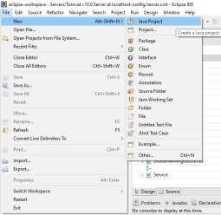

**Step2:**

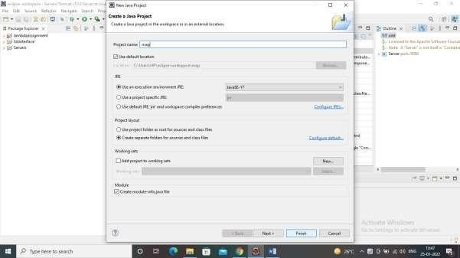

**Step3:**

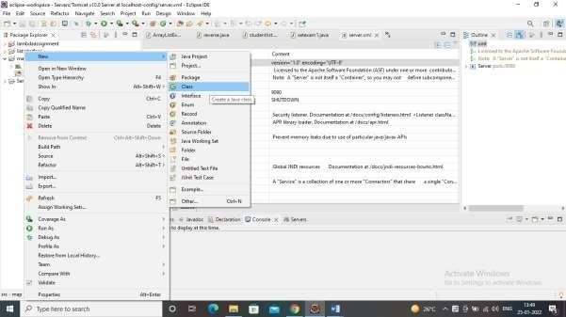

**Step4**:

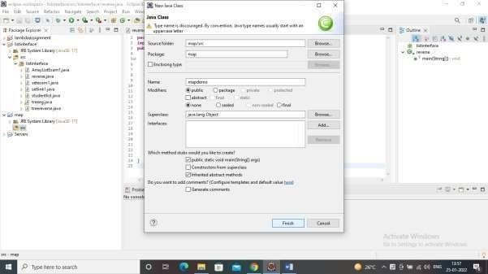

**1:**Write a Java program using Map interface containing list of items having keys and associated values and perform the following operations:

* + 1. Add items in the map.
    2. Remove items from the map
    3. Search specific key from the map
    4. Get value of the specified key
    5. Insert map elements of one map in to other map
    6. Print all keys and values of the map.

package map; import java.util.*;

public class mapdemo {

public static void main(String[] args) {

Map<String, String> hmap=new HashMap<>();

hmap.put("India", "New Delhi"); hmap.put("South Korea", "Seoul"); hmap.put("Japan", "Tokyo");

hmap.put("Russia", "Moscow");

hmap.put("UK", "London");

for(Map.Entry m:hmap.entrySet()){

System.*out*.println("capital of "+m.getKey()+" is "+m.getValue());

}

System.*out*.println(" ");

hmap.remove("UK"); for(Map.Entry m:hmap.entrySet()){

System.*out*.println("capital of "+m.getKey()+" is "+m.getValue());

}

System.*out*.println(" ");

System.*out*.println("capital of India is "+hmap.get("India")); System.*out*.println(" ");

Map<String, String> hmap2=new HashMap<>(); hmap2.put("Germany", "Berlin"); hmap2.put("Georgia", "Tbilisi");

hmap.putAll(hmap2); for(Map.Entry m:hmap.entrySet()) {

System.*out*.println("capital of "+m.getKey()+" is "+m.getValue());

}

}

}

**Output:**

