# Assignment No 9 Spring JDBC

1. Write a program to insert, update and delete records from the given table.
2. Write a program to demonstrate PreparedStatement in Spring JdbcTemplate.
3. Write a program in Spring JDBC to demonstrate ResultSetExtractor Interface.
4. Write a program to demonstrate RowMapper interface to fetch the records from the database.

# Steps to Create Spring Legacy Project Step 1 : Creating Spring Legacy Project.

* 1. **:** Open Eclipse. Go To File > New > Other.

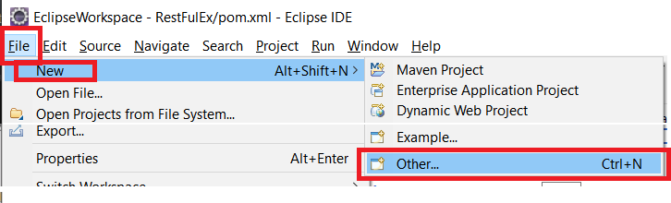

* 1. **:** Search for ‘spring’ and Select ‘Spring Legacy Project’. Then Click on Next.

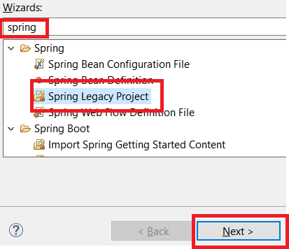

* 1. **:** ChooseProject Name of your wish, below there select **Simple Java**& simply Finish.

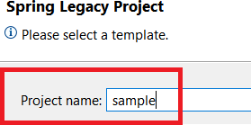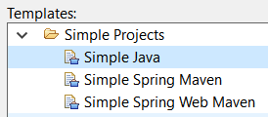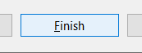

* 1. **:** If asked for Creating module-info.java file, click on **Don’t Create**.

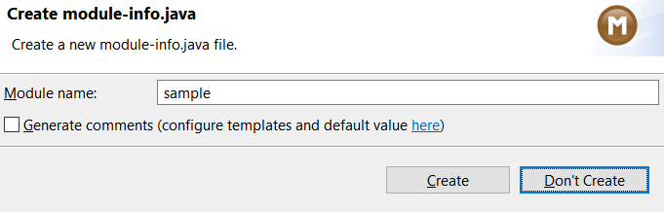

# Step 2 : Adding the Spring Libraries.

* 1. **:** Right click on your Newly created Spring Legacy project, Choose Build Path > Configure Build Path.

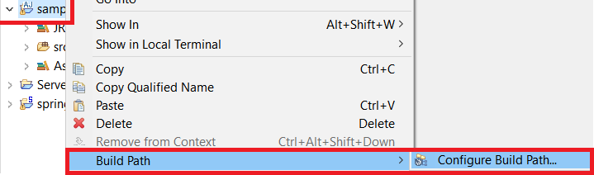

* 1. On Java Build Path wizard, Choose **Classpath** and then select **Add External JARs.**

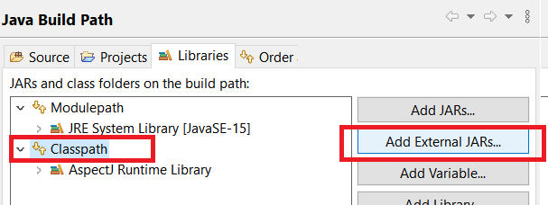

* 1. : Choose all the Spring Libraries you’ve downloaded, and click on OPEN. This will add all libraries to Classpath.

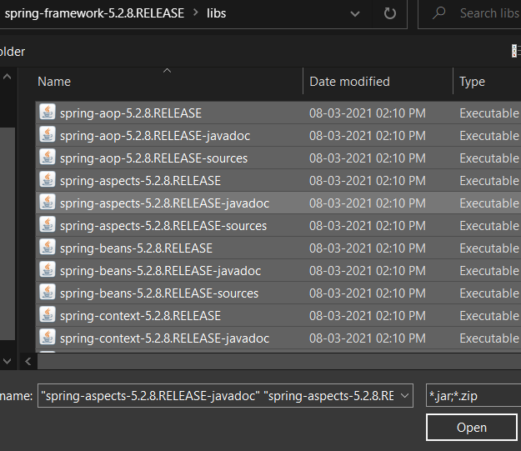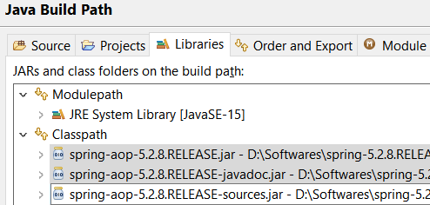

* 1. Finally click on Apply & Close, now you are ready to work with Spring Legacy Project.

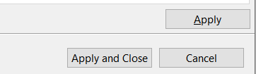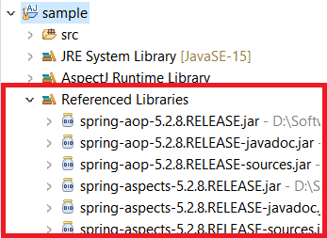

Add postgres jar file also

# Database:

Create Movies Table : CREATE TABLE mymovies1 ( mid int,

title varchar(50), actor varchar(50),

PRIMARY KEY (mid)

);

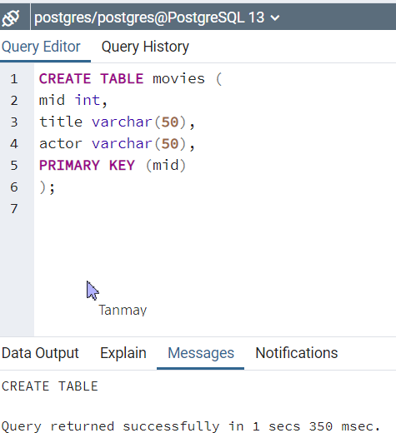

**Problem Statement 1 :** Write a program to insert, update and delete records from the given table.

Solution :

Solution:

How to generate getter and setter methods

Right click on file-> source-> Generate getters and setters methods.

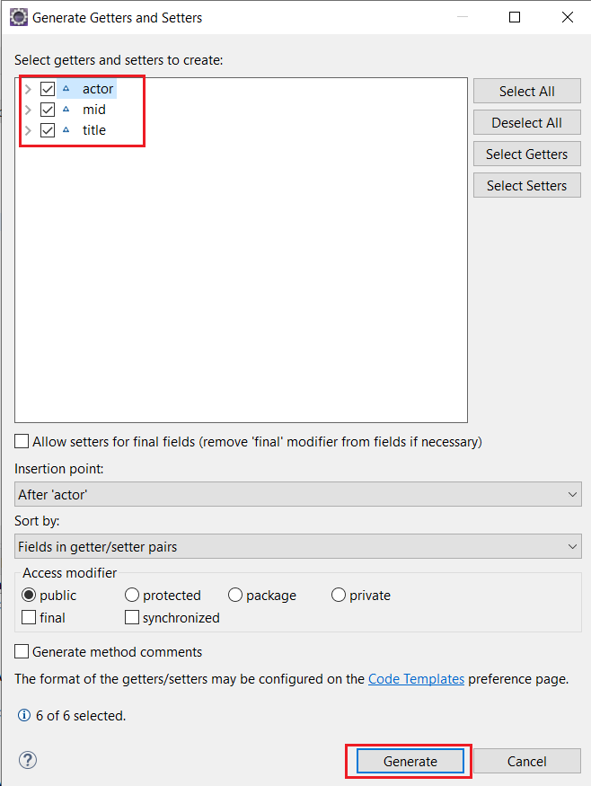

# Movie1.java

package org.me; public class Movie1 {

int mid;

String title;

String actor;

public Movie1(int mid, String title, String actor) { super();

this.mid = mid; this.title = title; this.actor = actor;

}

public Movie1() {

super();

// TODO Auto-generated constructor stub

}

public int getMid() {

return mid;

}

public void setMid(int mid) { this.mid = mid;

}

public String getTitle() { return title;

}

public void setTitle(String title) { this.title = title;

}

public String getActor() { return actor;

}

public void setActor(String actor) { this.actor = actor;

}

}

# MovieDAO.java

package org.me;

import org.springframework.jdbc.core.*; public class MovieDAO {

JdbcTemplate jdbcTemplate;

public void setJdbcTemplate(JdbcTemplate jdbcTemplate) { this.jdbcTemplate = jdbcTemplate;

}

public int insMovie(Movie1 m1)

{

String insSql="insert into mymovies1 values("+m1.getMid()+",'"+m1.getTitle()+"','"+m1.getActor()+"')";

return jdbcTemplate.update(insSql);

}

public int updateMovie(Movie1 m1){

String query="update mymovies1 set title='"+m1.getTitle()+"',actor='"+m1.getActor()+"' where mid='"+m1.getMid()+"' ";

return jdbcTemplate.update(query);

}

public int deleteMovie(Movie1 m1){

String query="delete from mymovies1 where mid='"+m1.getMid()+"' "; return jdbcTemplate.update(query);

}

}

# Create Xml file

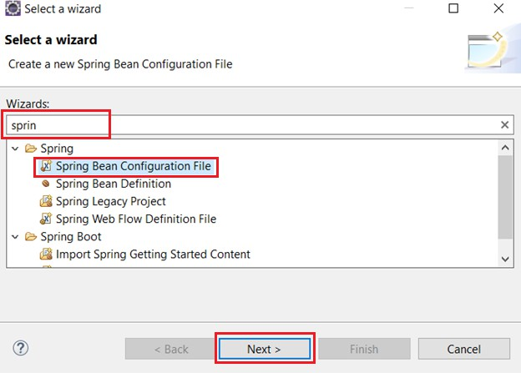

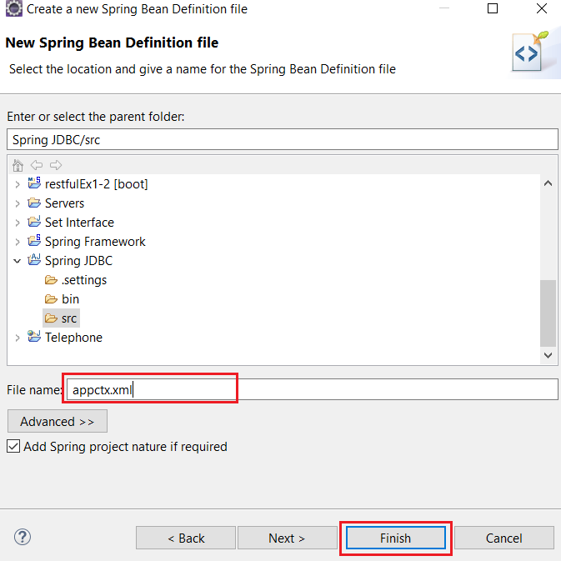

**appctx.xml**

<?xml version=*"1.0"* encoding=*"UTF-8"*?>

<beans xmlns=[*"http://www.springframework.org/schema/beans"*](http://www.springframework.org/schema/beans)xmlns:xsi=[*"http://www.w3.org/2001/XMLSchema-instance"*](http://www.w3.org/2001/XMLSchema-instance)xsi:schemaLocation=[*"http://www.springframework.org/schema/beans*](http://www.springframework.org/schema/beans)

[*http://www.springframework.org/schema/beans/spring-beans.xsd"*](http://www.springframework.org/schema/beans/spring-beans.xsd)>

<bean id=*"ds"* class=*"org.springframework.jdbc.datasource.DriverManagerDataSource"*>

<property name=*"driverClassName"* value=*"org.postgresql.Driver"* />

<property name=*"url"* value=*"jdbc:postgresql://localhost:5432/postgres"* />

<property name=*"username"* value=*"postgres"* />

<property name=*"password"* value=*"password"* />

</bean>

<bean id=*"jdbcTemplate"* class=*"org.springframework.jdbc.core.JdbcTemplate"*>

<property name=*"dataSource"* ref=*"ds"*></property>

</bean>

<bean id=*"mymovie"* class=*"org.me.MovieDAO"*>

<property name=*"jdbcTemplate"* ref=*"jdbcTemplate"*></property>

</bean> </beans>

# Create Main java File

Filename-MovieTest.java

import org.springframework.context.ApplicationContext;

import org.springframework.context.support.ClassPathXmlApplicationContext; public class MovieTest {

private static ApplicationContext appCon; public static void main(String[] args) {

// TODO Auto-generated method stub

appCon = new ClassPathXmlApplicationContext("appctx.xml"); MovieDAO m1 = (MovieDAO) appCon.getBean("mymovie");

// insert query

Movie1 t1 = new Movie1(4, "17 Again", "Zac"); System.out.println(m1.insMovie(t1));

Movie1 t = new Movie1(5, "Interstellar", "Christopher"); System.out.println(m1.insMovie(t));

// update query

int status = m1.updateMovie(new Movie1(1, "18 Again", "Zac")); System.out.println(status);

// delete

Movie1 t2=new Movie1(); t2.setMid(3);

int s=m1.deleteMovie(t2); System.out.println(s);

} }

# First we insert 3 records

// insert query

Movie1 t1 = new Movie1(1, "17 Again", "Zac"); System.*out*.println(m1.insMovie(t1));

Movie1 t2 = new Movie1(2, "23 Again", "Zac"); System.*out*.println(m1.insMovie(t));

Movie1 t3 = new Movie1(3, "Interstellar", "Christopher"); System.*out*.println(m1.insMovie(t));

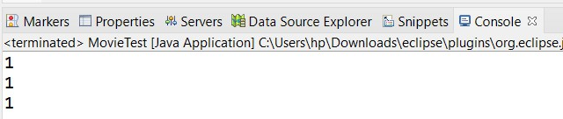

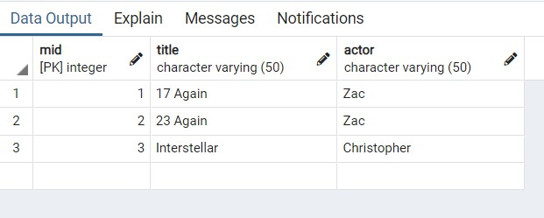

**Update:**

**We update row 1**

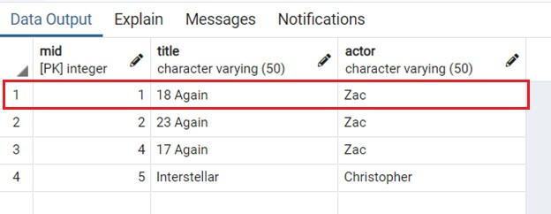

**Delete:**

**We deleted row no 3 So, After deleted row**

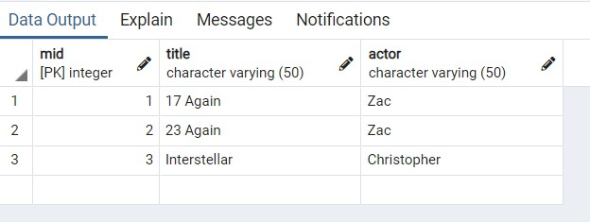

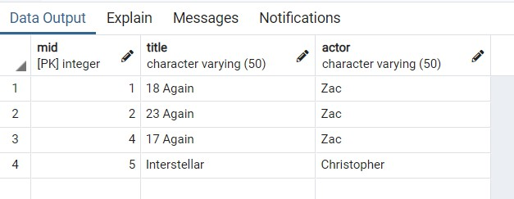

**Statement 2:** Write a program to demonstrate PreparedStatement in Spring JdbcTemplate.

# Solution :

**Movie1.java**

package org.me; public class Movie1 {

int mid;

String title;

String actor;

public Movie1(int mid, String title, String actor) { super();

this.mid = mid; this.title = title; this.actor = actor;

}

public Movie1() {

super();

}

public int getMid() {

return mid;

}

public void setMid(int mid) { this.mid = mid;

}

public String getTitle() { return title;

}

public void setTitle(String title) { this.title = title;

}

public String getActor() { return actor;

}

public void setActor(String actor) { this.actor = actor;

}

}

# MovieDAO1.java

package org.me;

import java.sql.PreparedStatement; import java.sql.SQLException;

import org.springframework.dao.DataAccessException; import org.springframework.jdbc.core.JdbcTemplate;

import org.springframework.jdbc.core.PreparedStatementCallback; public class MovieDAO1 {

JdbcTemplate jdbcTemplate;

public void setJdbcTemplate(JdbcTemplate jdbcTemplate) { this.jdbcTemplate = jdbcTemplate;

}

public Boolean saveMovieByPreparedStatement(final Movie1 e){ String query="insert into movies values(?,?,?)";

return jdbcTemplate.execute(query,new PreparedStatementCallback<Boolean>(){ @Override

public Boolean doInPreparedStatement(PreparedStatement ps) throws SQLException, DataAccessException {

ps.setInt(1,e.getMid()); ps.setString(2,e.getTitle()); ps.setString(3,e.getActor()); return ps.execute();

}

});

}

}

# appctx1.java

<?xml version=*"1.0"* encoding=*"UTF-8"*?>

<beans xmlns=[*"http://www.springframework.org/schema/beans"*](http://www.springframework.org/schema/beans)xmlns:xsi=[*"http://www.w3.org/2001/XMLSchema-instance"*](http://www.w3.org/2001/XMLSchema-instance)xsi:schemaLocation=[*"http://www.springframework.org/schema/beans*](http://www.springframework.org/schema/beans)

[*http://www.springframework.org/schema/beans/spring-beans.xsd"*](http://www.springframework.org/schema/beans/spring-beans.xsd)>

<bean id=*"ds"* class=*"org.springframework.jdbc.datasource.DriverManagerDataSource"*>

<property name=*"driverClassName"* value=*"org.postgresql.Driver"* />

<property name=*"url"* value=*"jdbc:postgresql://localhost:5432/postgres"* />

<property name=*"username"* value=*"postgres"* />

<property name=*"password"* value=*"password"* />

</bean>

<bean id=*"jdbcTemplate"* class=*"org.springframework.jdbc.core.JdbcTemplate"*>

<property name=*"dataSource"* ref=*"ds"*></property>

</bean>

<bean id=*"mymovie"* class=*"org.me.MovieDAO1"*>

<property name=*"jdbcTemplate"* ref=*"jdbcTemplate"*></property>

</bean>

</beans>

# MovieTest1.java

package org.me;

import org.springframework.context.ApplicationContext;

import org.springframework.context.support.ClassPathXmlApplicationContext; public class MovieTest1 {

private static ApplicationContext appCon; public static void main(String[] args) {

// TODO Auto-generated method stub

appCon = new ClassPathXmlApplicationContext("appctx1.xml"); MovieDAO1 m1=(MovieDAO1)appCon.getBean("mymovie");

m1.saveMovieByPreparedStatement(new Movie1(5,"Bhaijaan","Slemon"));

}

}

# Output :

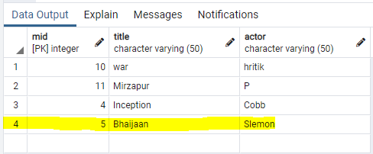

**Problem Statement 3 :** Write a program in Spring JDBC to demonstrate ResultSetExtractor Interface.

**Solution : Movie2.java** package org.me;

public class Movie2 {

int mid;

String title;

String actor;

public int getMid() {

return mid;

}

public void setMid(int mid) { this.mid = mid;

}

public String getTitle() { return title;

}

public void setTitle(String title) { this.title = title;

}

public String getActor() { return actor;

}

public void setActor(String actor) { this.actor = actor;

}

public String toString(){

return mid+" "+title+" "+actor;

}

}

# MovieDAO2.java

package org.me;

import java.sql.ResultSet; import java.sql.SQLException; import java.util.ArrayList;

import java.util.List;

import org.springframework.dao.DataAccessException; import org.springframework.jdbc.core.JdbcTemplate; import org.springframework.jdbc.core.ResultSetExtractor; public class MovieDAO2 {

JdbcTemplate jdbcTemplate;

public void setJdbcTemplate(JdbcTemplate jdbcTemplate) { this.jdbcTemplate = jdbcTemplate;

}

public List<Movie2> getAllMovie(){

return jdbcTemplate.query("select * from mymovies1",new ResultSetExtractor<List<Movie2>>(){

@Override

public List<Movie2> extractData(ResultSet rs) throws SQLException, DataAccessException {

List<Movie2> list=new ArrayList<Movie2>(); while(rs.next()){

Movie2 e=new Movie2(); e.setMid(rs.getInt(1)); e.setTitle(rs.getString(2)); e.setActor(rs.getString(3)); list.add(e);

}

return list;

}

});

}

}

# appctx2.java

<?xml version=*"1.0"* encoding=*"UTF-8"*?>

<beans xmlns=[*"http://www.springframework.org/schema/beans"*](http://www.springframework.org/schema/beans)xmlns:xsi=[*"http://www.w3.org/2001/XMLSchema-instance"*](http://www.w3.org/2001/XMLSchema-instance)xsi:schemaLocation=[*"http://www.springframework.org/schema/beans*](http://www.springframework.org/schema/beans)

[*http://www.springframework.org/schema/beans/spring-beans.xsd"*](http://www.springframework.org/schema/beans/spring-beans.xsd)>

<bean id=*"ds"* class=*"org.springframework.jdbc.datasource.DriverManagerDataSource"*>

<property name=*"driverClassName"* value=*"org.postgresql.Driver"* />

<property name=*"url"* value=*"jdbc:postgresql://localhost:5432/postgres"* />

<property name=*"username"* value=*"postgres"* />

<property name=*"password"* value=*"password"* />

</bean>

<bean id=*"jdbcTemplate"* class=*"org.springframework.jdbc.core.JdbcTemplate"*>

<property name=*"dataSource"* ref=*"ds"*></property>

</bean>

<bean id=*"mymovie"* class=*"org.me.MovieDAO2"*>

<property name=*"jdbcTemplate"* ref=*"jdbcTemplate"*></property>

</bean>

</beans>

**MovieTest2.java** package org.me; import java.util.List;

import org.springframework.context.ApplicationContext;

import org.springframework.context.support.ClassPathXmlApplicationContext; public class MovieTest2 {

private static ApplicationContext appCon; public static void main(String[] args) {

appCon = new ClassPathXmlApplicationContext("appctx2.xml"); MovieDAO2 m1=(MovieDAO2)appCon.getBean("mymovie"); List<Movie2> list=m1.getAllMovie();

for(Movie2 e:list) System.out.println(e);

}

}

# Output :

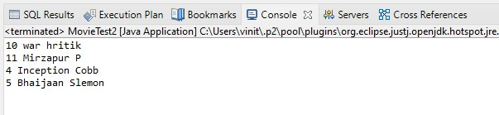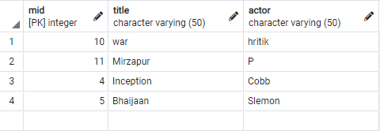

**Problem Statement 9.4 :** Write a program to demonstrate RowMapper interface to fetch the records from the database.

Solution :

# Filename-Movie.java

public class Movie3 { int mid;

String title;

String actor;

public Movie3(int mid, String title, String actor) { super();

this.mid = mid; this.title = title; this.actor = actor;

}

public Movie3() {

super();

// TODO Auto-generated constructor stub

}

public int getMid() {

return mid;

}

public void setMid(int mid) { this.mid = mid;

}

public String getTitle() {

return title;

}

public void setTitle(String title) { this.title = title;

}

public String getActor() {

return actor;

}

public void setActor(String actor) { this.actor = actor;

}

}

# Filename- MovieDAO3.java

import java.sql.ResultSet;

import java.sql.SQLException; import java.util.List;

import org.springframework.jdbc.core.JdbcTemplate; import org.springframework.jdbc.core.RowMapper;

public class MovieDAO3 { JdbcTemplate jdbcTemplate;

public void setJdbcTemplate(JdbcTemplate jdbcTemplate) { this.jdbcTemplate = jdbcTemplate;

}

public List<Movie2> getAllEmployeesRowMapper(){

return jdbcTemplate.query("select * from movies",new RowMapper<Movie2>(){ @Override

public Movie2 mapRow(ResultSet rs, int rownumber) throws SQLException { Movie2 e=new Movie2();

e.setMid(rs.getInt(1));

e.setTitle(rs.getString(2)); e.setActor(rs.getString(3)); return e;

}

}); }

}

# Filename- appctx3.xml

<?xml version=*"1.0"* encoding=*"UTF-8"*?>

<beans xmlns=[*"http://www.springframework.org/schema/beans"*](http://www.springframework.org/schema/beans)xmlns:xsi=[*"http://www.w3.org/2001/XMLSchema-instance"*](http://www.w3.org/2001/XMLSchema-instance)

xsi:schemaLocation=[*"http://www.springframework.org/schema/beans*](http://www.springframework.org/schema/beans)[*http://www.springframework.org/schema/beans/spring-beans.xsd"*](http://www.springframework.org/schema/beans/spring-beans.xsd)>

<bean id=*"ds"* class=*"org.springframework.jdbc.datasource.DriverManagerDataSource"*>

<property name=*"driverClassName"* value=*"org.postgresql.Driver"* />

<property name=*"url"* value=*"jdbc:postgresql://localhost:5434/postgres"* />

<property name=*"username"* value=*"postgres"* />

<property name=*"password"* value=*"password"* />

</bean>

<bean id=*"jdbcTemplate"* class=*"org.springframework.jdbc.core.JdbcTemplate"*>

<property name=*"dataSource"* ref=*"ds"*></property>

</bean>

<bean id=*"mymovie"* class=*"MovieDAO3"*>

<property name=*"jdbcTemplate"* ref=*"jdbcTemplate"*></property>

</bean>

</beans>

# Filename- MovieTest3.java

import java.util.List;

import org.springframework.context.ApplicationContext;

import org.springframework.context.support.ClassPathXmlApplicationContext; public class MovieTest3 {

private static ApplicationContext appCon; public static void main(String[] args) {

// TODO Auto-generated method stub

appCon = new ClassPathXmlApplicationContext("appctx3.xml"); MovieDAO3 m1=(MovieDAO3)appCon.getBean("mymovie");

List<Movie2> list=m1.getAllEmployeesRowMapper();

}}

# OUTPUT-

for(Movie2 e:list)

System.out.println(e);

