**1.Implement a complex modulation system with real operations. (Let I-branch transmit a rectangular pulse and Q-branch a triangular pulse).**

This practice’s result can see Figure 1 by matlab and my step as below:

a). for I-branch, create a rectangular pulse as m1(t) then mix carrier wave of I-branch.

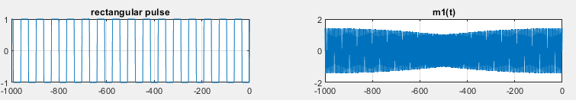

b). for Q-branch, create a triangular pulse as m2(t) then mix carrier wave of Q-branch.

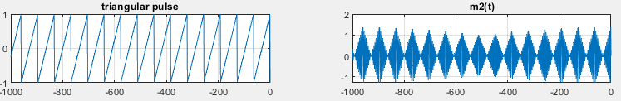

c). add step a and step b to create y(t)

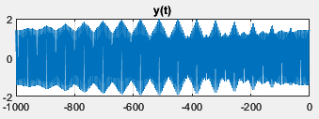

d). the y(t) mix carrier wave of I-branch to get y1(t)

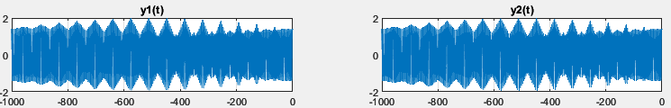

e). the y(t) mix carrier wave of Q-branch to get y2(t)



f). the y1(t) through LPF to get back m1(t)

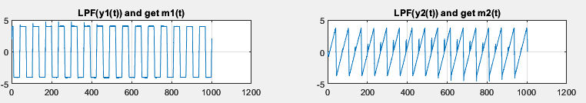

g). the y2(t) through LPF to get back m2(t)



**2.Implement a complex modulation system with complex operations.**

This practice’s result can see Figure 2 by matlab and my step as below:

a). for I-branch, create a rectangular pulse as m1(t) then mix carrier wave of real-part.

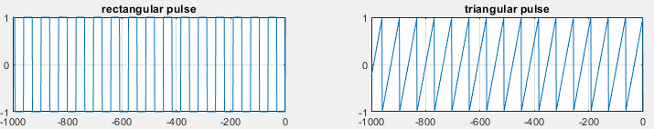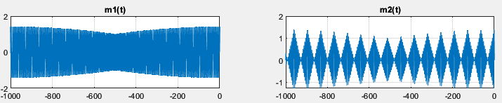

b). for Q-branch, create a triangular pulse as jm2(t) then mix carrier wave of imaginary-part.

 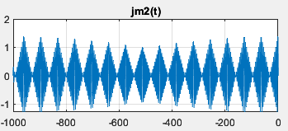

c). add step a (real(m1)) and step b(imag(1i*m2)) to create y(t)

d). the y(t) mix carrier wave of real-part to get y1(t)

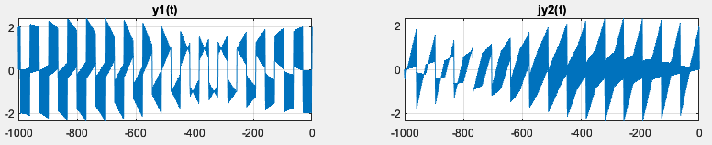

e). the y(t) mix carrier wave of imaginary-part to get jy2(t)



f). the y1(t) through LPF to get back m1(t)

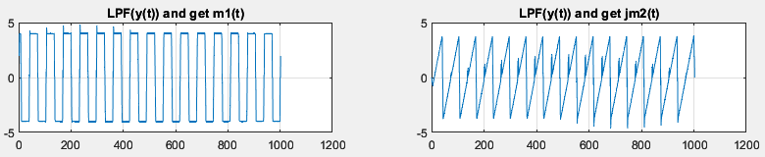

g). the jy2(t) through LPF to get back jm2(t)

