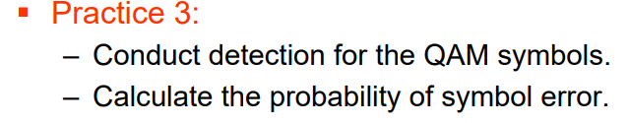

My practice as below:

1.Create SNR=1~20, QAM Symbol =10000

Result:

SNR 1~5:

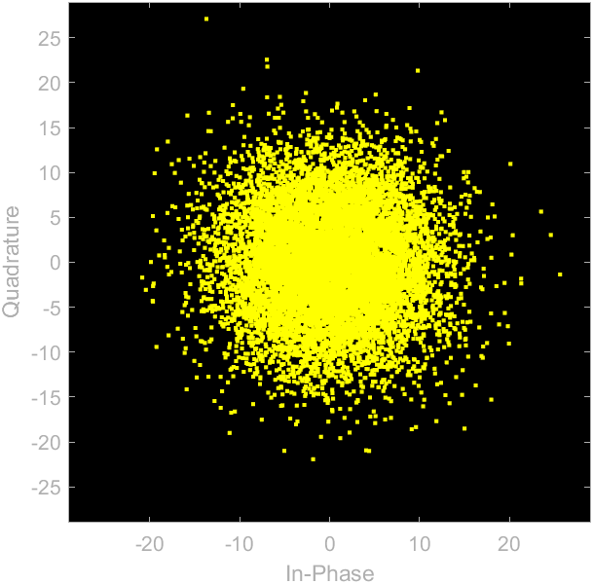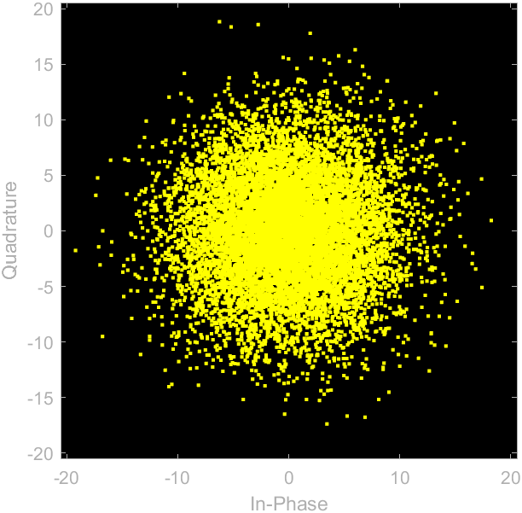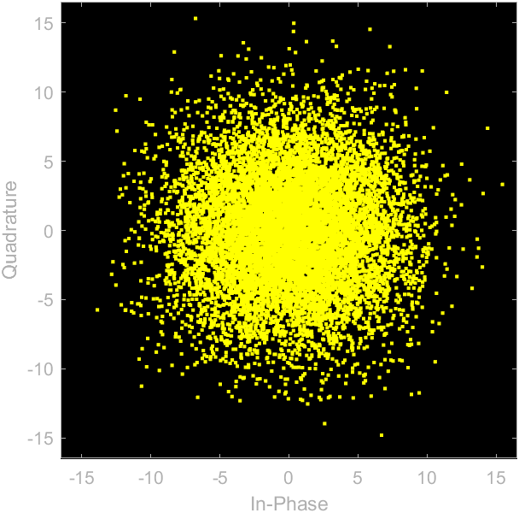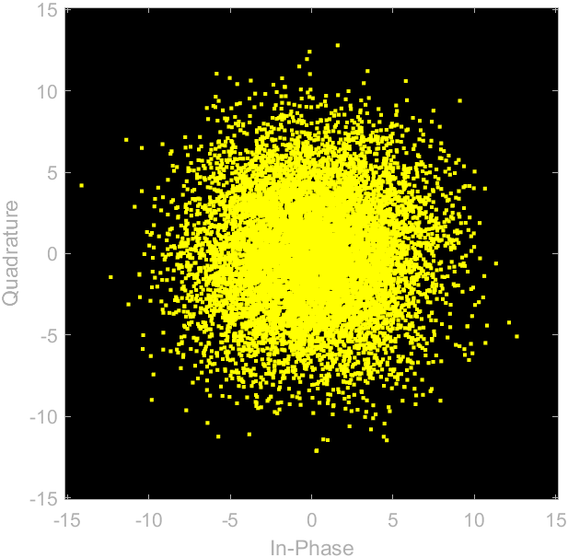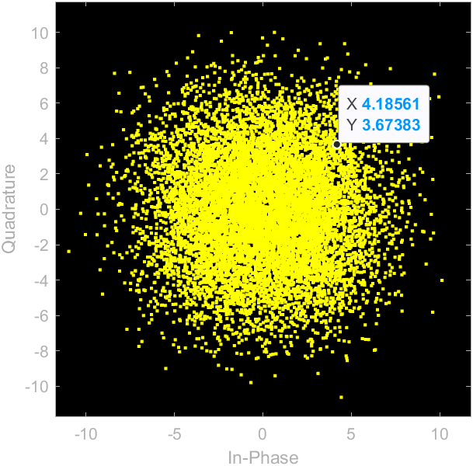

SNR 6~10:

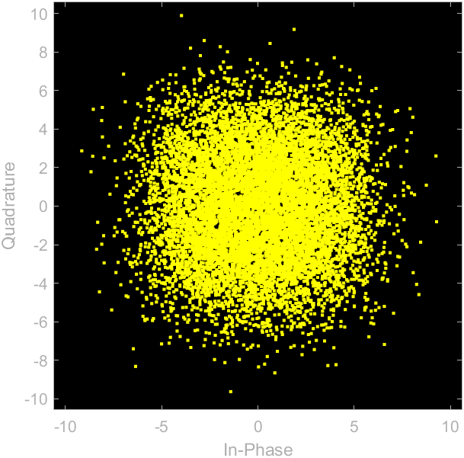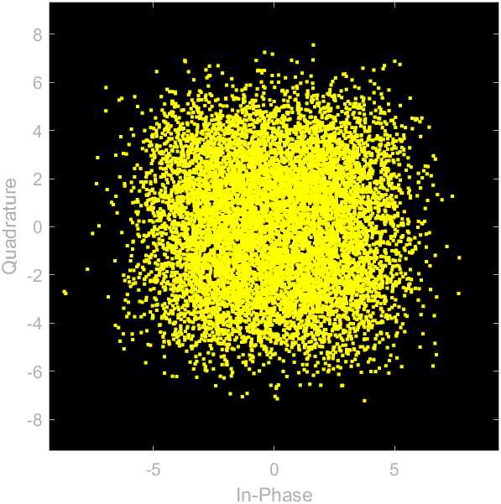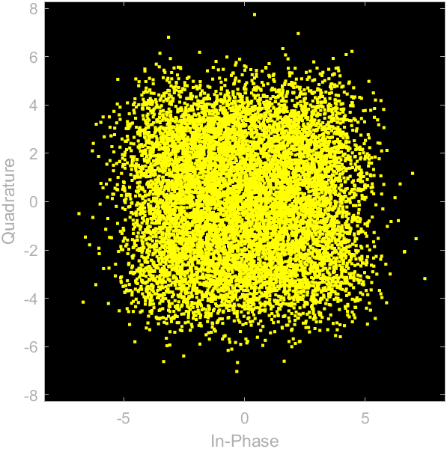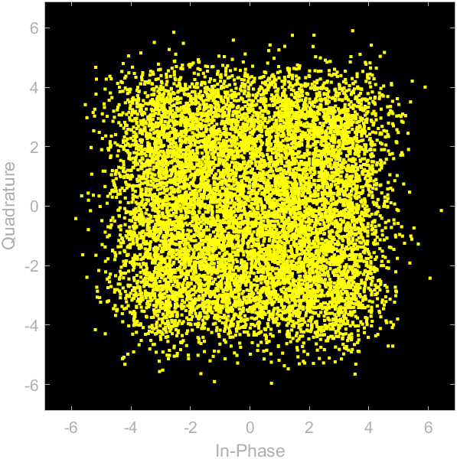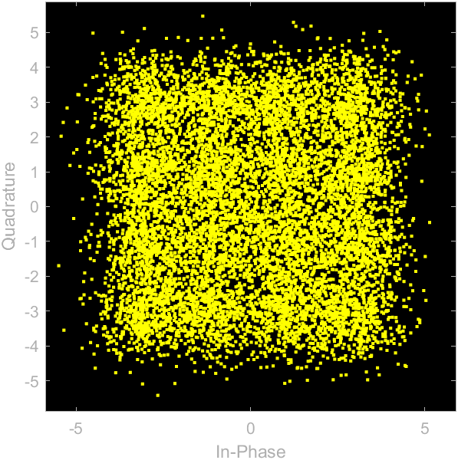

SNR 11~15:

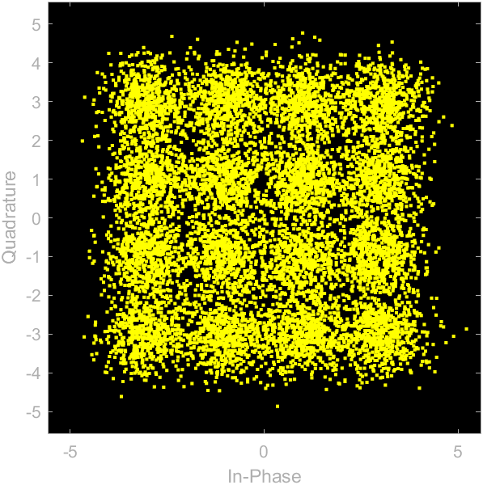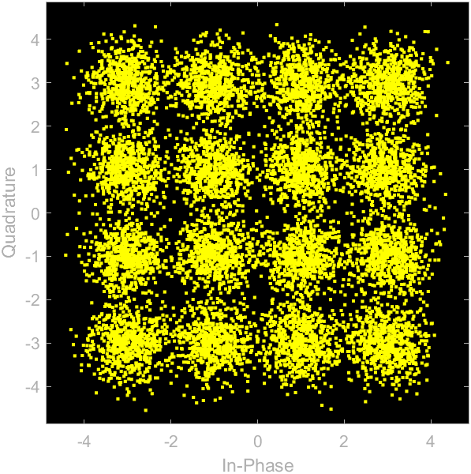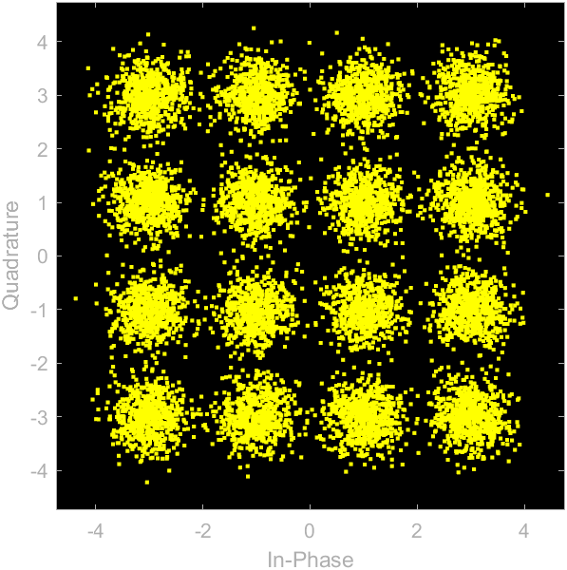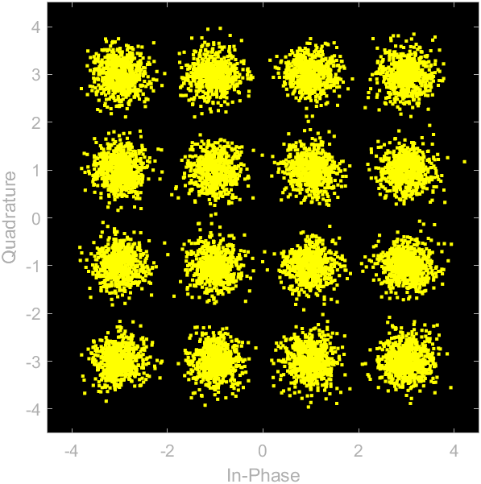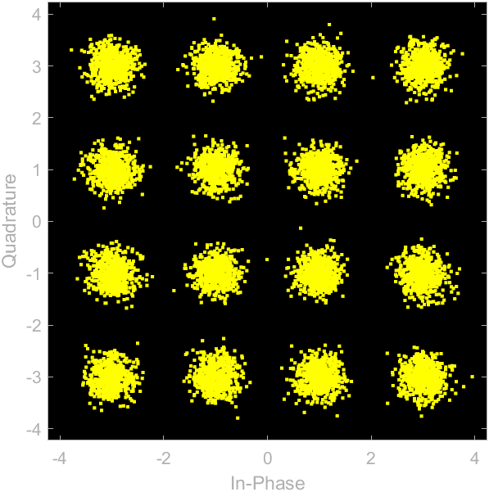

SNR 16~20:

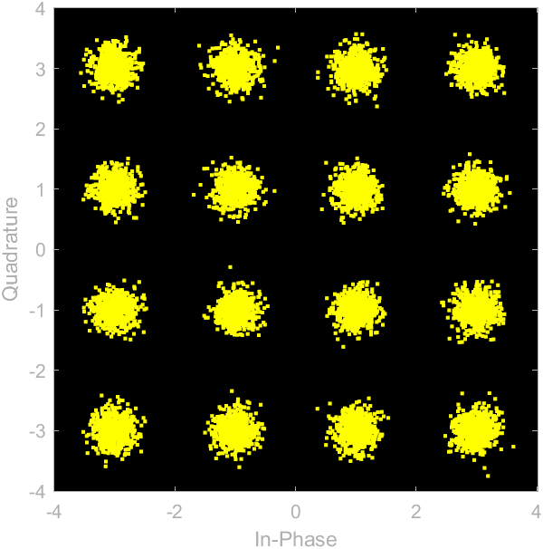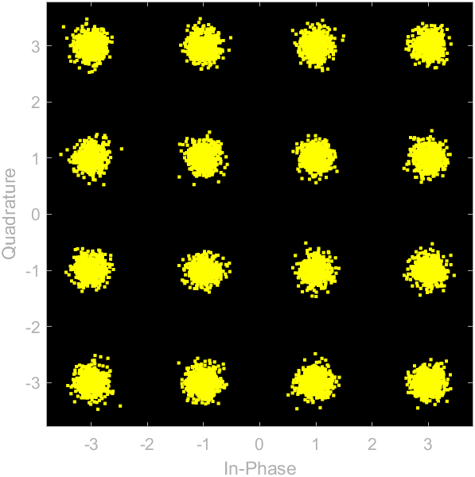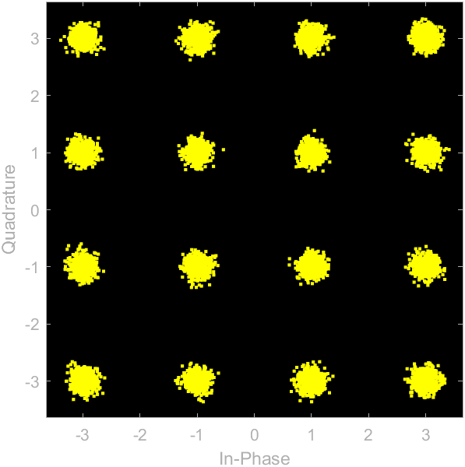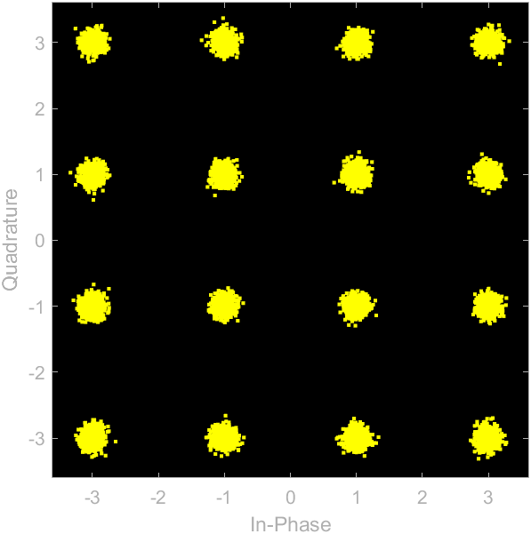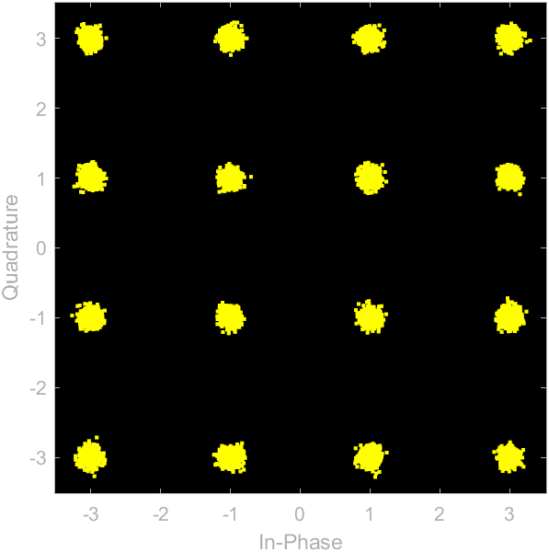

As the SNR increases, it can be observed that symbols become increasingly

concentrated within their respective intervals , which indicates that the error is becoming smaller.

2.Calculate BER and SER:

I make a function(gray_code_2bits_reverse

) to do decision boundary and convert the value of receive to symbol and bit.

Finally, print chart as below:

Represent BER using “*”

Represent SER using “o”

If the SNR < 10, the SER is larger than 21.83%, when the SNR is greater than or equal to 14, the SER is almost zero.

If the SNR < 10, the BER is larger than 11.45%, when the SNR is greater than or equal to 14, the BER is almost zero.

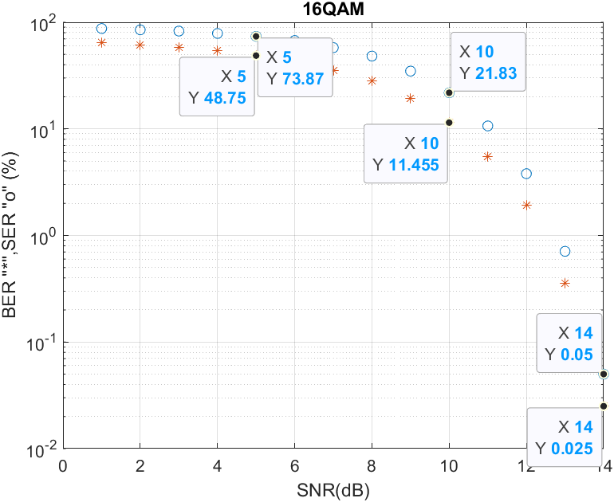

So, when we want to use 16QAM for transmission and desire good throughput, we must increase the SNR to at least 14dB.