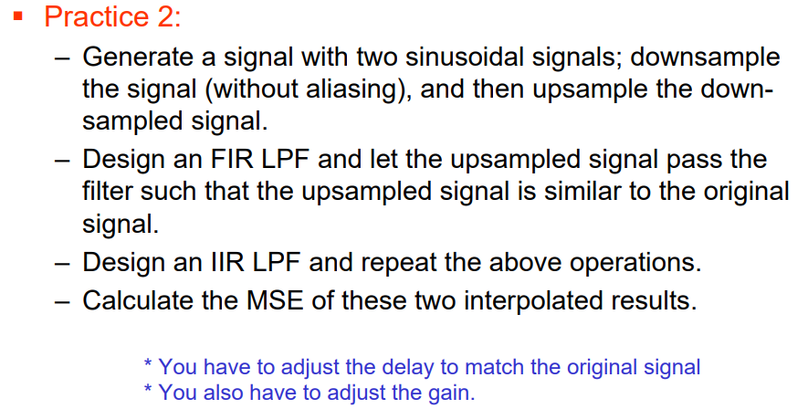

1.generate a signal with two sin wave

|  |
| --- |
| f1 = 100; %% frequency 1  f2 = 200; %% frequency 2  fs = 1024; %% frequency of sampling |



2.To avoid aliasing, doing LPF before doing downsampling



3.downsampling



4.upsampling



5.FIR(Finite impulse response)

Window Filter

|  |
| --- |
| Fs = 1024; % Sampling Frequency  N = 9; % Order  Fc = 110; % Cutoff Frequency |

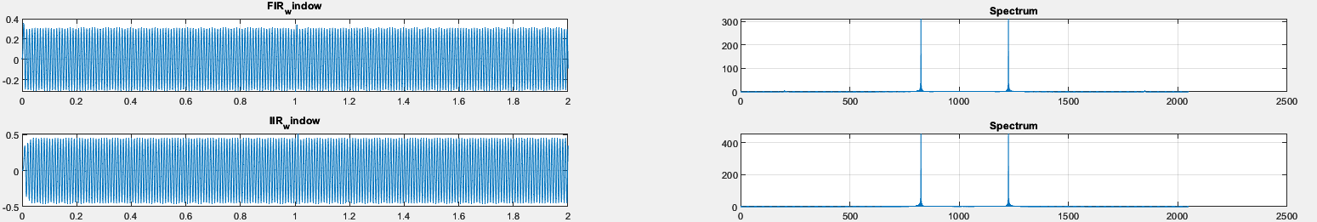

6.IIR(infinite impulse response filter)

Butterworth Filter

|  |
| --- |
| Fs = 1024; % Sampling Frequency  N = 8; % Order  Fc = 110; % Cutoff Frequency |



7.MSE

Using function immse() to measure MSE.

|  |
| --- |
| The FIR mean-squared error is 0.8329  The IIR mean-squared error is 0.3193 |

We can see the MSE result, the IIR is better than the FIR and has a lower order, resulting in faster execution speed.