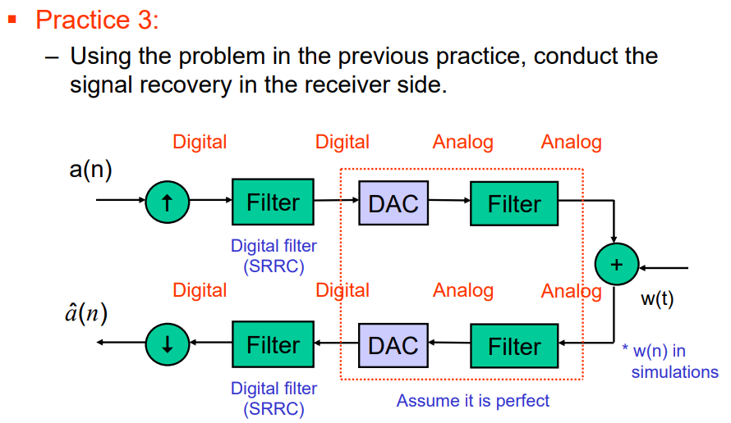

1.generate SRRC

|  |
| --- |
| M = 100; % number of sampling point in a T(symbol)  n = linspace(-fs/2, fs/2, fs); % sampling point interval  alpha = 0.1;  srrc_pulse = SRRC(alpha,n,M); |

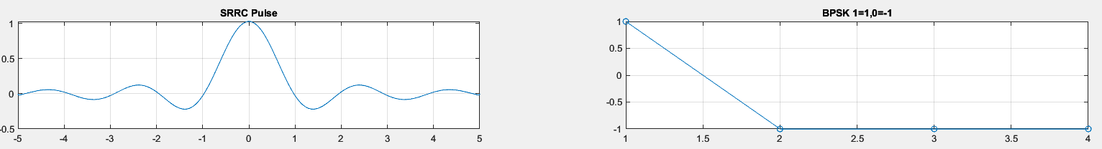

2.generate BPSK

|  |
| --- |
| numBits = 4; % number of symbol  multiple = 8; % sampling rate  bpsk = randi([0 1],1,numBits); % binary  bpsk_enc = BPSK_enc(bpsk); |



3.Upsample BPSK

|  |
| --- |
| multiple = 8; % sampling rate  bpsk_up = upsample(multiple,bpsk_enc); |

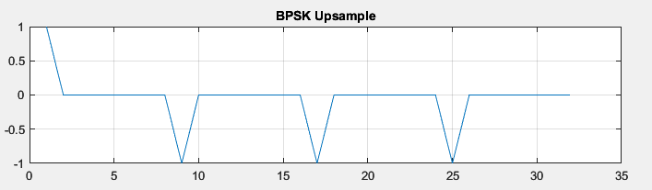

4.BPSK + SRRC (Tx)

|  |
| --- |
| bpsk_srrc = bpsk_up.' .* srrc_pulse; % combination SRRC |

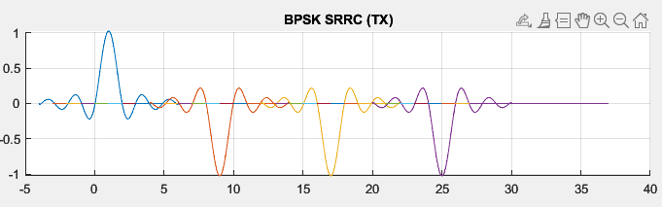

5.BPSK signal + Noise signal (AWGN)

|  |
| --- |
| SNR = 10; % SNR(dB)  fs = 1000;  [Eavg,sigma,noise] = AWGN(SNR,bpsk_enc,fs);  bpsk_tx = bpsk_srrc + noise; % add to Tx signal |

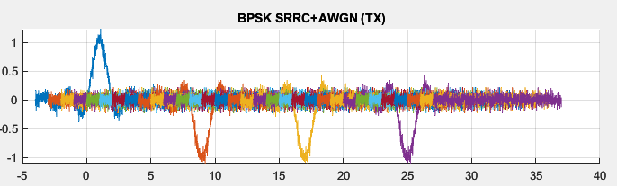

6.Using FIR Filter to remove noise in RX side

|  |
| --- |
| filternoise(x,:) = filter(fir,bpsk_tx(x,:)); % filter Noise |

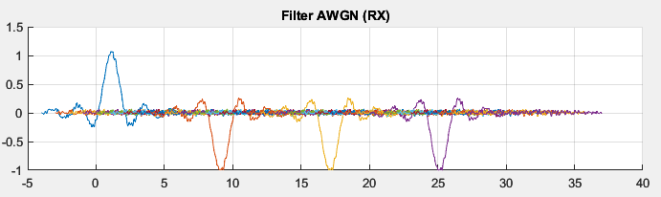

7.doing convolution to get BPSK signal

|  |
| --- |
| bpsk_rx = filternoise .* srrc_pulse; % convolution SRRC |

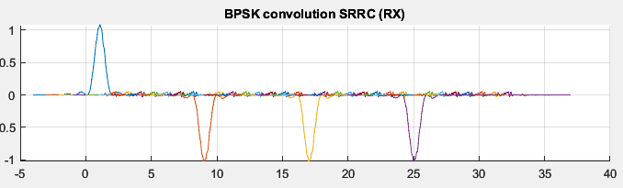

8.Downsampling BPSK

|  |
| --- |
| numBits = 4; % number of symbol  multiple = 8; % sampling rate  bpsk_down(:,:) = bpsk_rx(1:multiple:multiple*numBits,:);% Downsampling |

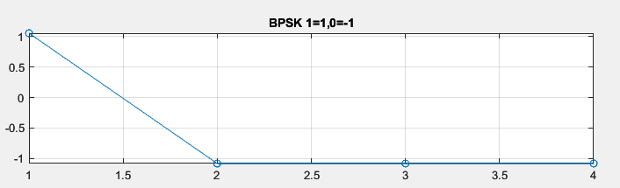

9.decode BPSK signal

|  |
| --- |
| bpsk_dec = BPSK_dec(bpsk_enc_rx,1,-1); |

