1. alpha

The parameter alpha is controls the response envelop.

alpha = 0.5, beta = 0.001:

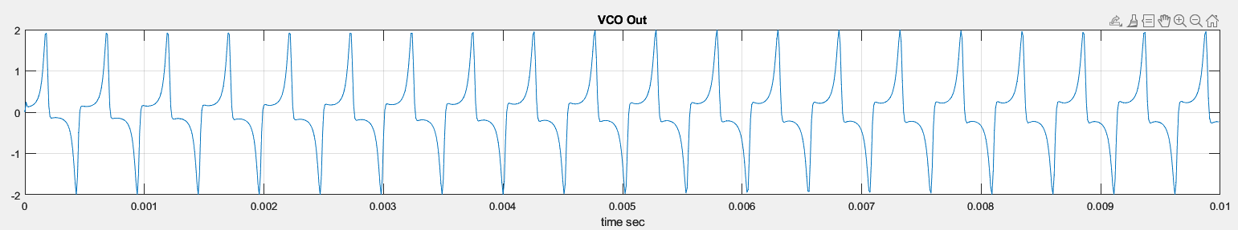

alpha = 0.1, beta = 0.001:

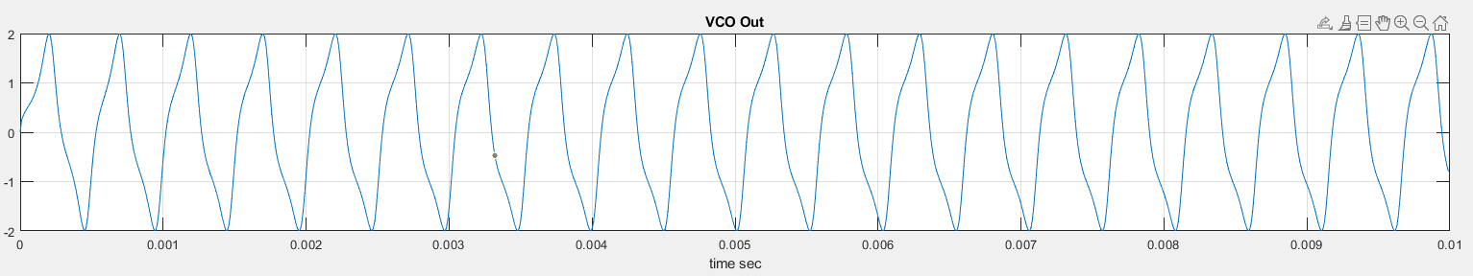

alpha = 0.05, beta = 0.001:

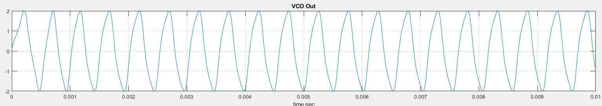

alpha = 0.01, beta = 0.001:

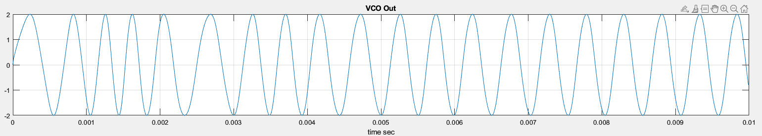

2. beta

The parameter beta is controls the value of damping frequency

alpha = 0.01, beta = 0.005

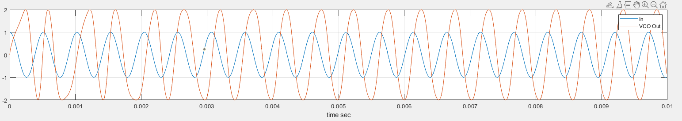表單的頂端

alpha = 0.01, beta = 0.001

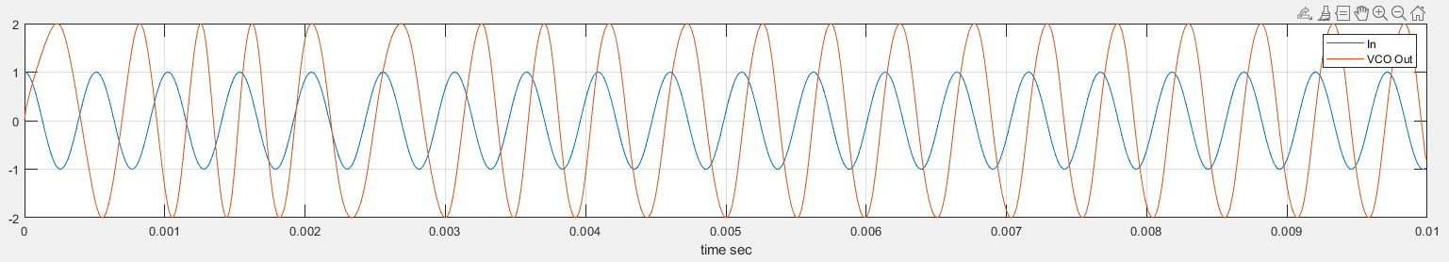

alpha = 0.01, beta = 0.0005

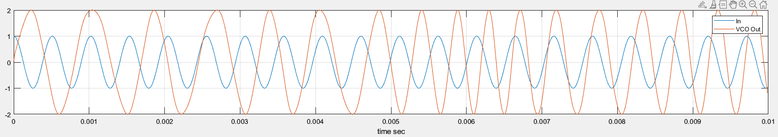

alpha = 0.01, beta = 0.0001

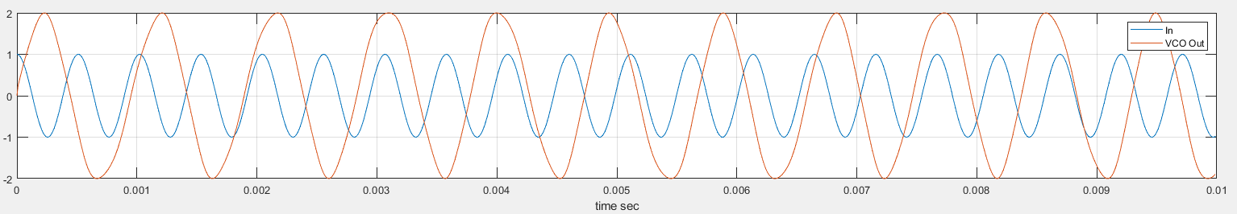

alpha = 0.01, beta = 0

