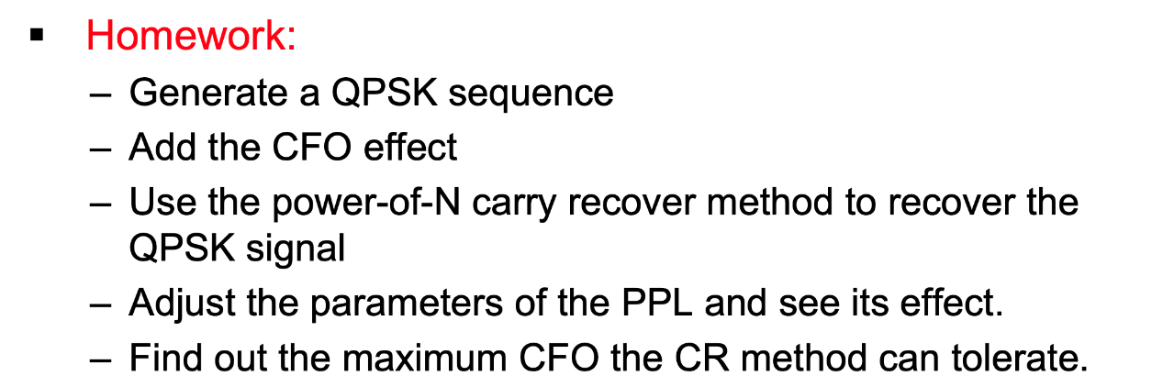

1.generate QPSK (number of symbol = 10000)

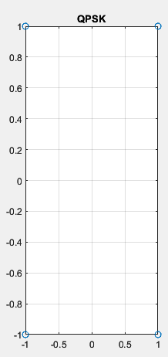

2.add the CFO

|  |
| --- |
| cfo = 200; % Carrier frequency offset  qpsk_cfo = qpsk .* exp(1i * 2 * pi * cfo * t); |

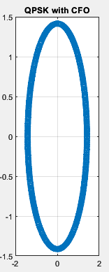

3. Use the power-of-N carry recover method to recover the QPSK signel

Find N and exp(j*N*arg(Ak))=1

|  |
| --- |
| For my practice, N = 8 |

4.Set PLL parameter

|  |
| --- |
| alpha = 0.01;  beta = 0.001; |

5.doing diagram and find phi

|  |
| --- |
| phi_k(a) = phi_k(a-1) + ck(a); |

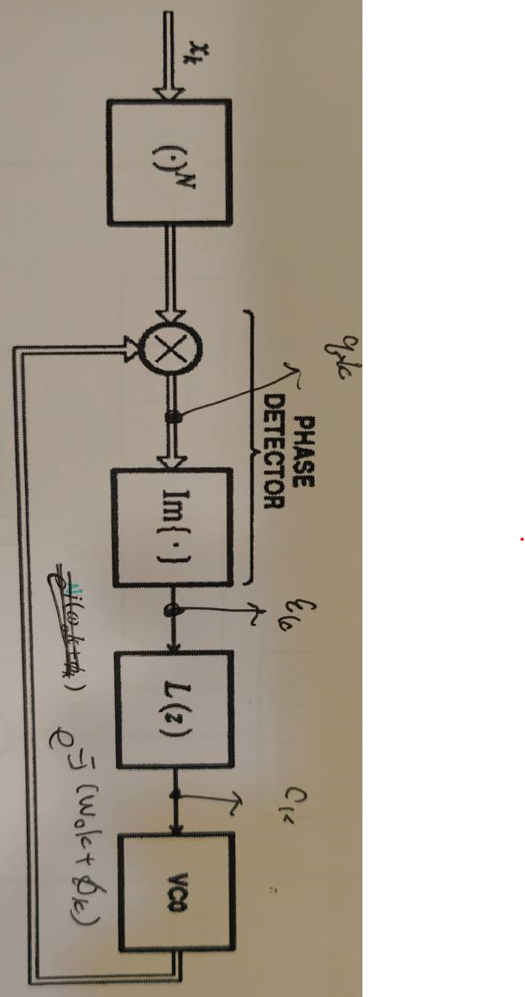

6.recovered QPSK

The phi is N times the CFO, so multiplying the CFO signal by exp(-i*(phi_k(a)/N)) can restore it.

|  |
| --- |
| output(a) = qpsk_cfo(a)*exp(-i*(phi_k(a)/N)); |

