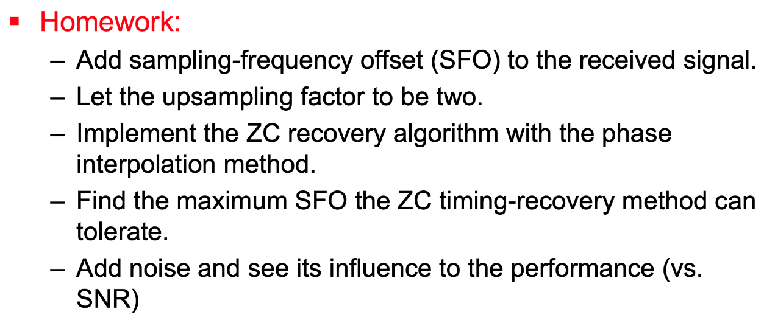

1. add SFO and result

|  |
| --- |
| sto=100;  qpsk_srrc_sto = resample(qpsk_srrc , length(qpsk_srrc)-sto , length(qpsk_srrc)); |

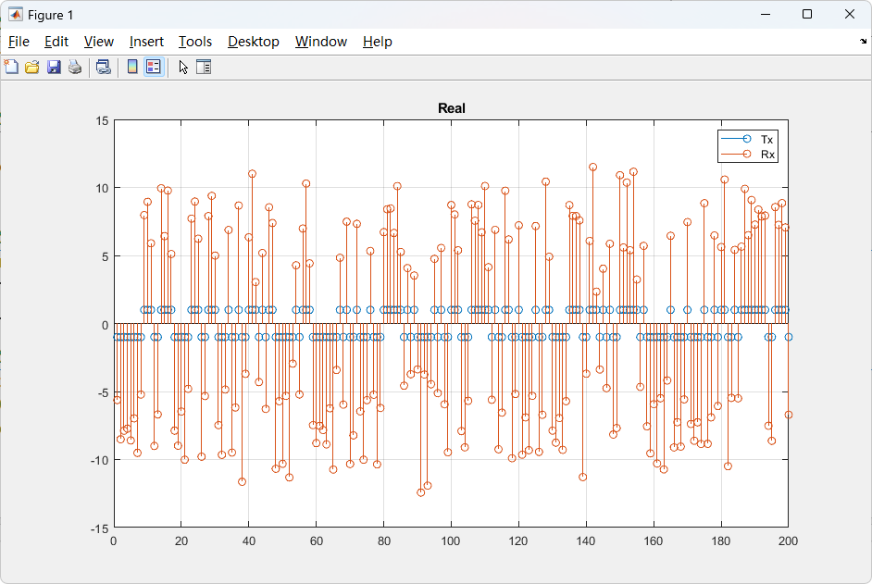

1. Find the maximum SFO

|  |
| --- |
| approximately  sto=100*2; |

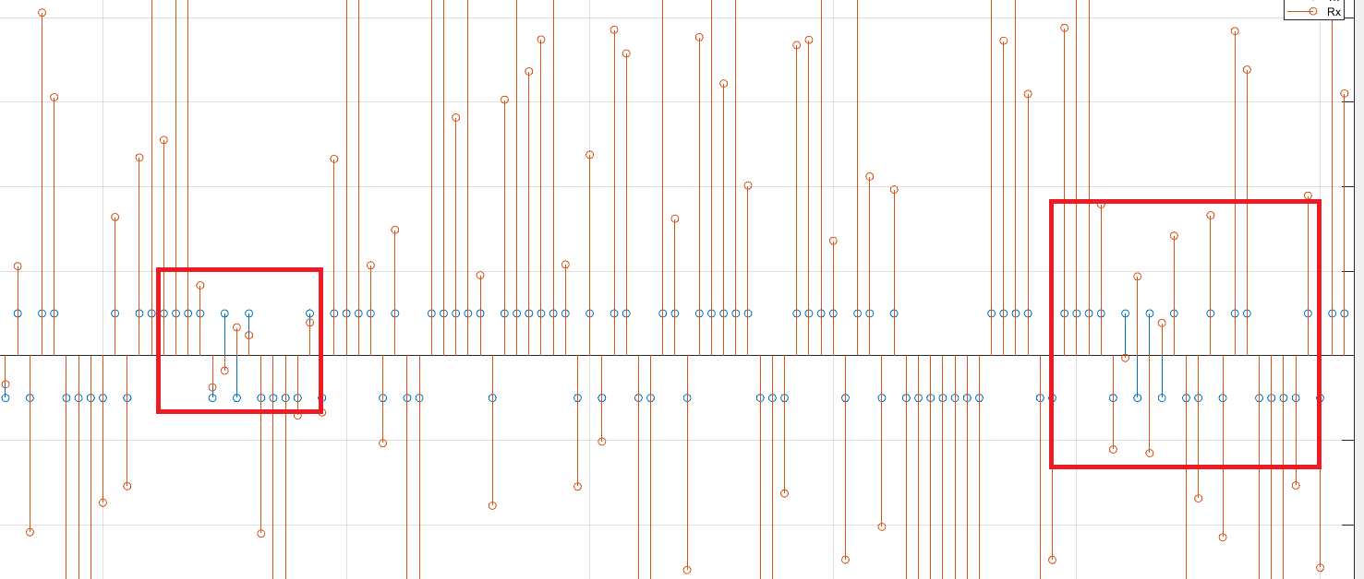

1. Add noise and see influence with SNR

SRN = 1

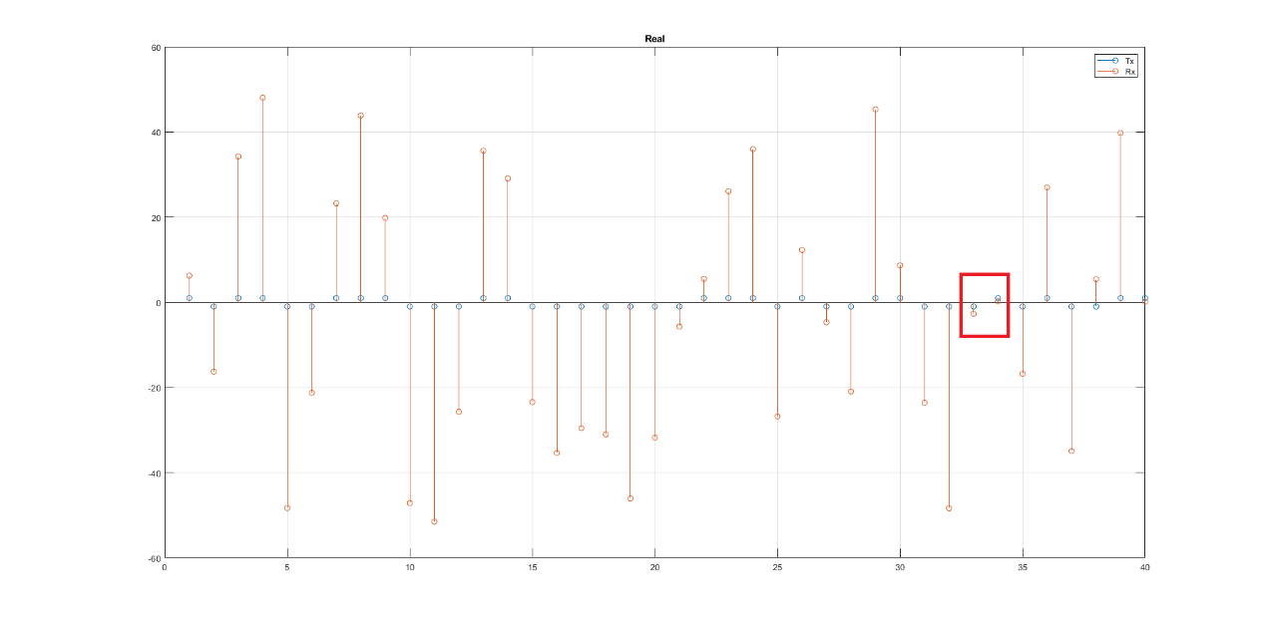

SNR = 10

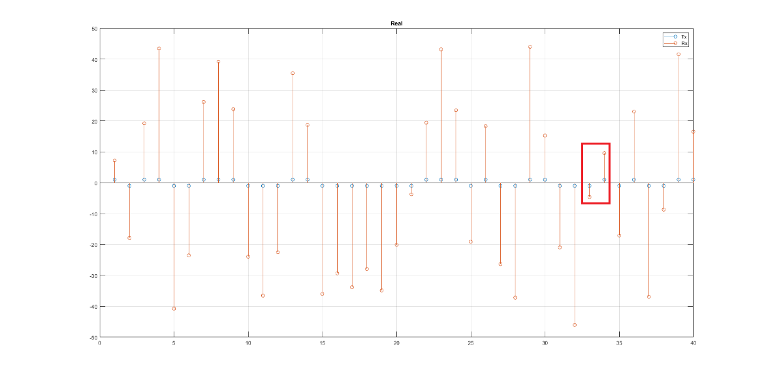

SNR = 20

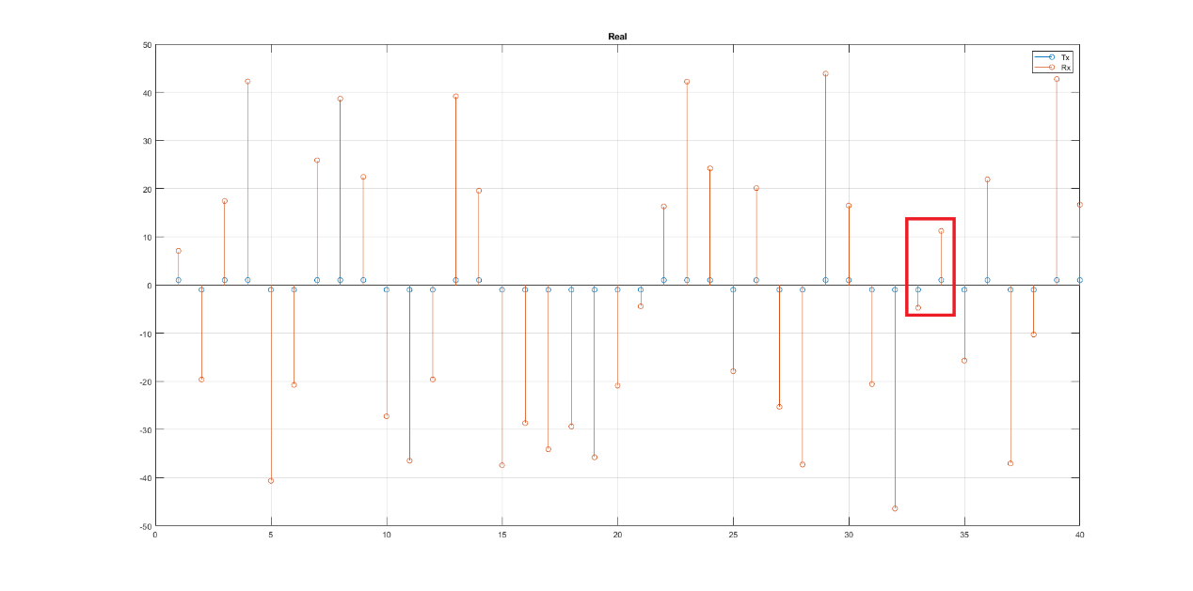

SNR越大越能抵抗值比較接近0的點，避免因為雜訊而+-交替影響取值