Part 1,

1~5

BDDAC

6~10

DACBC

11~15

DCABB

16~20

AEDCE

21~25

CEEBD

26~30

DEAEC

Part 2,

1, Answer : False

2, Answer : False

3, Answer : 1

4, Answer : False

5, Answer : False

Part 3,

1,



2,

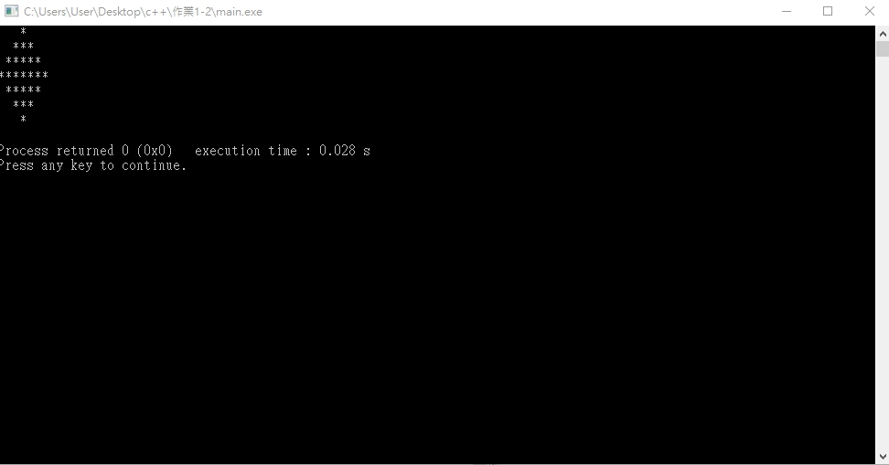

3,

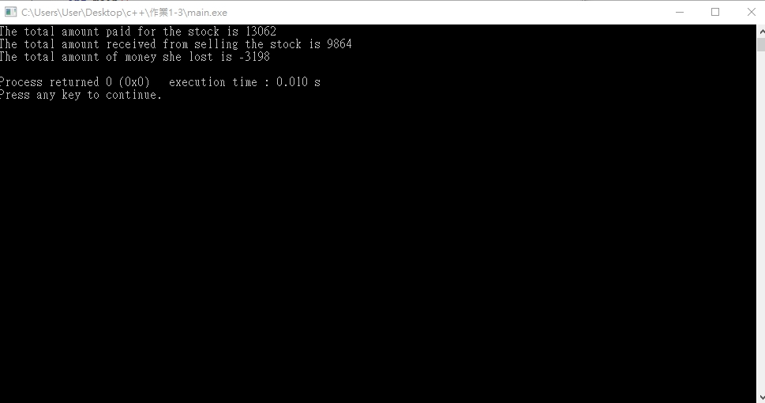

4,

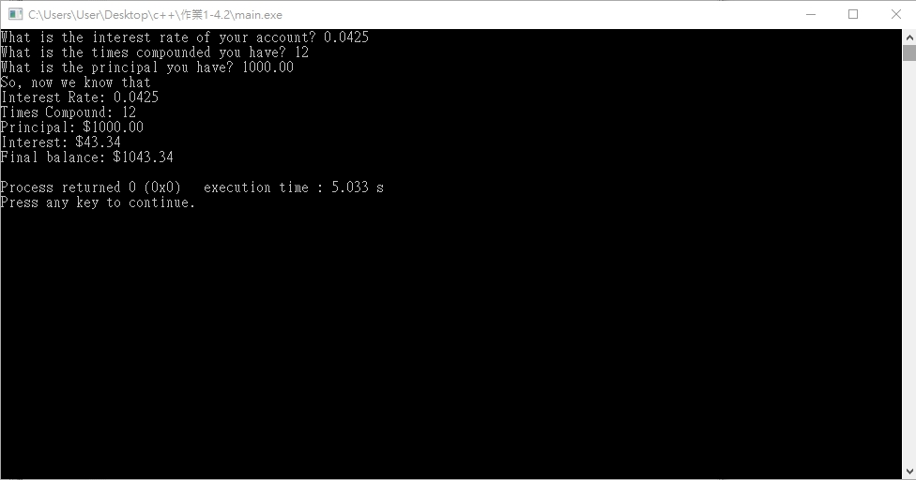

5,

