**PartA**

1. (A)1 (B)0 (C)0 (D)1
2. if(score >= 90 && score <=100)

cout << "Excellent" << endl;

else if(score >= 80 && score < 90)

cout << "Good" << endl;

else if(score >= 0 && score < 80)

cout << "Try Harder" << endl;

else if(score < 0 || score >100)

cout << "You enter a invalid score!Try again." << endl;

1. (A)

<<"average them:"; **沒有cout**

int score1, score2, score3, **沒有分號;**

if (average = 100); **括號內應該為邏輯運算子==**

perfectScore = true;// Set the flag variable **perfectScore沒有很好的define**

boolperfectScore; **沒有空格**

(B)

cout<< "Division by zero is not possible.\n";

cout<< "Please run the program again ";

cout<< "and enter a number besides zero.\n"; **沒有大括號**

quotient = num1 / num2;

cout<< "The quotient of " << num1 <<

cout<< " divided by " << num2 << " is ";

cout<< quotient <<endl; **沒有大括號**

(C)

inttestScore;  **int之後沒有空格**

else **應為else if**

(D)

doubletestScore; **double之後沒有空格**

switch (testScore)

1. (A)

} while (choice = 1) **少了分號;**

(B)

int count = 1, total; **應給total起始值為0**

total += count; **應再加一行count++; 且兩行加上大括號**

(C)

5. (1)O (2)O (3)X (4)O (5)O (6)X (7)O

**PartB**

1~5

FFFFT

6~10

TTTFT

**PartC**

1~5

ACACA

6~10

DBCBA

11~15

DBBBB

16~20

DDCBA

**PartD**

1.

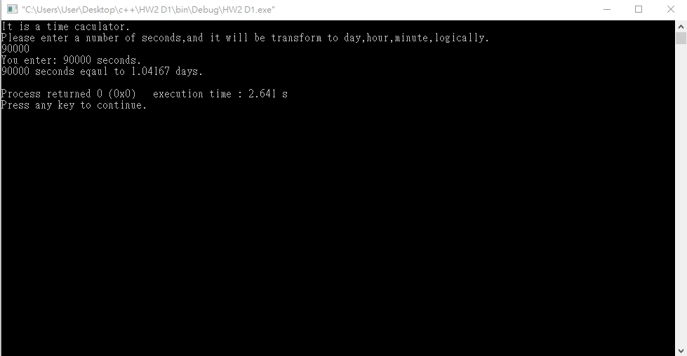

2.

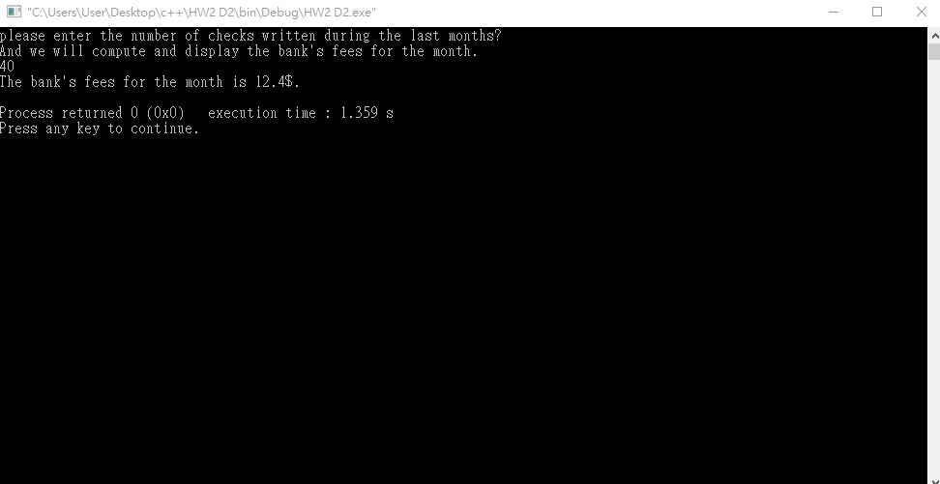

3.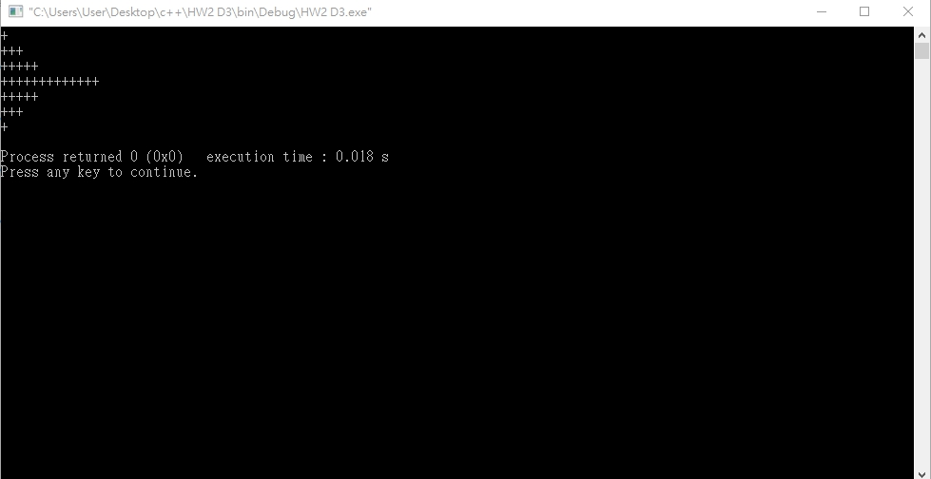

4.

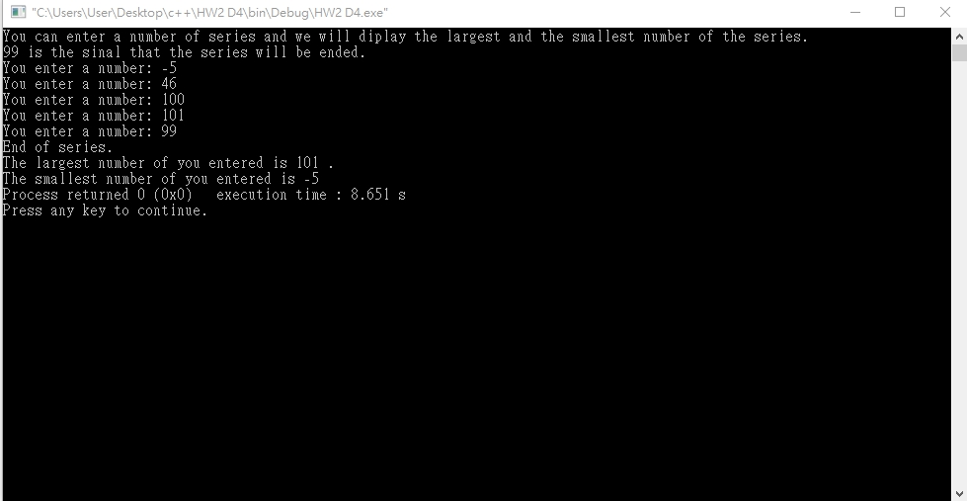

5.