# CS 340 README

## About the Project/Project Title

*Connecting MongoDB to a user-interface using Python Middle-Ware as a “Glue” level.*

## Motivation

*To develop a web application that connects a client-side user interface (such as a dashboard) to a database, it will help to develop a portable Python module that enables CRUD functionality for this data connection. This project utilizes a Python module that enables Create and Read functionality.*

## Getting Started

*To get a local copy up and running, follow these simple example steps:*

*Step 1 – Go to* [*https://github.com/ShawnWhittaker/CS-340/blob/main/ProjectTwo.zip*](https://github.com/ShawnWhittaker/CS-340/blob/main/ProjectTwo.zip)

*Step 2 – Download the zipped folder and Extract its contents.*

*Step 3 – Open Jupyter Notebook and upload Dashboard.ipynb and CRUDHandler.py into the same folder*

*Step 4 – Run the CRUDHandler.ipynb cell.*

## Installation

*Jupyter Notebook*

*Python 3.9.0 or greater*

## Usage

### Explanation of CRUD Operations

There are two attributes within the CRUDHandler python module: client and collection. MongoClient from PyMongo is utilized from the client attribute and can receive the IP address and database user credentials. The methods created in the CRUDHandler include create, findDocs, update, and delete. The create method inserts data into the animal collection. The findDocs method searches the animal collection for the given search criteria. The update method takes two arguments, the search criteria and data contents, to find the given data in the animal collection and replaces it with the new data. The delete method uses search criteria to find data in the animal collection, and then deletes it from the database.

**Code Example**

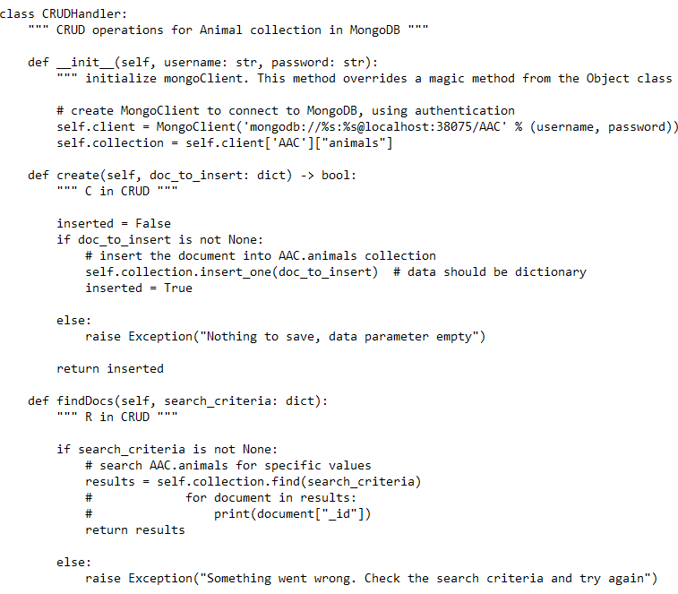

### Explanation of Middleware Code

The Dash framework and Pandas dataframe code comprises the middleware and allows data analysis. Dash framework structures the components used for the clientside dashboard. Pandas dataframes filter the data from the database queries. Combining Pandas and Dash allow us to implement radio buttons, data tables, maps, pie charts, and other forms of user interactivity.

### Code Example

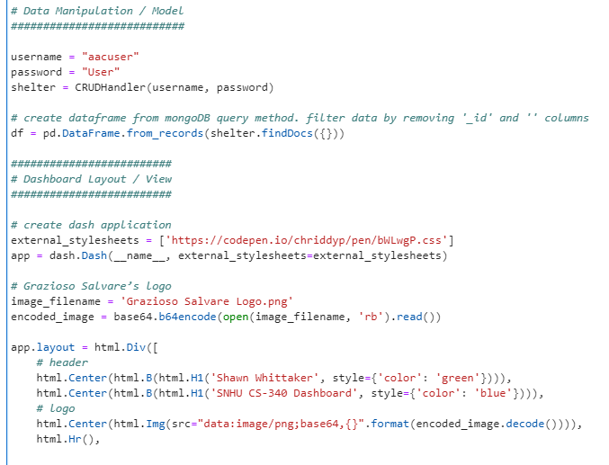

## Contact

Shawn Whittaker

Southern New Hampshire University