Example XML Document Instance

Instance with annotations:
This example uses xx-patent-document as the model for the creation of an example wo-patent-document. In particular the example is a PCT published application (an A1 document) - this PCT example uses some published parts of patent applications and parts created for example purposes only.
The example markup does not necessarily reflect PCT practice.

Note: Comments are printed in square brackets, greyed, in [italic bold].

First we start with the bibliographic data required to create the front page (title page) of a PCT patent document:

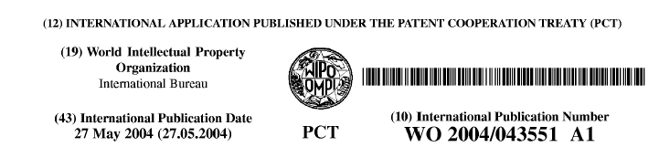

this would be the markup:

[Standard prolog lines]

<?xml version="1.0" encoding="UTF-8"?>
<!DOCTYPE wo-patent-document SYSTEM "wo-patent-document-v1-3.dtd">

[Now starts the actual patent document with various attributes. The attribute values at this “top” level may help processing – they may be repeated in the document as elements]

<wo-patent-document id="example01" file=”043551.xml” country="WO" doc-number=”043551” kind=”A1” date-published=”20040527” dtd-version="v1.3 2005-01-01" lang="en”>

[Here starts the actual bibliographic data]

<bibliographic-data id="bibl" country="WO" lang="en">

[Plain-language designation – INID code (12) – this could be generated by a style sheet simply based on the fact that it is a “wo” document (as for INID code (19) in this case – this is the kind of information to be given when data is exchanged]

<plain-language-designation>INTERNATIONAL APPLICATION PUBLISHED UNDER THE PATENT COOPERATION TREATY (PCT)</plain-language-designation>

[The publication number and date of publication – INID codes (43) and (10) ]

<publication-reference>
<document-id>
<country>WO</country>
<doc-number>043551</doc-number>
<kind>A1</kind>
<date>20040527</date>
</document-id>
</publication-reference>

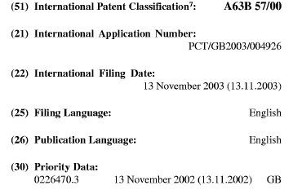

[The IPC – INID code (51) ]

<classification-ipc id="ipc7">
<edition>7</edition>
<main-classification>A63B 57/00</main-classification>
</classification-ipc>

[The application number- INID (21) and the date of filing – INID (22]

<application-reference appl-type="PCT">
<document-id>
<country>GB</country>
<doc-number>004926</doc-number>
<date>20031113</date>
</document-id>
</application-reference>

[The filing language – INID code (25) ]

<language-of-filing>en</language-of-filing>

[The publication language – INID code (26) ]

<language-of-publication>en</language-of-publication>

[Priority data – INID code (30) ]

<priority-claims>
<priority-claim>
<country>GB</country>
<doc-number>0226470.3</doc-number>
<date>20021113</date>
</priority-claim>
</priority-claims>

[Start of parties concerned with the patent - applicant – INID code (71) ]

<parties>
<applicants>
<applicant sequence="1" designation="all-except-us" app-type="applicant">
<addressbook>
<orgname>WORLD GOLF SYSTEMS LTD (GB)</orgname>
<address>
<street>Axis 4 Rhodes Way</street>
<city>Watford</city>
<county>Herts</county>
<postcode>WD24 4YW</postcode>
<country>GB</country>
</address>
</addressbook>
</applicant>
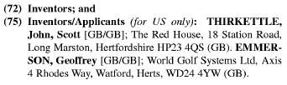

[Inventor/applicant – INID code (72) and (75) ]

<applicant sequence="2" designation="us-only" app-type="applicant-inventor">
<addressbook>
<last-name>THIRKETTLE</last-name>
<first-name>John</first-name>
<address>Somewhere over the rainbow</address>
</addressbook>
</applicant>
<applicant sequence="3" designation="us-only" app-type="applicant-inventor">
<addressbook>
<last-name>EMMERSON</last-name>
<first-name>Geoffrey</first-name>
<address>34 Ralph Waldo Pond</address>
</addressbook>
</applicant>
</applicants>

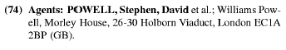

[Agent – INID code (74)]

<agents>
<agent sequence="1" rep-type="agent">
<addressbook>
<last-name>POWELL</last-name>
<first-name>Stephen</first-name>
<middle-name>David</middle-name>
<suffix>et al</suffix>
<orgname>Williams Powell</orgname>
<address>
<building>Morley House</building>
<street>35 Kings Row</street>
</address>
</addressbook>
</agent>
</agents>
</parties>

[Designated states – INID codes (81), (84)]

<designation-of-states>
<designation-pct>
<national>
<country>AE</country>
<country>AG</country>
</national>
<regional>
<region>
<country>AP</country>
<country>BW</country>
<country>GH</country>
</region>
<region>
<country>EA</country>
<country>AM</country>
<country>AZ</country>
</region>
</regional>
</designation-pct>
</designation-of-states>

[Invention title – INID code (54)]

<invention-title lang="en">GOLF TEE DEVICE
</invention-title>
</bibliographic-data>

[End of bibliographic data and start of abstract data – INID code (57) - the abstract drawing, taken from figures in the drawing pages (in this case Figure. 7) may be generated automatically from the referenced drawing and re-scaled for the title page but is commonly embedded as a separate, new, image file for publication processing – implementation may differ from office to office – here it is part of the abstract and the rendering process for the title page places it above the abstract]

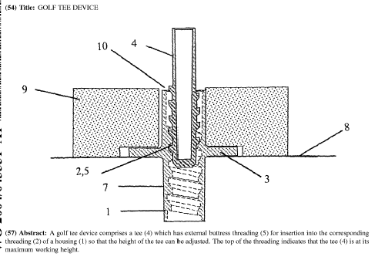

<abstract id="abst" lang="en">
<p id="p01a">A golf tee device comprises a tee (4) which has external buttress threading (5) for insertion into the corresponding threading (2) of a housing (1) so that the height of the tee can be adjusted. The top of the threading indicates that the tee (4) is at its maximum working height.
<img id="abs-fig01" file="043551-abs.tif" he="71" wi="120" img-content="drawing" img-format="tif"/>
</p>
</abstract>

[Description – note: this contains data NOT contained in the patent referenced above]

<description id="desc" lang="en">

[Invention title is repeated – it could have been taken from the bibliographic data]

<invention-title lang="en">GOLF TEE DEVICE</invention-title>
<p id="p0001" num="0001">The present invention relates to a golf tee device.</p>
<p id="p0002" num="0002">Golf driving ranges are popularly used to practise long shots that may be used during a game of golf . . .</p>

[Below we illustrate various paragraph element usage]

<p id="p0003" num="0003">The tees currently provided in driving ranges tend to be:

[ordered lists with italic text]

<ol>
<li>the conventional tee as used on a golf course:
<ol>
<li><i>plastic</i></li>
<li><i>wood</i></li>
<li><i>fibre-glass, etc</i></li>
</ol>
</li>
<li>fixed-height rubber tees.</li>
</ol></p>

<p id="p0004" num="0004">Conventional tees can:

[unordered lists with bold text]

<ul list-style="bullet">
<li><b>fly</b> out of their holder when the golf ball is struck</li>
<li><b>break</b></li>
<li><b>be lost</b></li>
</ul></p>

[A heading followed by paragraphs with patent citations]

<heading id="h0001" level="1"><b>Other patents of relevance</b></heading>
<p id="p0005" num="0005">
<patcit dnum="WO09937368" id="pcit0001" num="0001">
<document-id>
<country>WO</country>
<doc-number>09937368</doc-number>
</document-id>
</patcit> discloses a height-adjustable tee. However, this tee is located into a base . .
</p>
<p id="p0006" num="0006">
<patcit dnum="US6083121" id="pcit0002" num="0002">
<document-id>
<country>US</country>
<doc-number>6083121</doc-number>
</document-id>
</patcit>discloses a height-adjustable tee based on a vertically moveable piston within a housing. However, this tee is of a relatively complex construction . . .
</p>

[A three column, three row table]

Table 1
Tee type | Length (mm) | Colour
Wooden | 40.4 | Red
Plastic | 35 | Blue

<p id="p0007" num="0007">The following table contains relevant data:
<tables id="tab0001" num="0001">
<table frame="all">
<title><b>Table 1</b></title>
<tgroup cols="3"><colspec colnum="1" colname="col1" colwidth="2215"></colspec><colspec colnum="2" colname="col2" colwidth="1907"></colspec><colspec colnum="3" colname="col3" colwidth="1372"></colspec>
<thead>
<row><entry align="left" namest="col1" nameend="col1" colsep="yes" rowsep="yes" morerows="0" valign="top"><b>Tee type</b></entry>
<entry align="left" namest="col2" nameend="col2" colsep="yes" rowsep="yes" morerows="0" valign="top"><b><i>Length (mm)</i></b></entry>
<entry align="left" namest="col3" nameend="col3" colsep="yes" rowsep="yes" morerows="0" valign="top"><b><i>Colour</i></b>
</entry></row></thead>
<tbody>
<row><entry align="left" namest="col1" nameend="col1" colsep="yes" rowsep="yes" morerows="0" valign="top">Wooden</entry><entry align="left" namest="col2" nameend="col2" colsep="yes" rowsep="yes" morerows="0" valign="top">40.4</entry><entry align="left" namest="col3" nameend="col3" colsep="yes" rowsep="yes" morerows="0" valign="top">red</entry></row>
<row><entry align="left" namest="col1" nameend="col1" colsep="yes" rowsep="yes" morerows="0" valign="top">Plastic</entry><entry align="left" namest="col2" nameend="col2" colsep="yes" rowsep="yes" morerows="0" valign="top">35</entry><entry align="left" namest="col3" nameend="col3" colsep="yes" rowsep="yes" morerows="0" valign="top">blue</entry></row>
</tbody>
</tgroup>
</table>
</tables>
</p>

[An embedded image follows of a chemical formula; this could be encoded two ways]

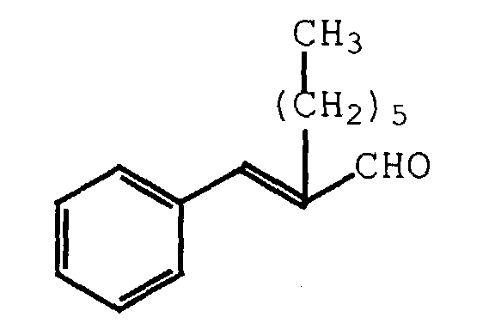

<p id="p0008" num="0008">The following formula.<br/>
<img id="i0001" wi="48" he="31" img-content="chemistry" img-format="tif" orientation="portrait" file="img0001.tif"/>
<br/>can be taken as an example.
</p>
<p id="p0009" num="0009">The following formula.
<chemistry id="chem0001" num="0001">
<img id="i0002" wi="48" he="31" img-content="drawing" img-format="tif" orientation="portrait" file="img0002.tif"/>
</chemistry>can be taken as an example.
</p>
</description>

[End of the description followed by the claims]

<claims id="claim">
<claim id="c0001" num="0001">
<claim-text>A golf tee device comprising a tee member removably supported in a holder member, wherein the tee member is movable in a continuous manner in a substantially vertical direction relative to the holder member, and wherein there is provided means to prevent movement between the tee member and the holder member on striking of a golf ball supported by the tee member.
</claim-text>
</claim>
<claim id="c0002" num="0002">
<claim-text>A device according to claim 1, wherein the means to prevent movement prevents axial movement of the tee member relative to the holder member.
</claim-text>
</claim>
<claim id="c0003" num="0003">
<claim-text>A device according to claim 1 or 2, wherein the tee member is supported by means of threading provided along at least a part of the length of the exterior of the tee member and/or at least a part of the length of the interior of the holder member.
</claim-text>
</claim>
</claims>

[End of the claims followed by the drawings]

<drawings id="draw">
<figure id="f0001" num="0001">
<img id="i0003" wi="113" he="147" img-content="drawing" img-format="tif" orientation="portrait" file="img0003.tif"/>
</figure>
</drawings>

[End of the drawings followed by the search report]

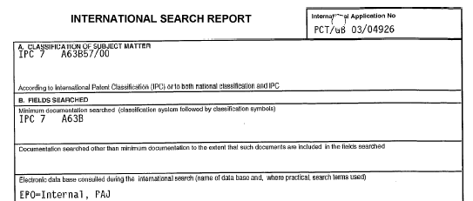

<search-report-data id="srep" lang="en" srep-type="isr" srep-office="EP">
<srep-for-pub>
<classification-ipc>
<edition>7</edition>
<main-classification>A63B 57/00</main-classification>
</classification-ipc>
<srep-fields-searched>
<minimum-documentation>
<classification-ipc>
<edition>7</edition>
<main-classification>A63B</main-classification>
</classification-ipc>
</minimum-documentation>
<database-searched>
<text>EPO internal, PAJ</text>
</database-searched>
</srep-fields-searched>

[Citations area]

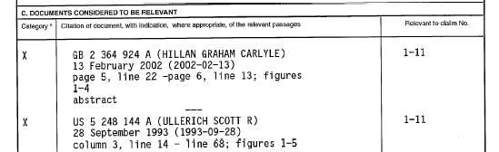

<srep-citations>
<citation>
<patcit dnum="GB2364924" id="sr-pcit0001" num="0001">
<document-id>
<country>GB</country>
<doc-number>2364924</doc-number>
<kind>A</kind>
<name>HILLAN GRAHAM CARLYLE</name>
<date>20020213</date>
</document-id>
<rel-passage>
<passage>page 5, line 22 - page 6, line 13; figures 1-4</passage>
<passage>abstract</passage>
</rel-passage>
<category>X</category>
<rel-claims>1-11</rel-claims>
</patcit>
</citation>
<citation>
<patcit dnum="US5248144" id="sr-pcit0002" num="0002">
<document-id>
<country>US</country>
<doc-number>5248144</doc-number>
<kind>A</kind>
<name>ULLERICH SCOTT R</name>
<date>19930928</date>
</document-id>
<rel-passage>
<passage>column 3, line 14 - line 68; figures 1-5</passage>
</rel-passage>
<category>X</category>
<rel-claims>1-11</rel-claims>
</patcit>
</citation>
</srep-citations>

[Administrative data]

<srep-admin>
<examiners>
<primary-examiner>
<name>Gelschläger, H</name>
</primary-examiner>
</examiners>
<srep-office>
<addressbook>
<orgname>European Patent Office</orgname>
<address>
<pobox>P.B.5818</pobox>
<street>Patentlaan 2</street>
<city>Rijswijk</city>
<postcode>NL - 2280 HV</postcode>
<country>NL</country>
</address>
<phone>(+31 70) 340 2040</phone>
<fax>(+31 70) 340 3016</fax>
</addressbook>
</srep-office>
<completion-date>
<date>20040310</date>
</completion-date>
<date-of-mailing>
<date>20040317</date>
</date-of-mailing>
</srep-admin>

[Patent family data]

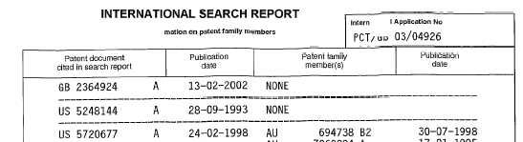

<srep-patent-family>
<patent-family>
<priority-application>
<document-id>
<country>GB</country>
<doc-number>2364924</doc-number>
<kind>A</kind>
<date>20020213</date>
</document-id>
<text>None</text>
</priority-application>
</patent-family>
<patent-family>
<priority-application>
<document-id>
<country>US</country>
<doc-number>5248144</doc-number>
<kind>A</kind>
<date>19930928</date>
</document-id>
<text>None</text>
</priority-application>
</patent-family>
<patent-family>
<priority-application>
<document-id>
<country>US</country>
<doc-number>5720677</doc-number>
<kind>A</kind>
<date>19980224</date>
</document-id>
<family-member>
<document-id>
<country>AU</country>
<doc-number>694738</doc-number>
<kind>B2</kind>
<date>19980730</date>
</document-id>
</family-member>
</priority-application>
</patent-family>
</srep-patent-family>
</srep-for-pub>
</search-report-data>
</wo-patent-document>

[End of search report and patent markup]

Complete instance without annotations:

<?xml version="1.0" encoding="UTF-8"?>
<!DOCTYPE wo-patent-document SYSTEM "wo-patent-document-v1-3.dtd">
<wo-patent-document id="example01" file="043551.xml" country="WO" doc-number="043551" kind="A1" date-published="20040527" dtd-version="v1.3 2005-01-01" lang="en">
<bibliographic-data id="bibl" country="WO" lang="en">
<plain-language-designation>INTERNATIONAL APPLICATION PUBLISHED UNDER THE PATENT COOPERATION TREATY (PCT)</plain-language-designation>
<publication-reference>
<document-id>
<country>WO</country>
<doc-number>043551</doc-number>
<kind>A1</kind>
<date>20040527</date>
</document-id>
</publication-reference>
<classification-ipc id="ipc7">
<edition>7</edition>
<main-classification>A63B 57/00</main-classification>
</classification-ipc>
<application-reference appl-type="PCT">
<document-id>
<country>GB</country>
<doc-number>004926</doc-number>
<date>20031113</date>
</document-id>
</application-reference>
<language-of-filing>en</language-of-filing>
<language-of-publication>en</language-of-publication>
<priority-claims>
<priority-claim>
<country>GB</country>
<doc-number>0226470.3</doc-number>
<date>20021113</date>
</priority-claim>
</priority-claims>
<parties>
<applicants>
<applicant sequence="1" designation="all-except-us" app-type="applicant">
<addressbook>
<orgname>WORLD GOLF SYSTEMS LTD (GB)</orgname>
<address>
<street>Axis 4 Rhodes Way</street>
<city>Watford</city>
<county>Herts</county>
<postcode>WD24 4YW</postcode>
<country>GB</country>
</address>
</addressbook>
</applicant>
<applicant sequence="2" designation="us-only" app-type="applicant-inventor">
<addressbook>
<last-name>THIRKETTLE</last-name>
<first-name>John</first-name>
<address>Somewhere over the rainbow</address>
</addressbook>
</applicant>
<applicant sequence="3" designation="us-only" app-type="applicant-inventor">
<addressbook>
<last-name>EMMERSON</last-name>
<first-name>Geoffrey</first-name>
<address>34 Ralph Waldo Pond</address>
</addressbook>
</applicant>
</applicants>
<agents>
<agent sequence="1" rep-type="agent">
<addressbook>
<last-name>POWELL</last-name>
<first-name>Stephen</first-name>
<middle-name>David</middle-name>
<suffix>et al</suffix>
<orgname>Williams Powell</orgname>
<address>
<building>Morley House</building>
<street>35 Kings Row</street>
</address>
</addressbook>
</agent>
</agents>
</parties>
<designation-of-states>
<designation-pct>
<national>
<country>AE</country>
<country>AG</country>
</national>
<regional>
<region>
<country>AP</country>
<country>BW</country>
<country>GH</country>
</region>
<region>
<country>EA</country>
<country>AM</country>
<country>AZ</country>
</region>
</regional>
</designation-pct>
</designation-of-states>
<invention-title lang="en">GOLF TEE DEVICE
</invention-title>
</bibliographic-data>
<abstract id="abst" lang="en">
<p id="p01a">A golf tee device comprises a tee (4) which has external buttress threading (5) for insertion into the corresponding threading (2) of a housing (1) so that the height of the tee can be adjusted. The top of the threading indicates that the tee (4) is at its maximum working height.
<img id="abs-fig01" file="043551-abs.tif" he="71" wi="120" img-content="drawing" img-format="tif"/>
</p>
</abstract>
<description id="desc" lang="en">
<invention-title lang="en">GOLF TEE DEVICE</invention-title>
<p id="p0001" num="0001">The present invention relates to a golf tee device.</p>
<p id="p0002" num="0002">Golf driving ranges are popularly used to practise long shots that may be used during a game of golf . . .</p>
<p id="p0003" num="0003">The tees currently provided in driving ranges tend to be:
<ol>
<li>the conventional tee as used on a golf course:
<ol>
<li><i>plastic</i></li>
<li><i>wood</i></li>
<li><i>fibre-glass, etc</i></li>
</ol>
</li>
<li>fixed-height rubber tees.</li>
</ol></p>
<p id="p0004" num="0004">Conventional tees can:
<ul list-style="bullet">
<li><b>fly</b> out of their holder when the golf ball is struck</li>
<li><b>break</b></li>
<li><b>be lost</b></li>
</ul></p>
<heading id="h01" level="1"><b>Other patents of relevance</b></heading>
<p id="p0005" num="0005">
<patcit dnum="WO09937368" id="pcit01" num="001">
<document-id>
<country>WO</country>
<doc-number>09937368</doc-number>
</document-id>
</patcit> discloses a height-adjustable tee. However, this tee is located into a base . .
</p>
<p id="p0006" num="0006">
<patcit dnum="US6083121" id="pcit02" num="002">
<document-id>
<country>US</country>
<doc-number>6083121</doc-number>
</document-id>
</patcit>discloses a height-adjustable tee based on a vertically moveable piston within a housing. However, this tee is of a relatively complex construction . . .
</p>
<p id="p0007" num="0007">The following table contains relevant data:
<tables id="tab0001" num="0001">
<table frame="all">
<title><b>Table 1</b></title>
<tgroup cols="3"><colspec colnum="1" colname="col1" colwidth="2215"></colspec><colspec colnum="2" colname="col2" colwidth="1907"></colspec><colspec colnum="3" colname="col3" colwidth="1372"></colspec>
<thead>
<row><entry align="left" namest="col1" nameend="col1" colsep="yes" rowsep="yes" morerows="0" valign="top"><b>Tee type</b></entry>
<entry align="left" namest="col2" nameend="col2" colsep="yes" rowsep="yes" morerows="0" valign="top"><b><i>Length (mm)</i></b></entry>
<entry align="left" namest="col3" nameend="col3" colsep="yes" rowsep="yes" morerows="0" valign="top"><b><i>Colour</i></b>
</entry></row></thead>
<tbody>
<row><entry align="left" namest="col1" nameend="col1" colsep="yes" rowsep="yes" morerows="0" valign="top">Wooden</entry><entry align="left" namest="col2" nameend="col2" colsep="yes" rowsep="yes" morerows="0" valign="top">40.4</entry><entry align="left" namest="col3" nameend="col3" colsep="yes" rowsep="yes" morerows="0" valign="top">red</entry></row>
<row><entry align="left" namest="col1" nameend="col1" colsep="yes" rowsep="yes" morerows="0" valign="top">Plastic</entry><entry align="left" namest="col2" nameend="col2" colsep="yes" rowsep="yes" morerows="0" valign="top">35</entry><entry align="left" namest="col3" nameend="col3" colsep="yes" rowsep="yes" morerows="0" valign="top">blue</entry></row>
</tbody>
</tgroup>
</table>
</tables>
</p>
<p id="p0008" num="0008">The following formula.<br/>
<img id="i0001" wi="48" he="31" img-content="chemistry" img-format="tif" orientation="portrait" file="img0001.tif"/>
<br/>can be taken as an example.
</p>
<p id="p0009" num="0009">The following formula.
<chemistry id="chem0001" num="0001">
<img id="i0002" wi="48" he="31" img-content="drawing" img-format="tif" orientation="portrait" file="img0002.tif"/>
</chemistry>can be taken as an example.
</p>
</description>
<claims id="claim">
<claim id="c0001" num="0001">
<claim-text>A golf tee device comprising a tee member removably supported in a holder member, wherein the tee member is movable in a continuous manner in a substantially vertical direction relative to the holder member, and wherein there is provided means to prevent movement between the tee member and the holder member on striking of a golf ball supported by the tee member.
</claim-text>
</claim>
<claim id="c0002" num="0002">
<claim-text>A device according to claim 1, wherein the means to prevent movement prevents axial movement of the tee member relative to the holder member.
</claim-text>
</claim>
<claim id="c0003" num="0003">
<claim-text>A device according to claim 1 or 2, wherein the tee member is supported by means of threading provided along at least a part of the length of the exterior of the tee member and/or at least a part of the length of the interior of the holder member.
</claim-text>
</claim>
</claims>
<drawings id="draw">
<figure id="f0001" num="0001">
<img id="i0003" wi="113" he="147" img-content="drawing" img-format="tif" orientation="portrait" file="img0003.tif"/>
</figure>
</drawings>
<search-report-data id="srep" lang="en" srep-type="ISR" srep-office="ep">
<srep-for-pub>
<classification-ipc>
<edition>7</edition>
<main-classification>A63B 57/00</main-classification>
</classification-ipc>
<srep-fields-searched>
<minimum-documentation>
<classification-ipc>
<edition>7</edition>
<main-classification>A63B</main-classification>
</classification-ipc>
</minimum-documentation>
<database-searched>
<text>EPO internal, PAJ</text>
</database-searched>
</srep-fields-searched>
<srep-citations>
<citation>
<patcit dnum="GB2364924" id="sr-pcit0001" num="0001">
<document-id>
<country>GB</country>
<doc-number>2364924</doc-number>
<kind>A</kind>
<name>HILLAN GRAHAM CARLYLE</name>
<date>20020213</date>
</document-id>
<rel-passage>
<passage>page 5, line 22 - page 6, line 13; figures 1-4</passage>
<passage>abstract</passage>
</rel-passage>
<category>X</category>
<rel-claims>1-11</rel-claims>
</patcit>
</citation>
<citation>
<patcit dnum="US5248144" id="sr-pcit0002" num="0002">
<document-id>
<country>US</country>
<doc-number>5248144</doc-number>
<kind>A</kind>
<name>ULLERICH SCOTT R</name>
<date>19930928</date>
</document-id>
<rel-passage>
<passage>column 3, line 14 - line 68; figures 1-5</passage>
</rel-passage>
<category>X</category>
<rel-claims>1-11</rel-claims>
</patcit>
</citation>
</srep-citations>
<srep-admin>
<examiners>
<primary-examiner>
<name>Gelschläger, H</name>
</primary-examiner>
</examiners>
<srep-office>
<addressbook>
<orgname>European Patent Office</orgname>
<address>
<pobox>P.B.5818</pobox>
<street>Patentlaan 2</street>
<city>Rijswijk</city>
<postcode>NL - 2280 HV</postcode>
<country>NL</country>
</address>
<phone>(+31 70) 340 2040</phone>
<fax>(+31 70) 340 3016</fax>
</addressbook>
</srep-office>
<completion-date>
<date>20040310</date>
</completion-date>
<date-of-mailing>
<date>20040317</date>
</date-of-mailing>
</srep-admin>
<srep-patent-family>
<patent-family>
<priority-application>
<document-id>
<country>GB</country>
<doc-number>2364924</doc-number>
<kind>A</kind>
<date>20020213</date>
</document-id>
<text>None</text>
</priority-application>
</patent-family>
<patent-family>
<priority-application>
<document-id>
<country>US</country>
<doc-number>5248144</doc-number>
<kind>A</kind>
<date>19930928</date>
</document-id>
<text>None</text>
</priority-application>
</patent-family>
<patent-family>
<priority-application>
<document-id>
<country>US</country>
<doc-number>5720677</doc-number>
<kind>A</kind>
<date>19980224</date>
</document-id>
<family-member>
<document-id>
<country>AU</country>
<doc-number>694738</doc-number>
<kind>B2</kind>
<date>19980730</date>
</document-id>
</family-member>
</priority-application>
</patent-family>
</srep-patent-family>
</srep-for-pub>
</search-report-data>
</wo-patent-document>

