Repository Analysis Report
IS390 - CLEAR Streaming CL + iNeMo-inspired Proxy
Repository: IS390
Evidence-based technical assessment of the runnable continual-learning benchmark implementation
Author: [Insert Name]
Date: May 09, 2026

Table of Contents
Right-click and update fields in Word if the table of contents does not populate automatically.

1. Executive Summary
This repository implements a compact PyTorch continual-learning benchmark around the CLEAR streaming protocol. The main workflow trains on bucket i, evaluates on bucket i+1, compares four ablation configurations, and writes per-run and suite-level metrics and plots. The central entry point is src/run.py, supported by config files in configs/ and automation scripts in scripts/.
Evidence: ReadMe.md; src/run.py; configs/base.yaml; scripts/run_ablation_suite.py
The most important confirmed technical findings are: the project is runnable from the documented CLI; it contains modular implementations for synthetic data generation, bucket discovery, replay memory, prototype memory, and reporting; and it already includes a May 8, 2026 delivery package with four ablation runs and aggregate plots. A fresh validation run executed successfully on May 9, 2026 and produced runs/20260509-002848.
Evidence: ReadMe.md; src/data/synthetic_clear.py; src/data/clear_dataset.py; src/memory/replay_buffer.py; src/memory/prototypes.py; deliverables/20260508_delivery/ablation_manifest.json; runs/20260509-002848/run_summary.json
Assessment (inference): the repository is experimental but substantially runnable. It is stronger as a research or course benchmark package than as a production-grade software system because it lacks automated tests, CI/CD assets, containerization, and a non-synthetic benchmark target.
Evidence: requirements.txt; ReadMe.md; deliverables/20260508_delivery/REPORT.md

2. Repository Overview
The repository inventory contains 4203 relevant files after excluding .git, caches, virtual environments, and typical build folders. 104 text/code/config/artifact files were read directly for this report, while the remaining files are primarily synthetic data images and generated plot images. The top-level footprint is dominated by data/ (4083 files) and runs/ (80 files).
Evidence: Repository inventory; .gitignore
The structure is conventional for a small research codebase: root documentation and dependency files, a src/ implementation tree, configs/ for ablations, scripts/ for utility automation, data/ for local synthetic benchmarks, runs/ for generated experiment outputs, and deliverables/ for a packaged reporting snapshot.
Evidence: ReadMe.md; .gitignore; src/; configs/; scripts/; data/; runs/; deliverables/20260508_delivery/
Path | Type | Purpose | Importance
ReadMe.md | Documentation | Primary setup, execution, output, and suite usage instructions. | High
requirements.txt | Dependency manifest | Declares the Python runtime dependencies used by the project. | High
.gitignore | Repository policy | Excludes generated data, runs, model files, and local IDE/cache files from version control. | Medium
configs/ | Configuration directory | Stores the base run configuration plus four ablation definitions. | High
src/run.py | CLI entry point | Loads config, optionally generates synthetic data, builds the pipeline, executes streaming training, and writes outputs. | High
src/data/ | Data module | Implements layout detection, bucket loader construction, and synthetic data generation. | High
src/models/ | Model module | Builds the backbone and linear classification head. | High
src/memory/ | Memory module | Implements replay buffering and prototype memory. | High
src/training/ | Training module | Implements losses, metrics, and the streaming trainer loop. | High
src/reporting.py | Reporting module | Reads metric CSV files and writes per-run plots. | Medium
scripts/ | Automation scripts | Provides plotting, ablation suite execution, and suite aggregation. | High
data/ | Local benchmark assets | Contains multiple synthetic CLEAR-style datasets in imagefolder and manifest layouts. | High
runs/ | Generated run artifacts | Contains resolved configs, metrics, plots, class maps, and summaries for historical runs. | High
deliverables/20260508_delivery/ | Delivery package | Contains suite manifests, result tables, plots, and narrative delivery documents dated May 8, 2026. | High
LICENSE | License | Apache License 2.0 terms for repository usage and distribution. | Medium
Table 1. Major repository components and their roles.
No Dockerfiles, Docker Compose files, .github workflows, pyproject.toml, package.json, Makefile, .env examples, notebooks, or tests/ directory were found in the repository inventory. This is a confirmed absence, not an assumption.
Evidence: Repository inventory

3. Technical Architecture
src/run.py is the orchestration layer. It loads YAML configuration, seeds the runtime, optionally auto-generates a synthetic dataset when the configured data root is missing, constructs bucketed data loaders, builds the model, instantiates the streaming trainer, executes the streaming loop, and writes CSV, JSON, PNG, and optional model artifacts. The rest of the source tree is arranged around that execution path.
Evidence: src/run.py; src/utils.py; configs/base.yaml
The data subsystem is split between src/data/clear_dataset.py for layout detection and loader construction and src/data/synthetic_clear.py for synthetic benchmark creation. The model subsystem is intentionally minimal, using a ResNet backbone without pretrained weights and a single linear classification head. The training subsystem concentrates stateful behavior in StreamingTrainer, which composes replay buffering, prototype memory, loss terms, and evaluation metrics.
Evidence: src/data/clear_dataset.py; src/data/synthetic_clear.py; src/models/backbone.py; src/models/head.py; src/training/streaming_trainer.py; src/training/losses.py; src/training/metrics.py
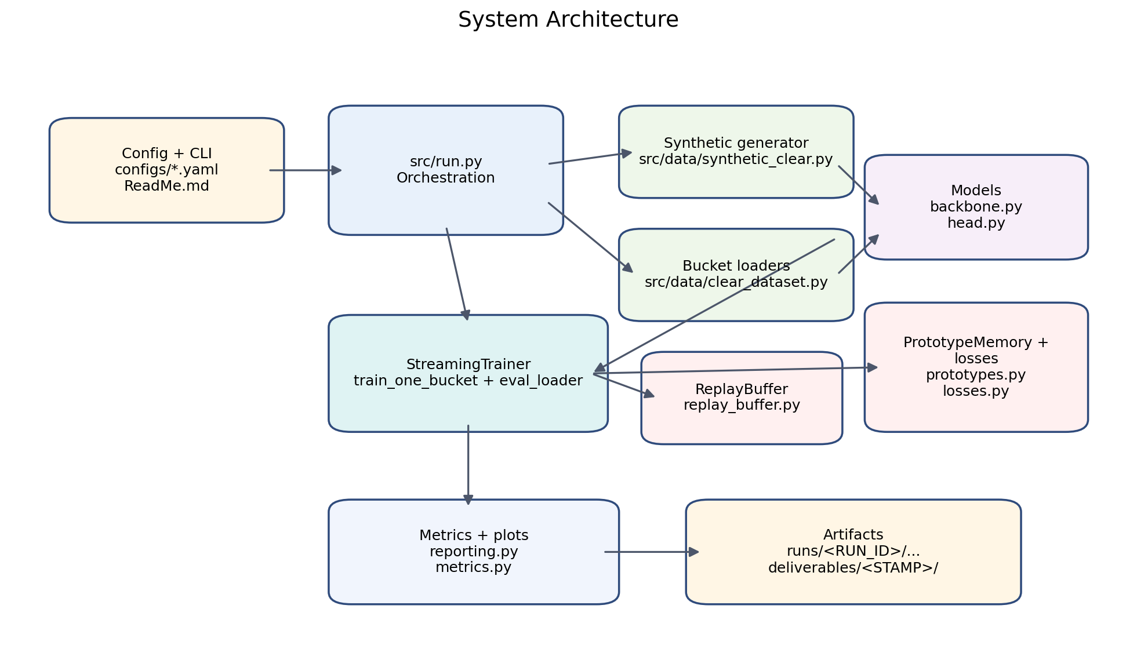
Figure 1. System architecture derived from the repository source files.

4. Execution Workflow
Installation is documented as a standard virtual-environment plus pip workflow. The primary execution command is python -m src.run --config configs/base.yaml. Additional entry points generate synthetic data directly, run each ablation individually, generate per-run plots from CSV files, and run the four-configuration suite with aggregate outputs.
Evidence: ReadMe.md; src/run.py; src/data/synthetic_clear.py; scripts/plot_metrics.py; scripts/run_ablation_suite.py
- Primary runner: python -m src.run --config configs/base.yaml
- Synthetic benchmark generation: python -m src.data.synthetic_clear --out_dir ./data/synth_CLEAR_delivery_v1 ...
- Per-run plotting: python scripts/plot_metrics.py --streaming_csv runs/<RUN_ID>/metrics_streaming.csv --out_png runs/<RUN_ID>/nda.png ...
- Suite automation: python scripts/run_ablation_suite.py --manifest_out deliverables/<STAMP>/ablation_manifest.json --aggregate_out_dir deliverables/<STAMP>
Runtime validation was performed in the current environment on May 9, 2026. The base configuration completed successfully and wrote a new run directory, runs/20260509-002848, confirming that the documented entry point remains operational.
Evidence: runs/20260509-002848/run_summary.json; runs/20260509-002848/metrics_streaming.csv
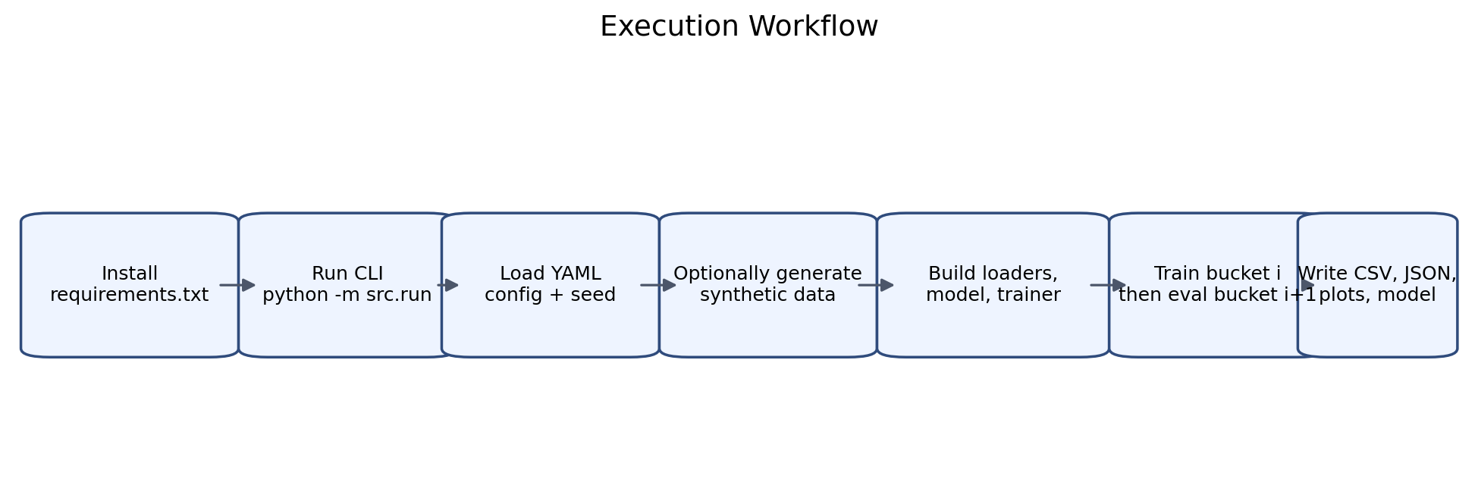
Figure 2. Execution workflow from installation to artifact generation.

5. Dependency and Environment Analysis
The declared dependency surface is deliberately small: PyTorch, Torchvision, tqdm, PyYAML, NumPy, Pillow, and Matplotlib. Observed imports in the source tree align with that manifest. There is no declared Python version in the repository, so environment compatibility is partially implicit rather than explicit.
Evidence: requirements.txt; src/; scripts/
Dependency | Declared Spec | Observed Usage | Role
PyTorch | torch>=2.1 | src/data/clear_dataset.py, src/memory/prototypes.py, src/memory/replay_buffer.py ... | Core tensor runtime, modeling, optimization, and evaluation.
Torchvision | torchvision>=0.16 | src/data/clear_dataset.py, src/models/backbone.py | ResNet backbone construction and image transforms.
tqdm | tqdm>=4.66 | src/training/streaming_trainer.py | Training progress display.
PyYAML | pyyaml>=6.0 | src/run.py | YAML config loading and saving.
NumPy | numpy>=1.24,<2.0 | src/data/synthetic_clear.py, src/utils.py | Random generation and image synthesis math.
Pillow | pillow>=10.0 | src/data/clear_dataset.py, src/data/synthetic_clear.py | Image generation and loading.
Matplotlib | matplotlib>=3.7 | scripts/aggregate_suite.py, src/reporting.py | Per-run and suite-level plotting.
Table 2. Declared dependencies and observed usage in the repository.
Observed validation environment: Python 3.12.4 on Windows PowerShell. This environment detail is confirmed from the live session, but it is not declared in repo metadata. No containerization or lockfile is present, so exact reproducibility across machines depends on external environment discipline.
Evidence: requirements.txt; Observed runtime environment
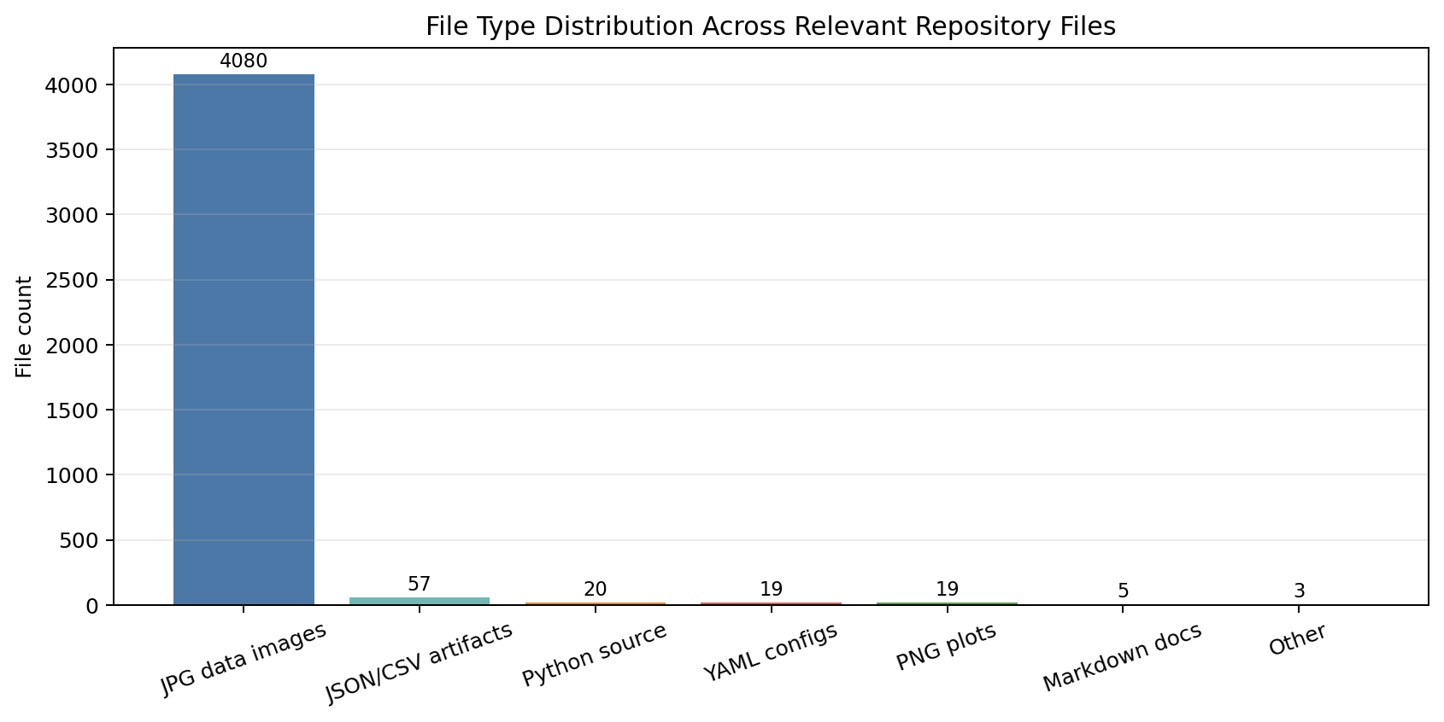
Figure 3. File type distribution across relevant repository files.
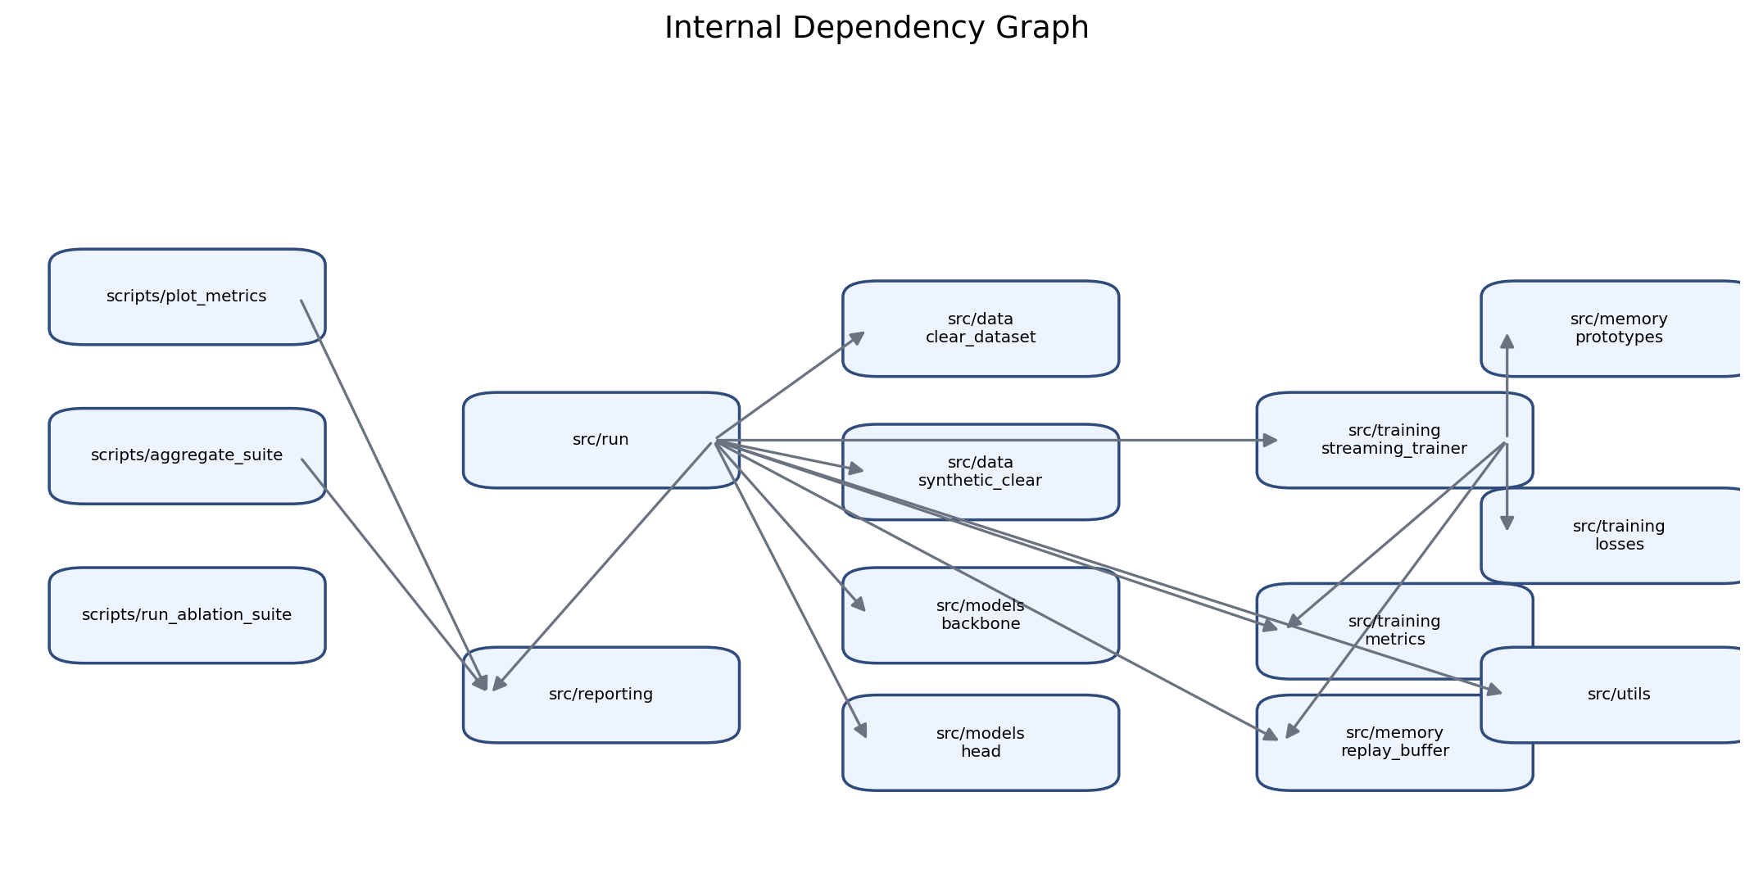
Figure 4. Internal dependency graph for the main source and script modules.

6. Functional Analysis
The repository implements five main functional capabilities. First, it supports a CLEAR-style streaming protocol in which training occurs on one bucket and evaluation occurs on the next bucket. Second, it implements a replay baseline through a configurable replay buffer with reservoir, biased reservoir, and FIFO options. Third, it implements an iNeMo-inspired proxy using prototype memory plus prototype-alignment and margin-separation losses. Fourth, it can generate synthetic CLEAR-like datasets automatically when the configured dataset root does not exist. Fifth, it produces per-run summaries and suite-level aggregate reporting artifacts.
Evidence: src/run.py; src/memory/replay_buffer.py; src/memory/prototypes.py; src/training/losses.py; src/data/synthetic_clear.py; scripts/aggregate_suite.py
- Inputs: YAML config, local dataset root or synthetic generation parameters, and the selected ablation command.
- Primary outputs: config_resolved.yaml, metrics_streaming.csv, optional metrics_shadow.csv, run_summary.json, optional class_map.json, nda.png, shadow.png, and optional model_final.pt.
- Primary metric: next-domain accuracy (NDA) per streaming step, with mean NDA tracked over time.
- Optional retention metric: shadow holdout accuracy and forgetting curves when eval.shadow_holdout_ratio > 0.
A notable design choice is the deliberate separation between run-level reporting in src/reporting.py and suite-level reporting in scripts/aggregate_suite.py. That keeps the training loop focused on artifact emission while aggregation logic remains reusable for later comparison workflows.
Evidence: src/reporting.py; scripts/aggregate_suite.py

7. Data and File Flow Analysis
The data layer supports two on-disk layouts. In imagefolder mode, each bucket contains per-class subdirectories of images. In manifest_csv mode, each bucket contains labels.csv with filepath and label columns plus a shared images/ subdirectory. src/data/clear_dataset.py auto-detects layout unless it is explicitly forced in config.
Evidence: src/data/clear_dataset.py; configs/base.yaml
The repository currently contains four local synthetic datasets: synth_CLEAR (6 buckets, 1,320 images at 224x224), synth_CLEAR_delivery_v1 (6 buckets, 2,640 images at 64x64), synth_CLEAR_manifest (3 buckets, 60 images at 32x32, manifest layout), and synth_CLEAR_stage1 (3 buckets, 60 images at 32x32). The default configuration points to synth_CLEAR_delivery_v1.
Evidence: data/; configs/base.yaml
Dataset Path | Buckets | Layout | Images | Sample Image Size
data/synth_CLEAR | 6 | imagefolder | 1320 | 224x224
data/synth_CLEAR_delivery_v1 | 6 | imagefolder | 2640 | 64x64
data/synth_CLEAR_manifest | 3 | manifest_csv | 60 | 32x32
data/synth_CLEAR_stage1 | 3 | imagefolder | 60 | 32x32
Table 3. Local dataset directories discovered under data/.
During execution, buckets are converted into train, full-eval, and optional shadow DataLoaders. The trainer consumes those loaders sequentially, writes streaming metrics row by row, optionally writes shadow metrics, then emits summary JSON and plots into a timestamped run directory. .gitignore excludes /data/ and /runs/, which indicates that these assets are expected to be large or regenerated rather than fully tracked.
Evidence: src/run.py; src/data/clear_dataset.py; .gitignore
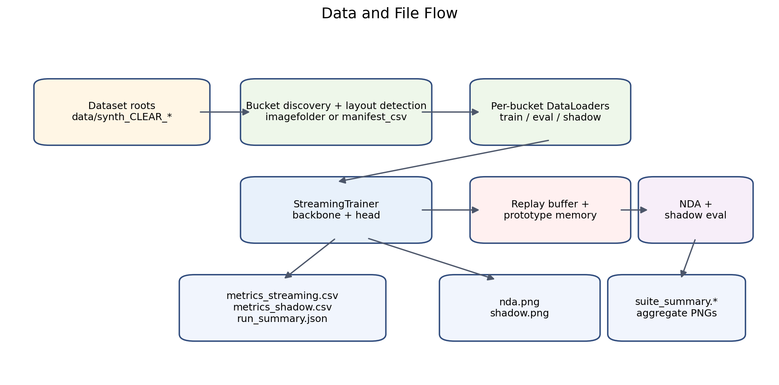
Figure 5. Data and file flow across dataset inputs, trainer state, and generated outputs.

8. Code Quality and Maintainability
Strengths:
- The code is split into small modules with clear responsibilities across data loading, models, memory, training, and reporting (src/data, src/models, src/memory, src/training, src/reporting.py).
- Experiment behavior is largely config-driven, and the four ablation YAML files make the intended comparisons explicit (configs/*.yaml).
- The main runner writes resolved configuration and summarized artifacts in stable, documented file names (src/run.py; ReadMe.md).
- Suite-level automation already exists for four ablations and aggregate plotting (scripts/run_ablation_suite.py; scripts/aggregate_suite.py).
Weaknesses:
- There are no automated tests or CI workflows in the repository inventory, so regressions are caught only by manual execution.
- Namespace marker files are named _init_.py rather than __init__.py across src/, src/data/, src/models/, src/memory/, and src/training/, which is misleading even though implicit namespace packages keep imports working.
- Formatting is not fully consistent; for example src/memory/prototypes.py uses tab indentation while most other modules use spaces.
- The suite runner depends on parsing a specific stdout message from src/run.py to locate run_summary.json, which creates brittle cross-script coupling (scripts/run_ablation_suite.py; src/run.py).
Overall maintainability assessment (inference): the codebase is readable and small enough to understand quickly, but its quality controls are informal. The modular structure reduces complexity, while the absence of tests and the presence of a few brittle integration points reduce long-term confidence.
Evidence: src/; scripts/; Repository inventory

9. Testing and Validation
No dedicated automated test suite was found. There are no unit tests, integration tests, or CI workflows in the repository. Existing validation is therefore operational rather than formal: the README documents commands, the delivery package records prior runs, and the current report includes a fresh live execution check.
Evidence: ReadMe.md; deliverables/20260508_delivery/PLAN.md; deliverables/20260508_delivery/REPORT.md; runs/20260509-002848/run_summary.json
The current validation evidence does confirm several things: the CLI executes; the config and artifact contract is stable enough for suite aggregation; and the delivery package contains consistent run manifests, suite summaries, and plots. What is missing are assertions about edge cases, reproducibility under multiple seeds, and regression detection when internal modules change.
Evidence: scripts/run_ablation_suite.py; scripts/aggregate_suite.py; deliverables/20260508_delivery/suite_summary.csv
- Recommended missing test: config smoke test for each YAML file, including artifact path creation and summary JSON schema validation.
- Recommended missing test: dataset-loader tests for imagefolder and manifest_csv layouts, including malformed buckets and missing files.
- Recommended missing test: replay buffer behavior under each sampling strategy and per-class cap setting.
- Recommended missing test: finite-loss and output-shape checks for prototype and margin-separation loss paths.
- Recommended missing test: suite runner contract test that avoids parsing human-readable stdout.

10. Security, Reliability, and Risk Review
No hardcoded credentials, tokens, or secret-bearing environment examples were found in the inspected repository files. The main concerns are research reliability and workflow fragility rather than classic application security issues.
Evidence: Repository inventory; src/; scripts/; .gitignore
Label | Item | Evidence
Confirmed issue | No automated tests or CI/CD automation were found. The repository does not contain a tests/ directory, notebook-based validation, or a .github workflow directory. | Repository inventory; ReadMe.md; scripts/
Potential risk | The benchmark results are based on synthetic datasets, and the May 8, 2026 delivery report explicitly notes that forgetting stayed at 0.0 across the suite. This limits how far the results can be generalized to harder continual-learning settings. | configs/base.yaml; data/synth_CLEAR_delivery_v1/; deliverables/20260508_delivery/REPORT.md; deliverables/20260508_delivery/suite_summary.csv
Potential risk | The shadow holdout split is random rather than class-stratified, which can produce uneven class coverage in smaller or imbalanced buckets. | src/data/clear_dataset.py
Potential risk | scripts/run_ablation_suite.py extracts the summary path by regex from stdout, so changing the run message format can silently break suite execution. | scripts/run_ablation_suite.py; src/run.py
Potential risk | Data and run outputs are excluded by .gitignore, which is reasonable for large/generated artifacts but makes exact local state dependent on regeneration unless manifests are preserved. | .gitignore; runs/; data/; deliverables/20260508_delivery/ablation_manifest.json
Recommendation | Add smoke tests for config loading, synthetic generation, bucket loading, and a single short streaming run, then execute them in CI on each change. | ReadMe.md; src/run.py; src/data/*.py; scripts/*.py
Table 4. Security, reliability, and risk observations.

11. Visualizations
This report includes repository-derived diagrams plus a benchmark result figure from the existing delivery package. The architecture, workflow, data-flow, file-type, and dependency visuals were rendered from the repository inventory and source relationships. The performance chart below is based on deliverables/20260508_delivery/suite_summary.csv.
Evidence: deliverables/20260508_delivery/suite_summary.csv; Repository inventory; src/; scripts/
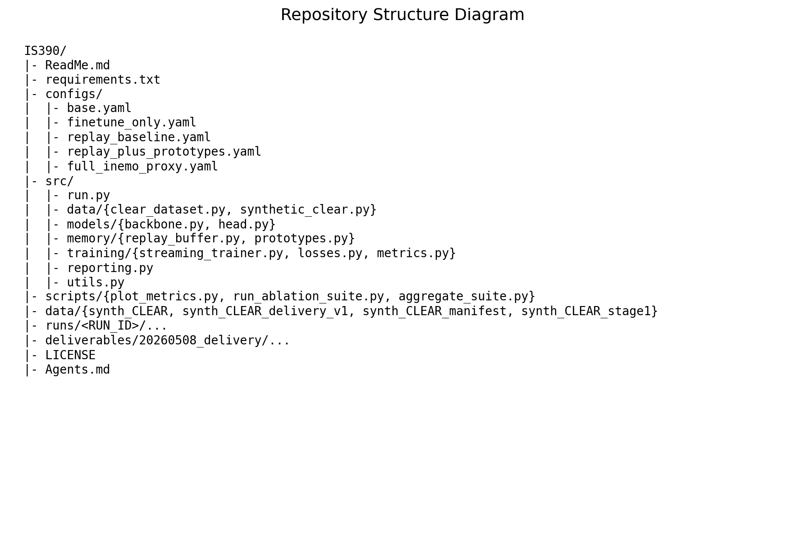
Figure 6. Repository structure diagram summarizing the major directories and files.
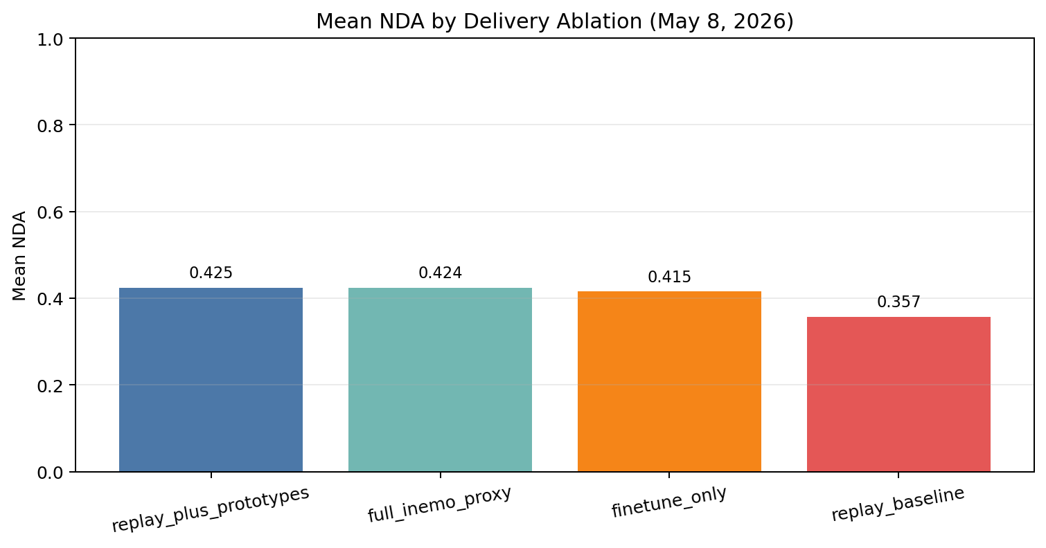
Figure 7. Mean next-domain accuracy by ablation from the May 8, 2026 delivery suite.
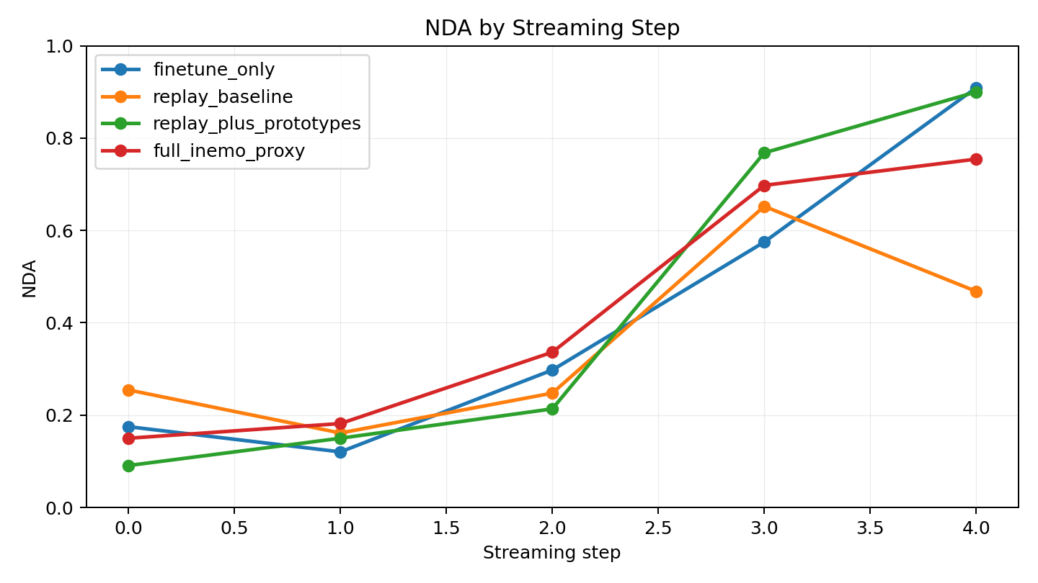
Figure 8. Existing delivery artifact: step-wise NDA comparison across the four reported ablations.

12. Recommendations
Recommendation | Priority | Impact | Effort | Rationale
Add automated smoke and unit tests for config parsing, dataset loading, replay behavior, and one short end-to-end run. | High | High | Medium | The code is runnable today, but it has no automated safety net for core behavior.
Add CI for dependency installation and a CPU-only smoke execution of python -m src.run. | High | High | Medium | This would turn the current manual validation path into a repeatable gate.
Replace stdout-based summary discovery in scripts/run_ablation_suite.py with an explicit output contract or direct path return. | Medium | Medium | Low | The current regex handoff is brittle and tightly couples the script to a console message.
Make the shadow holdout split class-stratified and document its statistical assumptions. | Medium | Medium | Low | This would reduce evaluation variance and improve reliability on imbalanced datasets.
Add multi-seed suite execution and aggregate variance reporting. | Medium | High | Medium | The current delivery package reports single-seed results only.
Normalize package marker files and formatting conventions. | Low | Low | Low | This is a maintainability cleanup that reduces reader confusion and future packaging issues.
Table 5. Prioritized recommendations for improving the repository.

13. Conclusion
Confirmed facts: the repository is a runnable continual-learning benchmark package with a working CLI, modular source structure, multiple synthetic datasets, historical run artifacts, and an existing delivery bundle dated May 8, 2026. The code and documentation are aligned closely enough that a fresh run on May 9, 2026 reproduced the expected artifact pattern.
Evidence: src/run.py; ReadMe.md; runs/20260509-002848/; deliverables/20260508_delivery/
Assessment (inference): the project appears partially complete and experimental rather than production-ready. It is complete enough for demonstration, ablation comparison, and academic discussion, but its reliance on synthetic data, lack of automated tests, and absence of environment-hardening mechanisms limit operational maturity.
Evidence: configs/base.yaml; deliverables/20260508_delivery/REPORT.md; requirements.txt
The most important next steps are straightforward: add tests and CI, reduce brittle script coupling, expand to multi-seed reporting, and stress the benchmark with harder data or a real CLEAR-style dataset. Those changes would improve both trustworthiness and maintainability without requiring a wholesale redesign.
Evidence: scripts/run_ablation_suite.py; scripts/aggregate_suite.py; src/data/clear_dataset.py; deliverables/20260508_delivery/REPORT.md

