# Chapter 1-Introduction

## Introduction:

Rainbow wonder world pre-school is a newly opened pre-school that admits child of age between 2 to 6. They provide Montessori based education system and helps their children to build excellent foundation of their education. Their parents were demanding them to provide a day book including some photos and videos about what their kids do in their school. Rainbow wants an information system to allow their parents to log in to their children's information system that only provides information about their kids.

## Background of the project:

This trend of sending information about what kids do in school premises to their parents is still been running but it is done manually. Some information would miss out to their parents and they start complaining. Sometime the school uploads information on facebook page but their ideas were copied by other pre-schools.

## Problem Statement:

These are the problem that arises while sharing information between school and parents:

* Time cost: Grade teacher's needed extra hours to write notes of each kids.
* Duplicates: Unique trainings and activities provided to their children was risky to share.
* Some points or actions were missing out to share among parents and teachers.
* Pictures and videos were not possible to send and receive between parents and teachers.

## Description of the project:

It is era of competition among businesses, In this business, almost all parents has eager to know work in detail the school does and the school also need to hear parent's feedbacks. Rainbow Information System will provide detailed activities of each kid in school, their improvements and communication between school and parents. This app will make school not necessarily conduct teachers-parents meeting in every week.

## Features of the project

Rainbow Information System will include following of these features:

* **Login feature:**

It will allow parents to log in to the children's information system or create an account for the app. ID used while creating account must have been registered into school administration.

* Rainbow Information System will allow parents to view pictures and video clips of their own kids.
* Rainbow Information System will allow to view activities of children with respective dates, their improvements and so on.

## Overview of the project:

I will be using Laravel (Framework of php) to develop a web app called Rainbows Information System. This application will be able to provide photos, videos, works, and notices. Data and information collected by school will only be given to respective parents of children. Progresses and a day note book will be provided in different slides to view their daily routine. There will be a notice slide if any news needs to be sent.

# Chapter 2-Scope of the Project

## 2.1 Scope:

Rainbow Information System will be developed to replace the traditional way of approaching information towards parents. This means that the new system will allow school to put out their student's information, and parents to view them.

## 2.2 Limitations:

* User should be parent member of school.
* User will not be able to download the available information.

## 2.3 Aims

* It reduces effort of teacher-parents communication.
* It will decrease unnecessary viewers.

## 2.4 Objectives

* To gather daily information about the students activities data using laravel framework.
* To run the information sharing process more effectively
* To review the progress of student including their healthy behaviors.

## 2.5 Overview of the scope

Every pre-school should share their daily conduction with their respective parents. Since none of them are based on computer system, moreover web. This LMS will help minimize teacher-parents meeting time just to know about what daily things are done with the children and will restrict unnecessary viewers. All they need is to create an log in id for 'Rainbow parent'. Only the id that was filled in the form of school registration will be valid. Random creation of id will not be allowed to maintain privacy of school's data. Those data will be kept by the school admin with some feature within the app that will show progression of child.

# Chapter 3- Development Methodology

# 3.1 Description of the methodology chosen:

Choosing methodology is an important part which decides project success or failure. Project development methodology is a framework that gives an overview of processes that will be involved in the software engineering.

Time for the project development is less and Information System for the school is small.

For development of Pre-School Information System I will be using **Waterfall Model**. Waterfall model emphasizes a logical progression of steps. It is very popular approach to the software development life cycle (SDLC). This method is a linear and sequential approach. This approach is similar to direction of water flowing from edge of a cliff. Each process will set by distinct goals and cannot be revisited after completion. The waterfall methodology will have these following seven steps:

* Requirements
* Analysis
* Design
* Coding/Implementation
* Testing
* Operation/Deployment
* Maintenance

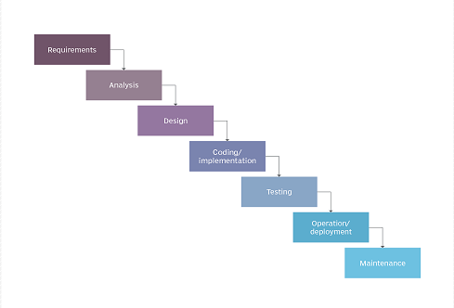

*Figure 1: Waterfall Model*

<https://airbrake.io/blog/sdlc/waterfall-model>

<https://searchsoftwarequality.techtarget.com/definition/waterfall-model>

**Advantages:**

* It will be simple in terms of visualizing, understanding and implementing.
* It will provide a structured way of doing things.
* It works well for small projects where there are no technological hurdles.

**Disadvantages:**

* It is not agile.
* Requirement needs to be clear which makes it difficult to cover all.

# 3.2 Design Pattern:

Design pattern is a way of how you organize your code. I will be using MVC(Model View Controller) for this project as this pattern won't have dependencies of code and help development more efficiently. MVC is an architectural design pattern that works out with three components of software engineering independently by dividing them into three different parts. Three components in software engineering are:

* Model(Storage)
* View(User Interface)
* Controller(Logic/Flow)

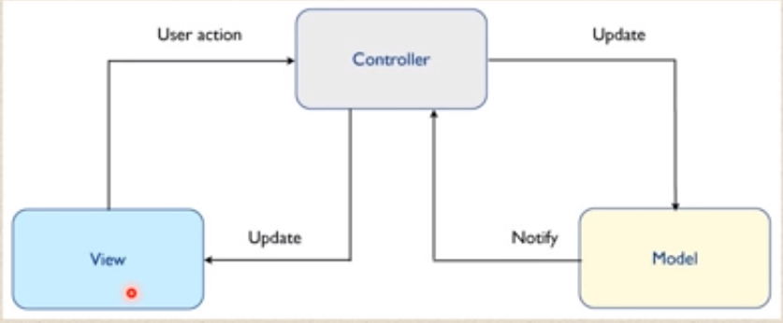

*Figure 2: MVC Pattern*

**Advantages:**

* It makes project easier to make changes
* It reduces cost of project development
* It makes the project more systematic

**Disadvantages:**

* Complexity increases
* Modern user interface will have difficult to use MVC

# 3.3 Architecture:

The project will be based on **3-Tier architecture**. There will be three layers involved in the application: Presentation, Business and Data layer.

* **Presentation tier:** This layer is also known as client layer. This will be the top most layer of an application. This layer will be seen when we use software. It's main functionality is to communicate with Application layer. This layer will pass the information which is given by the user in terms of keyboard actions, mouse clicks to application layer. For an example: Log in page of G-mail.
* **Application Layer:** This layer is also known as business logic layer, which is also known as logical layer. As per the g-mail login page example, when user clicks on a log in button, application layer interacts with the database layer and sends required information to the presentation layer. It acts as an mediator between presentation and database layer.
* **Data Layer:** The data is stored in data layer. Application layer communicates with database layer to retrieve the data. It contains the methods that connects the database and performs required actions. Example Insert, update, delete, etc.

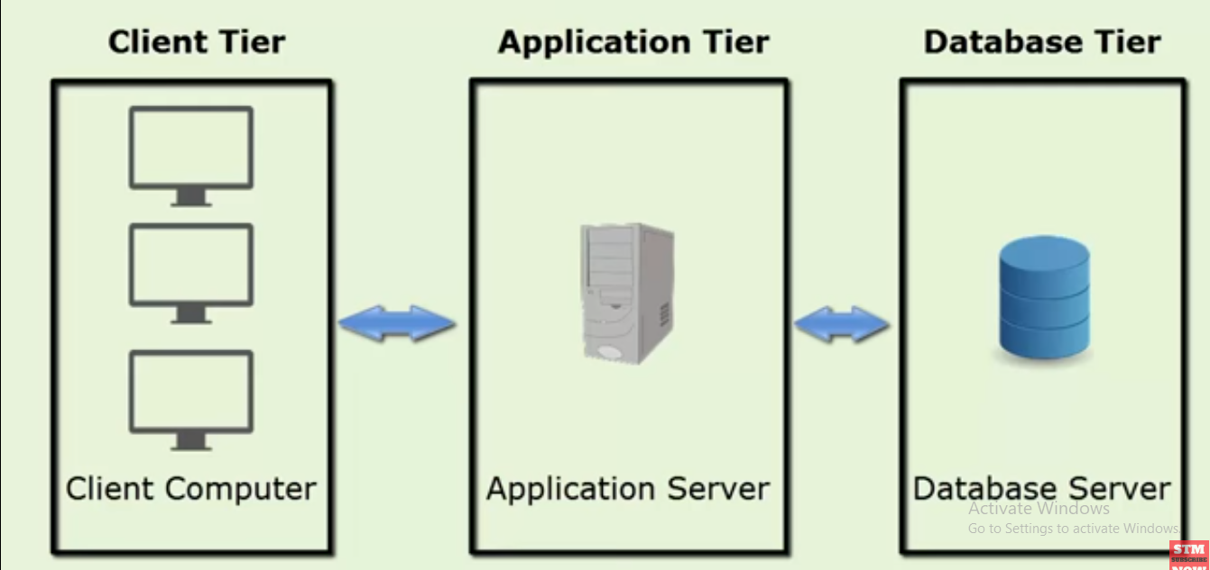

*Figure 3: Three-Tier Architecture*

## 3.2 Design pattern

## 3.3 Architecture:

# Chapter 4-Project planning

## 4.1 WBS (Work Break Down Structure):

## 4.2 Milestones:

## 4.3 Gantt Chart: