# Chapter 1-Introduction

## Introduction:

Rainbow wonder world pre-school is a newly opened pre-school that admits child of age between 2 to 6. They provide Montessori based education system and helps their children to build excellent foundation of their education. Their parents were demanding them to provide a day book including some photos and videos about what their kids do in their school. Rainbow wants an information system to allow their parents to log in to their children's information system that only provides information about their kids.

## Background of the project:

This trend of sending information about what kids do in school premises to their parents is still been running but it is done manually. Some information would miss out to their parents and they start complaining. Sometime the school uploads information on facebook page but their ideas were copied by other pre-schools.

## Problem Statement:

These are the problem that arises while sharing information between school and parents:

* Time cost: Grade teacher's needed extra hours to write notes of each kids.
* Duplicates: Unique trainings and activities provided to their children was risky to share.
* Some points or actions were missing out to share among parents and teachers.
* Pictures and videos were not possible to send and receive between parents and teachers.

## Description of the project:

It is era of competition among businesses, In this business, almost all parents has eager to know work in detail the school does and the school also need to hear parent's feedbacks. Rainbow Information System will provide detailed activities of each kid in school, their improvements and communication between school and parents. This app will make school not necessarily conduct teachers-parents meeting in every week.

## Features of the project

Rainbow Information System will include following of these features:

* **Login feature:**

It will allow parents to log in to the children's information system or create an account for the app. ID used while creating account must have been registered into school administration.

* Rainbow Information System will allow parents to view pictures and video clips of their own kids.
* Rainbow Information System will allow to view activities of children with respective dates, their improvements and so on.

## Overview of the project:

I will be using Laravel (Framework of php) to develop a web app called Rainbows Information System. This application will be able to provide photos, videos, works, and notices. Data and information collected by school will only be given to respective parents of children. Progresses and a day note book will be provided in different slides to view their daily routine. There will be a notice slide if any news needs to be sent.

# Chapter 2-Scope of the Project

## 2.1 Scope:

Rainbow Information System will be developed to replace the traditional way of approaching information towards parents. This means that the new system will allow school to put out their student's information, and parents to view them.

## 2.2 Limitations:

* User should be parent member of school.
* User will not be able to download the available information.

## 2.3 Aims

* It reduces effort of teacher-parents communication.
* It will decrease unnecessary viewers.

## 2.4 Objectives

* To gather daily information about the students activities data using laravel framework.
* To run the information sharing process more effectively
* To review the progress of student including their healthy behaviors.

## 2.5 Overview of the scope

Every pre-school should share their daily conduction with their respective parents. Since none of them are based on computer system, moreover web. This LMS will help minimize teacher-parents meeting time just to know about what daily things are done with the children and will restrict unnecessary viewers. All they need is to create an log in id for 'Rainbow parent'. Only the id that was filled in the form of school registration will be valid. Random creation of id will not be allowed to maintain privacy of school's data. Those data will be kept by the school admin with some feature within the app that will show progression of child.

# Chapter 3- Development Methodology

# 3.1 Description of the methodology chosen:

Choosing methodology is an important part which decides project success or failure. Project development methodology is a framework that gives an overview of processes that will be involved in the software engineering.

Time for the project development is less and Information System for the school is small.

For development of Pre-School Information System I will be using **Waterfall Model**. Waterfall model emphasizes a logical progression of steps. It is very popular approach to the software development life cycle (SDLC). This method is a linear and sequential approach. This approach is similar to direction of water flowing from edge of a cliff. Each process will set by distinct goals and cannot be revisited after completion. The waterfall methodology will have these following seven steps:

* Requirements
* Analysis
* Design
* Coding/Implementation
* Testing
* Operation/Deployment
* Maintenance

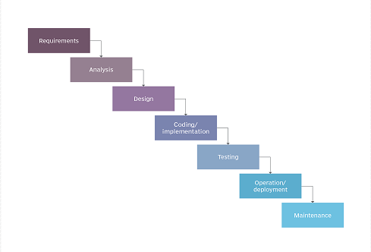

*Figure 1: Waterfall Model*

<https://airbrake.io/blog/sdlc/waterfall-model>

<https://searchsoftwarequality.techtarget.com/definition/waterfall-model>

**Advantages:**

* It will be simple in terms of visualizing, understanding and implementing.
* It will provide a structured way of doing things.
* It works well for small projects where there are no technological hurdles.

**Disadvantages:**

* It is not agile.
* Requirement needs to be clear which makes it difficult to cover all.

# 3.2 Design Pattern:

Design pattern is a way of how you organize your code. I will be using MVC(Model View Controller) for this project as this pattern won't have dependencies of code and help development more efficiently. MVC is an architectural design pattern that works out with three components of software engineering independently by dividing them into three different parts. Three components in software engineering are:

* Model(Storage)
* View(User Interface)
* Controller(Logic/Flow)

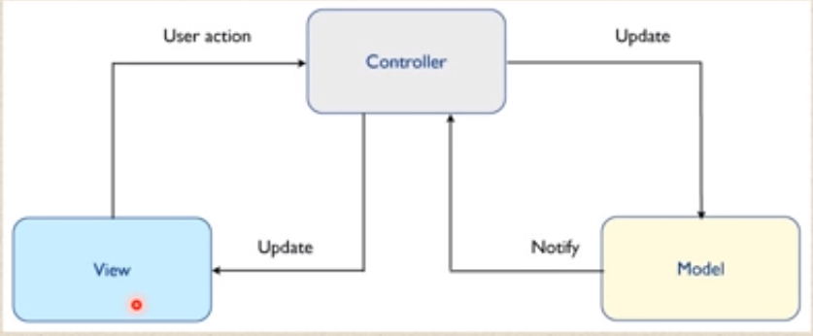

*Figure 2: MVC Pattern*

**Advantages:**

* It makes project easier to make changes
* It reduces cost of project development
* It makes the project more systematic

**Disadvantages:**

* Complexity increases
* Modern user interface will have difficult to use MVC

# 3.3 Architecture:

The project will be based on **3-Tier architecture**. There will be three layers involved in the application: Presentation, Business and Data layer.

* **Presentation tier:** This layer is also known as client layer. This will be the top most layer of an application. This layer will be seen when we use software. It's main functionality is to communicate with Application layer. This layer will pass the information which is given by the user in terms of keyboard actions, mouse clicks to application layer. For an example: Log in page of G-mail.
* **Application Layer:** This layer is also known as business logic layer, which is also known as logical layer. As per the g-mail login page example, when user clicks on a log in button, application layer interacts with the database layer and sends required information to the presentation layer. It acts as an mediator between presentation and database layer.
* **Data Layer:** The data is stored in data layer. Application layer communicates with database layer to retrieve the data. It contains the methods that connects the database and performs required actions. Example Insert, update, delete, etc.

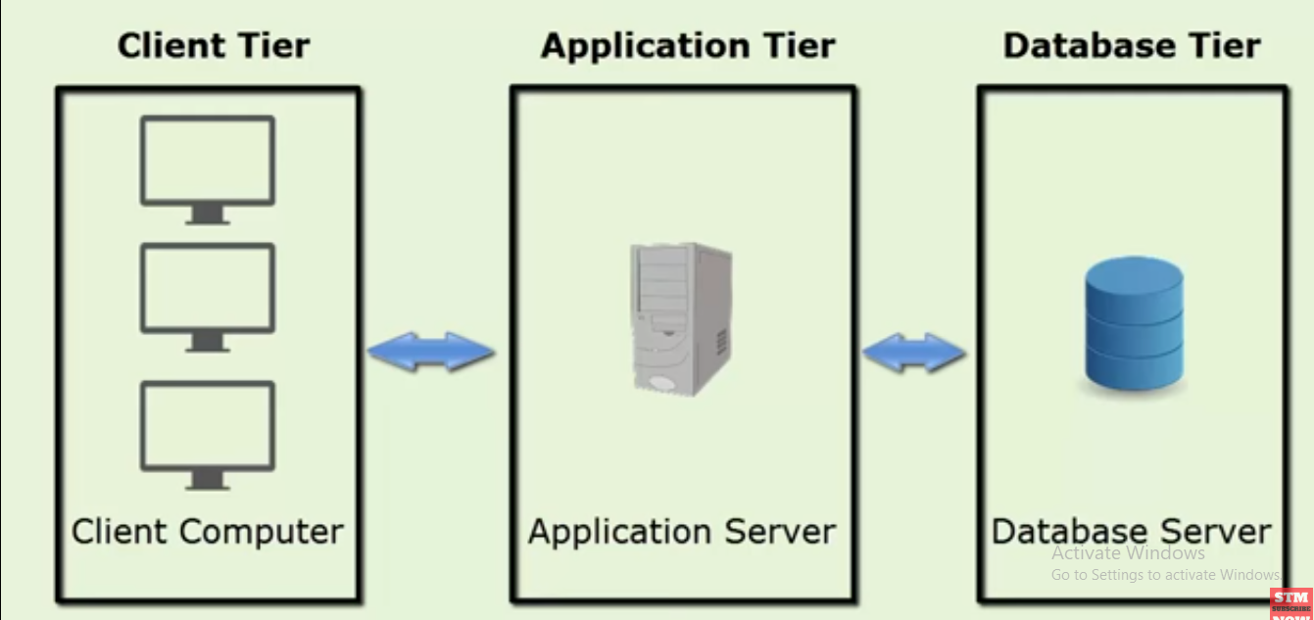

*Figure 3: Three-Tier Architecture*

# Chapter 4-Project planning

## 4.1 WBS (Work Breakdown Structure):

A Work Breakdown Structure is a deliverable-oriented hierarchical decomposition of the work to be 'executed' by the team to accomplish the project objectives and create the required deliverables. Work breakdown structure will be helping this pre-school project to be organized and defined with the total scope of the project. I will be dividing phases of the project into multiple units or sub projects. Each sub projects will be broken down into another deliverables and again into other sub deliverables and eventually into work packages. Reference— <https://marketplace.pmi.org/Pages/ProductDetail.aspx?GMProduct=00101095501>

|  |  |  |
| --- | --- | --- |
| Pre-School Information System | | |
| (WBS) | Name of Task | Days |
|  |  |  |
|  |  |  |
|  |  |  |
|  |  |  |
|  |  |  |
|  |  |  |
|  |  |  |
|  |  |  |

## 4.2 Milestone:

A milestone is a landmark movement that’s necessary for a project to achieve in order to move next step or phase. This will be used to measure progress of the project by stakeholders and project members. Milestones will be helpful to make projects objectives simpler to understand. During project management, it is very important to client to know about time details of project completion. This project will clarify the initial and final dates of each phase in simple way.

I have shown milestone of my project in this table;

|  |  |  |
| --- | --- | --- |
| S.N | Milestone | Date |
|  |  |  |
|  |  |  |
|  |  |  |
|  |  |  |
|  |  |  |
|  |  |  |
|  |  |  |

## 4.3 Gantt Chart:

Gantt chart is a visual representation of a project schedule which shows all those tasks and their relationships as well as their dependencies. As a project manager, I will make a Gantt chart using the application Project Libre to represent schedules of my project. It will help developer team member and stakeholder to learn about the app quickly. It will illustrate the starting elements and ending elements of the project.

# Chapter 5: Risk Management

## 5.1 Risk Management:

All type of organization face with some formal risks which may affect their chance of success. Understanding the risk and effectively managing these risk will greatly help the pre-school(Rainbow Pre-School) in achieving long term success. Risk management will be an important tool to eliminate the potential problems in this project. I will be using this method to determine the risks related to this project or company in order to reduce their likelihood and provide a means for better decision making in order to avoid future risks. Risk may relate to loss of data/no back-up, financial problems, legal issues, accidents or natural disasters.

## 5.2 Lifecycle:

Risk management in this project will involve seven cycles as described below:

1. Resource Profiling: Describe the resource and risk sensitivity (Business owners).
2. Risk Assessment: Identify and rate threats (information security).
3. Risk Evaluation: Decision to accept, avoid or transfer risk (information security and Business owner).
4. Document: Document risk (information security and business owner).
5. Risk mitigation: Implement mitigation plan with specified controls (Resource custodian).
6. Validation: Test the controls to ensure the actual risk exposure matches the desired risk level (Information security).
7. Monitoring and audit: Continually track changes to the system that may affect the risk profile and perform regular audits (Information security and business owners)

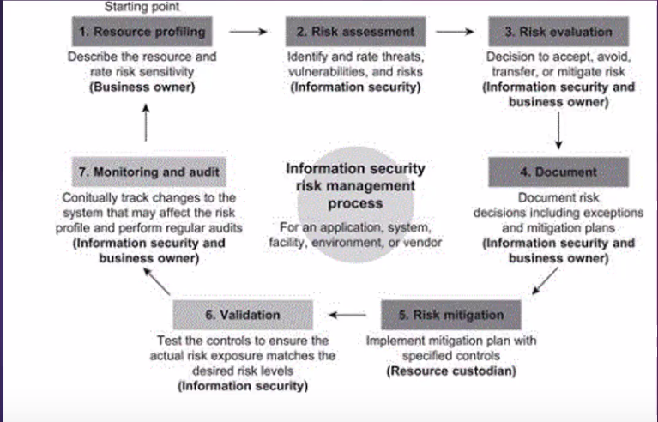

*Fig : Risk Management Lifecycle*

## 5.3 Diagram:

Risk management diagram is a figure that gives overview of likelihood, consequences and impact. It is described as follow:

Impact = Likelihood × consequence

|  |  |
| --- | --- |
| **Likelihood** | **Value** |
| Low | 1 |
| Medium | 2 |
| High | 3 |

Table: Likelihood Value

|  |  |
| --- | --- |
| **Consequences** | **Value** |
| Very Low | 1 |
| Low | 2 |
| Medium | 3 |
| High | 4 |
| Very High | 5 |

Table: Consequences Value

## 5.4 Table:

Risk management table will clear out the impact with respect of the risk's likelihood and consequences. Security recommendation are also given in the table:

|  |  |  |  |  |  |
| --- | --- | --- | --- | --- | --- |
| **S.N** | **Risk** | **Likelihood** | **Consequences** | **Impact** | **Security Recommendation** |
| 1 | Technical problem | 2 | 3 | 6 | Proper measures will be taken before problem arises. |
| 2 | Irresponsibility of workers | 2 | 4 | 8 | Supervise workers daily |
| 3 | Accidents | 1 | 4 | 4 | Safety measures will be taken. |
| 4 | Legal Issues | 1 | 3 | 3 | Project will be legally prepared. |
| 5 | Natural disaster | 1 | 5 | 5 | Backing up data and system time to time. |
| 6 | Data theft | 2 | 4 | 8 | Maintaining strong authentication. |
| 7 | Lacking time | 1 | 4 | 4 | Proper time and project allocation will be done before. |

Table: Risk Management table

# Chapter 6: Configuration Management

We will track and control the changes during project development in terms of the requirements, design, functions and development of the product. This process is known as configuration management.

IEE defines it as "the process of identifying and defining the items in the system, controlling the change of these items throughout their life cycle, recording and reporting the status of items and change requests, and verifying the completeness and correctness of items."

Simply, configuration management will be dealing with change management.

<https://www.tutorialspoint.com/itil/assets_and_configuration_management.htm>

# Chapter 7: Conclusion