# Chapter 2: Analysis

## 2.1 Introduction to analysis

Analysis is process in Software Development Lifecycle that specifies what the system should do. Analysis of any system or software is done to identify its objectives. It ensures all the component of the system works together and efficiently. The expectation system boundaries is defined in this phase and then collecting its fact data, requirements, creating working components and its smaller parts that help for a better understanding. This phase takes detailed study of various operations performed by the system. We use different kind of tools to collect the data, this is known as analysis methodology.

Reasons why analysis in this project:

* Never been applied on this environment.
* It helps to create a requirement specification document.
* It defines whether or not the project will be useful to user or not.
* Analysis pre-defines feasibility of the project.

## 2.2 Analysis Methodology

Developing software involves Software Development Lifecycle (SDLC) process at the very beginning of development. This includes Requirements, Design, Implementation, Verification and Maintenance. There more types of methodologies in software development that helps for better understanding. They evolved with time making development process easier than ever. Spiral development, Software Prototype, Rapid Application Design were evolved with time.

Analysis methodology is tool to collect fact data about the project. Soft approach, Hard approach and Combined approach are few methods for Analysis methods. I chose Hard approach for information system analysis of this project.

**Hard approach:**

It focuses on the needs of parents, teachers, their roles, rewards, motivation etc. There will be strong and regular two-way communication. It motivates greater use of non-financial methods including empowerment. It focuses on job satisfaction (customer & admin).

I have chosen Structured Systems Analysis and Design Methodology (SSADM). With waterfall life cycle a Structured Systems Analysis and Design Method works best. With some different terms than waterfall model, it mainly concentrates on early stages- capturing requirements and designing new system.

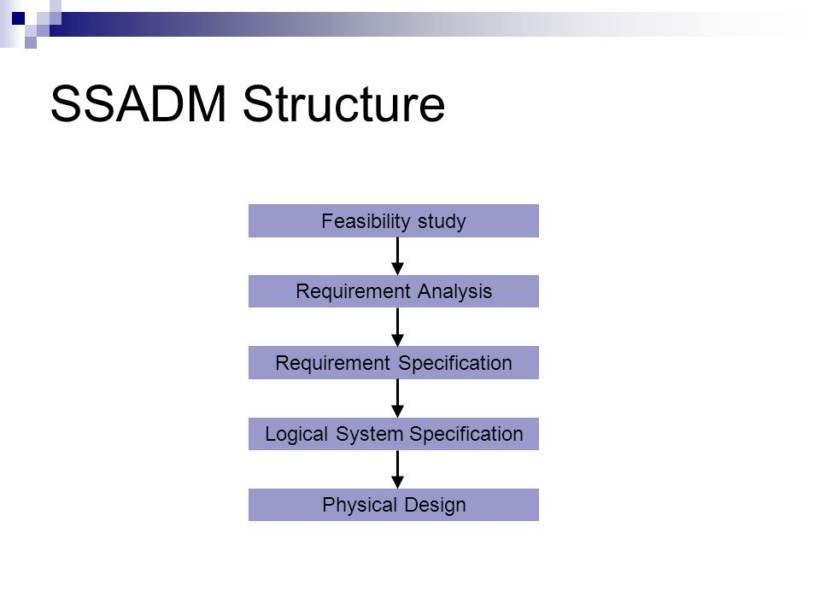

*Fig:1- SSADM PROCESS*

**Advantages of SSADM:**

* Reduce risk of going over budget or time
* More likely to meet requirements.
* Robust system
* Maintainable systems and code

**Disadvantages of SSADM:**

* Lack of user involvement
* It’s not flexible
* It costs time and money.

(bizfluent.com, 2019)

**These are the steps involved in SSADM:**

1. **Feasibility Stage:** Four main areas of consideration are economic feasibility, technical feasibility, organizational feasibility and ethical feasibility.
2. **Current environment investigation:** Requirements are gathered by interviewing employees, distributing questionnaires, observing existing documents which will allow to construct data model and define boundaries of the system.
3. **Business system option:** Using output of the previous stage to develop options for the system.
4. **Requirement specification:** An error free, unambiguous and consistent logical specification is developed.
5. **Technical system options:** This includes options for implementing the new system. Multiple options are generated and only suitable will be chosen.
6. **Logical Design:** This specifies the design of the user interface. The outputs of these stage are data catalogue, logical data structure and a logical process model.
7. **Physical Design:** This stage is to convert a logical design into real hardware or software. It is a specification of the exact structure of the functions and how they are implemented. This will enable to build the new system in specific details.

(selectdbs.com, 2019)

Techniques used in SSADM are: Logical Data Modeling, Data Flow Modeling, and Entity Behavior. I will be using Data Flow Diagram (DFD) for this system.

**Data Flow Diagram:** It is a graphical representation of the flow of data from one component to another component in any information system. Through this diagram, we can give the overview of the system without going into deep detail of the system.

(lucidchart.com, 2019)

* DFD Level 0: It is also called context diagram.

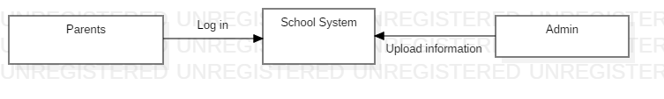

*Fig 2: Level 0 DFD*

* DFD level 1: It provides more detailed breakout of pieces of the contextual level diagram.

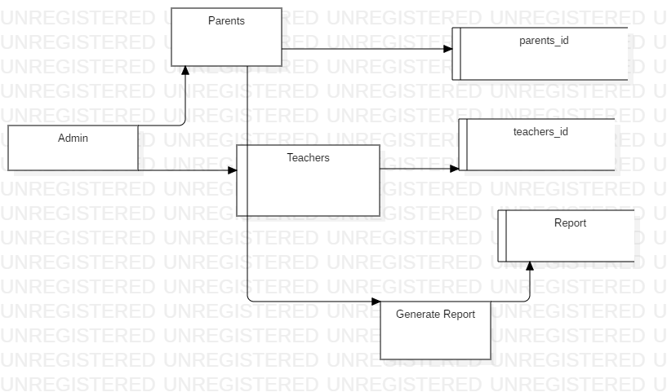

*Fig 3: Level 1 DFD*

* DFD level 2: It goes deeper into parts of level 1.

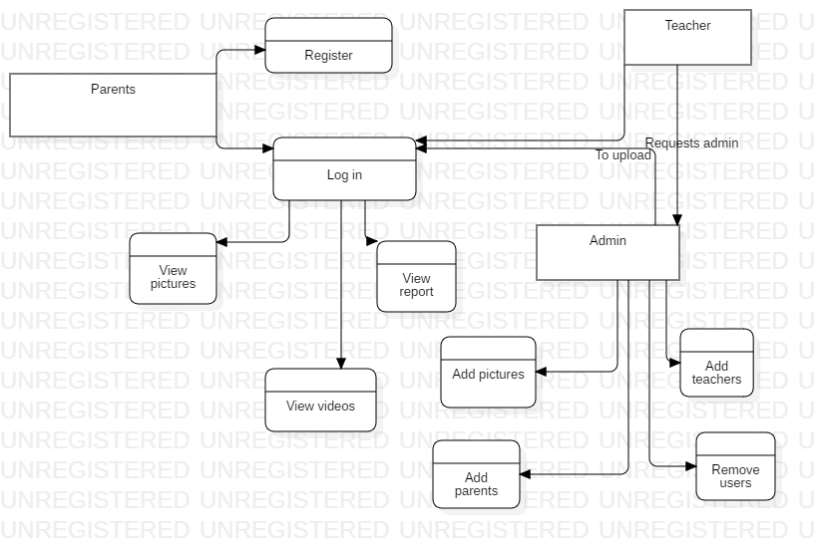

*Fig 4: Level 2 DFD*

* **Reason for choosing Hard Approach to Information System Analysis.**
* Requirements are well defined.
* Similar with waterfall.
* Based on technical requirement.
* Every step before progression to next one should be completed first.

## 2.3 Feasibility Study

It is about possibility of the project. Study about possible problems is undertaken with resulting solutions. Evaluation is done on the basis of three factors ie; Technical, Social, Political factors. All possible problems are analyzed before the completion of project and solutions are determined if it can be implement. In this project, technical requirement in user perspective ma In this project, technical requirement in user perspective may not be fulfilled.

A project is said technically feasible if it meets the technical requirements. After the calculation of Feasibility study based on those three issues, a final result is produced called feasibility report. Report will have clear statement of problem and all details found out will be listed. Those list help management to agree a top alternative.

I have described the components of feasibility study below:

* **Technical Feasibility:** It is concerned specific equipment and software that will successfully support the task required. Simply, study about technical feasibility about the project is undertaken.
* **Operational Feasibility:** It is related to human, organizational or political aspects.
* What changes will be brought in with the system.
* How organizational structure will be distributed.
* What new skills are required.
* **Economic feasibility:** Economic analysis is the most frequently used technique for evaluating the effectiveness of the school system. More commonly known as cost/benefit analysis.
* **Legal feasibility:** Project success or failure depend upon legalities. This directly or indirectly hampers the project.

## 2.4 Requirement analysis

Requirement Analysis, also known as requirement engineering is the process of defining user expectations for new software being built or modified. A requirement of a software system is a functional or a non-functional need that needs to be implemented on system. (visual-paradigm.com, 2019)

## 2.4.1 Functional Requirement

A functional requirement describes functionality of a system or system services. It depends upon type of software and expected users.

|  |  |  |  |  |
| --- | --- | --- | --- | --- |
| **ID** | **Title** | **Description** | **Rational** | **Dependencies** |
| FR1 | Registration | Parents can register to the system as a user and Admin can also register to run the system | To access log in. | N/A |
| FR2 | Log in | Verifying process of user name and password to allow or deny the user. | To maintain security. | FR1 |
| FR3 | Log out | Allows user/admin to exit the system. | To maintain integrity | FR2 |
| FR4 | Post news | Post news and updates of the school. | To inform parents. | FR1 |
| FR5 | Upload new pictures | Upload pictures of children. | To show parents. | FR1 |
| FR6 | Upload new videos | Allow admin to upload videos. | To show parents. | FR1 |
| FR7 | Notifications | Notifies user/parents about some post or news. | To notify users or parents. | FR1 |
| FR8 | View gallery | Gallery provides bunch of photos and videos that has been uploaded by the admin. | To allow parents view gallery any time they want. | FR1 |
| FR9 | Search student | Allows search bar to look after other children. | User can check if they exist in system or not. | FR1 |
| FR10 | Rating | Allows users/parents to click on this button and rate star out of 5. | Admin can know if their system or school is working fine or not. | FR1 |
| FR11 | Report generation | Allow parents to generate reports of progresses made by their child. | To view progress. | FR1 |
| FR12 | Report printing | Generated report could be print. | To print report. | FR11 |
| FR13 | Refer | Allow users to refer for another children which will then give enrollment options to new user. | To refer new user. | FR1 |
| FR14 | Enrollment | It will be displayed after refer is made by the user. New user can enroll in the new session. | To enroll for a class. | FR13 |
| FR15 | School dash board | Displays overall information and progress of the school. This dashboard may include history or background of the system and teachers information. | To provide information to registered parents. | FR1 |
| FR16 | Update Student | This function is to the admin. To update any new student’s profile. | To allow respective parents to register and view. | FR1 |
| FR17 | Delete pictures | Admin can use this function if the pictures need to be removed from the system. | Some parents may wish to remove. | FR1 |
| FR18 | Add new admin | Admin can add another new teacher as an admin. | Respective teacher could make change or add information to the system. | FR1 |
| FR19 | Feedback | This is to the parents or user. This allows to write few lines of text to comment or give positive or negative feedback to the system or school. | Admin or administration of the school can make change for good purpose. | FR1 |
| FR20 | Change password | Admin or user can change their password if they want. | To maintain security and integrity. | FR1 |

*Table 1: Functional Requirement*

## 2.4.2 Non-functional requirement

A non-functional requirements defines a system properties and constraints. Example; reliability, response time and storage requirements. It is more critical compared to functional requirements. Without this requirements, the system is useless.

|  |  |  |  |  |
| --- | --- | --- | --- | --- |
| **ID** | **Title** | **Description** | **Rational** | **Dependencies** |
| NF1 | Security | This is one of the key feature in this system that helps system protect from unauthorized access, | Protection of the system data. |  |
| NF2 | Reliability | This requirement fulfills the reliability of the system | Make user reliable the system. |  |
| NF3 | Availability | User associated with the system should be able to access the data at any time with correct format. | To maintain availability. |  |
| NF4 | Maintainability | The system must me maintainable if any bug arise in the future with the proper update and upgrade. | To maintain maintainability of the system |  |
| NF5 | Portability | The system needs to be portable. | To maintain portability. |  |
| NF6 | Scalability | The system functionality should be functioning well though the system is updated or upgraded according to need of the user. | Maintaining scalability. |  |
| NF7 | Confidentiality | Protecting the information from being disclosure to unauthorized access. | To maintain confidentiality. |  |
| NF8 | Accountability | The process of providing the data security and protecting it from internal as well as external threat of the organization to avoid leakage of the data. | Maintaining trustworthiness. |  |
| NF9 | Integrity | It is the process of making accuracy, consistency and reliability of data. The data must not be changed or altered due to unauthorized access. The steps must be taken for it. | To maintain integrity. |  |
| NF10 | Performance | It describes how quickly the system responds to the command given, how effectively it performs the functions available in it. | Smoothly running of the system. |  |

*Table 2: Non Functional Requirement*

## 2.4.3 MoSCoW Prioritizations:

To make prioritizations easier we use this method. Here, M is for Must have, S is for should have, C is for could have and W is for would have.

M – Must have this attribute or feature; a non – negotiable.

S – Should have this attribute or feature; should be included if possible.

C – Could have this attribute or feature; less critical, ‘Nice to have’.

W – Won’t have; least critical, lowest value, or ‘Would like to have in future’.

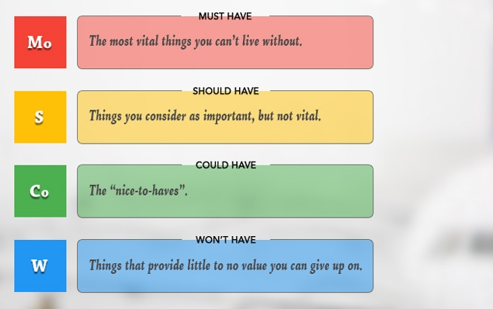

*Fig 5: MoSCoW Prioritazation*

|  |  |  |  |
| --- | --- | --- | --- |
| **ID** | **Title** | **MoSCoW** | **Description** |
| FR1 | Registration | Must | Registration allows to register for new user and parents. |
| FR2 | Log in | Must | Login maintains security. Hence it is must. |
| FR3 | Log out | Must | System with no logout will not maintain integrity. So it is must. |
| FR4 | Post news | Should | This is mandatory in the system. Should be prioritize. |
| FR5 | Upload pictures | Must | Hence the system is all about posting information about children, this is a must have. |
| FR6 | Upload videos | Should | This is also a mandatory function. |
| FR7 | Notifications | Must | Notification is a must have function to provide notification to parents. |
| FR14 | Enrollment | Would | Enrollment is mandatory. This would have make system function more. |
| FR17 | Delete pictures | Should | This should have in the system. |
| FR12 | Report | Would | This would help parents to view report. |
| FR13 | Refer | Would | This would help admin to gain more parents/ |
| NF1 | Security | Must | This is one must have non-functional requirement in this system. |
| NF3 | Availability | Should | System should be made available any time the user wants to use. |
| NF5 | Accountability | Could | This could make the system accountability. |

*Table 3 : MoSCoW Prioritization*

## 2.4.4 System Requirements Specification:

A requirement specification in a software system is a complete description of the behavior of the system to be developed. It includes set of use cases that describes all interactions the users will have with the system.

Users of the SRS are the Development team, Maintenance team, Clients, Technical writers.

* **Software Requirements**:

1. Operating System: Windows, linux
2. Browser: Google chrome, Mozilla, opera
3. Databases: Mysql

* **Hardware Specification:**

1. Ram: Minimum of 1GB.
2. Processor: I3 or above.
3. Hard disk: 500gb.

## 2.5 Use-Case Diagram

Use case diagram is used to make people understand how the system works. Components used in this diagram are:

1. Actor: They are external object, and placed outside of our system. It can be a specific person or a specific organization.
2. Use case: They are the verbs that reinforces the action that takes place.
3. Relationship: This defines the relationship between actor and use cases.
4. System Boundary: It defines the boundary of finite functionality.

* **Use case for admin.**

*Diagram 6: Use Case*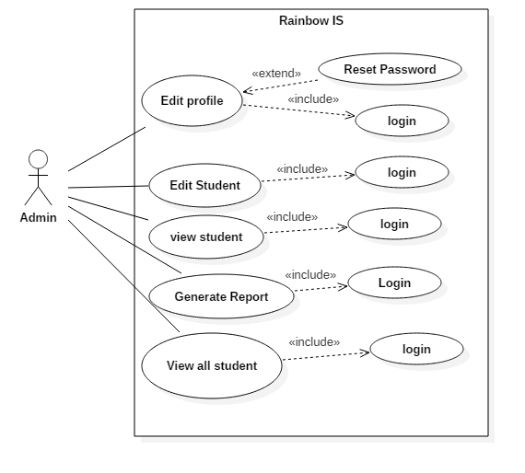

Above use-case is based on the functionality that can be accessed by the **Admin**.

* Admin first need to register in the system and login to access the functionality given by the system.
* Admin can view the registered user in the system with their children detailed information. Different information type made by the Teachers can be view/add/edit by the admin of the system
* All the information such as view student, daily activities are generated as report after the end of the day.
* **Use case for Parents.** 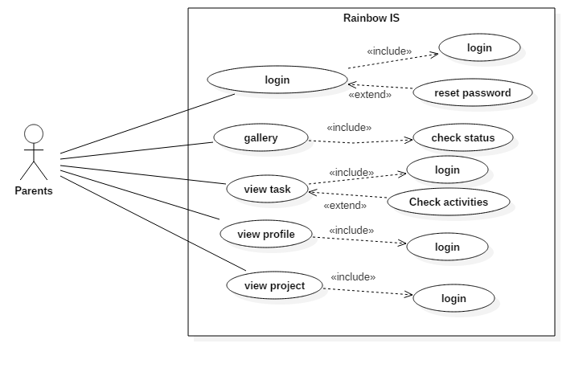

*Diagram 7: Use case*

* **Use case for Teacher**

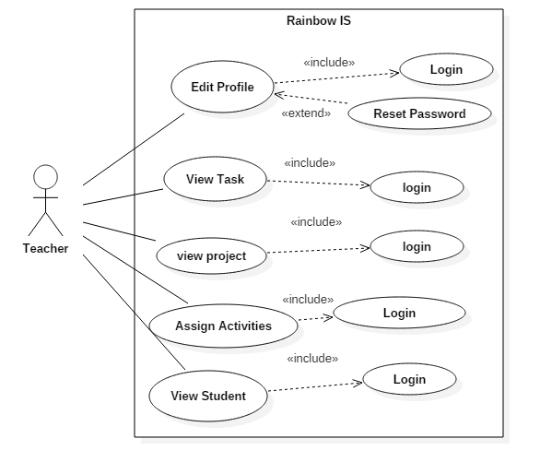

*Diagram 8: USE CASE*

* Teacher of the system can Add, Update and delete pictures, videos, news according to the need of the system.
* Teacher too can add the notification at the end of the day.
* Teacher can post status about the student progress.

## 2.6 Natural Language Analysis (NLA) and initial class diagram:

Pre-School information system is an online web-based system where parents could register in school’s database and log in into the system to view information about their children. Information might be photos, videos, and other news like in form of notifications which will be uploaded by teachers and all add and remove functions will be controlled by admin.

**Candidate class:**

* Parents
* Admins
* Teachers
* Children

Initial class diagram is a static diagram which helps in describing the structure of the system by showing the classes and the attributes that falls under it, operation of the system and relation between them.

Initial class diagram helps to find out initial class of the projects which helps in making the final class diagram. It also helps in making system better.

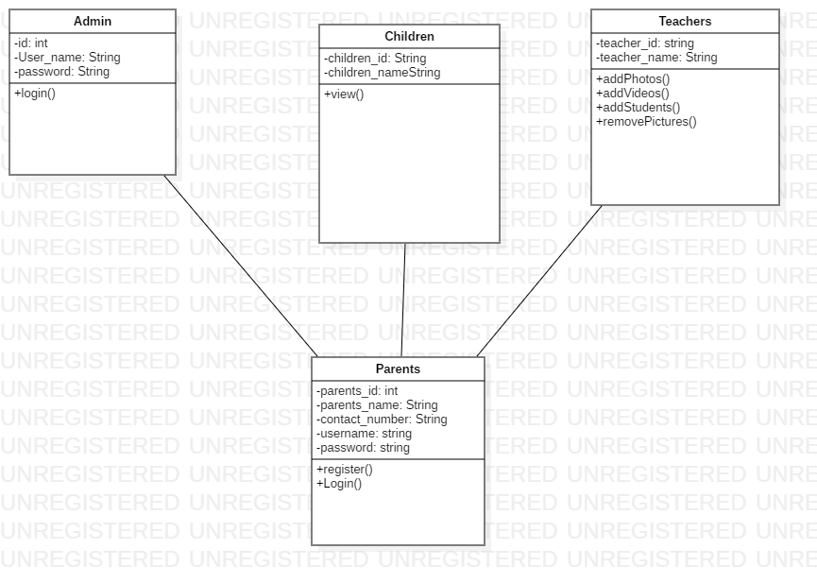

## 2.7 References

# Bibliography

(n.d.). Retrieved from http://www.selectbs.com/analysis-and-design/what-is-ssadm.

(2019, 05 08). Retrieved from selectdbs.com: http://www.selectbs.com/analysis-and-design/what-is-ssadm

(2019, 05 08). Retrieved from bizfluent.com: https://bizfluent.com/list-6781448-advantages-disadvantages-ssadm.html

(2019, 5 8). Retrieved from lucidchart.com: https://www.lucidchart.com/pages/data-flow-diagram

(2019, 5 8). Retrieved from visual-paradigm.com: https://www.visual-paradigm.com/guide/requirements-gathering/requirement-analysis-techniques/

Cohen, B. (n.d.). *https://bizfluent.com/list-6781448-advantages-disadvantages-ssadm.html*. Retrieved from https://bizfluent.com/list-6781448-advantages-disadvantages-ssadm.html.

## 