CSI473 Project Design Report
Tsa Temo Thuo - Team 10

Field | Complete
Assignment/phase | Phase 2
Approved project title | Tsa Temo Thuo - A Farm Produce Ordering and Delivery Coordination System for Botswana’s Horticulture Sector
Approval decision/date | Approved project baseline - 7 August 2026
Team number | 10
Members and IDs | Obvious Njembu 201801639  Ellen Lame Olifile 201800730  Stacey Batshanani Nthoi 202004071  Thatayaone Mogale 201802565
Repository URL | https://github.com/Shawnjembu/Tsa-Temo-Thuo
Submission tag and link | Phase 2 Final Design Report , https://github.com/Shawnjembu/Tsa-Temo-Thuo/tree/Lab-11/phase_2
Date | 30 October 2026

1. Executive summary
Tsa Temo Thuo is a proposed digital platform for coordinating farm-produce ordering and delivery in Botswana’s horticulture sector. It addresses coordination between verified farmers, buyers, administrators and transporters through a controlled listing, ordering, reservation and delivery lifecycle.
The Phase 2 design is bounded around the approved requirements and the detailed Place Order use case (UC-01). The key design decision is to make stock reservation atomic: an order may reserve quantity only when sufficient stock remains, the listing is still active, and the request has not already been processed under the same idempotency token.
The report defines FR-01 to FR-13, AC-01 to AC-05 and QS-01 to QS-10, plus the domain model, lifecycle/interaction models, architecture, data model, service contracts and verification plan. The Lab 11 bounded slice demonstrates the core reservation behaviour using Python/SQLite; the TypeScript contracts document the intended service boundary.
The lecturer indicated that there would not be enough time to implement the complete system. This report therefore distinguishes demonstrated bounded behaviour from planned design and does not claim full implementation of registration, listing/search, transport, delivery, reporting or production authentication.

2. Problem evidence, stakeholders and scope

Problem statement
The project concerns coordination of farm produce from verified farmers to buyers, including availability, ordering, reservation, farmer confirmation and delivery coordination. The central correctness risk is inconsistent stock under concurrent or repeated ordering.

Evidence and approval conditions
The project artefacts define requirements, use cases, acceptance criteria, quality scenarios, domain model, technical debt and reconciliation evidence. The project baseline records approval on 7 August 2026. The Phase 2 boundary is design plus a bounded core-use-case demonstration rather than a complete production application.

Objectives
- Provide a clear workflow for verified farmers to list produce and buyers to place orders.
- Prevent overselling through atomic reservation and explicit stock invariants.
- Support farmer confirmation/decline and the later transport/delivery lifecycle.
- Provide administrators with controlled registration and order-activity oversight.
- Specify measurable quality, usability, security and recovery obligations.

Stakeholders
- Buyer - searches active listings, places orders and confirms receipt.
- Farmer - manages produce listings and confirms or declines orders.
- Administrator - manages registration approval and views order activity reports.
- Transporter - accepts transport requests and updates delivery progress.
- Project team/lecturer - evaluates design, traceability and bounded evidence.

Scope
In scope: registration, produce listings, buyer search, order placement, atomic reservation, order state/history, farmer decision, SoldOut/Expired states, transport assignment/delivery, authorised history and administrator reporting.
Outside the bounded Lab 11 implementation: full registration/listing/search UI, production authentication, transport/delivery, administrator reporting, robust cancellation/expiry release, production-scale deployment and production monitoring.

Assumptions and constraints
- Roles are Buyer, Farmer, Administrator and Transporter.
- Produce quantity is represented as integer units in the bounded design.
- Reservation expiry remains configurable and must be agreed before production.
- SQLite is acceptable for the teaching slice; production should evaluate a transactional database such as PostgreSQL.
- External notifications must not corrupt the committed order transaction.

3. Glossary
Term | Definition
Available | Listing quantity not reserved or confirmed; derived as Total - Reserved - Confirmed.
Reserved | Quantity held for placed orders before final confirmation.
Confirmed | Quantity committed to confirmed orders.
Active | Listing state in which buyers may place orders, subject to availability and dates.
SoldOut | Listing state reached when no orderable quantity remains.
Expired | Listing state reached when the availability window has ended.
Idempotency token | Unique request token used so a retry does not create a second reservation.
OrderActivity | Persisted record describing an order-state transition.
Atomic reservation | Validation, stock change and order/history creation completed in one transaction.
ReservationExpired | Order state used when a reservation expires and held stock is released.
Declined | Order outcome when the farmer rejects an order and the reservation is released.

Core stock invariant
For every listing, Available + Reserved + Confirmed = Total. Available, Reserved and Confirmed must never become negative, and confirmation must not deduct stock a second time.

4. Functional requirements and use cases

Functional requirements
ID | Requirement
FR-01 | A buyer/farmer registration request can be submitted.
FR-02 | An administrator can approve or reject a registration request.
FR-03 | A verified farmer can create a produce listing.
FR-04 | A buyer can search active listings by crop and district.
FR-05 | A buyer can place an order within the remaining quantity.
FR-06 | Order reservation is atomic and prevents overselling under concurrency or duplicate submission.
FR-07 | Insufficient quantity or SoldOut/Expired listings are rejected without changing reserved stock.
FR-08 | A farmer can confirm or decline an order; decline releases the reservation.
FR-09 | Listings automatically transition to SoldOut or Expired when conditions are met.
FR-10 | A farmer can request transport and a transporter can accept it, producing Assigned.
FR-11 | A transporter can update InTransit/Delivered and the buyer can confirm receipt.
FR-12 | Authorised users can view order state and history appropriate to their role.
FR-13 | An administrator can view order-activity reports by state and date range.

Actors
- Buyer
- Farmer
- Administrator
- Transporter
- System

Detailed use case: UC-01 Place Order
Field | Specification
Primary actor | Buyer
Secondary actors | Farmer, System
Preconditions | Buyer verified; listing Active; availability > 0; availability window valid; required fields present.
Trigger | Buyer submits quantity and idempotency token.
Success postconditions | Order Placed; Reserved increases once; Available decreases once; Total unchanged; history persisted.
Special requirements | Atomic reservation, concurrency protection, idempotency, no negative stock, no oversell, persistent history and no double deduction.

Main flow
- Buyer searches and selects an active listing.
- Buyer enters quantity and submits with an idempotency token.
- System validates buyer, listing state, quantity and availability.
- System atomically reserves stock and creates the order/history within one transaction.
- System commits; notification is sent/queued after commit.
- Buyer sees Placed; farmer may confirm or decline.

Alternative and exception flows
- Insufficient quantity: reject with no stock change.
- Listing becomes SoldOut/Expired before reservation: reject with no stock change.
- Concurrent last-stock requests: exactly one request may reserve the remaining quantity.
- Duplicate retry: same token returns the existing result without a second reservation.
- Farmer declines: order becomes Declined and reservation is released.
- Cancellation/expiry: held quantity is restored according to lifecycle rules.
- Farmer confirms: Reserved becomes Confirmed without a second deduction.
- Quality dispute: follow the defined dispute/resolution process.

Acceptance criteria
ID | Acceptance criterion
AC-01 | Successful order reserves the requested quantity exactly once.
AC-02 | Order exceeding available quantity is rejected and reserved stock is unchanged.
AC-03 | SoldOut or Expired listings reject new orders without changing reserved stock.
AC-04 | Concurrent requests for final stock result in exactly one accepted reservation.
AC-05 | Same idempotency token does not create a second reservation.

5. Quality requirements
ID | Scenario / target | Design obligation
QS-01 | No oversell; invariant preserved under concurrency. | Transactional guarded reservation and appropriate locking/atomic update.
QS-02 | Search p95 <2s for 500 synthetic listings and 50 searches. | Indexed/filterable listing fields and bounded query path.
QS-03 | Dropped connectivity/idempotency across 20 runs. | Unique idempotency token and deterministic retry handling.
QS-04 | 4/5 synthetic users complete core task within <=5 screens. | Task-focused flow, clear status and validation.
QS-05 | Only authorised farmer confirms/declines. | Server-side role and ownership checks.
QS-06 | Decline/cancel/expiry restores reserved stock. | Single auditable state-transition rules.
QS-07 | Confirmation does not deduct stock twice. | Reserved-to-confirmed transfer, not second decrement.
QS-08 | Quality/grade responsibility is explicit. | Listing/order data and dispute responsibility defined.
QS-09 | Crash/restart preserves order history. | Transactional persistence and recoverable state history.
QS-10 | Full lifecycle preserves stock consistency. | State transition matrix and invariant checks.

Verification approach
The reconciliation artefact records bounded evidence for the core order slice, including concurrency and idempotency trials. It does not claim complete verification for unimplemented registration, transport, reporting, full usability or production-scale behaviour.

6. Analysis/domain model and responsibilities

Domain model
The model contains Administrator, Farmer, Buyer, Account, Listing, Order, Transporter, TransportJob and OrderActivityReport, with order and listing state enumerations.
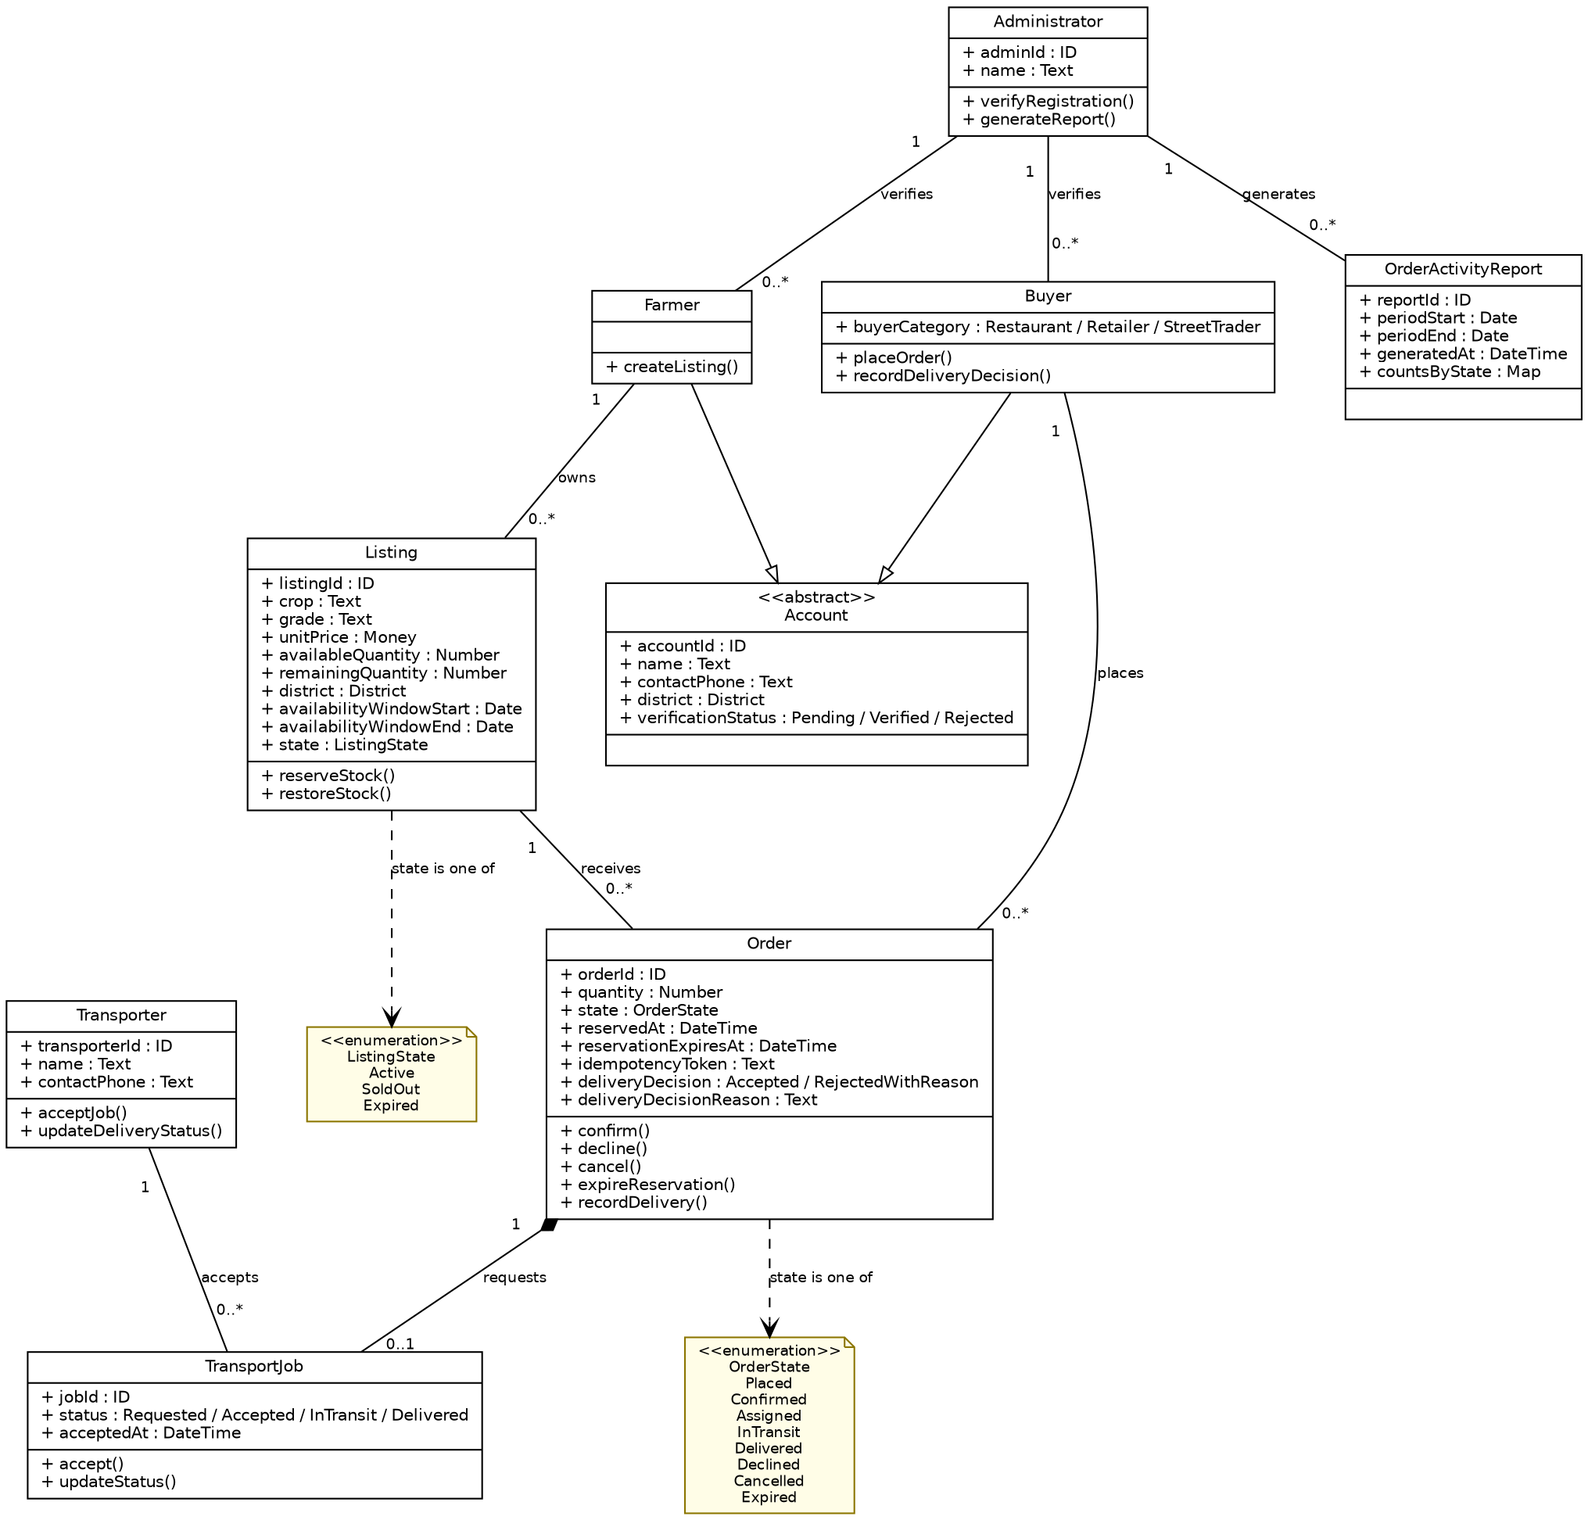
Domain model .

Business rules
- Only verified buyers can place orders.
- Only verified farmers can create/manage listings.
- Only Active listings with remaining quantity accept orders.
- Available = Total - Reserved - Confirmed.
- Reservation is atomic and idempotent.
- Confirmation moves Reserved to Confirmed without double deduction.
- Decline/cancel/expiry releases Reserved quantity according to lifecycle rules.
- Order history records state transitions.
- Authorisation is checked server-side.

Responsibility allocation
Responsibility | Primary responsibility
Registration approval | Administrator/account service
Listing creation/state | Farmer/listing service
Search | Buyer/listing service
Atomic reservation | Order service + repository + database transaction
Order decision | Farmer/order service
Transport lifecycle | Transporter/transport service
Order history | Order activity repository
Reporting | Administrator/reporting service

Rationale
Separating listing, order, transport and activity responsibilities reduces coupling and makes the stock invariant and audit history explicit. The bounded implementation focuses on reservation because FR-06 is the highest-risk correctness rule.

7. Interaction and lifecycle

UC-01 interaction sequence
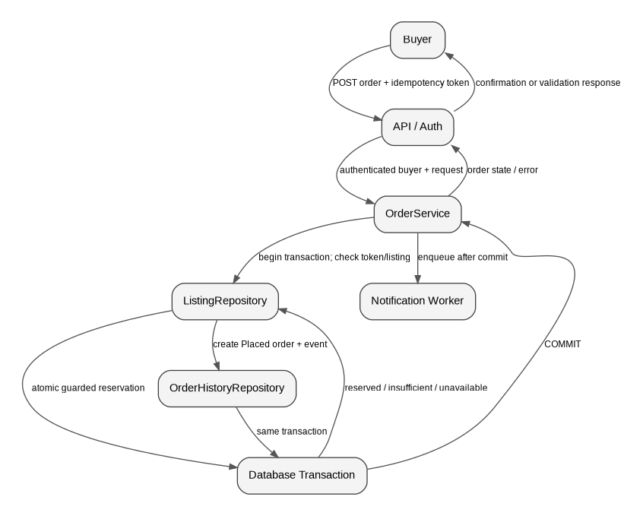
Sequence diagram for atomic Place Order.
Validation and reservation are inside the transaction boundary. Order and status history are persisted before commit. Notification occurs after commit so external failure cannot partially corrupt the stock transaction.

Order lifecycle
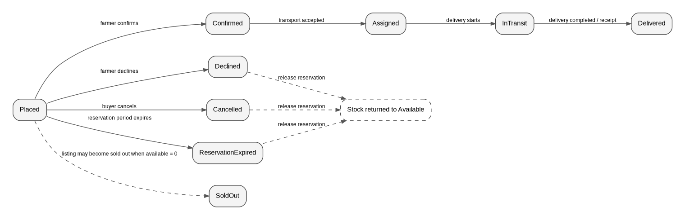
Order state lifecycle.
The lifecycle includes Placed, Confirmed, Assigned, InTransit, Delivered, Declined, Cancelled and ReservationExpired. Declined is the standard terminology used in this report.

Stock movement
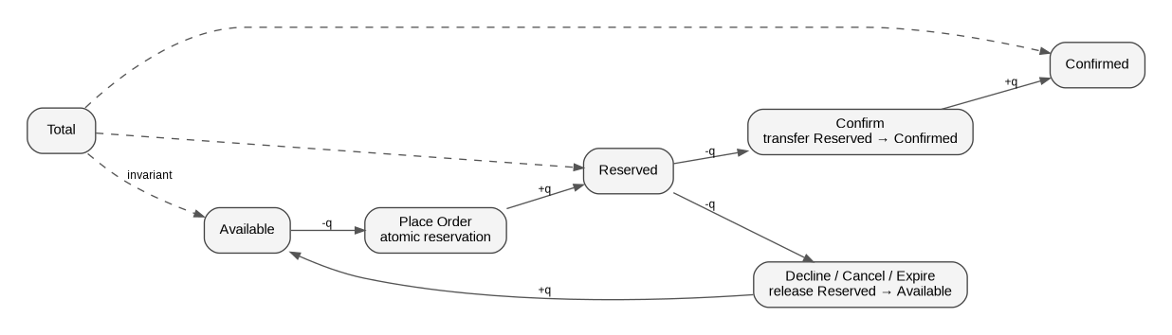
Stock movement and invariant.
Reserved and Confirmed quantities are separated so confirmation does not deduct stock twice. Release paths return reserved quantity to Available.

8. Architecture and decisions

Architecture drivers
- Stock correctness under concurrency.
- Role-based access control.
- Persistent order history.
- Recovery after dropped requests/failures.
- Separation of domain logic, persistence and integrations.
- Suitability for teaching while documenting production upgrades.

Component architecture
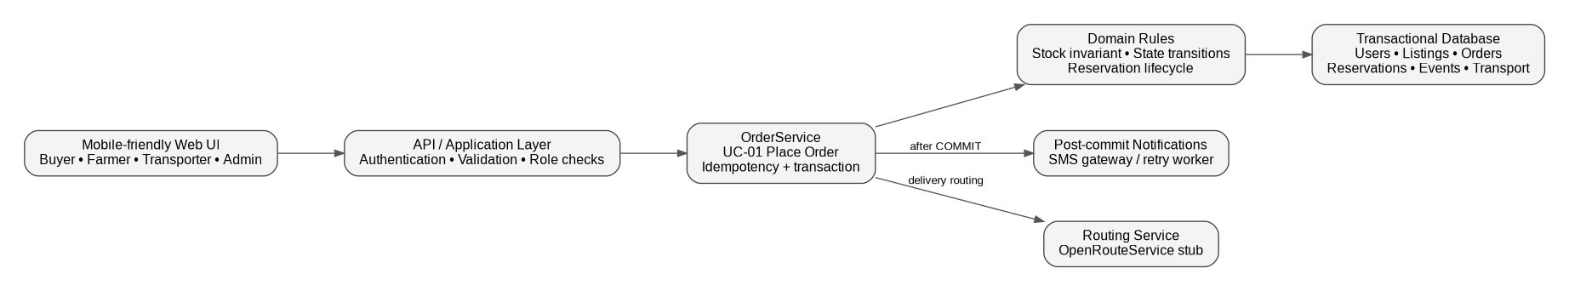
Logical component architecture.

Key decisions
Decision | Choice | Consequence
Reservation consistency | One transaction with guarded atomic update/lock. | Strong stock correctness; production DB must support suitable locking.
Idempotency | Unique idempotency token. | Safe retries; scope/retention must be defined.
History | Persist order status events. | Auditable lifecycle; storage grows with events.
Notifications | After successful commit. | External failure cannot corrupt stock transaction; production needs retry/outbox.
Production DB | Evaluate PostgreSQL/equivalent. | Better production concurrency than SQLite.
Authentication | Real identity/session/token authentication. | Demo actor headers are not acceptable for production.

Rejected/limited alternatives
- Blind read-then-write stock updates were rejected because they permit overselling.
- Client-only validation was rejected because it cannot enforce shared invariants.
- SQLite-only production deployment is not recommended for expected concurrency.
- Sending notifications inside the transaction is avoided because external failure can interfere with commit.

9. Data, API/service and deployment design

Logical data model
Logical data model for the bounded order slice.

Core data structures
Entity | Important fields/rules
users | id, role, verification/identity data.
listings | id, farmer, crop, district, total, reserved, confirmed, state, dates.
orders | id, buyer, listing, quantity, state, idempotency_token UNIQUE, timestamps.
order_status_events | order_id, state, timestamp, actor and event data.

Service contract
PlaceOrderRequest contains listingId, buyerId, quantity and idempotencyToken. OrderRecord contains order id, listing id, buyer id, quantity, state and timestamps. ListingRepository.tryReserve must perform a row lock or equivalent guarded update within a transaction. OrderRepository supports lookup by idempotency token and save. UnitOfWork coordinates the transaction.

Deployment and failure/recovery
- Client/UI calls an authenticated API boundary.
- Application service validates role, ownership, listing state and quantity.
- Transactional database persists listings, orders and history.
- External notification/routing is outside the commit boundary.
- Dropped responses are retried with the same idempotency token.
- After restart, persisted order/history state is authoritative.
- Production requires backups, monitoring, migration controls and recovery procedures.

10. Detailed design, patterns and framework

Interfaces/classes
- ListingRepository.tryReserve - atomic guarded reservation.
- OrderRepository.findByIdempotencyToken - retry detection.
- OrderRepository.save - persistence within UnitOfWork.
- OrderStatusEventRepository - append lifecycle history.
- BuyerAuthorization - role/ownership check.
- UnitOfWork - transaction boundary.
- Notification/routing adapters - integrations after commit.

Patterns
Pattern | Application
Repository | Abstract persistence and transaction-aware operations.
Unit of Work | Groups reservation, order and history into one commit.
State model | Makes legal order/listing transitions explicit.
Idempotency | Makes retried requests safe.
Transactional outbox (recommended) | Future production mechanism for reliable notifications.

Framework boundary
The supplied TypeScript contracts are illustrative service boundaries, while the bounded teaching implementation uses Python/SQLite. The report distinguishes documentation-level contracts from runtime evidence.

11. User-interface, accessibility and usability

Core task flow
- Buyer signs in and reaches active listings.
- Buyer filters by crop/district and opens a listing.
- Buyer enters quantity and submits the order.
- System clearly shows success, rejection or retry outcome.
- Buyer opens the order to see state/history.
- Farmer sees the order and can confirm or decline.

Required interface states
- Empty search results.
- Insufficient quantity.
- SoldOut/Expired listing.
- Duplicate/retry response.
- Placed order.
- Farmer confirmation/decline.
- Connectivity failure with safe retry instruction.
- Delivered/receipt confirmation.

Accessibility
- Use clear labels and meaningful validation.
- Do not rely on colour alone.
- Provide keyboard-accessible controls and logical focus order.
- Use readable text, sufficient contrast and descriptive status labels.
- Keep the core buyer task within five screens or fewer where practical.

Usability evidence
The supplied usability-test artefact explicitly says not to invent findings. Therefore this report records the evaluation plan and hypotheses rather than fabricated results. The planned target is at least 4/5 synthetic users completing the core task within five screens.

12. Implementation vertical slice

Approved core use case
The bounded vertical slice is UC-01 Place Order, including successful reservation, insufficient-quantity rejection, SoldOut/Expired rejection, concurrent last-stock protection and idempotent retry.

Repository structure
- docs/Requirements.md - requirements and traceability.
- docs/use cases/UC.md - detailed use case.
- docs/acceptance-criteria.md - AC-01 to AC-05.
- docs/quality-scenarios.md - QS-01 to QS-10.
- docs/domain-model.png - domain model.
- migrations-or-schema/001_initial.sql - bounded SQLite schema.
- src/contracts.ts - illustrative contracts.
- reconciliation-matrix.md - implementation/test evidence.
- technical-debt-and-risks.md - risks and release boundary.

Implementation boundary
Lab 11 provides bounded evidence for the core order slice. The complete application was not claimed as implemented because the lecturer indicated there was insufficient time. Registration, full listing/search, transport/delivery, administrator reports, production authentication and several lifecycle release paths remain incomplete.

Setup/run instructions
Use the exact setup and run instructions in the submitted repository README and approved Lab 11 environment. This report does not invent commands not present in the supplied artefacts.

13. Testing and results

Requirement-linked tests
Test | Expected result | Evidence status
AC-01 | Successful order reserves stock once. | PASS in bounded reconciliation evidence.
AC-02 | Insufficient quantity rejected with no stock change. | PASS in bounded reconciliation evidence.
AC-03 | SoldOut/Expired rejected with no stock change. | PASS in bounded reconciliation evidence.
AC-04 | Concurrent last-stock requests accept exactly one. | PASS in 100 classroom concurrency trials; SQLite scope.
AC-05 | Same token does not double-reserve. | PASS in 20 retry trials.

Quality evidence status
- QS-01 has bounded concurrency evidence through AC-04.
- QS-03 has bounded retry evidence through AC-05.
- QS-02, QS-04, QS-08 and QS-10 are not fully verified in the supplied reconciliation evidence.
- Registration, listing/search, transport/delivery and reporting are not implemented in the bounded slice.
- Usability findings are intentionally not fabricated; observation records must be completed during evaluation.

Interpretation
The evidence supports correctness of the bounded Place Order behaviour, not production readiness. SQLite concurrency results are teaching-scale evidence and should not be interpreted as production-scale performance evidence.

14. Reconciliation and change history

Model-to-code-to-test reconciliation
Area | Design/evidence | Status
FR-06 / AC-01 | Requirements + UC-01 + bounded implementation | PASS bounded evidence
FR-06 / AC-04 | Requirements + 100 concurrency trials | PASS bounded evidence
FR-06 / AC-05 | Idempotency contract + 20 retries | PASS bounded evidence
FR-08 | UC-01 lifecycle; decline/release | Partial
FR-01 to FR-04 | Requirements/design; no full implementation | Not implemented
FR-10 to FR-11 | Requirements/design; no transport/delivery implementation | Not implemented
FR-13 | Requirements/design; no reporting implementation | Not implemented

Change history
- Preserved the lecturer-supplied section structure and numbering.
- Standardised order refusal terminology to Declined.
- Made ReservationExpired explicit in the lifecycle.
- Separated demonstrated Lab 11 behaviour from proposed production design.
- Added architecture, sequence, state, stock and logical data diagrams.
- Documented authentication, notification, expiry/cancellation and database-concurrency risks.
- Kept usability findings as planned evaluation rather than invented results.

15. Risks, technical debt and release recommendation
Priority | Risk/debt | Required action
Critical | Demo actor identity is spoofable; not real authentication. | Implement authenticated sessions/tokens and server-side authorisation.
High | Runtime Python/SQLite differs from illustrative TypeScript contracts. | Align implementation stack before release.
High | Cancellation/expiry release not fully implemented. | Implement and test stock restoration transitions.
High | Registration, listing/search, transport and reporting not implemented. | Complete approved vertical slices.
High | Post-commit notification failures may be lost. | Use transactional outbox/retry.
Medium | SQLite concurrency is not production-scale. | Evaluate PostgreSQL/equivalent.
Medium | Expiry processing is limited. | Add scheduler/expiry filtering.
Medium | Idempotency scope/retention undefined. | Define uniqueness and retention policy.
Medium | No production backup/monitoring/audit/migration process. | Define operational controls.
Low | Integer-only quantities may not fit all produce types. | Define unit/precision policy if required.

Release recommendation
The bounded design is suitable for academic demonstration and further development, but public/production release is not recommended yet. Release should be conditional on real authentication and authorisation, completion of the full lifecycle, transport/reporting, expiry/cancellation release, reliable notifications, production database concurrency testing, usability/accessibility testing, security testing, backup/recovery and monitoring.

16. Academic integrity and AI-use record
This report consolidates the supplied project artefacts and design evidence. Any tool-assisted drafting or diagram preparation must be verified by the student team against the repository, requirements and lecturer-provided template before submission.
The report does not claim evidence absent from the supplied artefacts. In particular, it does not fabricate usability observations, production performance results or implementation of features recorded as incomplete.
The team remains responsible for the accuracy of the submitted design, interpretation of test evidence, references and compliance with University of Botswana academic-integrity requirements.

References
- University of Botswana, CSI473 Project Design Report Template, Semester 1, 2026/27.
- Tsa Temo Thuo project repository and supplied artefacts: Requirements.md; acceptance-criteria.md; quality-scenarios.md; docs/use cases/UC.md; docs/domain-model.png; migrations-or-schema/001_initial.sql; src/contracts.ts; reconciliation-matrix.md; technical-debt-and-risks.md.
- CSI473 Tsa Temo Thuo Phase 1 Report Final (2), supplied project artefact.

Appendices

Appendix A - Requirement traceability
Requirement | Design / verification evidence
FR-01 | Registration request - requirements/design scope; not implemented in bounded slice.
FR-02 | Administrator approval - requirements/design scope; not implemented in bounded slice.
FR-03 | Verified farmer listing - requirements/design scope; not implemented in bounded slice.
FR-04 | Buyer search by crop/district - requirements/design scope; not implemented in bounded slice.
FR-05 | Place order within quantity - UC-01, AC-01/02/03.
FR-06 | Atomic reservation/no oversell/idempotency - UC-01, AC-01/04/05, QS-01/QS-03.
FR-07 | Reject insufficient/SoldOut/Expired - AC-02/03.
FR-08 | Farmer confirm/decline - lifecycle design; partial bounded evidence.
FR-09 | SoldOut/Expired transitions - lifecycle design; expiry implementation limited.
FR-10 | Transport request/accept - requirements/design only.
FR-11 | Transport and receipt - requirements/design only.
FR-12 | Authorised history - data/history design; bounded core evidence.
FR-13 | Admin reports - requirements/design only.

Appendix B - Design diagrams
Appendix B1 - Domain model
Appendix B2 - Place Order sequence
Appendix B3 - Order lifecycle
Appendix B4 - Stock movement
Appendix B5 - Architecture
Appendix B6 - Logical data model

Appendix C - Implementation and test status
Artefact | Purpose | Status
Requirements.md | FR-01 to FR-13 | Supplied
acceptance-criteria.md | AC-01 to AC-05 | Supplied
quality-scenarios.md | QS-01 to QS-10 | Supplied
docs/use cases/UC.md | UC-01 Place Order | Supplied
docs/domain-model.png | Domain analysis | Supplied
migrations-or-schema/001_initial.sql | Bounded SQLite schema | Supplied
src/contracts.ts | Illustrative service/repository contracts | Supplied
reconciliation-matrix.md | Model/code/test reconciliation | Supplied
technical-debt-and-risks.md | Risk/release boundary | Supplied
Python/SQLite bounded slice | Core Place Order evidence | Demonstrated bounded behaviour
Full application system | Complete project lifecycle | Not implemented

