Report 01

1. **Problem Description**In this assessment, except establish the coding environment, my goal is to learn how to think like a computer through a basic turtle python application, and how the programming work in a step-by-step process.
2. **Required Task Elements**

shapeOne.py shows the logo “I ♥ NEU”, formed by the text “I” and “NEU”, the heart in the middle is a closed shape formed by two straight lines and two circle arcs, filled with red color.

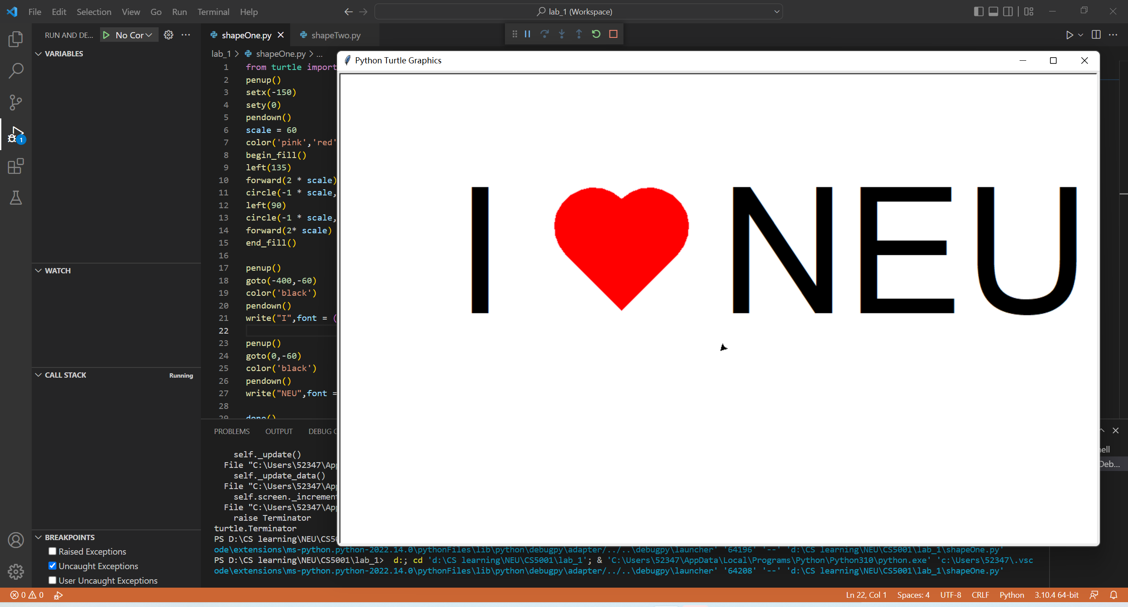

Screenshot for shapeOne.py (I ♥ NEU)

shapeTwo.py shows a blooming rose formed by circulated patterned arcs, with the text “Rose Blooms for you.” marked at the bottom right.

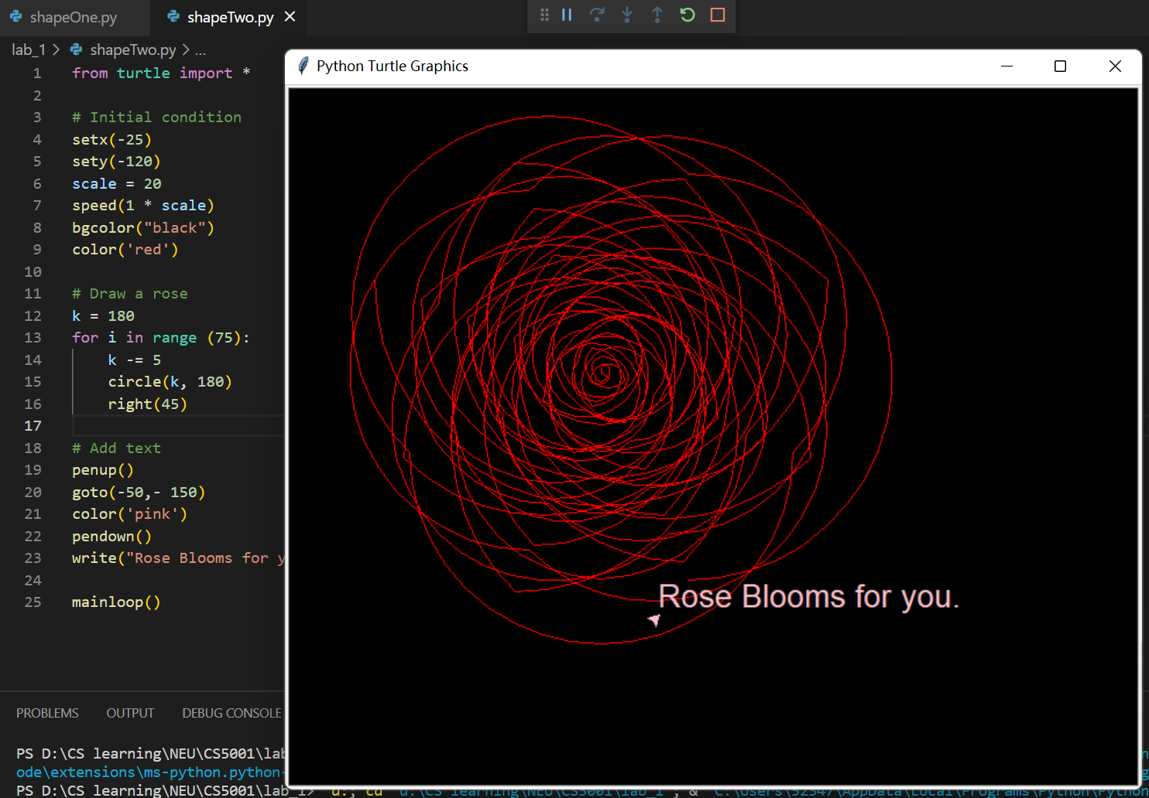

Screenshot for shapeTwo.py (Rose Blooming)

1. **Extensions**I tried different methods to give more interesting properties to my drawings, extensions are as follows.

* Controlled the speed of the drawing;
* Created separated patterns in a single drawing;
* Add color for the outline, background, and filling;
* Create an abstract rose image with circulated patterned arcs;
* Added customized text with certain font and size in the drawings;
* Set coordinates for texts and patterns.

1. **Reflection**

* I learned multiple turtle methods such as circle(), fill(), speed(), penup(), pendown() in order to add different properties for my assignment.
* Most importantly, I learned how to use the correct logic to combine different statements and methods together and achieve the function you want.
* Can’t use turtle.py as a file name, or it will cause an error during runtime. the reason is that when you write import turtle in the first line, it would import this turtle.py instead of the turtle module of python, and you will fail to use the methods from the turtle module.

from turtle import *

1. **Acknowledgements**

To get more properties of python turtle, especially more interesting methods, I read the related chapter on the official python document.

Except above, I did not ask anybody for help in this assignment.

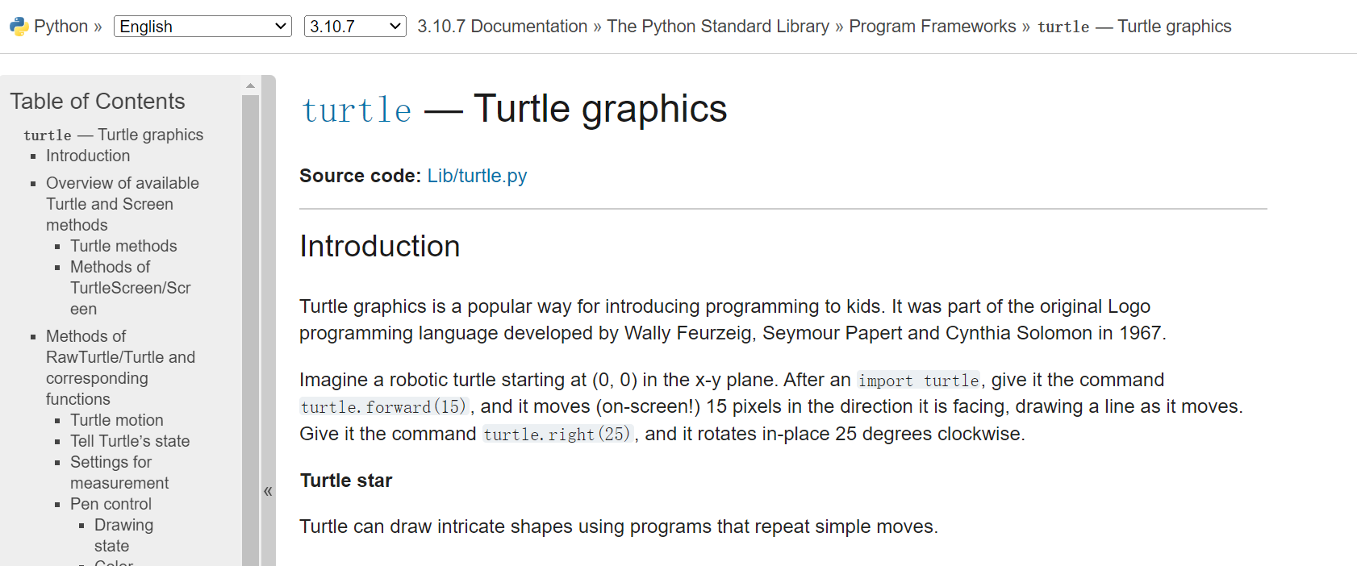

**Grading Statement**

Both two python files are functioning well without significant error, scaling is added in both python files, the report is also provided.

I tried to create a self-designed logo and a complicated rose pattern, and let my submission more creative, also I learned different advanced methods in turtle, which were not taught in class, and applied them in my assignment.

For the above reasons, I think this work deserves a full mark.

