Report 02

1. **Flow Chart**The flow chart of this assignment is as follow.

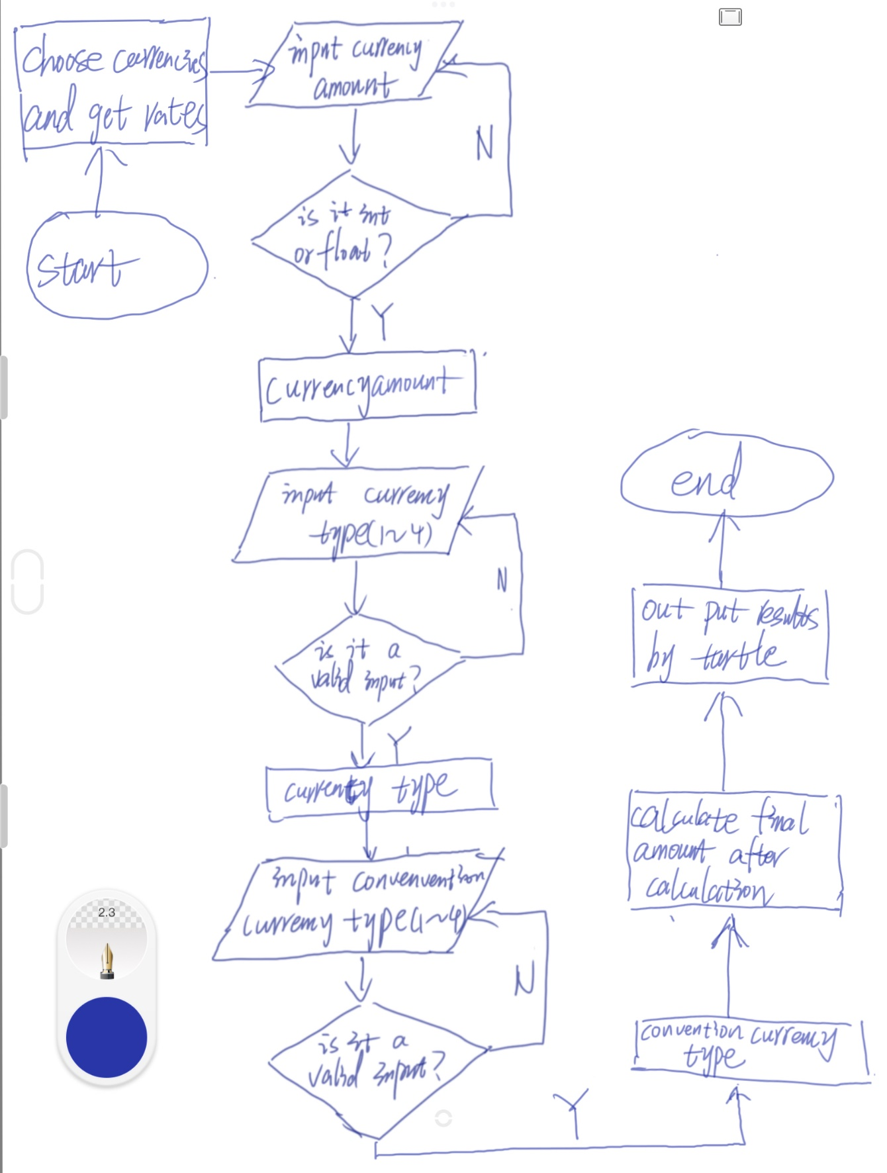

1. **Required Task Elements**

The task of the assignment is to create a menu-driven program. The program could allow users to input the amount of currency, currency type, and convention currency type. After user input, the program will give the result by turtle drawing.

The achievement of tasks is as follows.

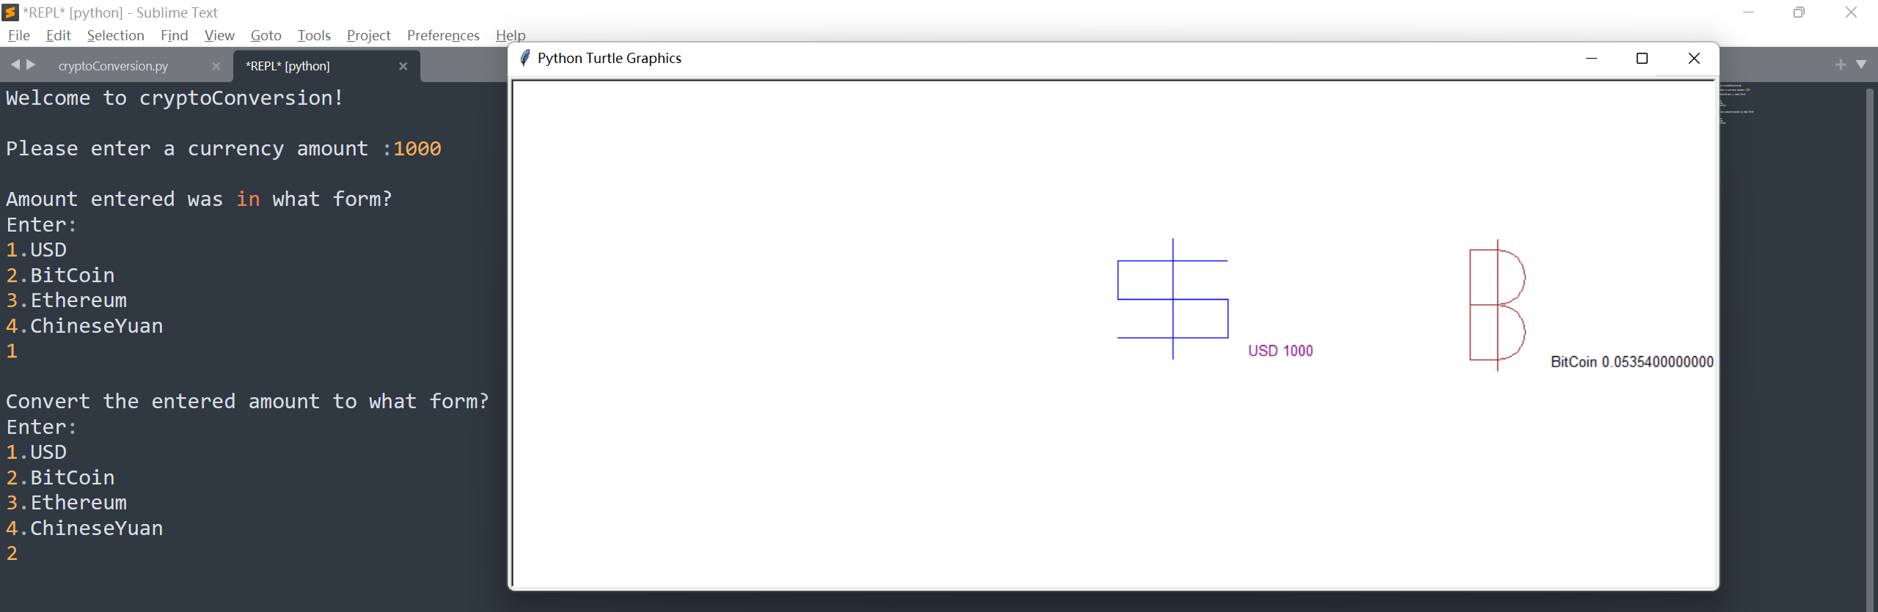

USD to BTC

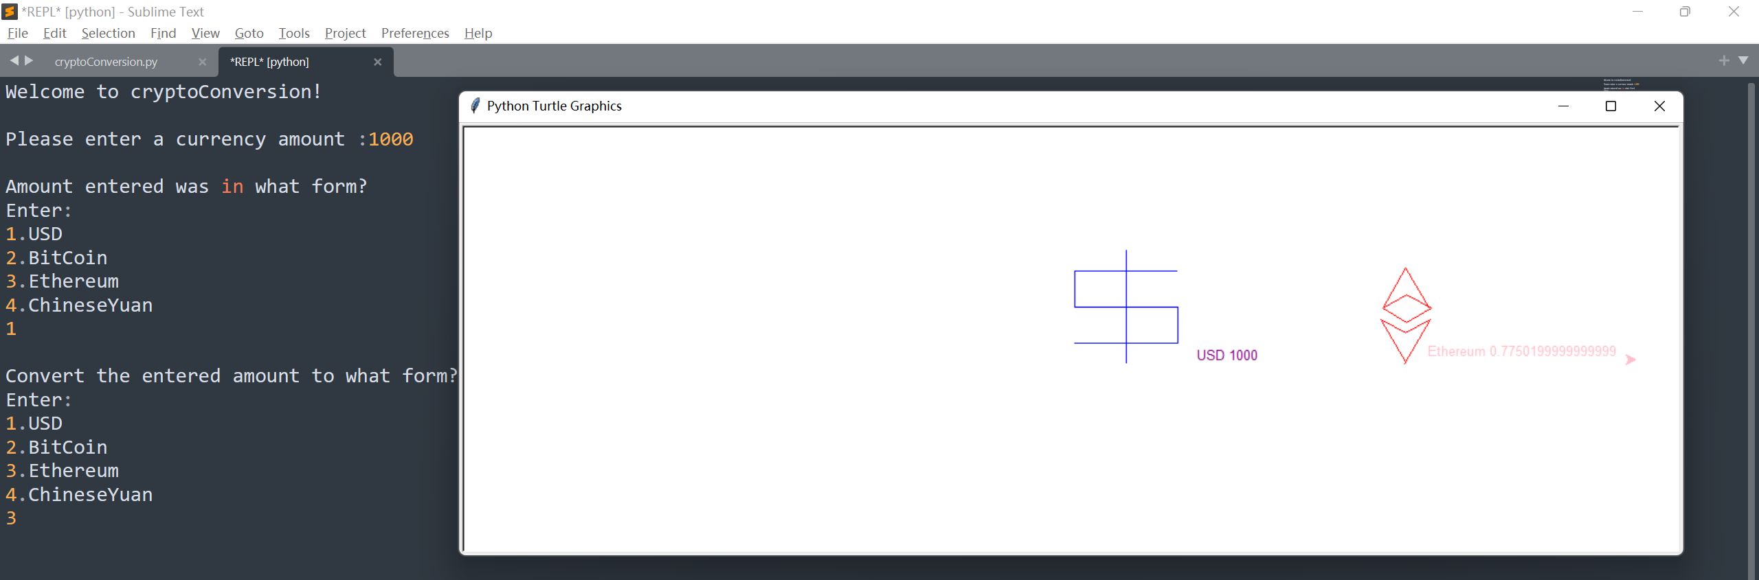

USD to ETH

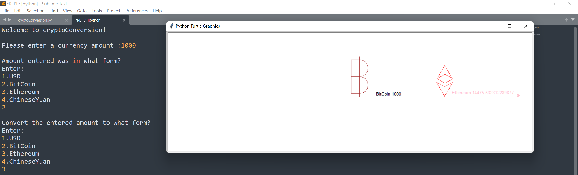

BTC to ETH

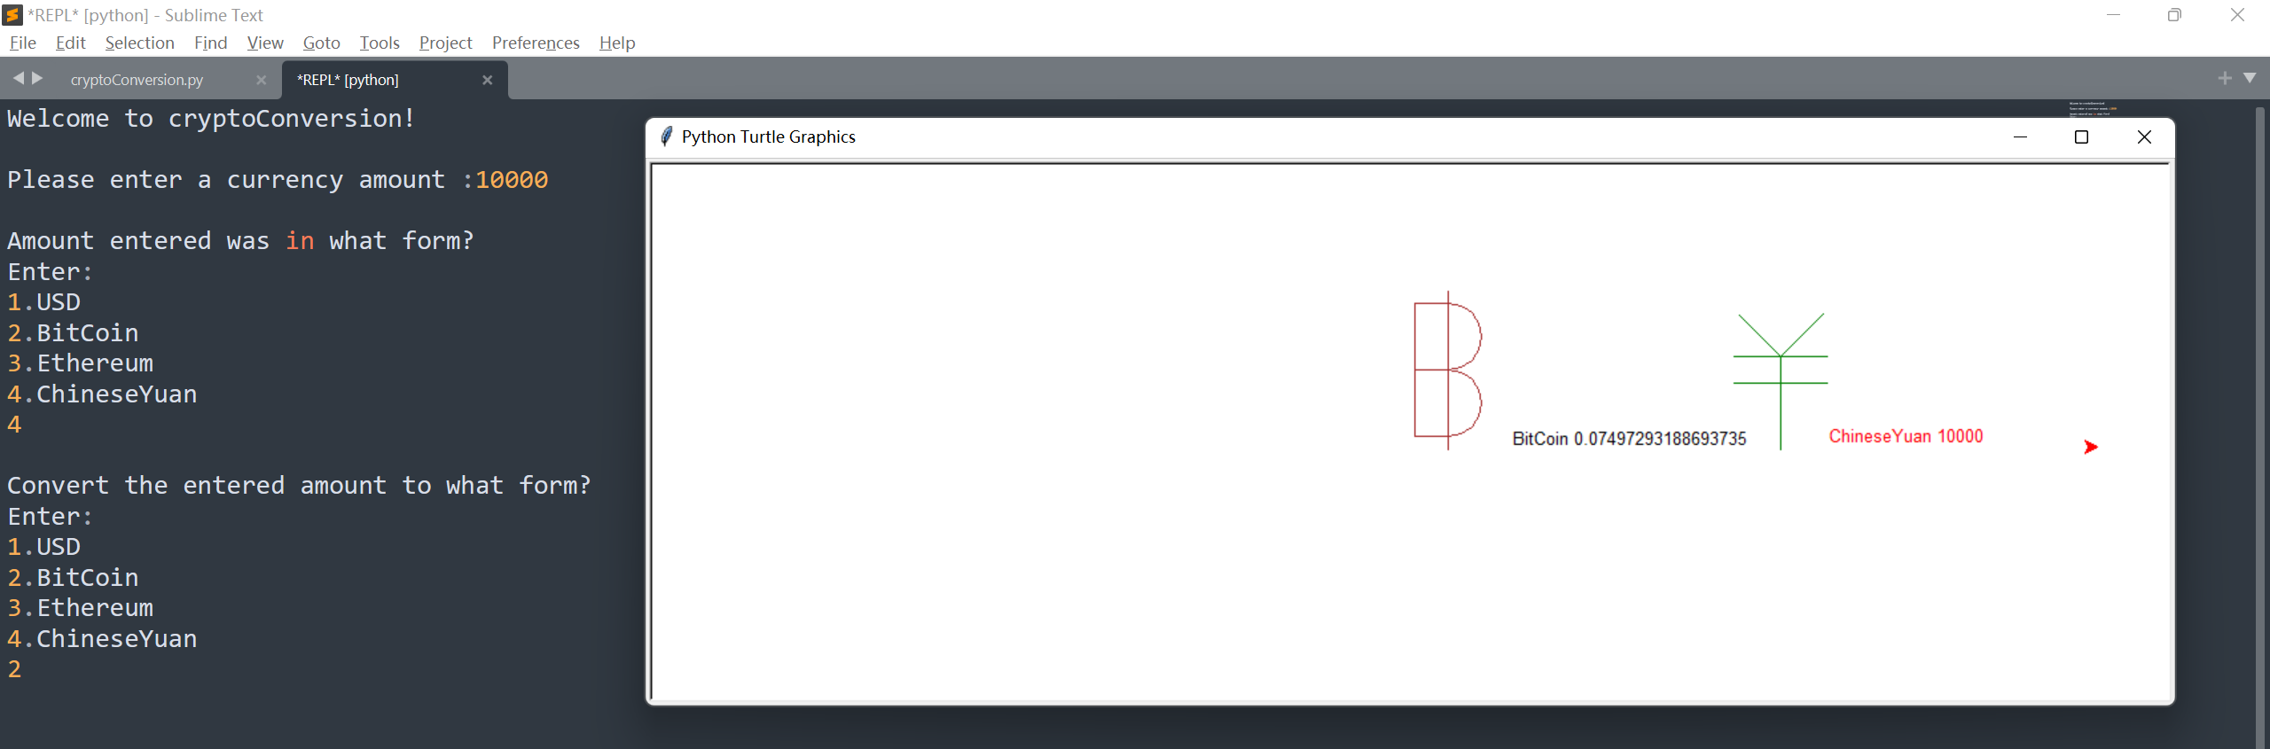

CNY to BTC

1. **Extensions**

* Handle the user input gracefully, for examples in currency amount input, if user input is neither int nor float, it will notify the user to input again until it is correct, and the program will not easily crash for errors;

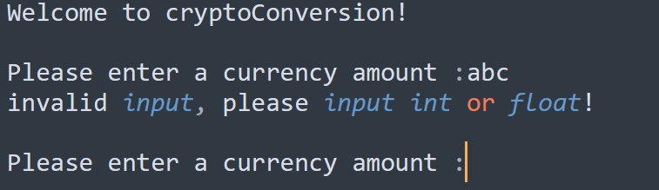

Input letters(currency_amount)

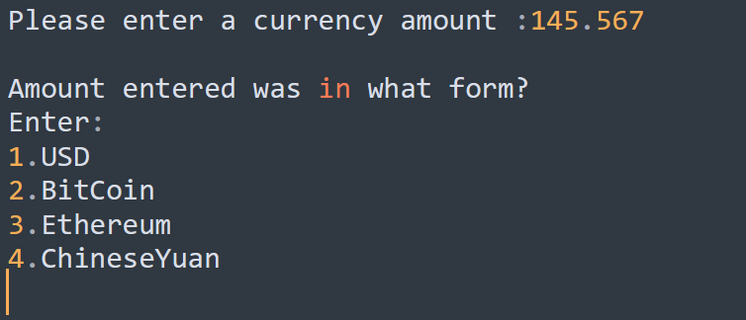

Input float(currency_amount)

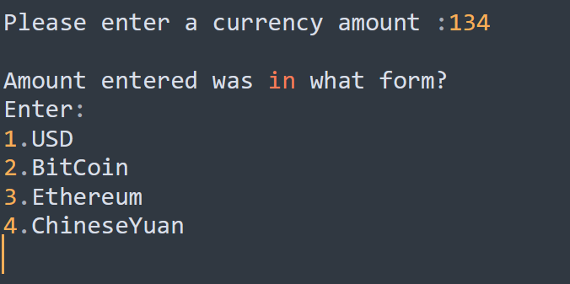

Input int

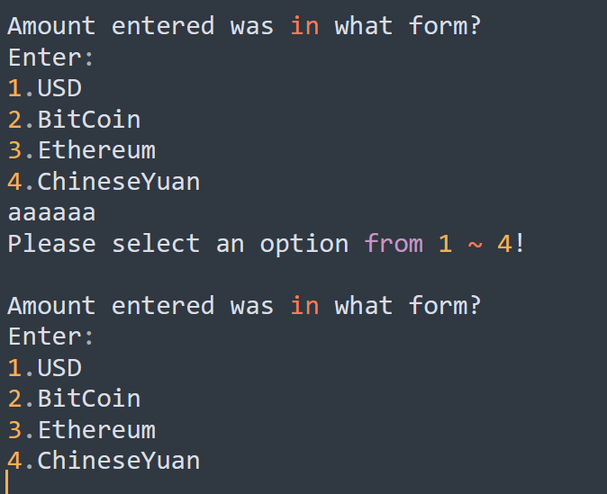

Input letters(choose currency number

* Adopt while loops, string methods such as isdigit(), replace(), and boolean flags to handle invalid input in multiple scenarios;
* Use functions to simplify the code logic;

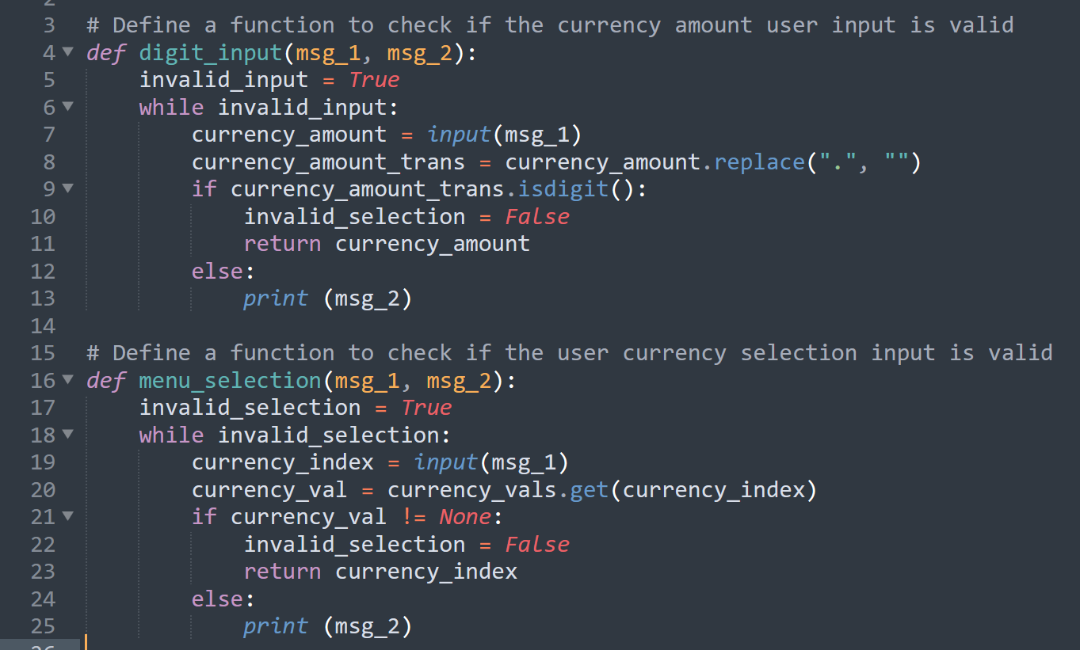

* Add an additional currency(“ChineseYuan”);
* Use dictionary to store the user input currency number(1~4) and its value;

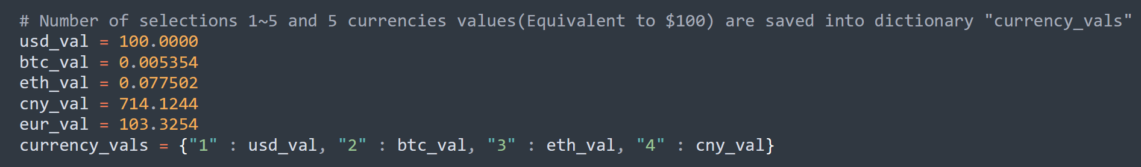

* Add color for the logo and text outline;

1. **Tests**

There are 4 currencies, so possible combination scenarios are 16 cases, all cases pass the tests, results are as follows.

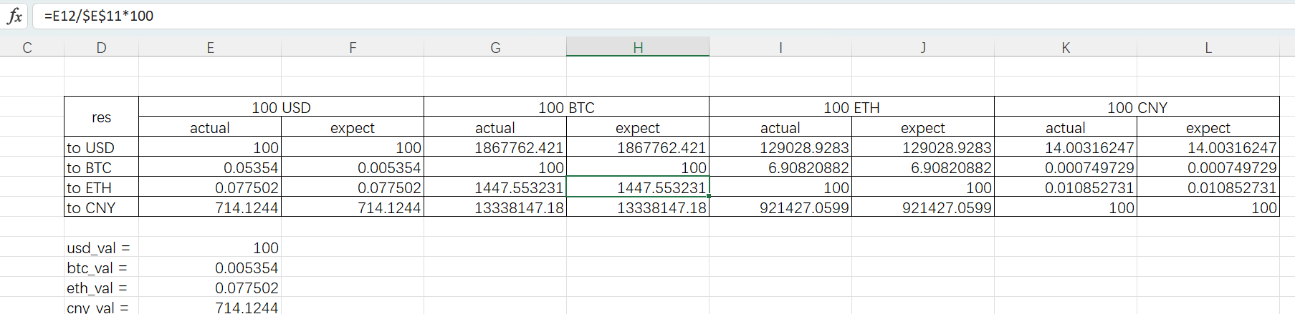

1. **Grading Statement**

The python program runs fine without significant error, also meets all the functional requirements in the rubric.

Besides extensions such as additional currency and colored logos, I also tried to optimize user input handling to improve robustness.

In this assignment, I self-learned knowledge of while loops, string methods such as isdigit(), replace(), boolean flags, functions, and dictionary, and applied them in my assignment.

For the above reasons, I think this work deserves a full mark.