Report 03

1. **Problem Description**Scene1: create different functions, use while loop and different functions to create complex scene, achieve random size and colors.

Scene2: use existing functions to create a totally different scene, write test functions to find errors.

1. **Screenshots**

**Scene1**

Scene1 is a Portland city view, which formed by multiple small houses, medium-height buildings and few high towers..

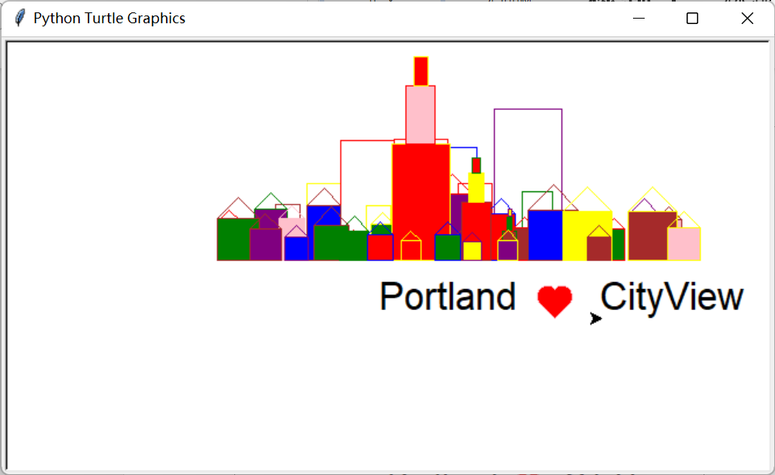

Portland City View

The interesting thing is that every time I run scene1(), I got a random picture with a random size of houses with random colors. Though these elements are random, the scene looks fine.

Though the scene has plenty of elements, each element is created by a function in while loops, and the code is concise.

**Scene2**

Scene2 is a Portland lighthouse, which formed by a light house, the light, three small houses, ground level and sea level.

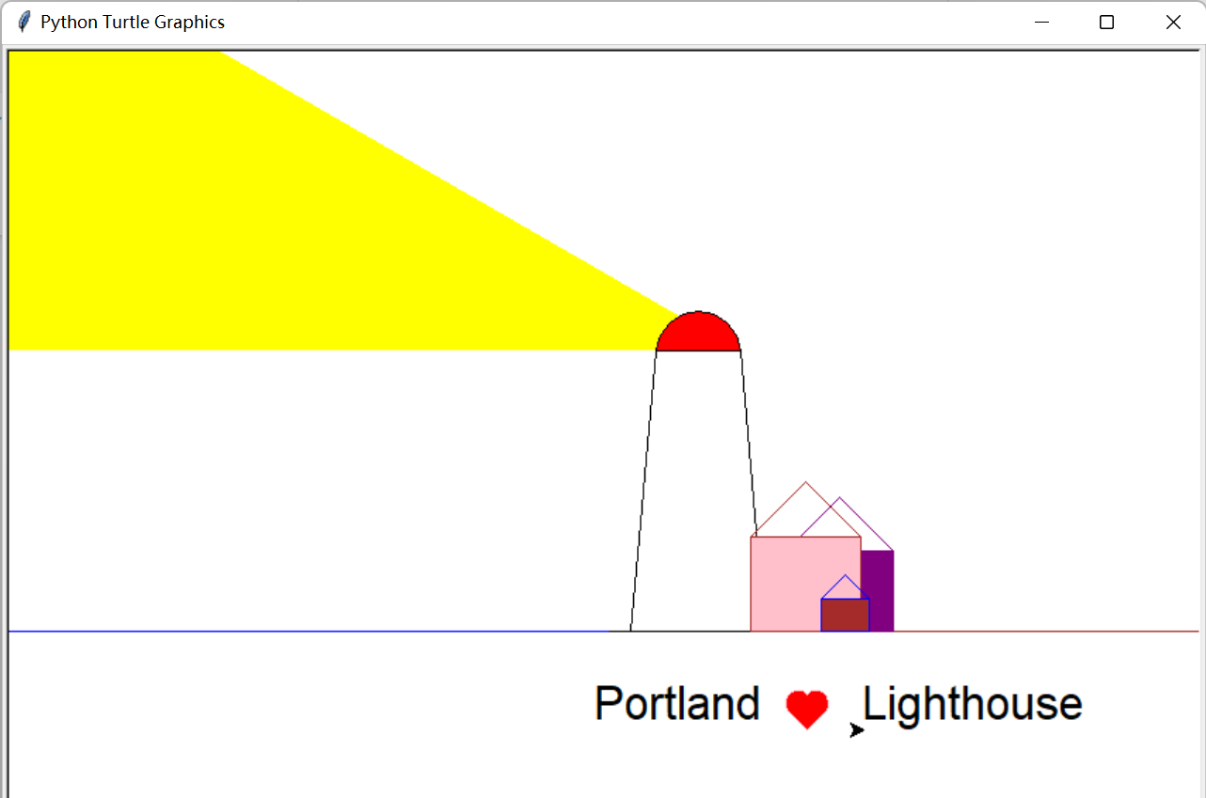

Portland Lighthouse

I found it interesting that I reused the some functions in scene1, but I eventually got a total different style picture.

1. **Extensions**

* Created some additional functions that draw different shapes, such as:

draw_house(height,width),

draw_building(height,width),

draw_skyline(height,width),

draw_lighthouse(),

add_text(text1 = "",text2 = "")

…

* Added additional parameters to functions, such as custom text input parameter, or Boolean parameter to control whether fill or not.

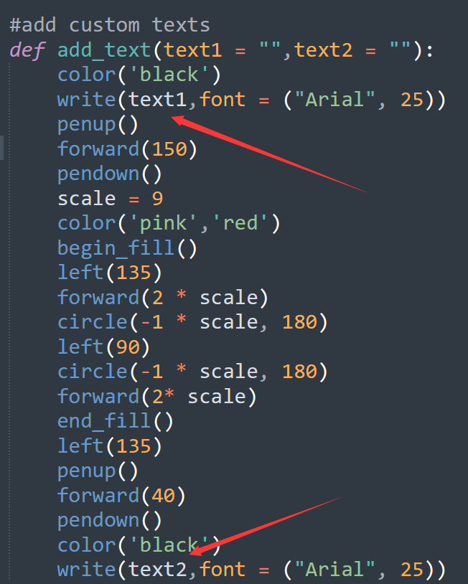 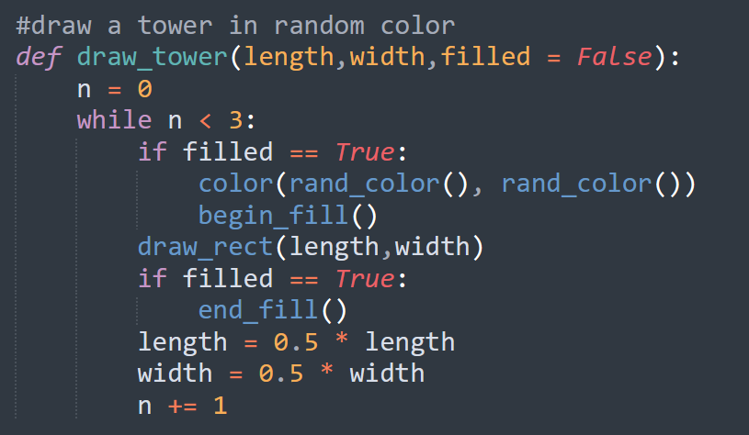

* Add some randomness in color or in the objects by a rand_color() function, as can be seen, every element of the drawing is in random color.

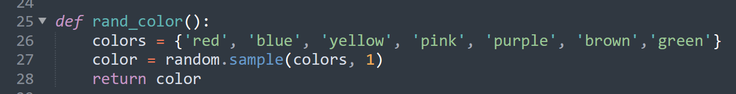

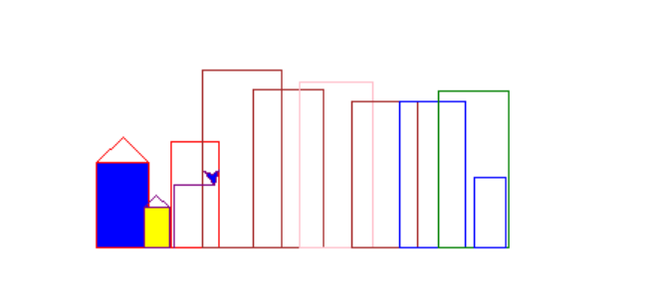

* Creative and Complex scenes above and beyond the basic expectations count as extensions, though the code is short, by while loops and functions, the scene looks complex.



1. **Reflection**

* I learned to use functions with parameters to achieve certain module, and avoid repetitive codes.
* I learned to create random number and random selection in a list, this could be used to create elements in random color and size.
* I learned to combiner while loops and functions to create complex scene.

1. **Acknowledgements**

To get more properties of python turtle, especially more interesting methods, I read the related chapter on the official python document.

Except above, I did not ask anybody for help in this assignment.

1. **Grading Statement**

The python program runs fine without significant error, also tested by test functions and meets all the functional requirements in the rubric.

Extensions such as additional functions, additional parameters, random colors and size or in the objects, complex scenes are implemented.

For the above reasons, I think this work deserves a full mark.