Report 04

1. **Reflections**

* How was this application designed with usability in mind?

The program is designed in three layers, user interface, fill library, and basic library.

**Basic library** includes the functions to draw basic element to form a pattern.

**Fill library** includes the functions to draw pattern in different quads, using methods in basic library.

For two patterns of blocks, nested while loops are used. First loop is to move to the new start point of the blocks, which should be limited in the quad. Second loop is to draw the block in a certain width, block is formed by lines in interval 0.1.

For patterns of wallpaper, it is similar as blocks, using nested while loops, one for draw circles in different horizonal coordinates and another is for different vertical coordinates.

For patterns of stairs, two separated while loops are used to draw vertical and horizonal lines.

**User interface** is to deal with user input, create CLI menu, parse input and use functions in fill library to draw corresponding pattern(s) in the frame

* What was the easiest and hardest part of this assignment?

Easiest part:

Easiest part is to create simple helper method, such as goto(), square (x, y, len), it is easy to finish a small goal rather than a big project, that is why we can start at the easy helper method, then use these helper methods to in a more complicated method, and use these methods to achieve the final goal of the project.

Hardest part:

Hardest part is to set the boundary conditions for each loop, need to be very clear about each step to make sure you are in the right coordinate and draw right pattern.

Also need to be very careful to deal with nested loops, they need to written in correct order.

* What did you learn?

In this assignment I learned:

Set boundary conditions and use nested while loops to draw a 2d pattern.

Give a clear structure to a project in different function layers(files).

Use simple helper methods, to form a more complicated method, and achieve the project goal.

While loop and Boolean to deal with wrong user input.

* What grade would you give yourself?

The python program includes all of the functions requested in recitation and the for functions of filling, runs fine without significant error, also tested by test functions and meets all the functional requirements in the rubric.

Extensions such as random colors, separated files(layers), additional text and user input checking are implemented.

For the above reasons, I think this work deserves a full mark.

1. **Extensions**

* Added random color for the patterns

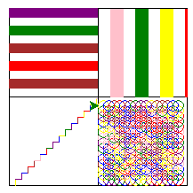

* Separate code into separate files for portability, these three files represent three different layers with no interference, clear structure and easy to maintain if needed, including:
  + patterns.py: user interface of the program, dealing with user input, need import fill_lib.py only.
  + fill_lib.py: library with 4 filling related functions such as wall_paper, zebra_stripes etc, and one function fill to draw multiple patterns based on the quad selections. Need import base_lib only.
  + base_lib.py: basic functions library, such as draw_frame, set_speed etc.

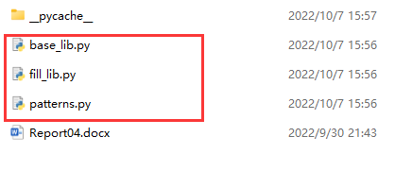

* Add another option for adding random colored loop word at the right side of the frame

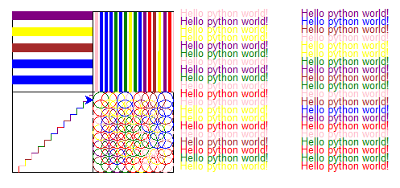

* Use while loop and Boolean running to handle invalid user input

