Report 09

1. **Reflections**

* **What was the easiest and hardest part of this assignment?**

Easiest part:

The creation of character class and weapon class, just follow the general routine to create a class, write constructor, set default values and give different methods for the class.

Hardest part:

To be very clear with the OOD concepts and their usage such as __init__, __str__, self.

Dealing with the complicated relationships in mulitiple objects.

The random magic , heal and critical effect, need to go though the logical order before write the code.

* **What did you learn?**

Some OOD concepts and their usage such as class, object, __init__, __str__, self.

How to create a class, create an object, and set parameter for the objects.

Practiced the skills to error handling in the user input part.

Use time and String library to create a type writer printing effect.

* **What grade would you give yourself?**

All 7 test cases has passed, and all basic requirements in rubrics are met. I also added 5 extension ideas such as error handling, fire magic, heal, critical attack, and type writing effect.

For these reasons, I will give myself a 30 to this lab.

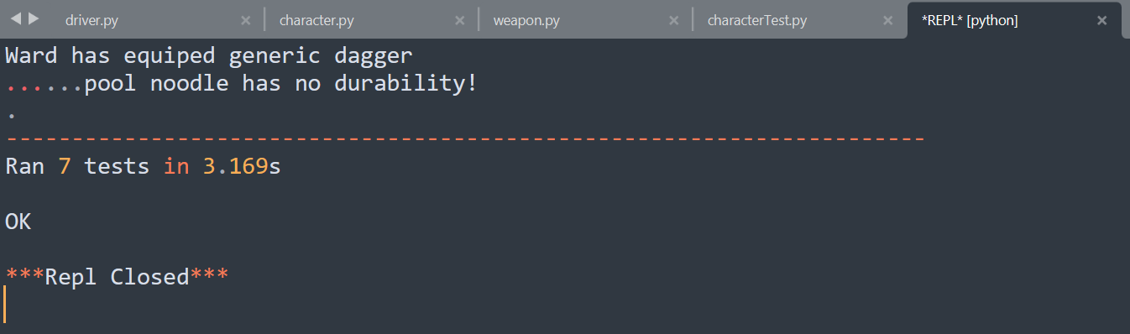

1. **Extensions**

* **Add logical exception handling in user input.**

An exception is added to limit the user input in the character and weapon selection to avoid crushing.

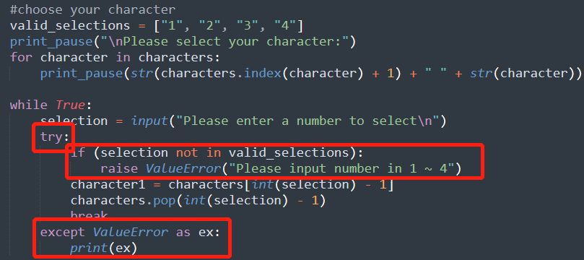

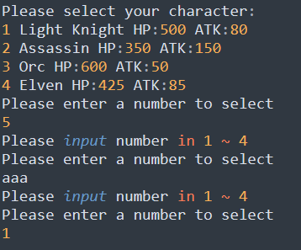

* **Add random effects with a weapon**

In Weapon class, I added a boolean variable “critial”, it is default to be False, but this variable is True for the weapon “Elven Dagger”.

If critical is True, when the character use this weapon attack opponent, there is a 50% chance to cause an extra damage, and user can get the information during battle.

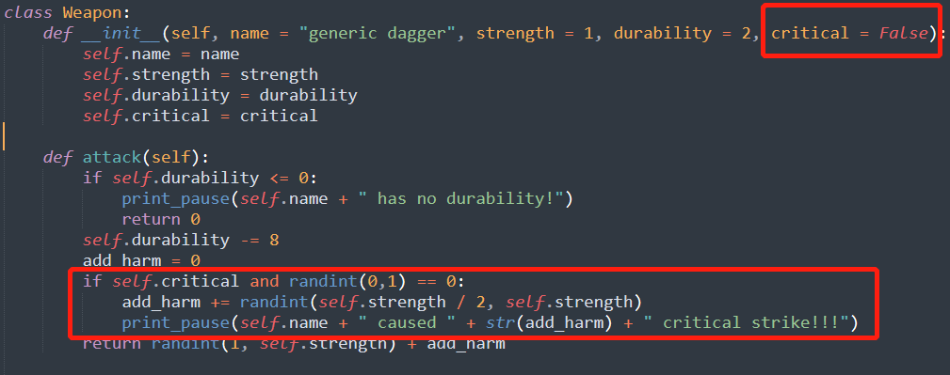

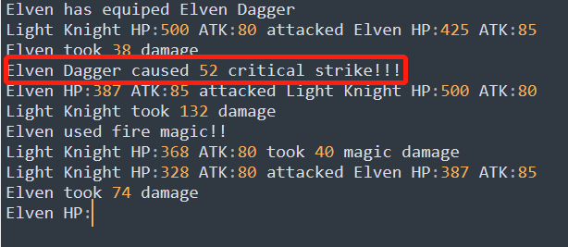

* **Add** **fire magic to a character**

In Character class, I added a boolean variable “magic”, it is default to be False, but this variable is True for the Character “Elvenr”.

If magic l is True, when the character attack opponent, there is a 50% chance to cause an extra fire magic attack, and user can get the information during battle.

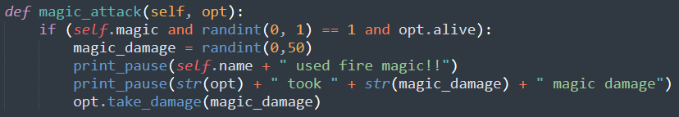

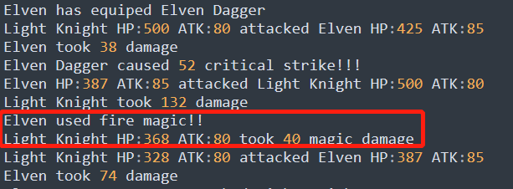

* **Add the ability for a character choose to heal instead of attack**

In Character class, I added a boolean variable “healing”, it is default to be False, but this variable is True for the Character “Light Knight”.

If healing is True, when the character hit point is lower than 40, the character will heal instead of attack, and user can get the information during battle.

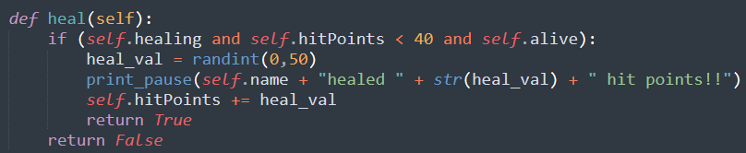

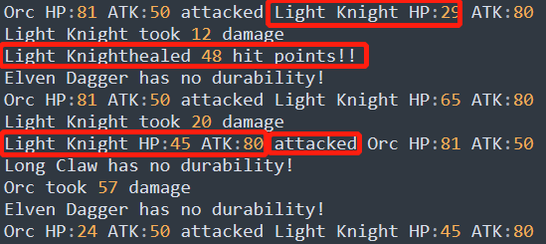

* **Add type writer effect in message**

A type writer effect is added in text printing to improve game experience, the text is printed character by character.

