**Submissible for Part 1 :** Take a screenshot showing you running a “Hello World” program from the command line to include in your report.

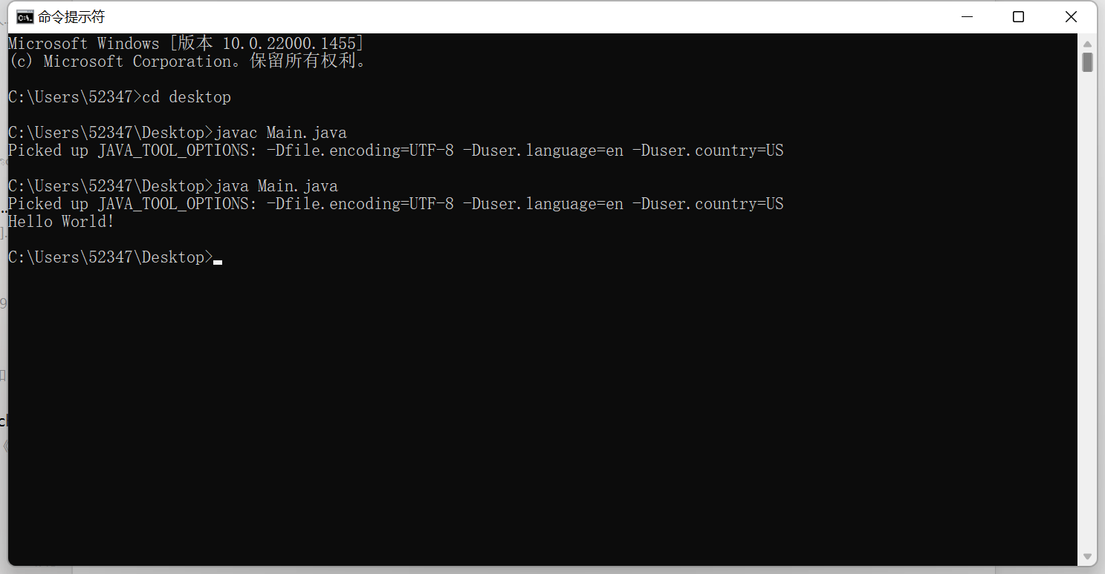

**Submissible for Part 2 :** Take a screenshot showing you running a “Hello World” program in two different cloud compilers to include in your report.

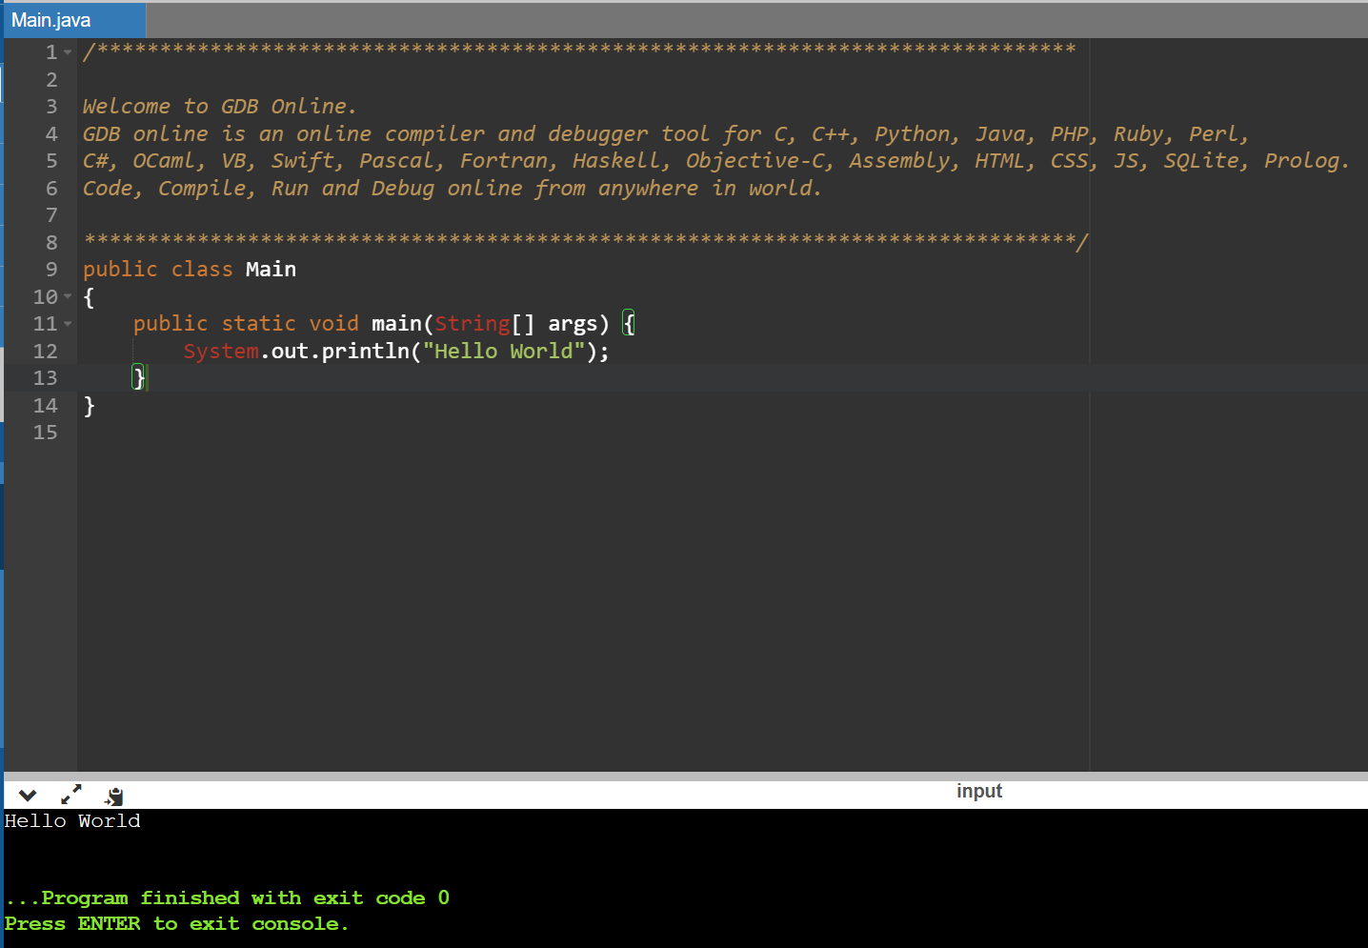

Online GDB

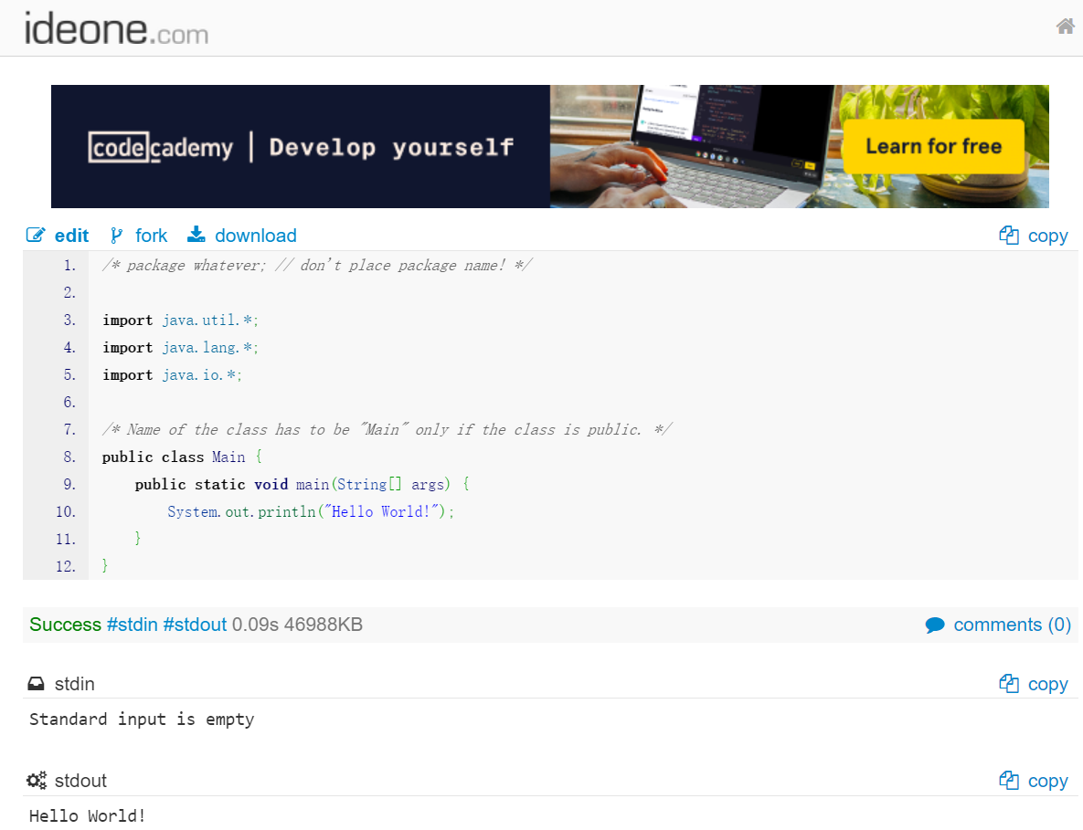

Ideone

**Submissible for Part 3 :** a screenshot showing you running a “Hello World” program in either Eclipse or IntelliJ

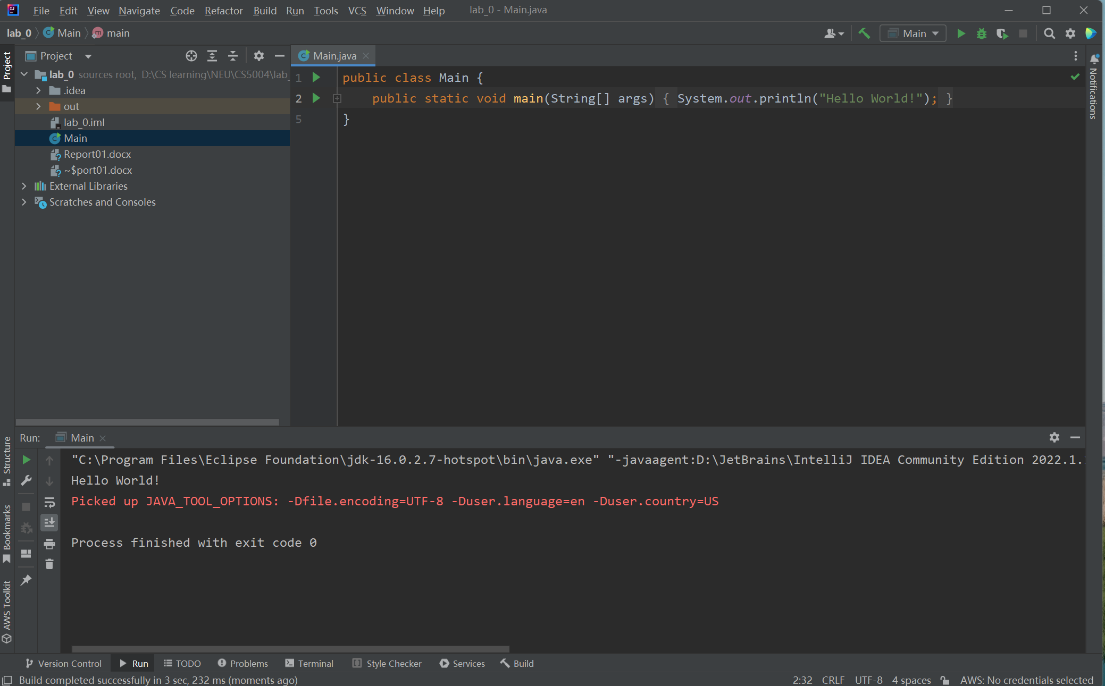

IntelliJ

**Submissible for Part 4 :** Provide those four sources as citations or links followed by why you think they would be a good resource.

Source1: Oracle Java Doc <https://docs.oracle.com/en/java/javase/18/docs/api/index.html>

The official doc offers a thorough collection of lessons and documentation that cover both the language's fundamentals and more complex subjects.

Source2: Head First Java

<https://www.oreilly.com/library/view/head-first-java/9781492091646/>

A beginner friendly textbook with a lot of pictures for understanding java concepts and usage.

Source3: UCB CS61B <https://sp21.datastructur.es/>

Though it is a data structure and algorithm course, it is good since it has a crash course in Java as well as data structure and algorithm with a lot of practical exercise. It would help me with understand the data structure and algorithm in Java language.

Source4: The Complete Java Development Bootcamp <https://www.udemy.com/course/the-complete-java-development-bootcamp/>

I was interested in the project of this online bootcamp Stock Trading Simulation, it might enhance my application of Java skills.