Report 0

1. **Reflection**In this assessment, I learned to establish the Java coding environment, IDE installation, as well as running Java programs by IDE, command line and online compiler.

I learned to create class, instance and write a driver in a Java project. In terms of test, I learned to write simple unit tests for the program and utilizing a few modules in junit.

1. **Required Task Elements**

**Part 5: Running an Existing Project and Running JUnit Tests**

**IntelliJ project screen shot**

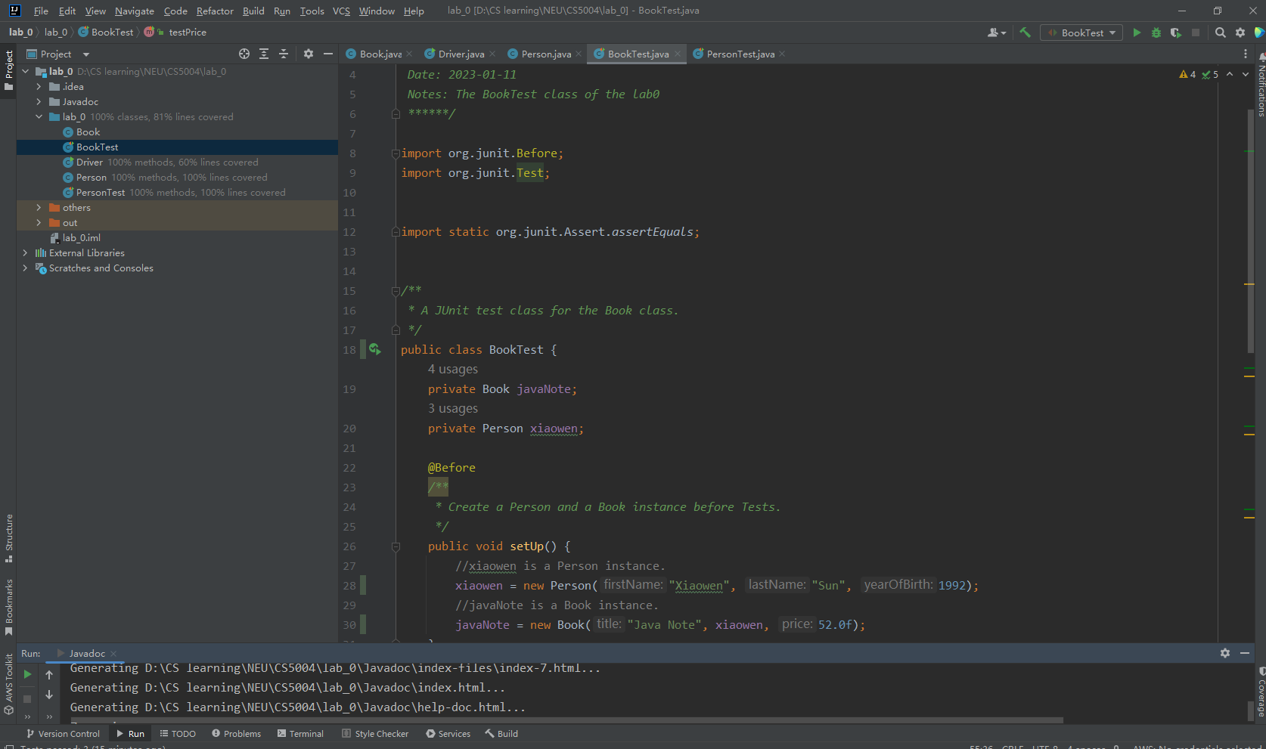

**Eclipse project screen shot**

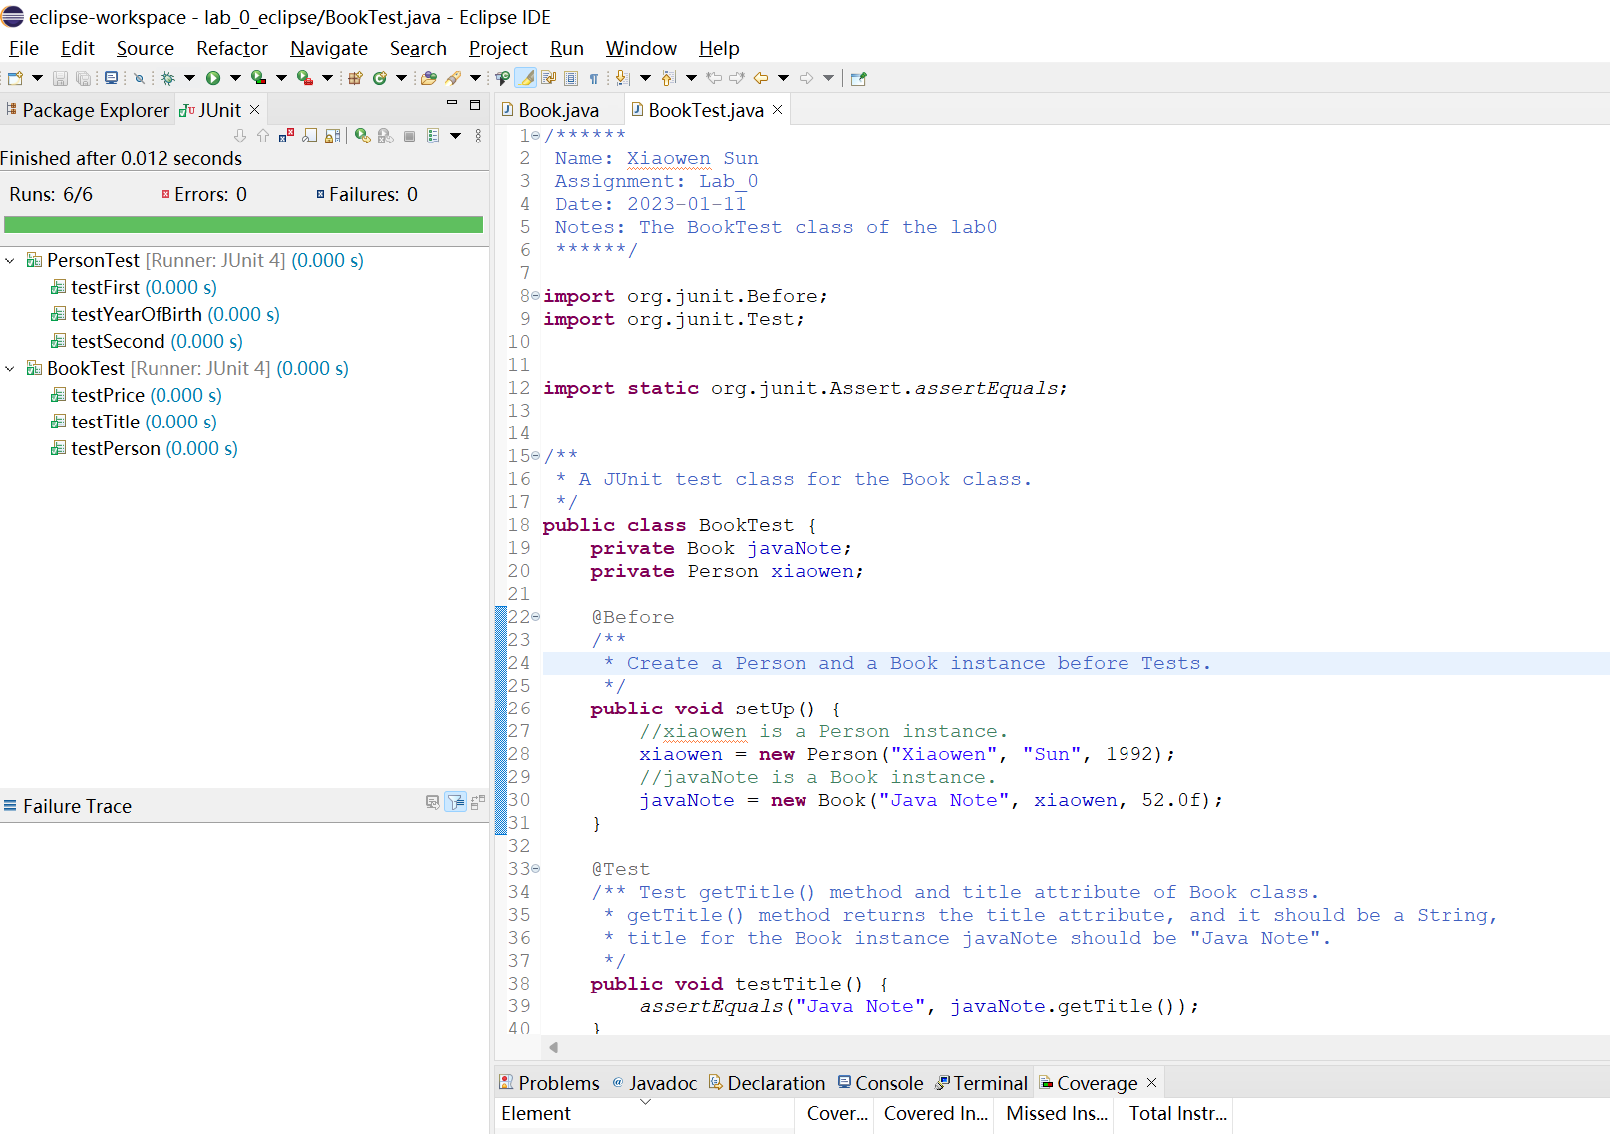

Test for person class, 3 passed

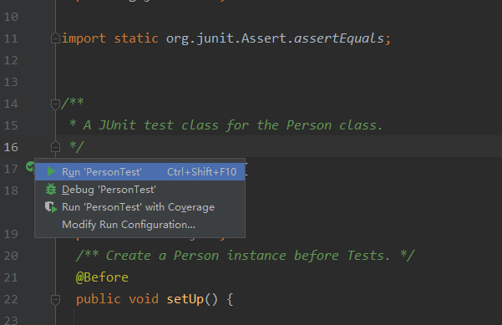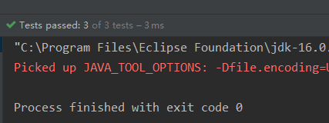

Test for book class, 3 passed

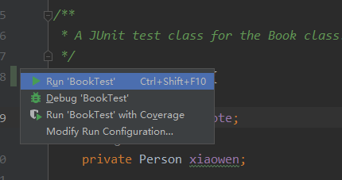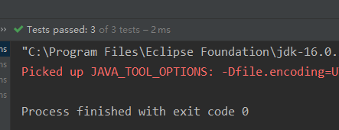

The coverage of booktest and persontest is 100%

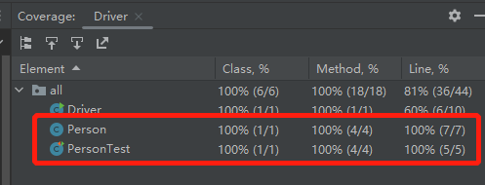

**Part 6: Documenting Your Code**

Top comment block

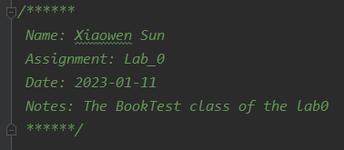

Class comment block

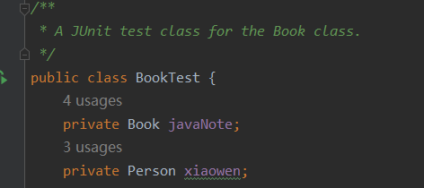

Function comment block and Java doc line

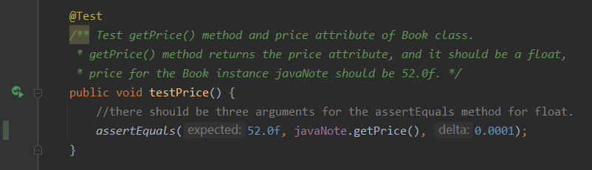

Generated Java Doc

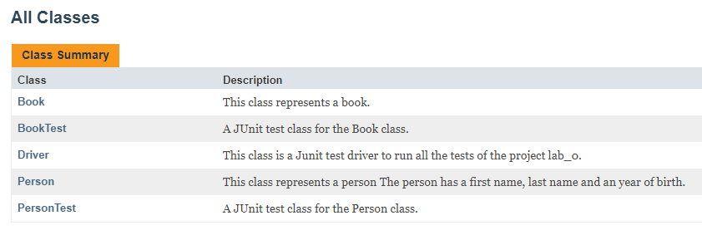 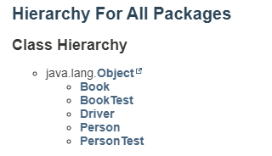

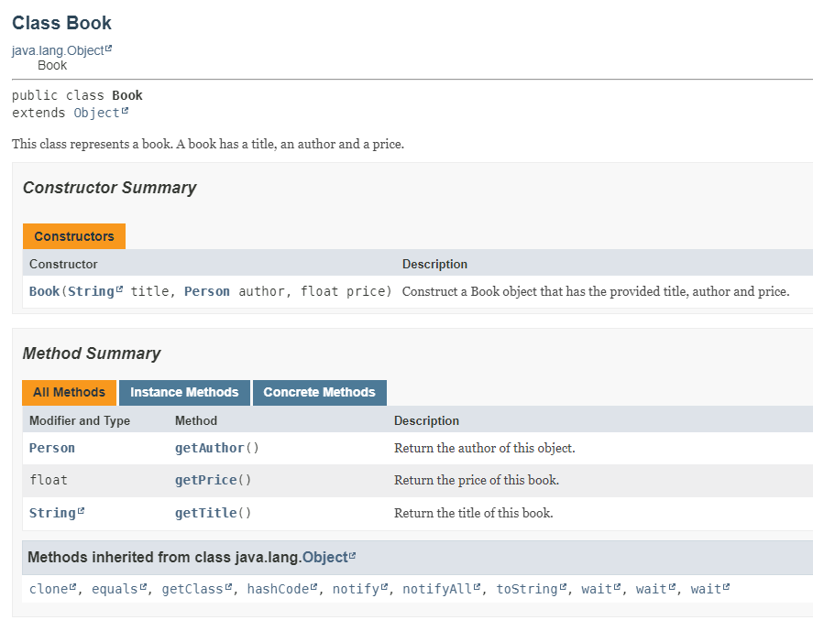 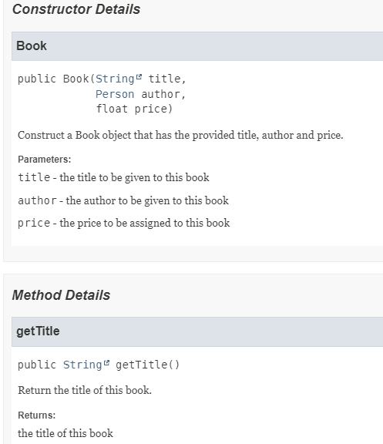

1. **Extensions**I tried several extensions as follows.

* Provide screenshots of both Eclipse and IntelliJ, see “2.Required Task Elements”
* Created a driver for this application.

I created a driver.java, with several modules in junit to run all the tests and print messages.

Driver code:

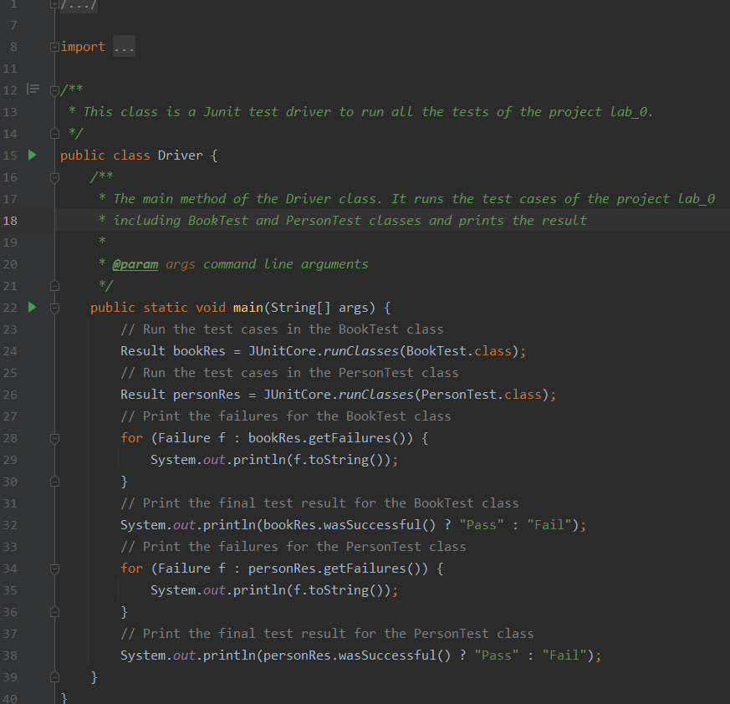

Driver output:

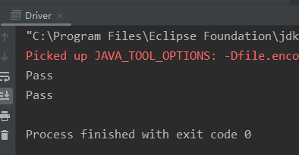

* Submitted code as a GitHub link instead

Github link:

**https://github.com/Shawnsuun/CS5004_PTL/tree/main/lab_0**

* High quality submission

**Grading Statement**

Part5: The coverage of two tests are both 100%.

Part6: I added Comment blocks correctly in each file, I also wrote java docs for each class ,method, and somewhere necessary in the code, then generated the html formatted javadocs.

Misc: Report is included and the code quality meets the requirement of the lab.

Extensions: I made extensions including:

using Eclipse and IntelliJ

created a driver

submit as a GitHub link

high quality submission

For the above reasons, I think this work deserves a full mark.

