Report 01

1. **Reflection**In this assessment, I learned to establish the Java coding environment, IDE installation, as well as running Java programs by IDE, command line and online compiler.

I learned to create class, instance and write a driver in a Java project. In terms of test, I learned to write simple unit tests for the program and utilizing a few modules in junit.

1. **Required Task Elements**

**Part 5: Running an Existing Project and Running JUnit Tests**

**IntelliJ project screen shot**

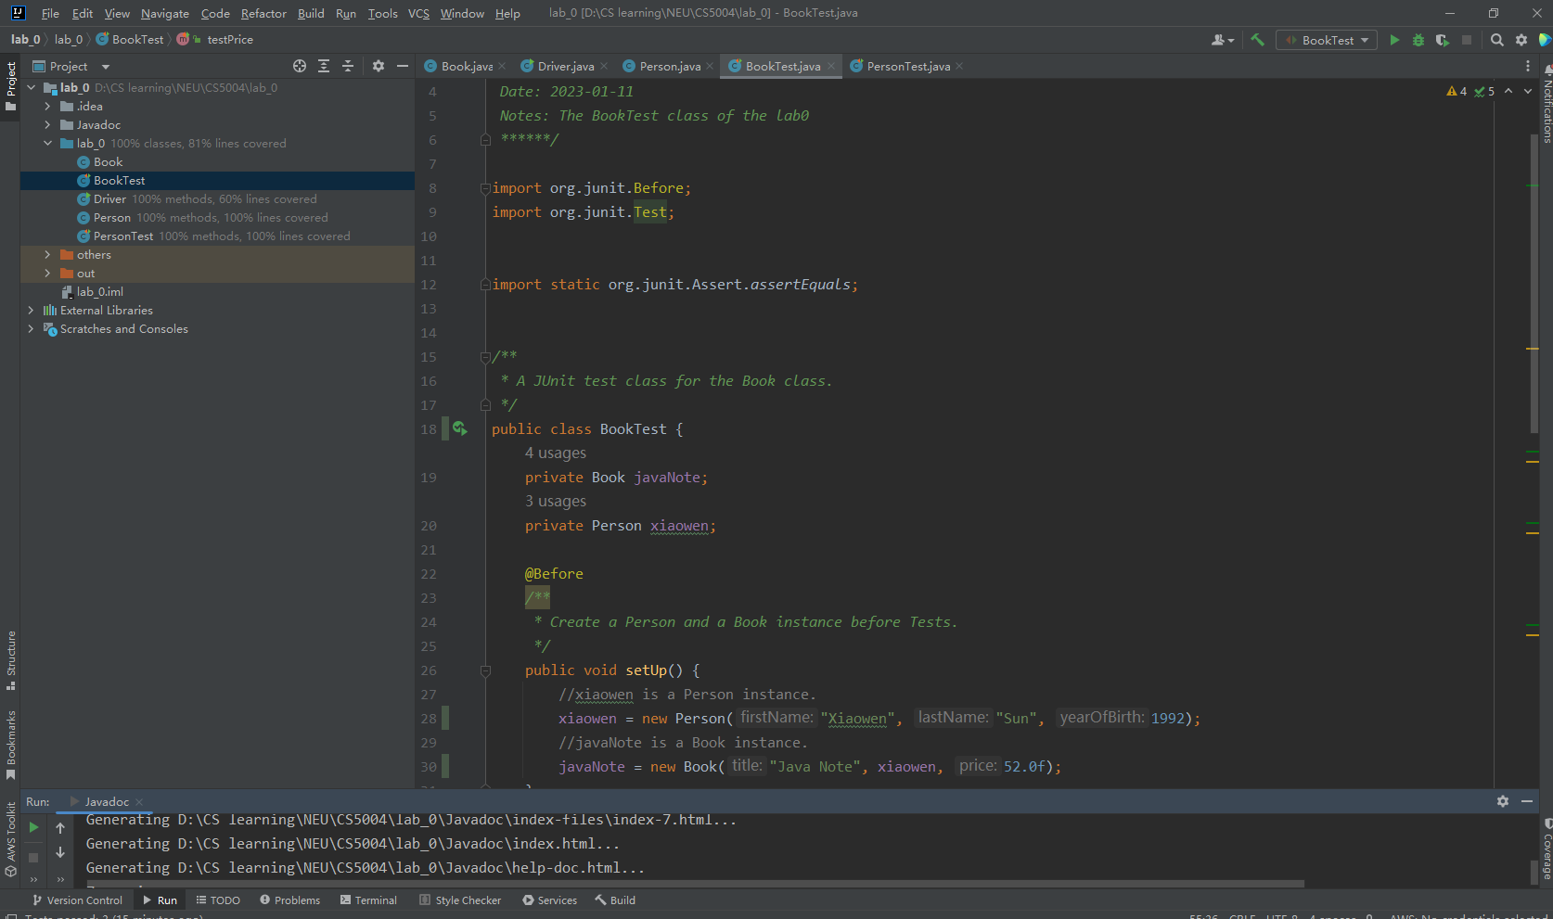

Test for person class, 3 passed

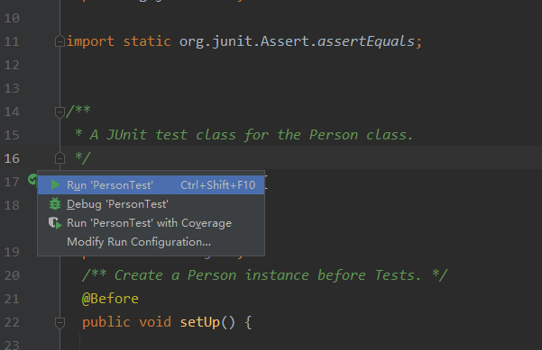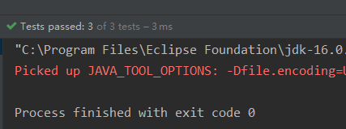

Test for book class, 3 passed

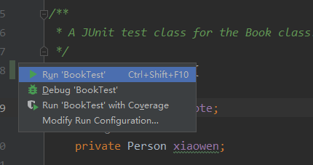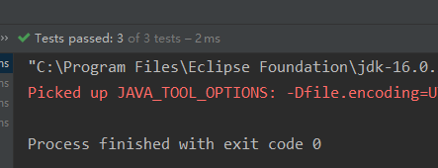

The coverage of booktest and persontest is 100%

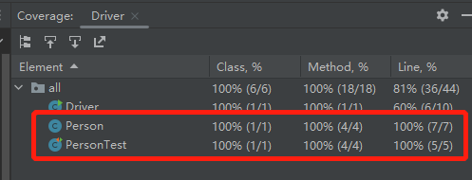

**Part 6: Documenting Your Code**

Top comment block

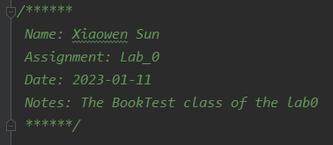

Class comment block

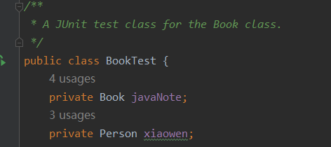

Function comment block

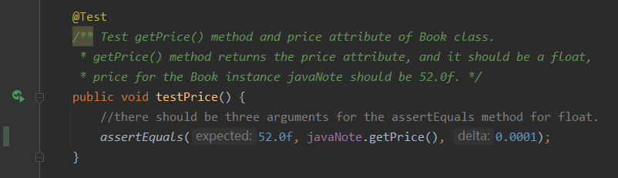

Generated Java Doc

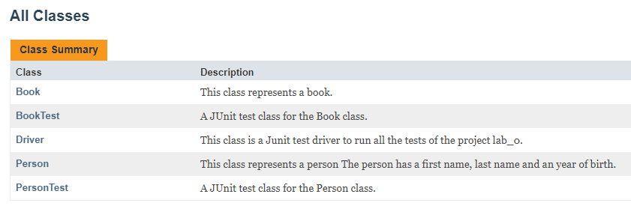 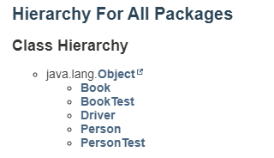

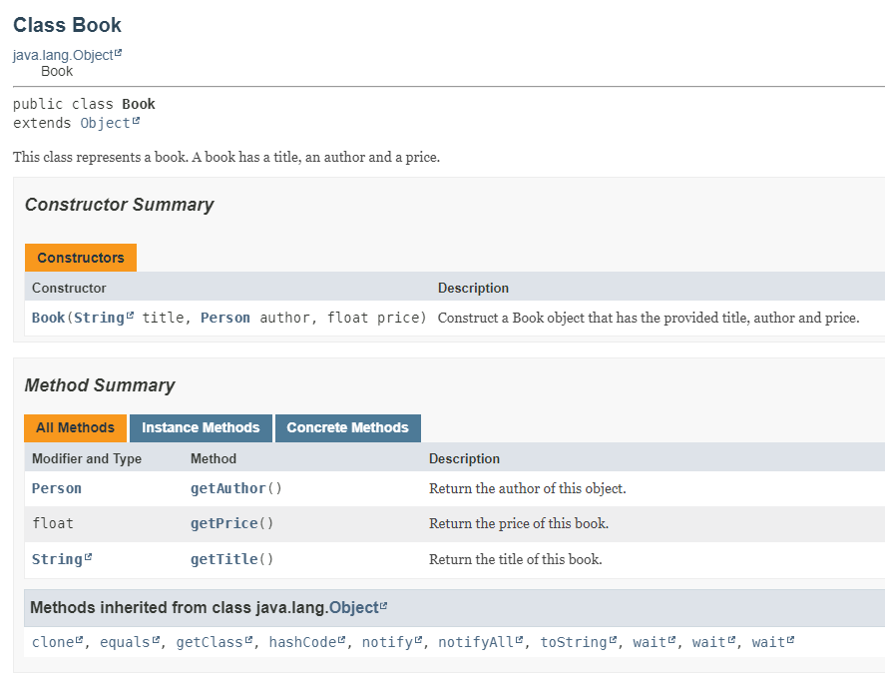 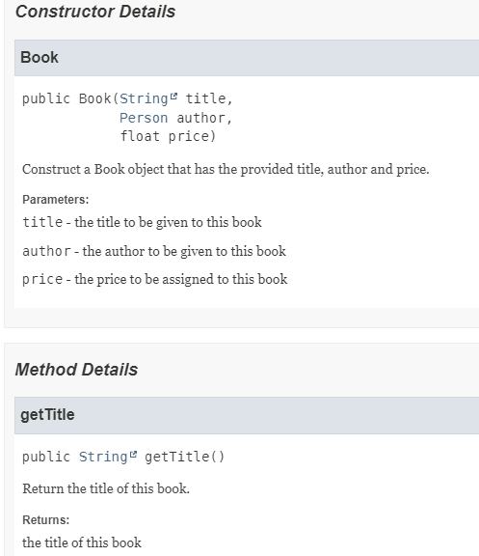

1. **Extensions**I tried different methods to give more interesting properties to my drawings, extensions are as follows.

* Provide screenshots of both Eclipse and IntelliJ
* High quality submission
* Created a driver for this application.
* Submitted code as a GitHub link instead

**Grading Statement**

Both two python files are functioning well without significant error, scaling is added in both python files, the report is also provided.

I tried to create a self-designed logo and a complicated rose pattern, and let my submission more creative, also I learned different advanced methods in turtle, which were not taught in class, and applied them in my assignment.

For the above reasons, I think this work deserves a full mark.

