**Group Member: Xiaowen Sun, Chenyi Xiang**

**Progress**

I have completed the constructor for point class(with 0 args and 2 args), wrote the methods in Point class such as getX, getY, setX, setY, and use the given test file to check the correctness of the methods

**The constructor for point class**

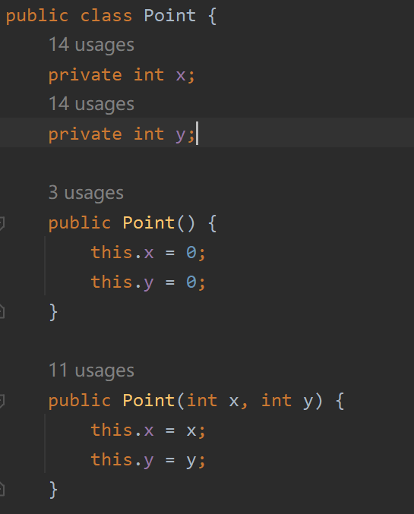

**The methods of Point class written in ICE**

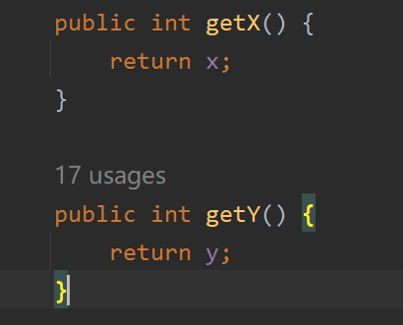

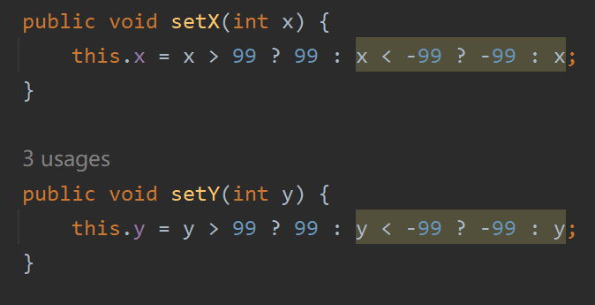

**The passed two ICE tests**

