Report 3

1. **Reflection**In this assessment, I learned and practiced a lot of object-oriented programming concepts such as inheritance, interfaces, abstract class, polymorphism, SOLID Principles of OOD, prototyping, also some knowledge on switch statements, unittests, UML diagram.
2. **How did this design incorporate future growth?**

This is my first system design project start from scratch, guided by SOLID Principles, from UML design, write a lot of tests and comments, create global class, abstract class, interface, and inherence and implements from them and build a whole system. I think this might be very similar as the real-world project in the workplace. I would definitly benefit from the habits formed by this project in the future groth, such as make a clear structure, design UML before coding, test driven and give lots of comments to increase readability.

1. **Did you change up the driver at all? If so, how?**

I did not change the original driver since it works fine with my code.

1. **Extensions**

* **Create a JUnit test file for at least some of your classes**

I have created 3 additional unittest classes, including HousefactoryTest, HouseblockTest, ResourceTest classes.

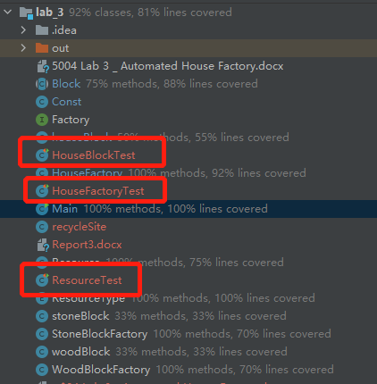

* **Add useful comments to the provided driver**

I have added detailed comments on the provided driver

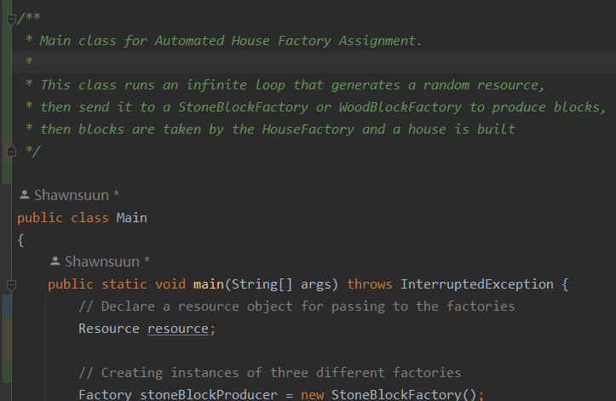

* **Find a way to exercise the break block function**

I have created a recycleSite class to use the break block function in the recycle function

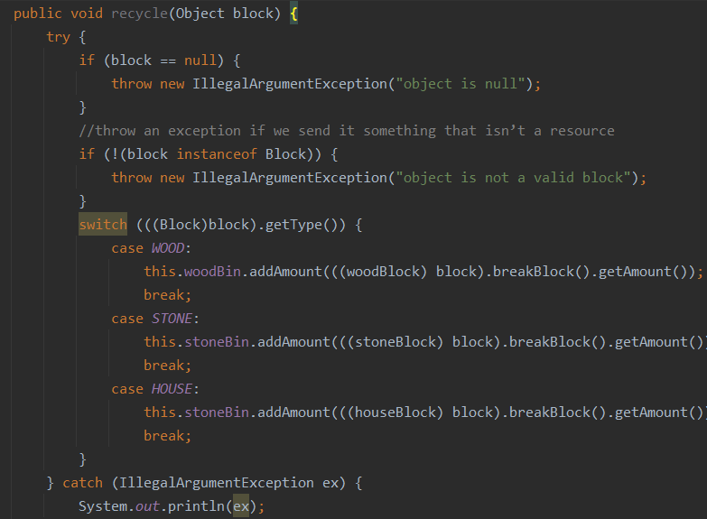

* **Add more than the requested exception handling**

Several exception handling are added such as the above recycle function in recycleSite class.

1. **recitation UML diagram**

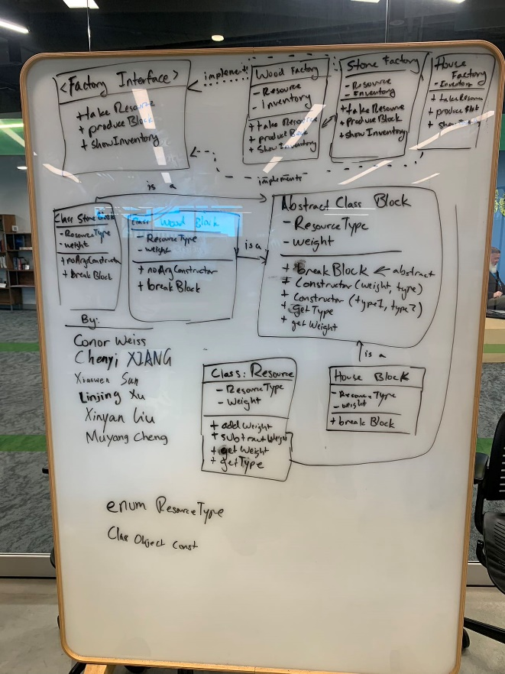

1. **Grading Statement**

The project fulfills all basic functions required by the lab instructions, there is 89 points on it.

Extensions: 4 extensions are implemented for 10 points.

I wrote a lot of tests and comments and this might add points in the Creative or went above and beyond part.

For the above reasons, I think this work should be graded as 99 or above.