CS 1632 - DELIVERABLE 2

UNIT TESTING AND CODE COVERAGE

Github Repo:

<https://github.com/Shawnxkwang/CoffeeMaker>

Group Members:

Xiaokai Wang

Jason Greenlaw

**Unit Test Screen Shots:**

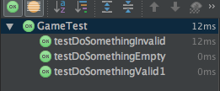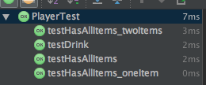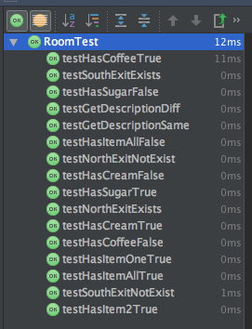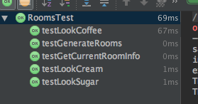

**Code Coverage:**

**/Users/xiaokaiwang/Desktop/Screen Shot 2016-02-16 at 3.58.31 PM.png**

**/Users/xiaokaiwang/Desktop/Screen Shot 2016-02-16 at 3.58.54 PM.png**

