# Title

Personalized Reliability Prediction of Web Services

# Citation

ZIBIN ZHENG, MICHAEL R. LYU

# Abstract

Author proposes two personalized reliability prediction approaches of Web services, that is, neighborhood-based approach and model-based approach. The neighborhood-based approach employs past failure data of similar neighbors (either service users or Web services) to predict the Web service reliability. The model-based approach fits a factor model based on the available Web service failure data and use this factor model to make further reliability prediction.

# Issues

Without sufficient past failure data, without internal information of Web services, influenced by the unpredictable Internet connections, How to design more efficient and more effective reliability prediction approaches of Web services?

# Approach

## Neighborhood-Based Reliability Prediction

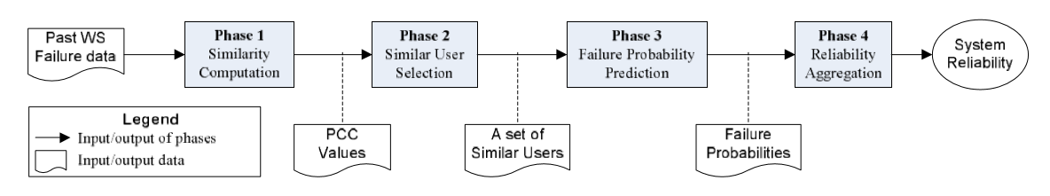

Fig. 2. Procedures of neighborhood-based reliability prediction.

Procedures of neighborhood-based reliability prediction is shown in Figure 2.

First, Author defines the performance of a Web service as its average failure probability (pi), as below:

$\overline{p_{i}}=\frac{1}{m}\sum_{a=1}^{m}{p_{a,i}}$, (1)

where $p_{a,i}$ is failure probability of Web service candidate $i$ observed by the service user $a$, $m$ is the number of service users, and $\overline{p_{i}}$ is the average failure probability of the Web service candidate $i$.

### Phase 1: Similarity Computation

Author uses Pearson Correlation Coefficient (PCC) to compute the similarity between service user u and service user a based on their commonly invoked Web services, as follow:

$Sim\left(a,u\right)=\frac{\sum_{i∈I_{a}∩I_{u}}{(p_{a,i}-\overline{p_{a}})(p_{u,i}-\overline{p_{u}})}}{\sqrt{\sum_{i∈I_{a}∩I_{u}}{{(p_{a,i}-\overline{p_{a}})}^{2}}}\sqrt{\sum_{i∈I_{a}∩I_{u}}{{(p_{u,i}-\overline{p_{u}})}^{2}}}}$, (2)

where $I_{u}∩I_{a}$ is a set of commonly invoked Web services by both user $u$ and user $a$, $p_{u,i}$ is the failure probability of Web service $i$ observed by the service user $u$, and $\overline{p_{u}}$ represents the average failure probability of all the Web services invoked by user u.

Similar to this procedure, PCC can also be employed to calculate the similarity between Web service $i$ and Web service $j$ by using:

$Sim\left(i,j\right)=\frac{\sum_{u∈U_{i}∩U_{j}}{(p_{u,i}-\overline{p_{i}})(p_{u,j}-\overline{p_{j}})}}{\sqrt{\sum_{u∈U_{i}∩U_{j}}{{(p_{u,i}-\overline{p_{i}})}^{2}}}\sqrt{\sum_{u∈U_{i}∩U_{j}}{{(p_{u,j}-\overline{p_{j}})}^{2}}}}$, (3)

where $U_{i}∩U_{j}$ is a set of service users who invoke both the Web services $i$ and $j$, and $\overline{p_{i}}$ is the average failure probability of Web service $i$, which can be calculated by Eq. (1)

Author employ a logistic function to reduce the influence of a small number of similar yet co-invoked Web services. An enhanced PCC for the similarity computation between two service users is defined as:

${Sim}^{'}\left(u,a\right)=\frac{1}{1+e^{-\left|I_{u}∩I_{a}\right|}}Sim(u,a)$, (4)

where $Sim'(u,a)$ is the new similarity value, $|I_{u}∩I_{a}|$ is the number of Web services that are invoked by both user $u$ and user $a$.

Just like the user-based methods, an enhanced PCC for the similarity computation between different Web services is defined as:

${Sim}^{'}\left(i,j\right)=\frac{1}{1+e^{-\left|U_{i}∩U_{j}\right|}}Sim(i,j)$, (5)

where $|U_{i}∩U_{j}|$ is the number of service users who invoked both Web service $i$ and item $j$ previously.

### Phase 2: Similar User Selection

Using a parameter Top-K and excluding the service users who have negative correlation, a set of similar service users $S(u)$ can be identified as:

$S\left(u\right)=\{a|Sim'\left(u,a\right)≥{Sim}_{k}^{'},Sim'\left(u,a\right)>0,a≠u)$, (6)

Where ${Sim}_{k}^{'}$ is the $k$ th largest PCC value with the current user $u$.

Similar to the above procedure, a set of similar Web services $S(i)$ with the current Web service $i$ can also be identified as:

$S\left(i\right)=\{j|Sim'\left(i,j\right)≥{Sim}_{k}^{'},Sim'\left(i,j\right)>0,i≠j)$, (7)

where ${Sim}_{k}^{'}$ is the $k$ th largest PCC value with the current Web service $i$.

### Phase 3: Failure Probability Prediction

Employing the similar users, the user-based approaches (named as UPCC) predict the missing value $p_{u,i}^{'}$ by the following equation:

$p_{u,i}^{'}=\overline{p_{u}}+\sum_{a∈S(u)}{w_{a}×(p_{a,i}-\overline{p_{a}})}$, (8)

where $\overline{p_{u}}$ and $\overline{p_{a}}$ are average failure probabilities of different Web services observed by user $u$ and $a$, respectively, and $w_{a}$ is the significant weight of the similar user $a$, to increase the influence of users with higher similarity values, which is defined as:

$w_{a}=\frac{{Sim'(a,u)}^{2}}{\sum_{b∈S(u)}{{Sim'(b,u)}^{2}}}$, (10)

Similar to the user-based approach, item-based approaches (named as IPCC) predict the missing value $p_{u,i}^{''}$ by:

$p_{u,i}^{''}=\overline{p_{i}}+\sum_{k∈S(i)}{w_{k}×(p_{u,k}-\overline{p_{k}})}$, (11)

where $\overline{p_{i}}$ and $\overline{p_{k}}$ are average failure probabilities of Web services $i$ and $k$ observed by different service users, respectively, and $w_{k}$ is the weight of the similar Web service $k$ with respect to Web service $i$, which is defined as:

$w_{k}=\frac{{Sim'(i,k)}^{2}}{\sum_{j∈S(i)}{{Sim'(i,j)}^{2}}}$, (12)

Author combines the prediction results by the user-based approach in Eq. (8) and the item-based approach in Eq. (11) to fully utilize the information of both similar users and similar Web services, as follow:

$p_{u,k}=\left\{\begin{aligned}λ×p_{u,i}^{'}+(1-λ)×p_{u,i}^{''}, &S(u)≠∅∧S(i)≠∅ \\ p_{u,i}^{'}, &S(u)≠∅∧S(i)=∅ \\ p_{u,i}^{''}, &S\left(u\right)=∅∧S\left(i\right)≠∅ \\ NoPrediction, &S\left(u\right)=∅∧S\left(i\right)=∅\end{aligned}\right.$, (14)

where $p_{u,i}^{'}$ is the Equation (8), $p_{u,i}^{''}$ is the Equation (11), and $λ$ $(0≤λ≤1)$ is a user-defined parameter for determining how much the missing value prediction relies on the similar users or the similar Web services.

### Phase 4: Reliability Prediction

To predict the Web service reliability, we adopt the commonly used exponential reliability function:

$R\left(t\right)=e^{-p×f×t}$, (16)

where $p$ is the failure probability of the Web service, $f$ is the invocation frequency of the Web service and $t$ is the time period for which the reliability is to be calculated.

## Model-Based Reliability Prediction

Author presents a model-based approach for predicting the missing failure probability values in the user-item matrix. This model-based approach is designed as a two-phase process. In Phase 1, the missing value problem is modeled as an optimization problem; and in Phase 2, an algorithm is proposed for solving the problem.

### Matrix Factorization

Considering an $m×n$ user-item matrix $P$, an $l$-factor model is attempted to find two matrices $W$ ( $m$ rows and $l$ columns) and $H$ ( $l$ rows and $n$ columns), such that:

$P≈WH$, (17)

where $l$ is the number of factors. Physical meanings of this matrix factorization: Each column of $H$ is a factor vector including the values of the $l$ factors for a Web service, while each row of $W$ is the user-specific coefficients for a user.

The matrices $W$ and $H$ are generally nonunique and we need to identify the optimal ones by minimizing the distance between $WH$ and $P$.

Employing the sum-squared errer and adding the constraints of the norms of $W$ and $H$ to penalize large values of $W$ and $H$, author gets the following optimization problem:

$\min{L(W,H)}=\frac{1}{2}\sum_{i=1}^{m}{\sum_{j=1}^{n}{I_{ij}^{P}{(p_{ij}-W_{i}H_{j})}^{2}+\frac{γ}{2}{\left\|W\right\|}_{F}^{2}+\frac{γ}{2}{\left\|H\right\|}_{F}^{2}}}$, (19)

where $I_{ij}^{P}$ is the indicator function that is equal to 1 if the value $p_{ij}$ is available in the user-item matrix (indicating that Web service $j$ has been invoked by user $i$ previously) and equal to 0 otherwise, $W_{i}$ is the $i$ th row of matrix $W$ (representing the user-specific coefficients of user $i$), $H_{j}$ is the $j$ th column of matrix $H$ (representing the factor vector of Web service $j$), $γ$ controls the extent of regularization for penalizing large values in the matrices $W$ and $H$ to avoid the overfitting problem, and ${||∙||}_{F}^{2}$ denotes the Frobenius norm, which is defined as the square root of the sum of the absolute squares of values in a matrix. ${||W||}_{F}^{2}$ ( $m$ rows and $l$ columns) can be calculated by:

${\left\|W\right\|}_{F}^{2}=\sqrt{\sum_{i=1}^{m}{\sum_{j=1}^{n}{{\left|w_{ij}\right|}^{2}}}}$.

### Gradient Descent

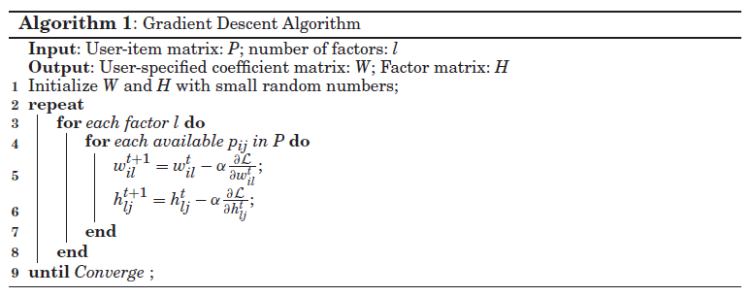

Author employs the Gradient descent to minimizing the function in Eq. (19). The gradient descent algorithm loops through all available values in the user-item matrix and train the l factors one by one. One gradient step intends to decrease the square of prediction error of only one value.

The gradients can be computed by:

$\frac{dL}{dw_{il}}=γw_{il}-\sum_{j=1}^{n}{I_{ij}^{P}(p_{ij}-W_{i}H_{j})h_{lj}}$, (20)

$\frac{dL}{dh_{lj}}=γh_{lj}-\sum_{i=1}^{m}{I_{ij}^{P}(p_{ij}-W_{i}H_{j})w_{il}}$, (21)

where $w_{il}$ is the $l$ th coefficient of user $i$ in the matrix $W$, $h_{lj}$ is the $l$ th factor of Web service $j$ in the matrix $H$, $W_{i}$ is the $i$ th row of the matrix $W$, $H_{j}$ is the $j$ th column of the matrix $H$, and the prediction error is computed by $p_{ij}-W_{i}H_{j}$.

Algorithm 1 shows the iterative process of the gradient descent algorithm for solving the optimization problem in Eq. (19). $w_{il}^{t}$ means the value of $w_{il}$ in the $t$ th iteration. The parameter $α$ is named learning rate, which controls the speed of iteration.

# Conclusion

Author proposes two personalized reliability prediction approaches of Web services, that is, neighborhood-based approach and model-based approach. The neighborhood-based approach employs past failure data of similar neighbors (either service users or Web services) to predict the Web service reliability. The model-based approach fits a factor model based on the available Web service failure data and use this factor model to make further reliability prediction.

The comprehensive experimental analysis shows the effectiveness of these reliability prediction approaches.

# My Idea

1. In the model-based approach, Gradient Descent may cause easily the local optimal solution. One of methods is to use the modern optimization algorithms (like PSO, GA) and so on.
2. Maybe we could make some parameter self-adaptive, like $λ$ in neighborhood-based approach. Just according to the experiment result, maybe there is some relation between $λ$ and density of matrix.
3. We could consider the updates of services into the approach. For example, we could weight the time, which leads to that newer the data is, greater the weight is.