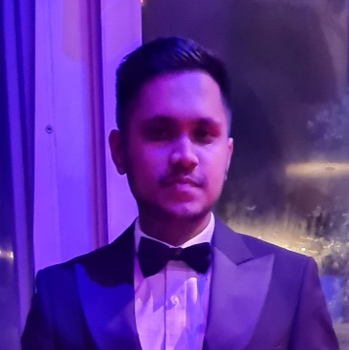

***MD SAMSUDDUHA***

***SHAWON***

**Head Waiter,** 01/12/2021 – Present

Shampan at The Spinning Wheel,

Westerham, Kent. TN16 2HX

* Taking Care of Customers Satisfaction
* Promoting Menu Items
* Assigning Tasks
* Training Juniors
* Solving Customer Complaints

***CONTACT INFORMATION***

***PROFESSIONAL SUMMARY***

Punctual to my work, passionate to programming and a very quick learner. I like learning new things every day. Very supportive to my teams and be there to help and fulfil their needs. The great thing about me is I never quit, won’t stop until the final result. Always focused on my work and give the best of me to my job.

***EDUCATION***

* ***University of East London***

BSc (Hons) Computer Science

Year: 2021 - Present

* ***Python***
* ***Java***
* ***JavaScript***
* ***HTML***
* ***CSS***
* ***Responsive Web Design***
* ***React + Redux***
* ***SQL***
* ***Presentation Skills***

***Work History***

***+44 7888 370 889***

***Shawon1024@Gmail.Com***

***79 Lower Sloane Street***

***London, SW1W 8DA***

***www.ShawOnline.Me***

***SKILLS***