: Airline Reservation :

:Group member:

:Name: :ID:

1 .Akand ,Moniruzzaman 14-28134-3

2 .Afroz, Sadia 16-32471-2

3.Fahmida ,Maisha 16-32192-2

Summary :

1)Passenger:has a unique passenger id and a unique contact.

2)A passenger makes multiple transection.

3)Each transection has a unique charges,unique discounts,uniquen flight,unique passengers,unique employees and unique transection id.

4)Exactly one transection can have at least one charges.

5)Exactly one transection can have at least one discounts.

6)Exactly one transection creates for at least one employee.

7)Exactly one employee has a unique employee id and a branch.

8)Employee has a at least one branch.

9)Branch has a unique branch-id and a unique state.

10)Exactly one transection for at least one flight –schedule.A flight schedule has a unique flight-id and unique aircraft.

11)Exactly one flight-schedule is for at least one air-crafts.Air-crafts have a unique air-crafts id.

12)Exactly one flight schedule has at least one air-fare.Air-fare has a unique r has a

route and a unique air-fare id.

13)At least one air-fare is for one router.Router has a unique router id and routecode.

14)At least one passenger have at least one contact-details.Contact-details has a unique contact id

And unique state.

15)Exactly one contact-details have at least one states.states have unique state-id and unique country.

16)Exactly one states have at least one country.country has a country name and a unique country-id.

## ***Entity list:***

1. AirCrafts
2. Route
3. AirFare
4. Flight_Schedule
5. Discounts
6. Charges
7. Countries
8. State
9. Contact_Details
10. Passengers
11. Branches
12. Employee
13. Transactions

ER Diagram:

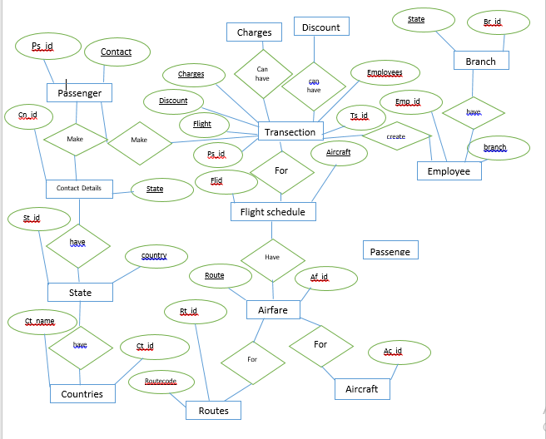

Primary key and foreign key:

|  |  |  |  |  |
| --- | --- | --- | --- | --- |
| **SN** | **Table** | **Primary Key** | **Foreign Keys** | |
| **Column** | **References** |
| 1 | AirCraft | AcID | - | - |
| 2 | Flight_Schedule | FlID | AirCraft | AirCraft.AcID |
| Route | Route.RtID |
| AirFare | AirFare.AfID |
| 3 | Route | RtID | - | - |
| 4 | AirFare | AfID | Route | Route.RtID |
| 5 | Discounts | DiID | - | - |
| 6 | Charges | ChID | - | - |
| 7 | Passengers | PsID | Contacts | Contact_Details.CnID |
| 8 | Contact_Details | CnID | State | State.StID |
| 9 | State | StID | Country | Country.CtID |
| 10 | Country | CtID | - | - |
| 11 | Transaction | TsID | Passenger | Passengers.PsID |
| Flight | Flight_Schedule.FlID |
| Employee | Employee.EmpID |
| Charge | Charges.ChID |
| Discount | Discounts.DiID |
| 12 | Employee | EmpID | Branch | Branch.BrID |
| 13 | Branch | BrID |  |  |

Cardinality:

|  |  |
| --- | --- |
| Entities | cardinality |
| AirCrafts & Flight_Schedule | 1 : M |
| Route & AirFare | 1 : 1 |
| AirFare & Flight_Schedule | 1 ; M |
| Discounts & Transactions | N : 1 |
| Charges & Transactions | N : 1 |
| Countries & State | 1 : M |
| State & Branches | 1 : M |
| Contact_Details & State | M : 1 |
| Passengers & Contact_Details | 1 : 1 |
| Passengers & Transactions | 1 : 1 |
| Branches & Employee | 1 : M |
| Employees & Transactions | 1 : M |
| Transactions & Flight_Schedule | M : 1 |

: ***TABLE CREATE***:

***Aircraft table create*:**

1. create table aircraft(

acid int primary key,

acno varchar(25) not null

)

***Insert into aircraft table :***

insert into aircraft(acid,acno) values(1,'234567F');

desc aircraft:

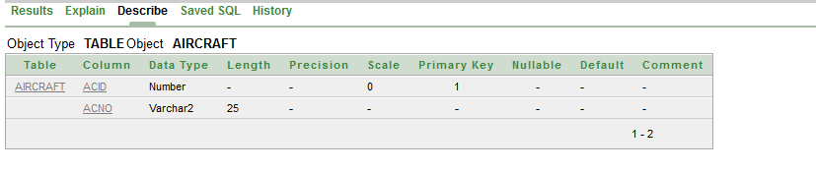

select *from aircraft:

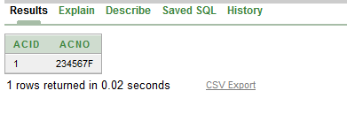

**Route table create:**

create table Route(

rtid int primary key,

airport varchar(30) not null,

destination varchar(40) not null,

rtcode varchar(40) not null unique

)

***Insert int Route table :***

insert into route(rtid,airport,rtcode,destination) values(123,'H_SH_Air','thailand','28134')

desc route:

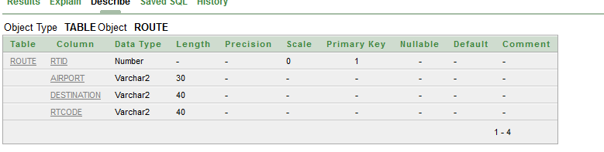

select *from route:

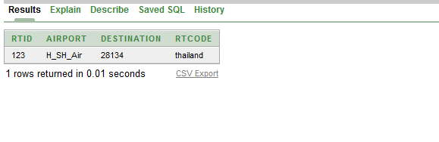

***Airfare table create:***

create table airfare(

afid int ,

airfare int,

rtid int,

primary key(afid),

constraint fk_route foreign key(rtid) references route(rtid)

)

***Insert into airfare table:***

insert into airfare(afid,airfare,rtid)values(123456,600,123)

select *from airfare:

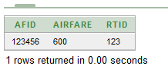

Desc airfare:

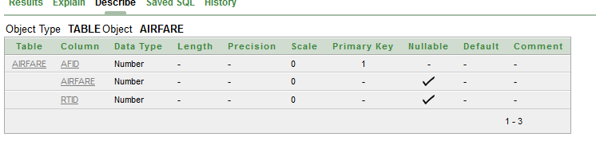

create table flight_schedule:

create table flight_schedule(

flid int ,

aircraft int,

netfare int,

constraint fk_aircraft foreign key(aircraft) references aircraft(acid),

constraint fk_airfare foreign key(netfare) references airfare(afid)

)

***Insert into flight_schedule table:***

insert into flight_schedule(flid,aircraft,netfare)values(67433,1,123456)

select *from ***flight_schedule:***



Desc ***flight_schedule:***

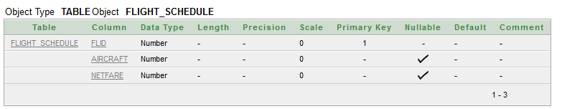

***create table discount:***

create table discount(

diid int primary key,

amount int

)

***Insert into discount table :***

insert into discount(diid,amount)values(1678,566)

desc discount:

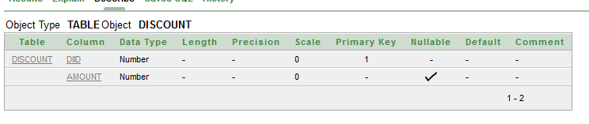

Select *from discount:

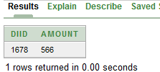

create table charges:

create table charges(

chid int primary key,

amount int

)

***Insert into charges table*** :

insert into charges(chid,amount)values(1234,78);

desc charges:

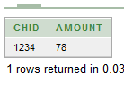

Select *from charges:

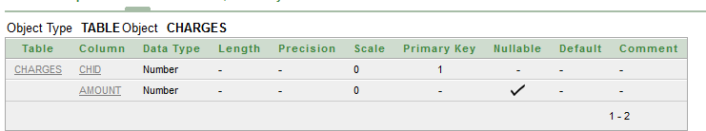

create country table:

create table country(

ctid int primary key,

country_name varchar(30)

)

***Insert into country table:***

insert into country(ctid,country_name)values(345,'bangladesh')

desc country:

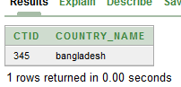

Select *from country:

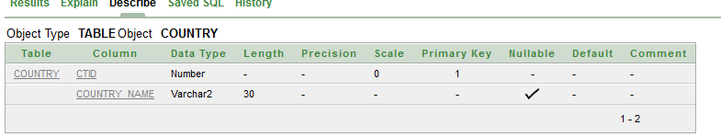

***create state table :***

create table state(

stid int primary key,

country int,

constraint fk_country foreign key(country) references country(ctid)

)

***Insert into state table :***

insert into state(stid,country)values(567,345);

select *from state:

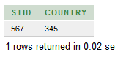

desc state:

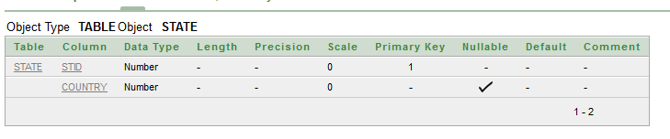

***create contact_details table :***

create table contact_details(

cnid int primary key,

email varchar(50),

state int not null,

constraint fk_state foreign key(state) references state(stid)

)

***Insert into contact_details table :***

insert into contact_details(cnid,email,state)values(789,'shawonaiub96@gmail.com',567)

desc contact_details:

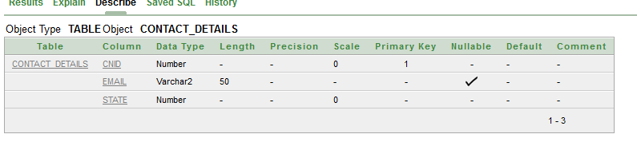

Select *from contact_details:

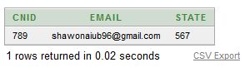

***create passenger table :***

create table passenger(

psid int primary key,

psname varchar(50) not null,

contact int not null,

constraint fk_contact foreign key(contact) references contact_details(cnid)

)

***Insert into passenger table:***

insert into passenger(psid,psname,contact)values(12345,'shawon',789);

desc passenger:

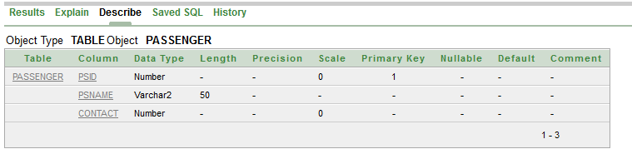

Select *from passenger:

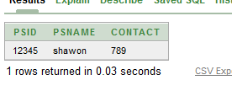

***create branch table*** :

create table branch(

brid int primary key ,

address varchar(40) not null,

state int ,

constraint fk_state2 foreign key(state) references state(stid)

)

***Insert into branch table :***

insert into branch(brid,address,state)values(1234,'dhaka',567)

desc branch:

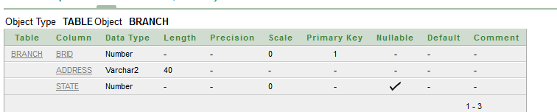

select *from branch:

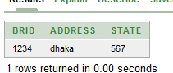

***create employee table :***

create table employees(

empid int primary key,

branch int not null,

name varchar(40) not null,

address varchar(40) not null,

email varchar(50) not null,

constraint fk_branch foreign key(branch) references branch(brid)

)

***Insert into employees table:***

insert into employees(empid,branch,name,address,email)values(3456,1234,'shawon','dhaka','shawonaiub96@gmail.com')

desc employees:

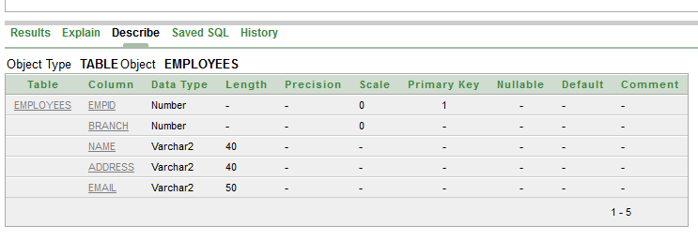

select *from employees :

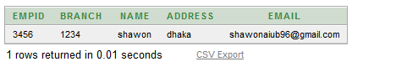

***Create transection table :***

create table transection(

tsid int primary key,

booking_date DATE,

depurture_date DATE,

passenger int ,

flight int,

employee int ,

charges int,

discount int,

constraint fk_passenger foreign key(passenger) references passenger(psid),

constraint fk_flight foreign key(flight) references flight_schedule(flid),

constraint fk_employee foreign key(employee) references employees(empid),

constraint fk_charges foreign key(charges) references charges(chid),

constraint fk_discount foreign key(discount) references discount(diid)

)

***Insert into transection table:***

insert into transection (tsid,booking_date,depurture_date,passenger,flight,employee,charges,discount)values(12345,to_date('20000720','yyyymmdd'),to_date('20000820','yyyymmdd'),12345,67433,3456,1234,1678);

select *from transection:



desc transection :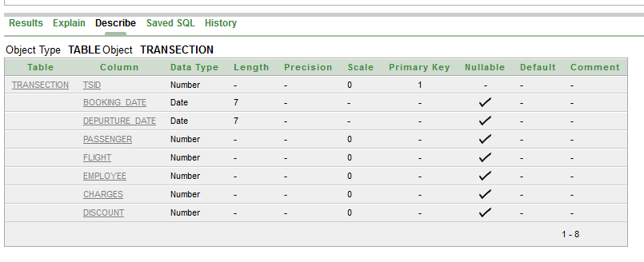

: Project End :