**UNIVERSITY OF ASIA PACIFIC**

Department of Computer Science and Engineering



**Course Title :**

**Artificial Intelligence and Expert Systems Lab**

**Course Code : CSE 404**

**Project : 01**

|  |  |
| --- | --- |
| **Submitted By:**  **Shawon Barman**  Section: A  ID: 18201043 | **Submitted to:**  **Dr. Nasima Begum**  Assistant Professor  Department of CSE, University Of Asia Pacific |

**Project Name: Implementation of a small address map using A* search algorithm**

**Introduction:**

The project problem is to implementation of a small address map from my home to UAP, using A* search algorithm and then find out the optimal path. A* algorithm is a searching algorithm that searches for the shortest path between the initial state to the final state. In this project, I will find the most optimal path from my home (Brahmonkitta road) to my university (UAP) using A* search algorithm.

**Objective:**

The objective of this project is to find an optimal path from my home (Brahmonkitta road) to my university (UAP).

**Tools And Languages:**

* **Distance Measurement:** Google Maps
* **Map Designing:** Draw.io
* **IDE:** PyCharm
* **Programing Language:** Python

**Designed Map:**

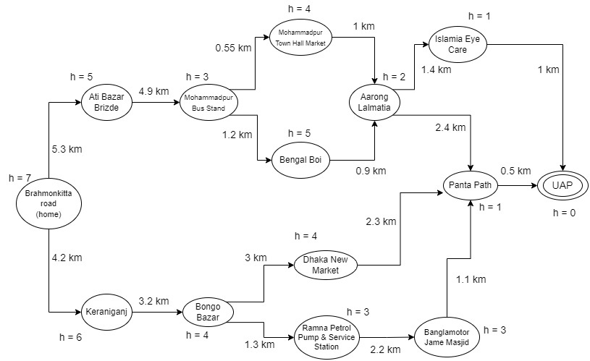

Here,

Start Node : Shawon’s house

Goal Node : UAP

Cost in Distance : kilometer (km)

**Search tree of designed map:**

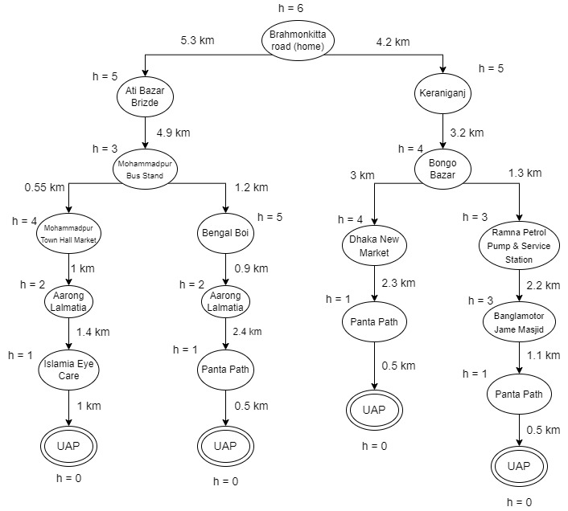

**Implemented using python:**

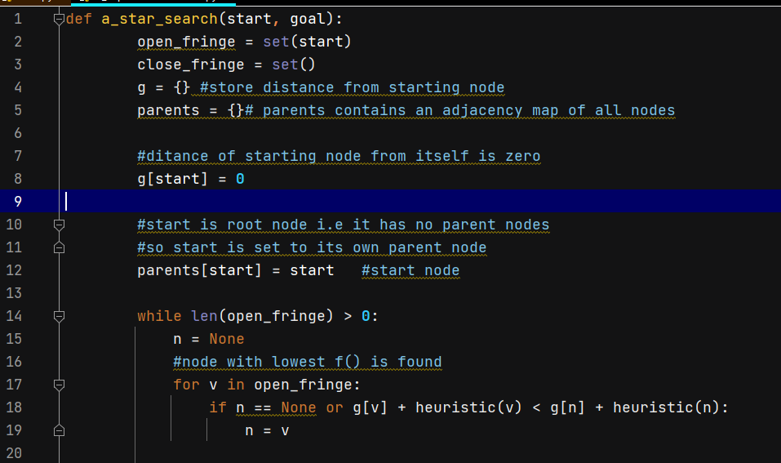

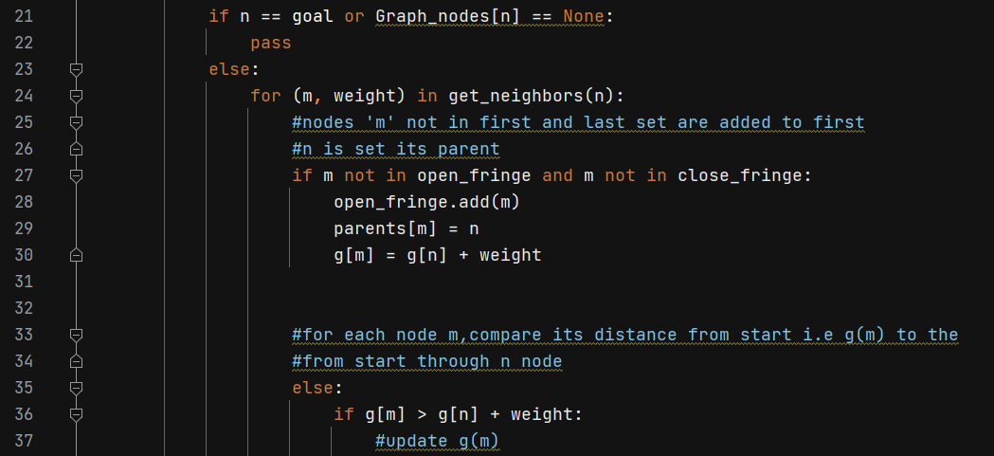

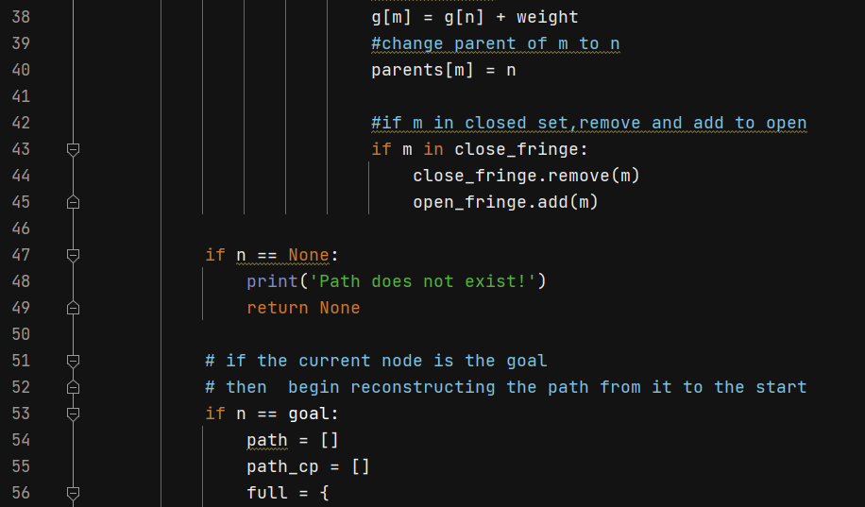

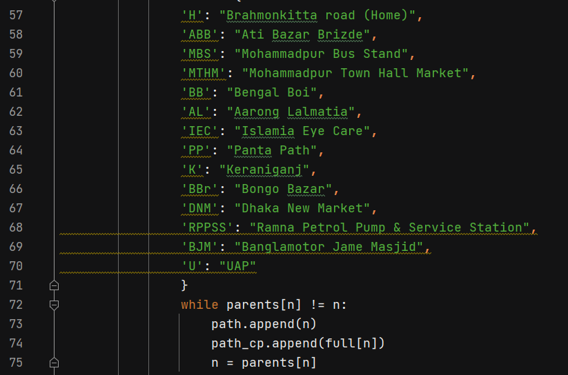

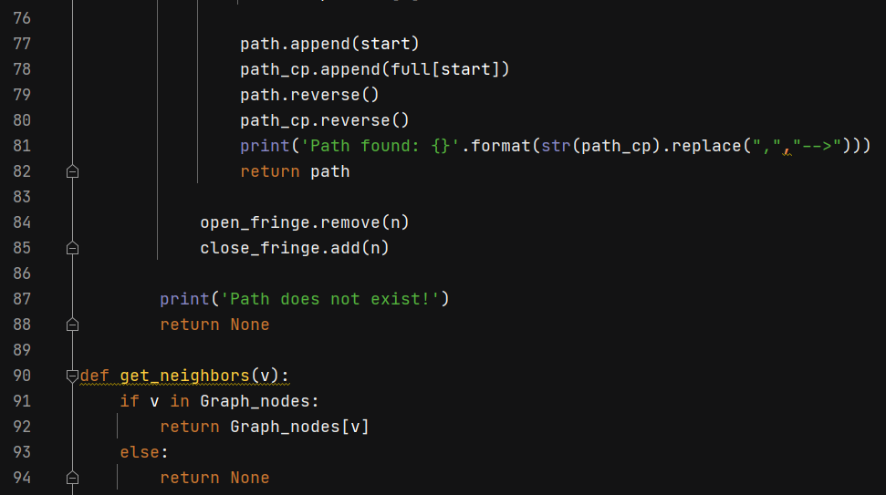

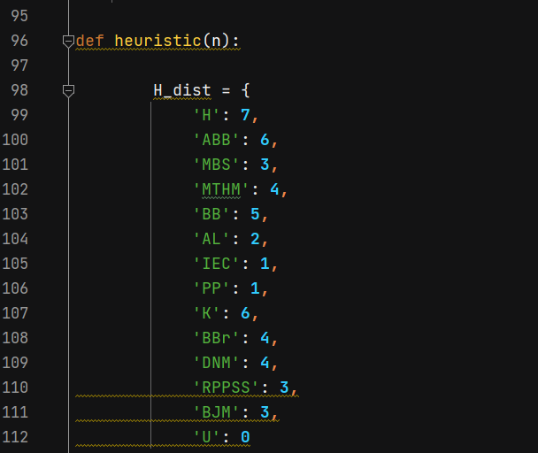

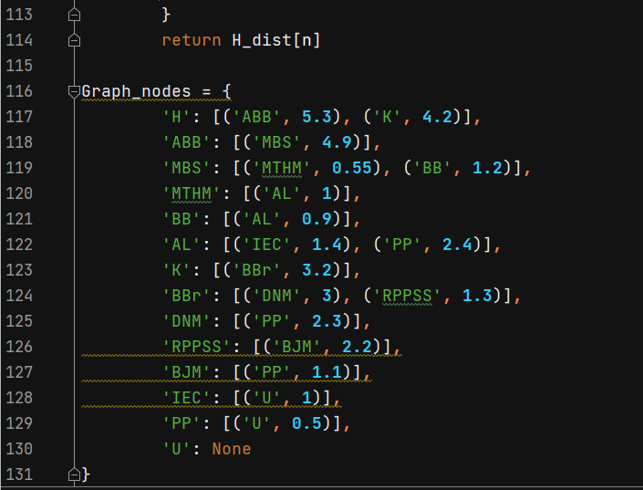

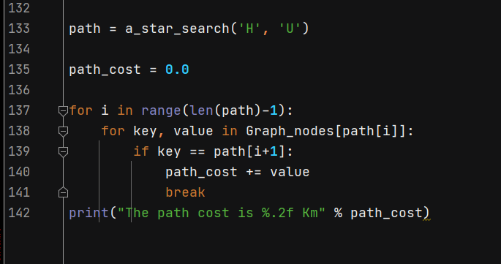

**Output:**

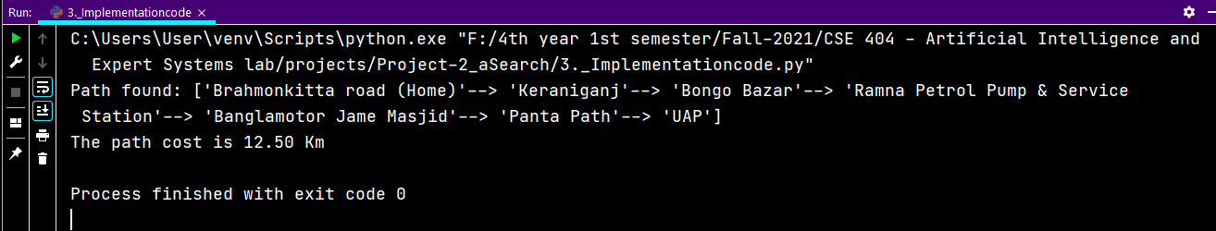

**Result Analysis:**

After Using A* Search Algorithm on this designed map, on output we can find the shortest path:

Brahmonkitta road (home) -> Keraniganj -> Bongo Bazar -> Ramna Petrol Pump & Service Station -> Banglamotor Jame Masjid -> Panta Path -> UAP

So, we can say that that is the most optimal and shortest path.

**Conclusion:**

In this project, after successful implementation, A* search algorithm gives the most optimal path as output. In conclusion, A* search algorithm is a powerful and beneficial algorithm with all the potential. So we can use this algorithm for approximate the shortest path in real-life situation, like - in maps, games etc.