Create 20 HTML ”themes” for subscribe forms.

**File Structure:**

* 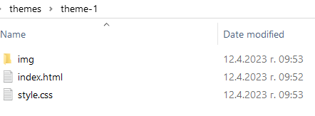

All themes must follow this file structure.

Must not contain JavaScript

Must not be directly stolen/copied off 3rd party websites or bought online with problems with copyright. Images and graphics that are provided must not be copyrighted!

Must be different visual style each. See some examples in the examples directory.

Must contain /fields/:

First Name   
Last Name

Email

20%-40% of the themes must also contain:  
  
Message /textarea field/  
Phone /text field/

Some 10-20% must be compromised of Button/graphic to click on which reveals the form itself, this one can contain simple JS to reveal the form when clicked:

