1. **Product_listing Page**

This page is the Homepage. After a user sign up or sign in, he sees the product listing page which contains items that are being sold. The buyer can bid on an item. The bid should always be **higher** than the current bid. There is also the deadline for the bidding.

In the Home bar at the top (as shown below), there are buttons for Home, Products, About Us and Contact Us, this should be changed.   
New layout should be: **Profile, About Us, Contact** and **sign out button.**The products should also be centered on the page with better aesthetic.  
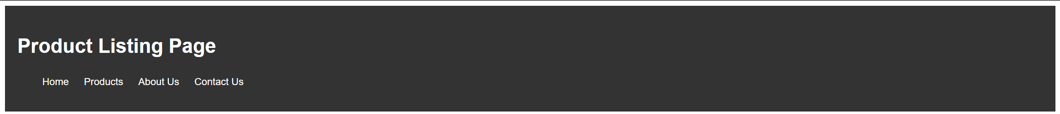

1. **Buyer Profile Page**

The Buyer profile page contains the name, address, picture, credit card and email. The is also the Biding history tab in the end. It shows items which the user has bought and items which the user has bid but still not won.  
  
The Change price option is a new Bid button. Recall from the product listing page, *The bid should always be* ***higher*** *than the current bid.*This page should be made more aesthetic too.

1. **Seller Profile Page**

The Seller profile page contains information of people who want to sell products. It has a Selling History tab which shows items which the user has already sold.  
  
And an Active Listings tab, which shows products which are currently on the Product Listing page and still not sold.  
  
Below, the seller can also add new products to be sold:  
  
