**UNIVERSITY OF ASIA PACIFIC**

Department of Computer Science and Engineering



**Course Title :**

**Artificial Intelligence and Expert Systems Lab**

**Course Code : CSE 404**

**Assignment No: 01**

|  |  |
| --- | --- |
| **Submitted By:**  **Shawon Barman**  Section: A  ID: 18201043 | **Submitted to:**  **Dr. Nasima Begum**  Assistant Professor  Department of CSE, University Of Asia Pacific |

# Problem Title: Implement a basic family relationship tree structure of your own family using Prolog

**Problem Description:**

Implement a basic family tree structure of your own family using prolog. Write the rules against the degree and removal up to the 3rd degree and the twice removed situation.

**Tools and Languages:**

* Draw.io
* Notepad
* SWI-Prolog

**Diagram:**

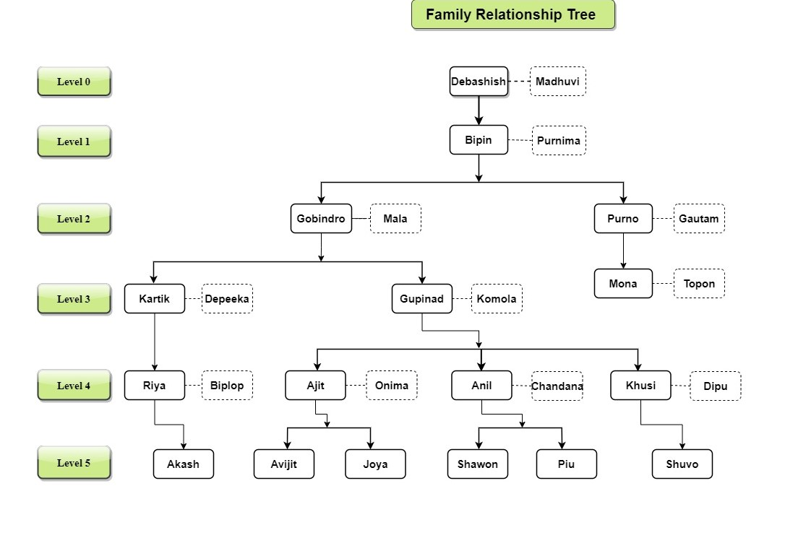

The above diagram is my family relationship tree structure. Now with help of SWI-Prolog, I’ll remove the first, second, third cousin twice times. In the tree, all bold rectangular box represents a strong entity, and the dotted rectangular box represents a weak entity.

**Sample Input/Output:**

In the below screenshot, here is the sample output for father, mother, parent, and sibling for a individual person.

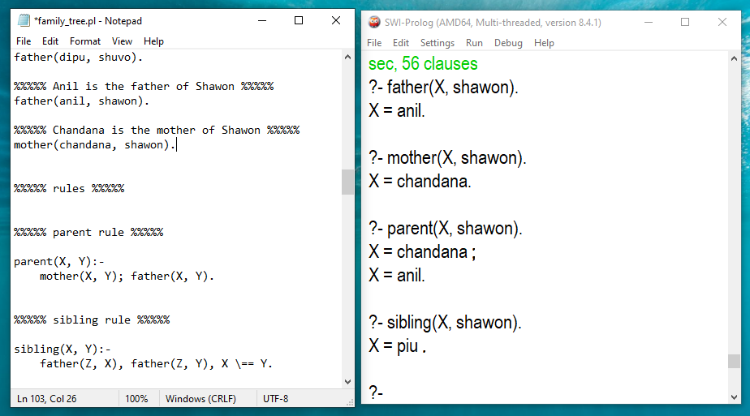

In the below screenshot, here is the sample output for grandparent, great-grandparent, great-great-grandparent, great- great-great-grandparent for a individual person.

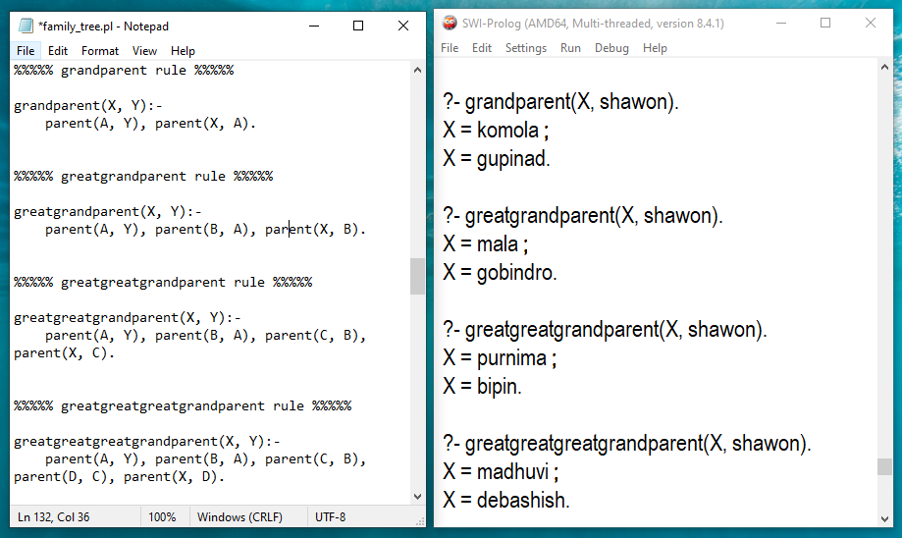

Is Ajit is the uncle of shawon? The sample input and output in the below screenshot.

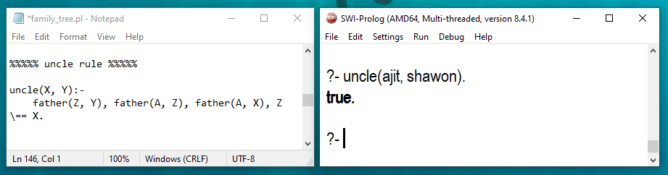

In the below screenshot, here is the sample input output for first cousin, second cousin, and third cousin for a individual person.

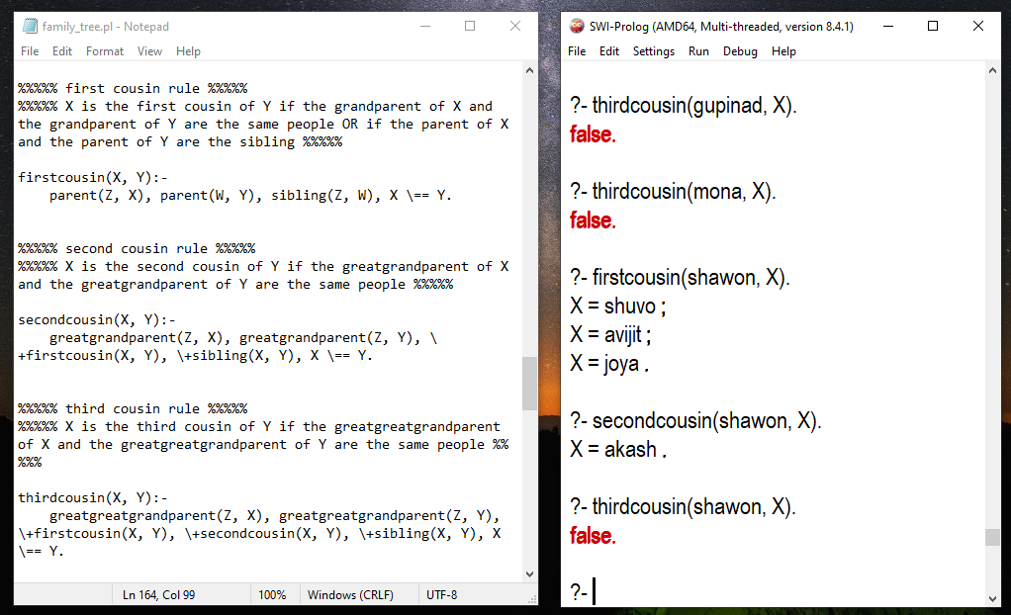

In the below screenshot, here is the sample input output for first cousin once removed, and first cousin twice removed for a individual person.

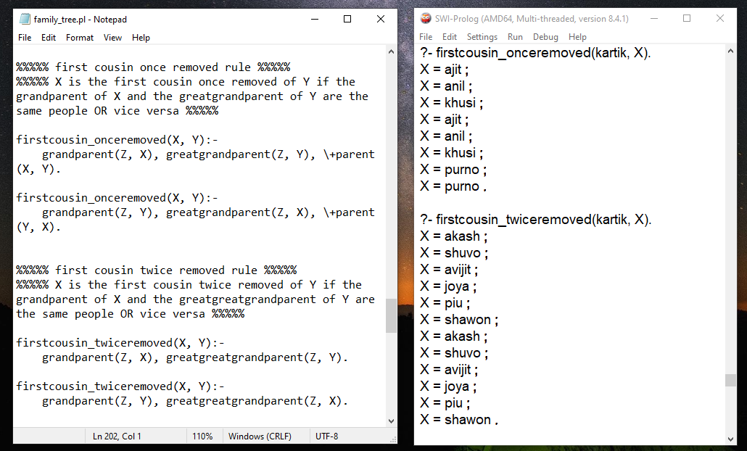

In the below screenshot, here is the sample input output for second cousin once removed, and second cousin twice removed for a individual person.

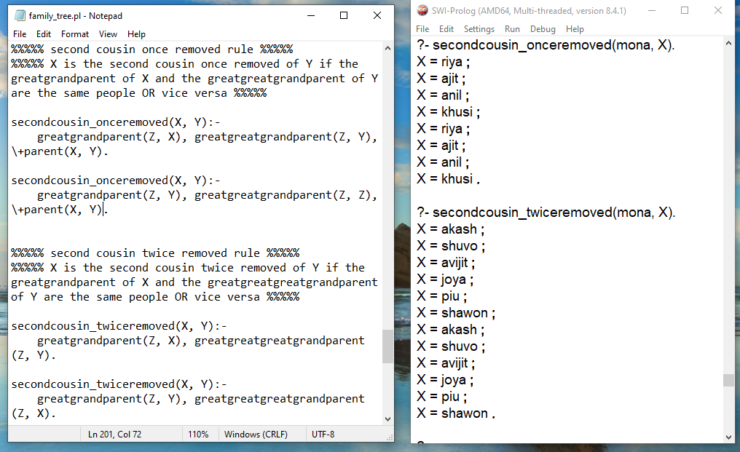

In the below screenshot, here is the sample input output for third cousin once removed, and third cousin twice removed for a individual person.

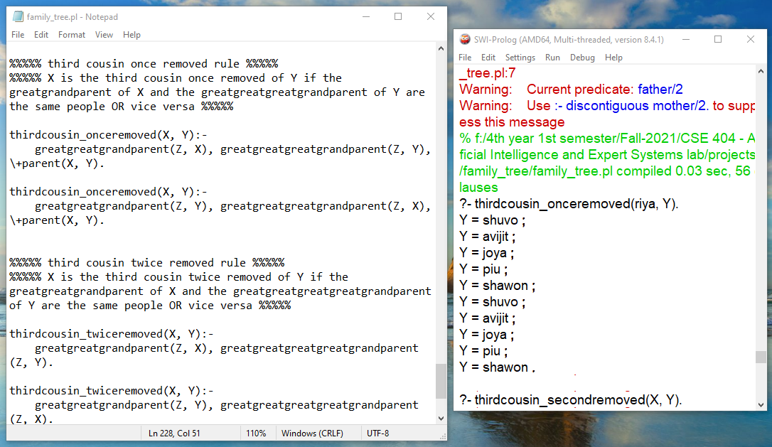

Who is the predecessor of shawon. In the below screenshot, here is the sample input and output:

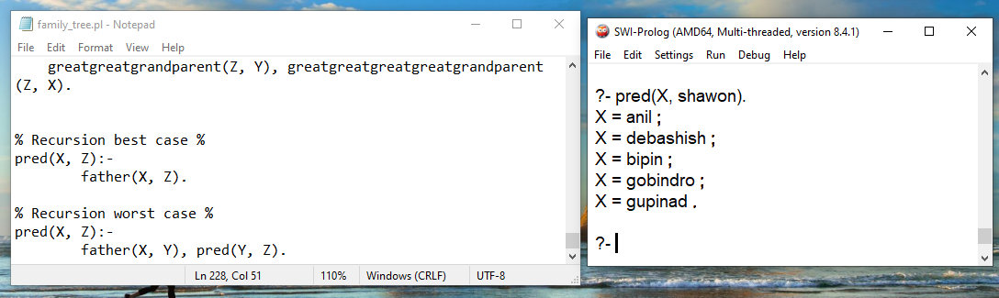

**Conclusion:**

I’ve faced some minor difficulties during completing this assignment. SWI-Prolog was showing some errors. But after some troubleshooting I was able to fix all the errors of SWI-Prolog. https://swi-prolog.discourse.group/ has some amazing solution which helps me a lot during troubleshooting