7.Laboratoriya ishi Mavzu: AND, OR, NOT mantiqiy standart so‘zlardan foydalanish.  
**Ishdan maqsad**: AND, OR, NOT mantiqiy standart so‘zlardan

foydalanish bo`yicha ko`nikmaga ega bo`lish.  
Masalani qo`yilishi: Berilgan predmet soha ma`lumotlar bazasidagi barcha  
ob`yektlarni ustida saralash amallarini bajarish.

Uslubiy ko`rsatmalar: BETWEEN ifodasi bu qiymatlar diapazonigategishlilikni tekshirishdir. Ifoda sintaksisi quyidagicha: --- tekshirilayotgan ifoda ------ BETWEEN ----- quyi ifoda AND yuqori ifoda - NOT - NOTifodasi shartni teskarisiga o’giradi, ya‘ni tegishli emas ma‘noni bildiradi. Misol:Narxi har xil diapazonga mos keluvchi buyurtmalarni topish. SELECTORDER_NUM, AMOUNT FROM ORDERS WHERE AMOUNT BETWEEN20.000 AND 29.999

Mysql> select *from ishchilar where Yoshi=’20’ or H_Id=’5’;

Mysql> select *from ishchilar where Yoshi=’20’ and H_Id=’5’;

Mysql> select *from ishchilar where not(Familya like ‘%ov%’);

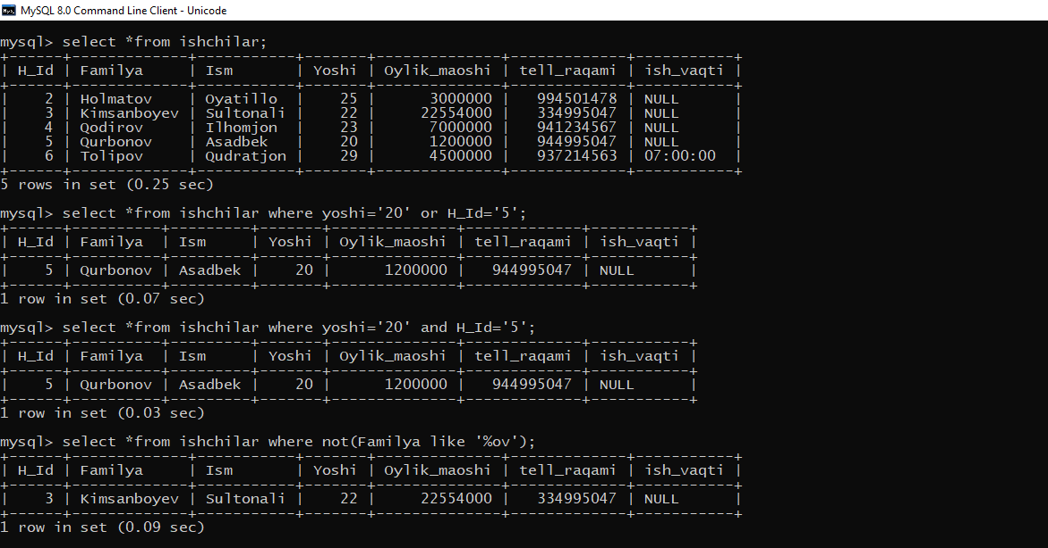

Mysql> select *from ishchilar where not(Familya like ‘%ev%’);

Mysql> select Yoshi, Familya, H_Id from ishchilar where H_Id between 2 and 5;

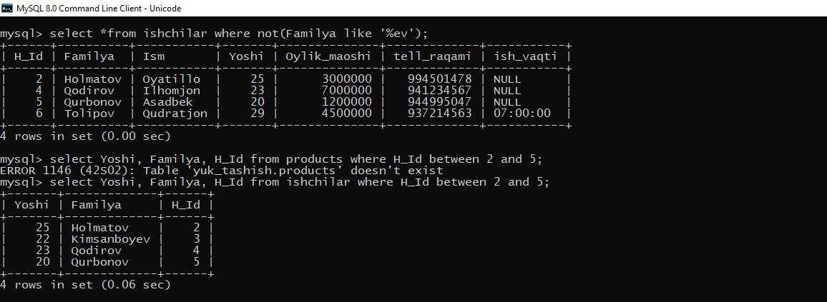

Mysql> select Yoshi, Oylik_maoshi from ishchilar where Oylik_maoshi between 1200000 and 4500000;

Mysql> select Familya,Ism, Yoshi, Oylik_maoshi from ishchilar where Oylik_maoshi between 1200000 and 4500000;

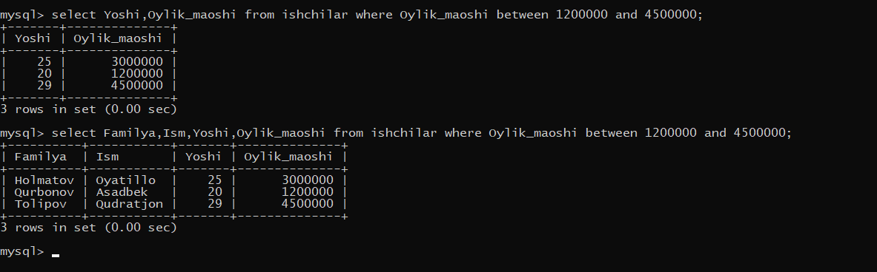

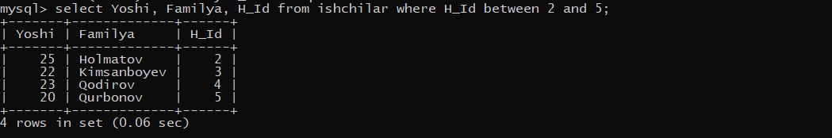

8.Laboratoriya ishiMavzu: Ma’lumotlarni saralash. Where standart so’zidan foydalanish.  
Ishdan maqsad: Ma’lumotlarni saralash va Where standart so’zidan foydalanish  
bo`yicha ko`nikmaga ega bo`lish.

Masalani qo`yilishi: Berilgan predmet soha ma`lumotlar bazasidagi barcha  
ob`yektlarni ustida saralash amallarini bajarish.

Uslubiy ko`rsatmalar: SQL da WHERE operatori natijalarni filtrlash va SELECT,INSERT, UPDATE yoki DELETE bandlarida shartlarni qo'llash uchun ishlatiladi.SQL WHERE kalit so'zi ma'lumotlarni allaqachon mavjud bo'lgan SQL SELECTso'roviga qo'shib shartli ravishda tanlash uchun ishlatiladi. WHERE kalit so'zinijadval (lar) dan ma'lumotlarni kiritish, yangilash va o'chirish uchun ishlatilishimumkin, ammo hozirda biz SELECT kalit so'zidan qanday foydalanishni bilganimizsababli, shartli ravishda olinadigan ma'lumotlarni berishda davom etamiz.

mysql> select all Familya from ishchilar where H_Id=any (select H_Id from maxsulot_turlari where M_Id=3;

Mysql> select Familya, Yoshi H_Id from ishchilar where H_Id in (2,5);

Mysql> select Familya, Yoshi H_Id from ishchilar where H_Id in (2,4,5);

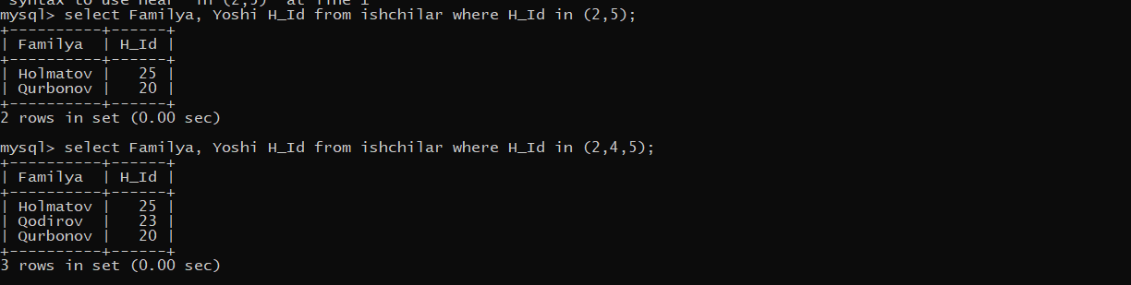

Mysql> select Familya, Ism, Yoshi H_Id from ishchilar where Ism like ‘%a%’;

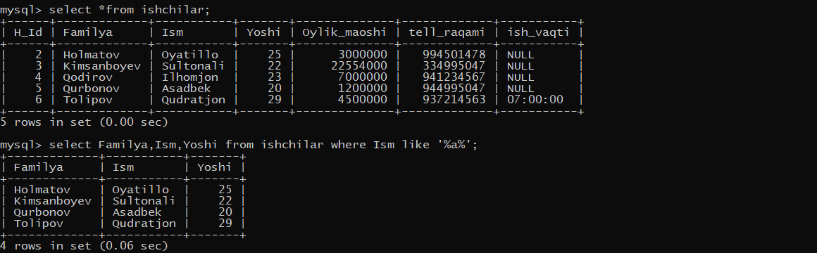

Mysql> select *from ishchilar where Oylik_maoshi is not NULL;

Mysql> select *from ishchilar where ish_vaqti is not NULL;

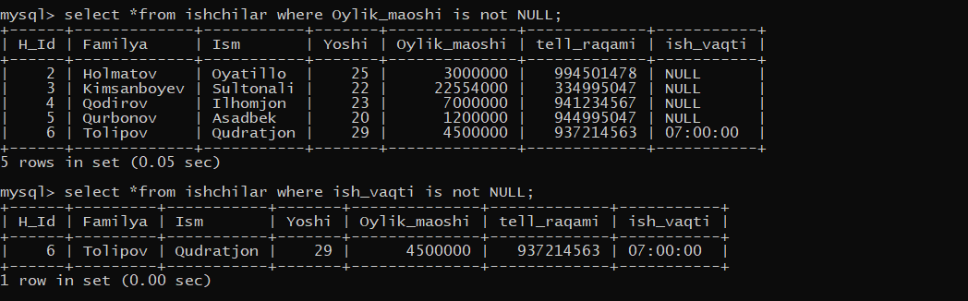

Mysql> select Familya,Ism,Yoshi from ishchilar where Ism like ‘A%’;

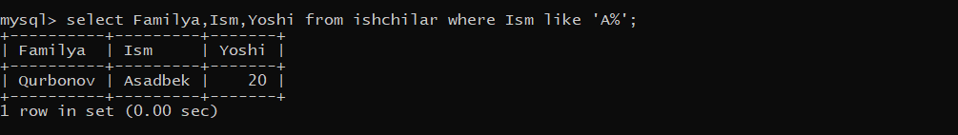

mysql> select all Familya from ishchilar where true;

