**9.Laboratoriya ishi**

**Mavzu:** Group by va Order by standart so’zlaridan foydalanib so’rov yaratish.

**Ishdan maqsad:** Group by va Order by standart so’zilaridan foydalanish bo`yicha ko`nikmaga ega bo`lish.

**Masalani qo`yilishi:** Berilgan predmet soha ma`lumotlar bazasidagi barcha ob`yektlarni ustida tartiblash amallarini bajarish.



ORDER BY kalit so'zidan natijani o'sish yoki kamayish tartibida tartiblash uchun foydalaniladi.

Yozuvlarni kamayish tartibida tartiblash uchun DESC kalit so'zidan foydalaning.

Ko'tarilish tartibida tartiblash uchun ASC kalit so'zidan foydalaning.

**mysql> select *from davlatlar order by D_Nomi;**

**mysql> select *from davlatlar order by D_Nomi desc;**

**mysql> select *from davlatlar order by D_Nomi,Transport_nomi;**

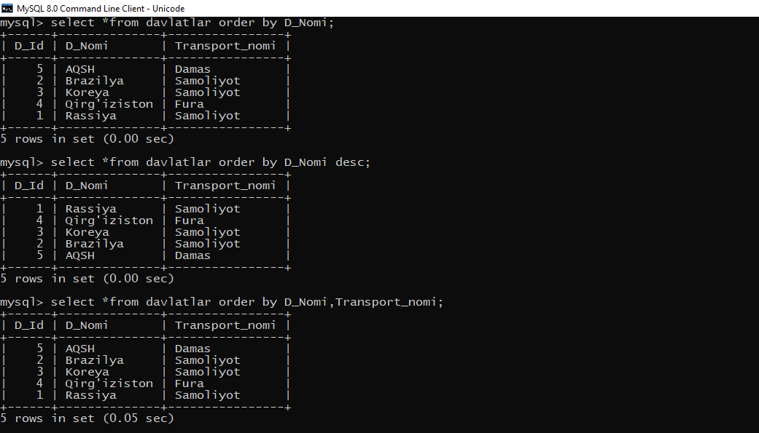

**mysql> select *from davlatlar order by D_Nomi asc,Transport_nomi desc;**

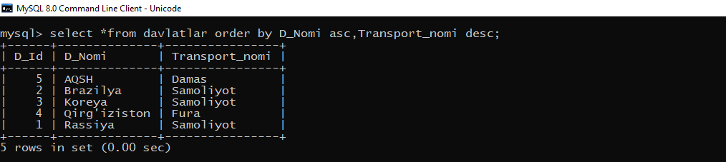

**mysql> select *from ishchilar;**

**mysql> select count(H_Id),Familya from ishchilar group by Familya;**

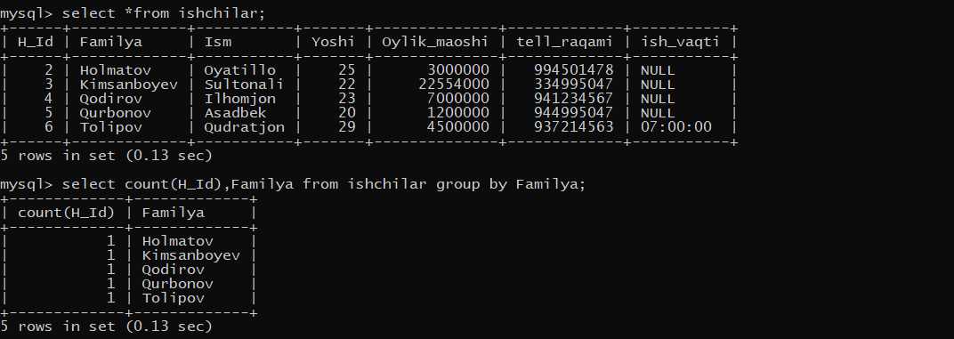

**mysql> select count(H_Id),Familya from ishchilar group by Familya order by count(H_Id) desc;**

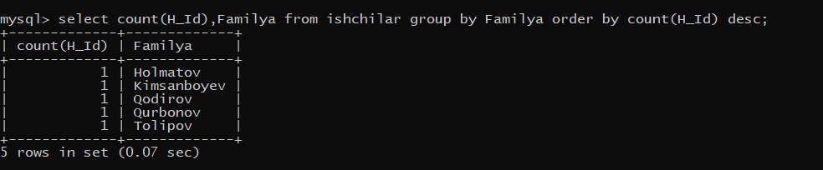

**mysql> select count(D_Id),D_Nomi from davlatlar group by D_Nomi order by count(D_Id) desc;**

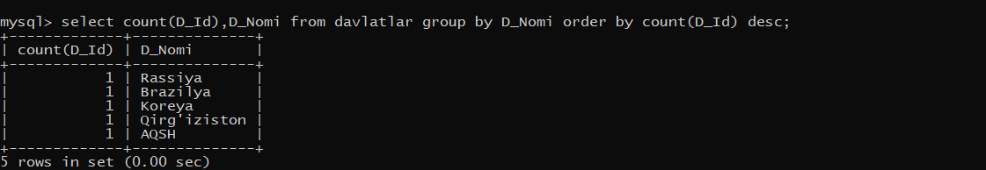

**mysql> select max(Yoshi),Familya from ishchilar group by Familya;**

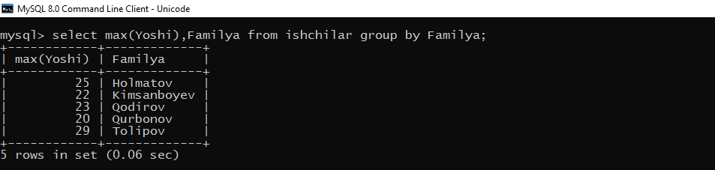

**mysql> select sqrt(H_Id),Oylik_maoshi from ishchilar group by Oylik_maoshi;**

**mysql> select avg(H_Id),Oylik_maoshi from ishchilar group by Oylik_maoshi;**

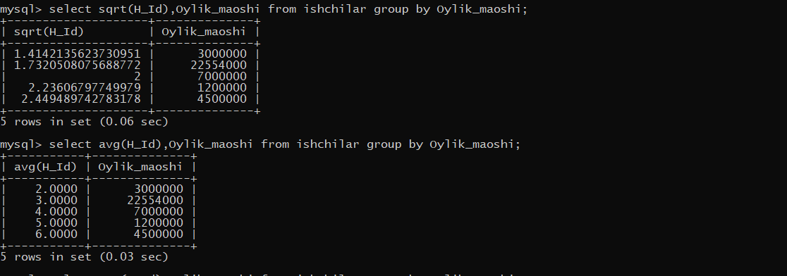

**mysql> select sum(H_Id),Oylik_maoshi from ishchilar group by Oylik_maoshi;**

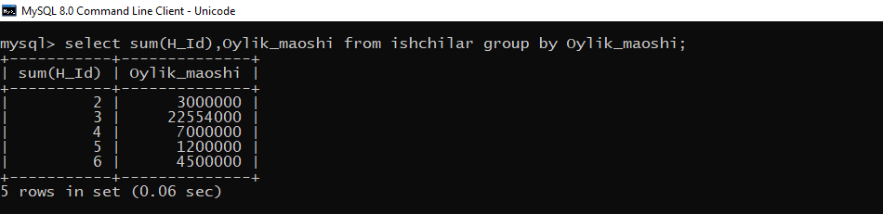

**10.Laboratoriya ishi**

**Mavzu:** HAVING standart so’zidan foydalanib so’rov yaratish.

**Ishdan maqsad:** HAVING standart so’zidan foydalanish bo`yicha ko`nikmaga ega bo`lish.

**Masalani qo`yilishi:** Berilgan predmet soha ma`lumotlar bazasidagi barcha ob`yektlarni ustida Having standart so’zidan foydalanib amallarini bajarish.

HAVING buyrug'i guruh yordamida amalga oshirilgan guruhlash natijalarini filtrlash imkoniyatini beradi.

**mysql> select yoshi, sum(Oylik_maoshi) as sum from ishchilar group by yoshi having sum>=1200000;**

**mysql> select yoshi, sum(Oylik_maoshi) as sum from ishchilar group by yoshi having sum>=7000000;**

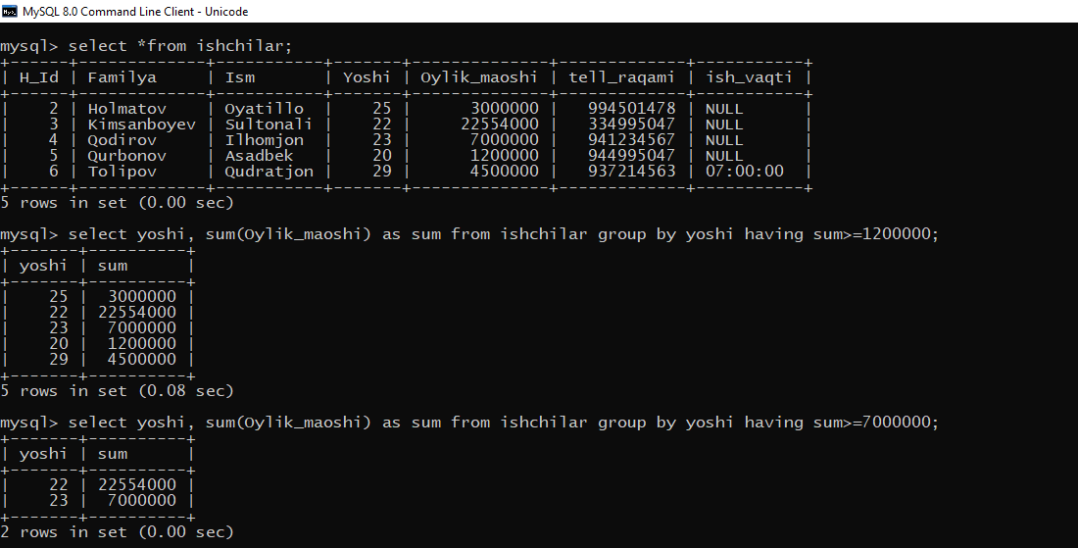

**select yoshi,count(*) as soni from ishchilar group by yoshi;**

**mysql> select yoshi,count(*) as soni from ishchilar group by yoshi having soni<=2;**

**ysql> select yoshi,count(*) as soni from ishchilar group by yoshi having soni<2;**

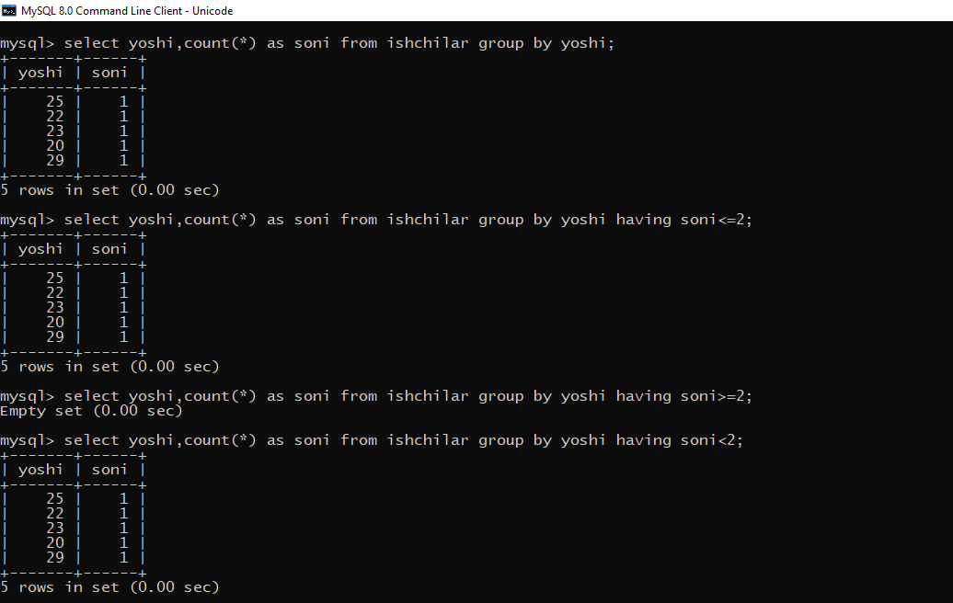

**mysql> select yoshi,count(*) as soni from ishchilar group by yoshi having soni in(1,2);**

**mysql> select yoshi,count(*) as soni from ishchilar group by yoshi having soni BETWEEN 1 AND 2;**

