* 回归1：仅包含核心解释变量aging
reghdfe nqp aging, absorb(province_id year) vce(cluster province_id)

* 回归2：加入控制变量 ur_gap
reghdfe nqp aging ur_gap, absorb(province_id year) vce(cluster province_id)

* 回归3：加入控制变量 ur_gap 和 digint
reghdfe nqp aging ur_gap digint, absorb(province_id year) vce(cluster province_id)

* 回归4：加入控制变量 ur_gap digint in_fdi
reghdfe nqp aging ur_gap digint in_fdi, absorb(province_id year) vce(cluster province_id)

* 回归5：加入全部控制变量
reghdfe nqp aging ur_gap digint in_fdi in_elec, absorb(province_id year) vce(cluster province_id)
缩尾* aging
gen aging_w = aging
sum aging, detail
scalar p1 = r(p1)
scalar p99 = r(p99)
replace aging_w = p1 if aging < p1
replace aging_w = p99 if aging > p99

* road
gen road_w = road
sum road, detail
scalar p1 = r(p1)
scalar p99 = r(p99)
replace road_w = p1 if road < p1
replace road_w = p99 if road > p99

* 依此类推 ur_gap, in_fdi, in_elec, digint
xtreg nqp aging_w road_w ur_gap_w in_fdi_w in_elec_w digint_w i.year, fe cluster(prov_id)
Lagged Control Variable Robustness Test
******************************************************

控制滞后控制变量* Step 1: 设定面板数据结构
xtset prov_id year

* Step 2: 生成控制变量的滞后一期值
gen l_aging = L1.aging
reghdfe nqp l_aging ur_gap digint in_fdi in_elec, absorb(province_id year) vce(cluster province_id)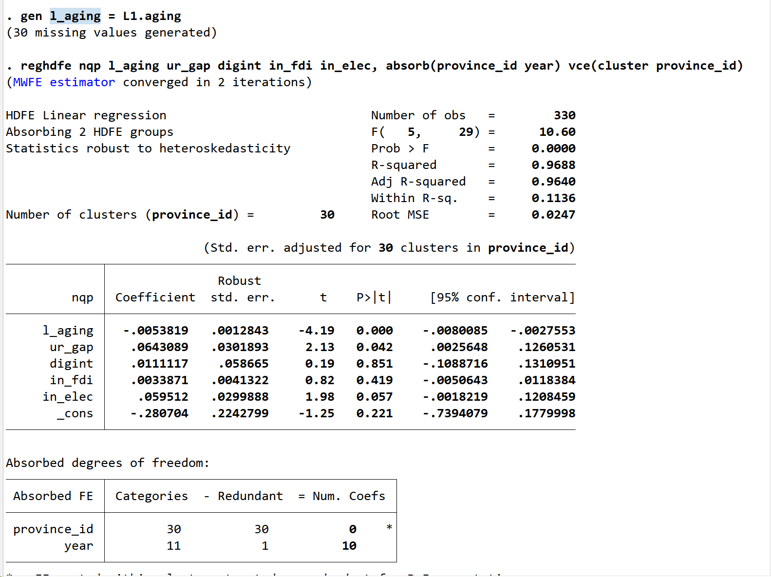
年份趋势项代替年份虚拟变量
gen year_trend = year - 2011
* 年份趋势变量，从 1 开始
reghdfe nqp aging ur_gap in_fdi in_elec digint year_trend, absorb(province_id) vce(cluster province_id)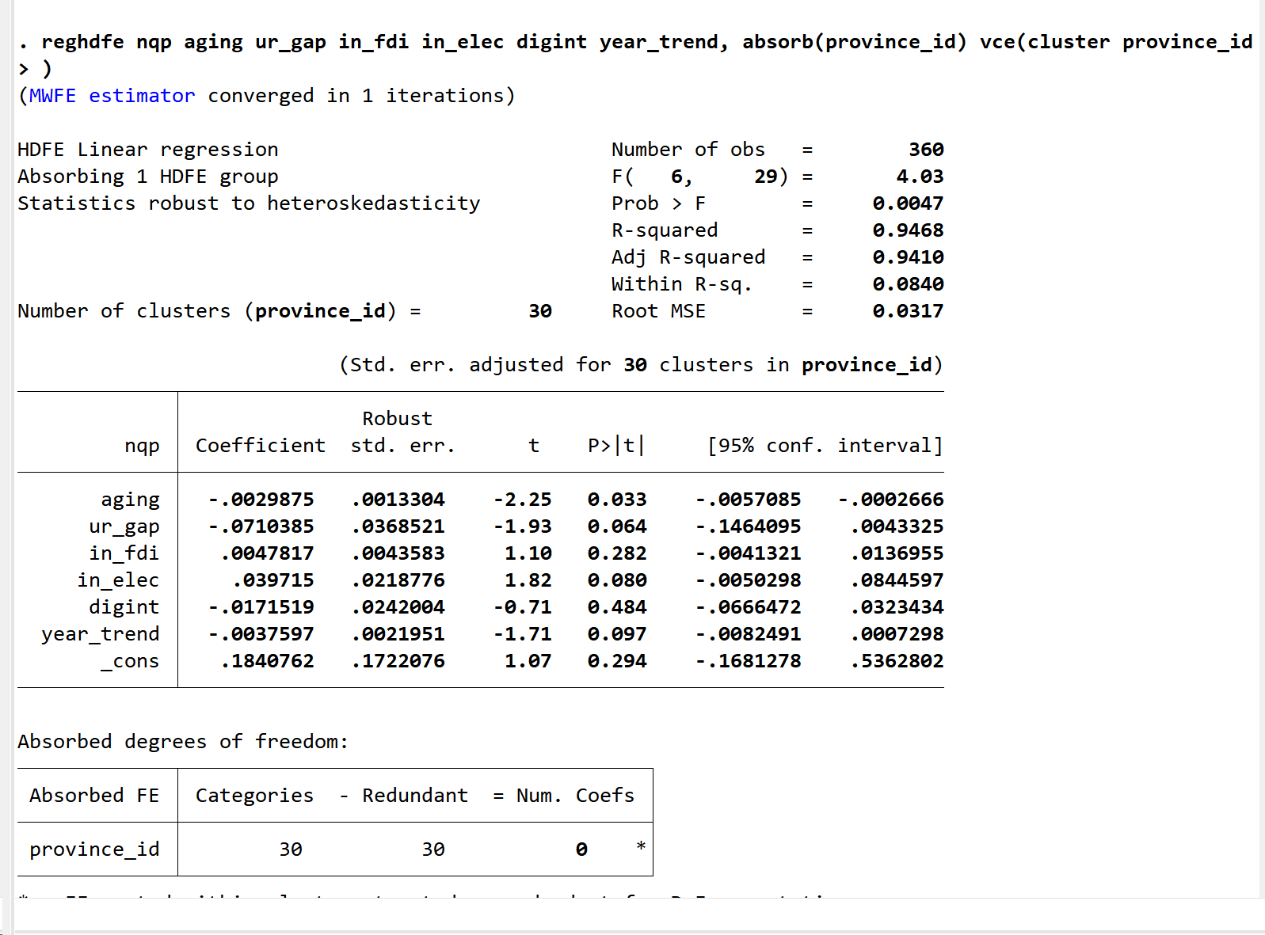
替代模型设定
xtgls nqp aging road ur_gap in_fdi in_elec digint i.prov_id i.year, panels(heteroskedastic) corr(ar1)

import delimited "C:\Users\77977\Desktop\AGRI_winsor.csv", clear encoding(gbk)
(18 vars, 360 obs)

. encode province, gen(province_id)

. xtset province_id year

Panel variable: province_id (strongly balanced)
Time variable: year, 2011 to 2022
Delta: 1 unit
reghdfe nqp aging ur_gap in_fdi in_elec digint, absorb(province_id year) vce(cluster province_id)
reghdfe tpl aging ur_gap in_fdi in_elec digint, absorb(province_id year) vce(cluster province_id)
reghdfe nqp aging tpl ur_gap in_fdi in_elec digint, absorb(province_id year) vce(cluster province_id)
bootstrap r(ind_eff) r(dir_eff) r(tot_eff), reps(500): sgmediation2 nqp, iv(aging) mv(infoent) cv(i.province_id i.year road ur_gap in_fdi in_elec digint)
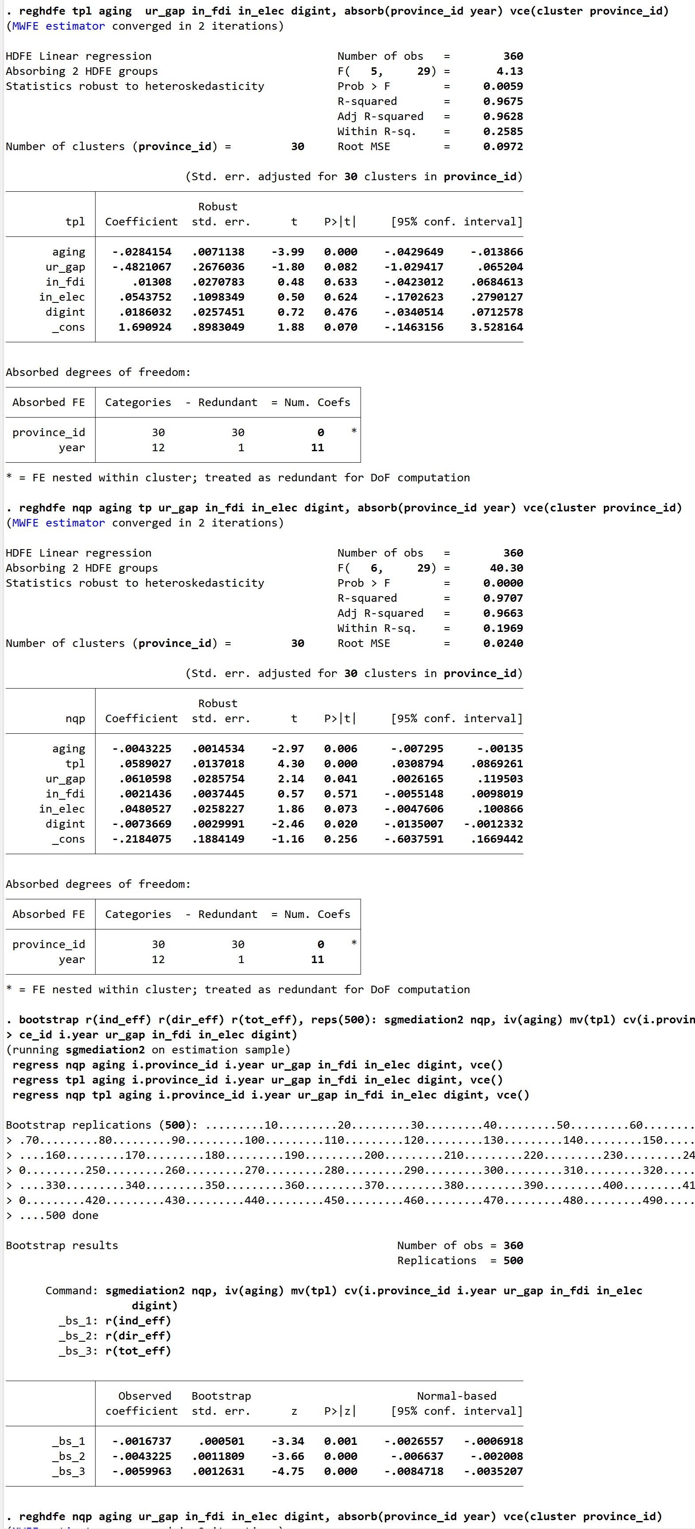
中介效应
reghdfe nqp aging ur_gap digint in_fdi in_elec, absorb(province_id year) vce(cluster province_id)
reghdfe lp aging ur_gap digint in_fdi in_elec, absorb(province_id year) vce(cluster province_id)
reghdfe nqp aging lp ur_gap digint in_fdi in_elec, absorb(province_id year) vce(cluster province_id)
program define mediate_lp, rclass
reghdfe lp aging ur_gap digint in_fdi in_elec, absorb(province_id year) vce(cluster province_id)
scalar a = _b[aging]

reghdfe nqp aging lp ur_gap digint in_fdi in_elec, absorb(province_id year) vce(cluster province_id)
scalar b = _b[lp]

return scalar ab = a * b
end

bootstrap ab=r(ab), reps(1000) seed(1234): mediate_lp
交互项
gen aging_urban = aging * urban

reghdfe nqp aging urban aging_urban ur_gap digint in_fdi in_elec, absorb(province_id year) vce(cluster province_id)
gen L_ur_gap = L1.ur_gap
gen L_digint = L1.digint
gen L_in_fdi = L1.in_fdi
gen L_in_elec = L1.in_elec
reghdfe nqp aging urban aging_urban L_ur_gap L_digint L_in_fdi L_in_elec, absorb(province_id year) vce(cluster province_id)
异质性
* ==================== 分组准备 ====================

* 区域划分：region = 1（东部），0（中西部）
gen region = .
replace region = 1 if inlist(province, "北京", "天津", "河北", "上海", "江苏", "浙江", "福建", "山东", "广东", "海南")
replace region = 0 if inlist(province, "山西", "安徽", "江西", "河南", "湖北", "湖南", "内蒙古", "广西", "重庆", "四川", "贵州", "云南", "陕西", "甘肃", "青海", "宁夏", "新疆")
label define region_lab 1 "East" 0 "Central&West"
label values region region_lab

* 按全国中位数划分产业结构类型：industry_type = 1（高技术服务型），0（传统产业型）
bysort province: egen median_tertiary = median(tertiary_share)
egen nat_median = median(tertiary_share)
gen industry_type = .
replace industry_type = 1 if median_tertiary >= nat_median
replace industry_type = 0 if median_tertiary < nat_median
label define ind_lab 1 "High-tech Service" 0 "Traditional"
label values industry_type ind_lab

* 生成交互项
gen aging_urban = aging * urban

* ==================== 分组回归 ====================

* 东部地区
reghdfe nqp aging urban aging_urban ur_gap digint in_fdi in_elec if region==1, absorb(province_id year) vce(cluster province_id)

* 中西部地区
reghdfe nqp aging urban aging_urban ur_gap digint in_fdi in_elec if region==0, absorb(province_id year) vce(cluster province_id)

* 高技术服务型省份
reghdfe nqp aging urban aging_urban ur_gap digint in_fdi in_elec if industry_type==1, absorb(province_id year) vce(cluster province_id)

* 传统产业型省份
reghdfe nqp aging urban aging_urban ur_gap digint in_fdi in_elec if industry_type==0, absorb(province_id year) vce(cluster province_id)

