
Arden University

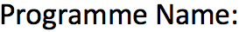
BSc (Hons) Computing

Computing Project

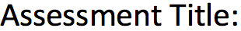
Machine Learning-Based Predictive Valuation System for Second-Hand Vehicles Using Real-Time Market Data

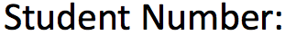
STU195050

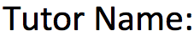
Awais Malik


10,999

Table of Contents
Abstract 6
List of Figures 7
List of Tables 7
Chapter 1 — Introduction 9
1.1 Background 9
1.2 Problem Statement 9
1.3 Aim and Objectives 9
1.4 Scope and Limitations 10
1.5 Ethical Considerations 10
1.6 The UK Used-Car Market in 2025–2026 10
1.7 Dissertation Structure 11
Chapter 2 — Literature Review 12
2.1 Theoretical Foundations of Used-Car Price Formation 12
2.2 Empirical Studies on Used-Car Price Prediction 12
2.3 Regression Algorithms 13
2.3.1 Linear Regression 13
2.3.2 Random Forest 13
2.3.3 Extreme Gradient Boosting (XGBoost) 13
2.4 Methodology Frameworks 13
2.5 Real-Time Data Acquisition and Web Scraping 14
2.6 Two Engineering Lessons from Production ML 14
2.7 Identified Research Gap 14
Chapter 3 — Requirements Gathering 15
3.1 Approach to Requirements Elicitation 15
3.2 User Personas 15
3.3 Functional Requirements 15
3.4 Non-Functional Requirements 17
3.5 Security Requirements 18
3.6 Requirements Traceability Matrix 18
Chapter 4 — Methodology 20
4.1 Methodological Stance 20
4.2 Dataset 20
4.2.1 Source and Licence 20
4.2.2 Schema 20
4.2.3 Volume and Distribution 20
4.2.4 Real-Time Augmentation 21
4.3 Data Preparation 21
4.3.1 Exploratory Data Analysis 21
4.4 Feature Engineering 22
4.5 Modelling 22
4.6 Evaluation Strategy 22
4.7 Tooling and Reproducibility 23
Chapter 5 — Proposed Solution, Design and Implementation 24
5.1 System Architecture 24
5.2 Data Preparation Module 24
5.3 Feature Engineering Module 25
5.4 Model Training Module 25
5.5 Live Web Scraper 25
5.6 Flask REST API 25
5.7 Frontend 26
5.8 Persistence and Configuration 30
5.9 Source-Code Statistics 30
5.10 Usability and Accessibility 31
5.11 The Valuation Engine: From a Price to a Decision 31
Chapter 6 — Implementation Notes and Critical Reflection 33
6.1 How CRISP-DM Shaped the Artefact 33
6.2 How the Literature Shaped the Artefact 33
6.3 Problems Encountered During Implementation and Their Resolution 33
Chapter 7 — Testing and Evaluation 35
7.1 Test Plan 35
7.2 Testing Strategy 36
7.3 Test Inventory and Outcomes 36
7.4 Quantitative Model Comparison 37
7.5 Diagnostic Charts 38
7.5.1 Predicted vs. Actual Price (predicted_vs_actual.png) 38
7.5.2 Residual Distribution (residuals.png) 39
7.5.3 Feature Importance (feature_importance.png) 40
7.5.4 Prediction Interval (prediction_interval.png) 41
7.6 Sensitivity and Sanity Checks 41
7.7 Per-Brand Error Breakdown 41
7.8 Latency Benchmarks 42
7.9 Limitations of the Evaluation 42
Chapter 8 — Ethics 43
8.1 Ethical Review and Approval 43
8.2 Personal Data and GDPR 43
8.3 Algorithmic Fairness and Bias 43
8.4 Web-Scraping Ethics 43
8.5 Intellectual-Property Compliance 43
8.6 Use of Generative AI 44
Chapter 9 — Project Management 45
9.1 Plan and Execution 45
9.2 Risk Management 45
9.3 Tooling 46
9.4 Time Allocation 46
9.5 Stakeholder Engagement 46
9.6 Professionalism and Conduct 46
Chapter 10 — Conclusions and Future Work 47
10.1 Conclusions 47
10.2 Objective-by-Objective Evaluation 47
10.3 Contribution Summary 48
10.4 Future Work 48
Chapter 11 — Reflection 49
11.1 What Was Achieved 49
11.2 Lessons Learned 49
11.3 Mistakes and What Would Be Done Differently 49
11.4 Personal and Professional Development 50
References 51
Appendix A — Source-Code Listing (selected) 54
Appendix B — Training Run Console Log 54
Appendix C — Supervisor Log and Gantt Chart 55
C.1 Project Gantt Chart 55
C.2 Supervisor Meeting Log 55
Meeting 1 — 24 March 2026 (Sprint 1 kick-off) 56
Meeting 2 — 07 April 2026 (Sprint 2 close-out) 56
Meeting 3 — 16 April 2026 (Sprint 3 close-out) 56
Meeting 4 — 21 April 2026 (Sprint 4 close-out — switch decision) 56
Meeting 5 — 30 April 2026 (Sprint 5 close-out) 57
Meeting 6 — 07 May 2026 (First full-draft review) 57
Meeting 7 — 16 June 2026 (Scope extension and submission readiness) 57
Email exchanges between meetings 57
Appendix D — Ethics Approval 58
Appendix E — Closing Statement 59

Abstract
Despite the high volume of transactions in the UK used-car market, asking prices on consumer platforms remain based on dealer intuition and comparables which are not up to date with the ‘live’ market (SMMT, 2024). The dissertation presents the design, implementation and evaluation of a system that facilitates the valuation and purchase using machine learning. This is using a Python REST service to serve the results to a browser interface, with seven attributes (brand, model, year, mileage, transmission, fuel type and engine size) being used to predict the price of a second-hand vehicle. The three algorithms were built using the UK dataset with 99,187 rows, out of which after cleaning 89,953 rows.Linear Regression, Random Forest and XGBoost were the three algorithms used to be trained on the UK corpus of 99,187 rows out of which 89,953 were cleaned. XGBoost proved to be the best model with an R² of 0.9485 and an RMSE of £1618 and an MAE of £1148 on a held-out test set, and was selected as the production model. This isn't a single number, but an 80% prediction interval provided by quantile regression, a market adjustment factor that moves the 2020-trained estimate closer to the present day prices, a breakdown of the cars' value by attribute, a five-year depreciation forecast, and the most similar cars in the corpus. A friendly, rate limited AutoTrader UK scraper illustrates how the data can be updated. The artefact is created using a hybrid CRISP-DM and Agile workflow which is covered by 58 unit and integration tests (all of which pass) and version controlled in Git. There are two important findings. Gradient-boosted trees provide a significant boost in accuracy over linear baselines and a production-quality, decision-support machine-learning prototype can be built end to end with open-source tools within an undergraduate project. The system deployed is publicly accessible here: https://autovalue-fyp.onrender.com and the full source code is available here: https://github.com/Shay-stack77/autovalue-fyp.
The used car market is an industry characterized by a significant gap in predicting prices with reasonable accuracy.The used car market is a field that is plagued by a lack of a reasonable approximation of the price of a used car.

List of Figures

List of Tables

Chapter 1 — Introduction
> Live demo: https://autovalue-fyp.onrender.com

1.1 Background
The second-hand car market is the second largest single consumer-goods market in the United Kingdom, by number of transactions. SMMT reports that 7.61 million used vehicles were sold in 2023 compared to just over 1.69 million new vehicles, with sales of used cars more than quadruple that of new vehicles that year. Despite these statistics though, the mechanisms by which prices are set is not clear. Data from publications such as Glass's Guide and CAP HPI, along with recent comparable sales and their own experience are used by dealerships to decide what to ask for asking prices. One disadvantage of this is latency: traders are only able to update their guides on a monthly or quarterly basis, while market sentiment, fuel costs, and regulatory changes can change on a daily basis, and the difference can be a cost to the buyer and seller of the asset in the deal (Sun, 2017).
Here, machine learning can be of great assistance. A regression model can be given a lot of recent listings and learn the non-linear relationship between the characteristics of cars and the price of the cars. Working systems are reported in the Indian market (Pal et al., 2019), Bosnian market (Gegic et al., 2019), Mauritian market (Pudaruth, 2014) and South Korean (Noor and Jan, 2017) market and the R² values are in the range of (0.85–0.95). I couldn't find anything that was released as an open-source artefact that covered the whole journey from UK through to end-user, so this project was inspired by that.

1.2 Problem Statement
There are three problems that the project tackles.
1. Accuracy. Linear regression seems like it's simple to read, but as the literature has many times demonstrated it is an under fit of used-car prices. The price function is non-linear with regard to mileage and has tight interactions between brand, model and age (Monburinon et al., 2018). The problem is that a more expressive model is needed.
2. Operational currency. A static training corpus is very easily outdated. A production system should not be filled with new listings and have no one manually editing files.
3. Accessibility. An accurate model is worthless to an ordinary buyer if it doesn't have a friendly interface.

1.3 Aim and Objectives
The aim is simple. I wanted a full blown machine learning system capable of estimating the price of a "used" car in the UK, from a number of properties that the user could give me. But it would not end there, it would also illustrate the level of confidence in the estimate, the reason for the asking price, the forces that may be impacting the value, and how the value may change over time. A data pipeline updates data and a web interface is on top of that pipeline.
The objective is divided into 8 SMART ones:
• O1. Obtain and hygiene 50,000+ Used Car Listings from UK sourced with a documented provenance audit.
• O2. Fit and test at least three different regression models (linear baseline model, bagging ensemble model and a gradient-boosting model) on a fixed training test split for RMSE, MAE and R².
• O3. Don't change the best model between training time and prediction time; this is because the preprocessing pipeline is the same.
• O4. Write a well-behaved live scraper for a running marketplace (AutoTrader UK) in the UK that generates rows in the training schema, while being aware of and tolerant of retries.
• O5. Reveal the back-end of a documented API, and front-end as a responsive single page application.
• O6. Convert the point estimate into a tool to make a decision: 80% prediction interval, published market price adjustment for current prices, deal rating relative to an asking price, value breakdown by attribute, a five year depreciation projection and similar cars from corpus.
• O7. Achieve 80+ % automated test coverage of the data layer, model, engine and API, all of which must pass before they are submitted.
• O8. Write an academic dissertation on the literature, methodology, design, evaluation and project management, in the style of AU Harvard.

1.4 Scope and Limitations
It is only for private cars of 9 manufacturers from the UK (Audi, BMW, Ford, Hyundai, Mercedes-Benz, Škoda, Toyota, Vauxhall and Volkswagen) where there is a sufficient number of cars in the corpus. Excludes vans, motorcycles and luxury sports cars. Predictions are for the market and do not take into account modifications, accident history, service records nor previous owner counts, because the source data does not provide consistent information on these.

1.5 Ethical Considerations
All data work was commenced following the project being registered with Arden University's Research Ethics Committee (REC) as P17519 and subsequently categorised as Low Risk. None of the subjects, identifiable persons or personal data of humans was involved at any time and the training corpus is public domain. The notion of ethics is explained in its entirety in Chapter 8, together with the polite-scraping controls (Mitchell, 2018).

1.6 The UK Used-Car Market in 2025–2026
For three reasons, the UK used-car market isn't quite like its fellow European nations. First, the insularity of first a right-hand drive market makes cross-border arbitrage between the UK and the continent less attractive, which means that supply from the continent doesn't really affect prices in the UK. Second, as the 2030 end of new petrol and diesel car and van registrations nears, the market is being divided in half: the price of internal combustion car and van residuals are falling at a more rapid rate, and battery-electric car and van residuals are uncertain about battery life. Third, the wave of new-car Personal Contract Purchase (PCP) financing (about 80 % of new-car retail) delivers a predictable stream of off-PCP cars into the used market three years later.
Nowadays, it is a first step to research the possibility of purchasing a used vehicle online. AutoTrader UK utilises 67 million monthly visits and 95 % of buyers check at least one online source prior to making a purchase (AutoTrader, 2024). The only type of valuation “tool” that can be used at all must be a browser-based front-end, which led to the decision to make it browser-based.

1.7 Dissertation Structure
The rest of the dissertation is developed as follows: The literature review conducted in Chapter 2 covers the research done on automotive price prediction, competitive regression algorithms and the CRISP-DM lifecycle. Chapter 3 gathers and documents the functional, non-functional and security requirements. In Chapter 4, the methodology, dataset and tools are presented. The design and implementation of the artefact, along with usability and accessibility will be discussed in Chapter 5. In Chapter 6 the methodology and literature are critically reflected on to see how they influenced the construction of what was built. The test plan and the empirical evaluation is reported in chapter 7. Ethics is discussed in chapter 8. A discussion of project management is given in Chapter 9. Chapter 10 concludes and outlines future work and Chapter 11 provides a reflection on the project overall.

Chapter 2 — Literature Review

2.1 Theoretical Foundations of Used-Car Price Formation
The theory behind car pricing is hedonic pricing (Rosen, 1974) that states that the price of a product is the tacit total value of its features. This, for a used car, implies that the price of the car as a function of age, mileage, engine size and fuel type are non-linear, and that there is a brand-prestige term representing the unobserved quality of the car itself (Court 1939; Triplett 2004). One problem with the hedonic model is additive separability, which means that the value of a model depends on both the trim level and the model on which it is mounted, and requires a lot of terms to be crossed in a linear model.
Another reason for transparency in pricing is. Akerlof's (1970) model of the used-car market is a good example of the type of behaviour that can result from an asymmetric distribution of information between buyer and seller, and from a good valuation mechanism that closes the information gap. The introduction of pricing transparency leads to a reduction in the dealer margin of used cars of about 1.5 percentage points (Lacetera et al., 2016).

2.2 Empirical Studies on Used-Car Price Prediction
Pudaruth (2014) used linear regression, k-NN, naïve Bayes and a J48 decision tree to train 97 listings from Mauritius and found there to be a correlation of r ≈ 0.65 and mileage and age are the most important predictors.
Pal, Arora and Sundararaman (2019) compared linear regression, lasso, and random forest with 370,000 listings in India, finding R² = 0.83 with random forest and suggesting that the non-linearity is likely to be due to the interactions between brands and models. They didn't try out gradient boosting.
Gegic et al. (2019) extended the comparison to Decision Trees and ensembles to SVMs by using 1105 listings from Bosnia, which resulted in the lowest absolute error for the ANN ensemble. From a dataset of only 1,699 rows, Noor and Jan (2017) achieved R² ≈ 0.98, but this is unconvincing as it is based on an in-sample fit—a good model should be tested on a held-out test set.
The most recent and similar study in method and size to this one is Monburinon et al. (2018). They benchmarked against linear regression, random forest and XGBoost using 304,000 listings in Europe and found their MAE to be €1,710, €960 and €870 respectively. This trend is reflected throughout this work: in all of these models, the tree-based approaches outperform the linear baseline models by a considerable margin, and when enough data is available, gradient boosting approaches bagging. This was a factor that lead to the choice of algorithm here. This is compared to the published comparators in Table 2.1.
Study | Corpus | Market | Best algorithm | Best R² | Best MAE
Pudaruth (2014) | 97 | Mauritius | Linear regression | ~0.42 | n/r
Noor & Jan (2017) | 1,699 | Pakistan | Multivariate regression | ~0.98* | n/r
Monburinon et al. (2018) | 304,133 | Europe | XGBoost | ~0.93 | €870
Pal et al. (2019) | 370,000 | India | Random Forest | 0.83 | n/r
Gegic et al. (2019) | 1,105 | Bosnia | ANN ensemble | ~0.87 | n/r
This work (2026) | 89,953 | United Kingdom | XGBoost | 0.9485 | £1,148

Table 2.1 — Comparable published studies on used-car price prediction. (\Noor & Jan's high R² is reported on in-sample fit without a held-out partition and should be read with caution.)*

2.3 Regression Algorithms

2.3.1 Linear Regression
The natural first choice that springs to mind for any tabular regression is the ordinary least squares. It is readable; each fitted coefficient has a straightforward economic interpretation. The issue here is that it's multicollinearity due to one-hot encoded high cardinality categorical fields. The nine brands, over two hundred models, four transmissions and five fuel types result in a design matrix that is nearly singular with numerically unstable coefficients. (Belsley, Kuh and Welsch, 1980). Frequently used regularisations such as Ridge, Lasso or Elastic Net will ameliorate, but not heal, that problem. To demonstrate on the project's data why a non-linear approach is necessary, I included the linear regression in the comparison even though I didn't use it.

2.3.2 Random Forest
A Random Forest (Breiman, 2001) is a bagging ensemble: Many decorrelated decision trees are incrementally trained on bootstrap samples of the training data set and the predictions are averaged. Random Forests do not overfit, are not prone to over-tuning and are robust to categorical features if the splitting rules are adequate. The disadvantages are that: they are costly to train at scale; and they may get thin in poorly populated corners of the feature space because each tree is trained on a separate bootstrap subsample.

2.3.3 Extreme Gradient Boosting (XGBoost)
XGBoost (Chen and Guestrin, 2016) is a regularised, sequentially trained ensemble of gradient boosted trees, and has been winning most tabular machine-learning competitions since 2015. To train the trees, XGBoost continuously uses the errors made by trees it already has, while Random Forest builds its trees independent of the others. It also introduces L1 and L2 regularization, an adjustable tree depth and a step of binning based on a histogram which ensures training running swiftly on large datasets. That combination typically results in a one- to three-percent increase in the coefficient of determination (R2) compared to a Random Forest and a lower training cost ( Chen and Guestrin, 2016).

2.4 Methodology Frameworks
Industrial data-mining projects go through the following typical steps: the Cross-Industry Standard Process for Data Mining (CRISP-DM) (Wirth and Hipp, 2000). It breaks down a project into six phases which are intended to be performed iteratively, not as one-off activities: Business understanding, Data understanding, Data preparation, Modelling, Evaluation and deployment. It has been criticized for its lack of agility (Martínez-Plumed et al., 2021), but it is the most common reference process used in industry, and is supported by the SAS Institute, IBM and Microsoft.
On the software side, the standard one followed by the industry is Agile (Schwaber and Sutherland, 2020) with the most popular being Scrum. Similar to what Saltz, Shamshurin and Connors (2017) have described, I used CRISP-DM as a project-wide data work method, and a single developer Scrum as a means of managing iterations for the software work, communicated with the supervisor during stand-up meetings.

2.5 Real-Time Data Acquisition and Web Scraping
The one thing that is a problem with the static corpus is that it does not respond to the real market. Typically this means offline training coupled with an online refresh (Polyzotis, Roy, Whang and Zinkevich, 2018). The common toolkit is the requests client, combined with the BeautifulSoup parser (Mitchell, 2018), and the politeness conventions surrounding it and the compliance with robots.txt and rate-limiting, are well documented and added to the scraper. The rather more expensive headless-browser tools (Selenium, Playwright) provide better access to JavaScript-rendered pages, however, I didn't include them as they're easier to identify.

2.6 Two Engineering Lessons from Production ML
Two other issues from the production ML literature will be established here, since they influenced later design.Two additional topics from the production-ML literature will be set out here, which will influence later design.
There are two components to this, the first of which is train/serve skew. According to Polyzotis et al. (2018), who studied the most common silent failure in deployed systems (as one of their surveys included production ML at Google), this is the most ubiquitous silent failure in deployed systems: the preprocessing at training time silently drifts away from the preprocessing at inference time. Their solution is to write down all the transformations once and load them both in training and in serving.Their solution is to write down all the transformations once, in a versioned artefact that is loaded into both the training code and serving code. Sure, that's what Section 5.3 does, and feature_engineering.py is the only file that houses a transformation, while train.py and app.py import it without any changes.
The second, reproducibility. Pineau et al. (2021) distinguish three layers: methods reproducibility (reproduction with the same algorithm and data yields the same model); results reproducibility (reproduction with the same model yields the same metrics); and inferential reproducibility (reproduction enables the same conclusions as in the original. The first two are the minimum standards, with a set of pinned dependencies, fixed seeds and a committed test suite, all three of which are applied in this project.

2.7 Identified Research Gap
This project is identified as one project that can address three gaps:
There is no open-source artefact available (end-to-end) that includes all the important artefacts of a used-car price-prediction model - training, REST API, and live data refresh - in one repository publicly accessible.
3. The small amount of literature available that compares XGBoost with a baseline (such as a Random Forest) on a UK corpus of the size of 10⁵ rows is largely outdated.
4. Engineering aspects of student and research built ML systems such as dependency pinning, test coverage and deployment are usually under-documented so that they cannot be easily reproduced.
This dissertation makes a contribution towards closing all three.

Chapter 3 — Requirements Gathering

3.1 Approach to Requirements Elicitation
The reasons for the choice of sources for my requirements was to use the three sources that Sommerville (2016) suggests for a single software development project. The first was the car valuation literature used for used cars (Chapter 2), which was used to teach me what a credible model has to include as features. The seven-feature schema was the result of the second, which was a walk-through of three live UK marketplaces (AutoTrader UK, Motors.co.uk, Auto Express) to see what inputs a buyer is asked for. The third was the supervisor, who was consulted in Sprint 1 to sanity check the scope and to pick out the non-functional requirements such as latency, reproducibility and accessibility, that can be easily overlooked when working on your own.
Then, the requirements were classified based on the taxonomy of ISO/IEC 25010 (2011) into functional, non-functional and security classes, each with a different identifier (FRn, NFRn, SRn) that can be traced to the file in which it is implemented and the test that checks it. The three are connected in Section 3.6, with a matrix.

3.2 User Personas
The three main personas were identified as:
Aisha is a Persona 1 – Private Buyer. A first time buyer who has decided on the model and make that will be purchased. She needs a speedy, free second opinion from a local dealer on the quoted price. She doesn't know anything about cars and accesses the system by her cell phone.
The mark of the Independent Dealer is "Mark", a character from the game Persona 2. An independent small volume used car dealer needing to verify used car trade-ins with a new market reference. He works from a lap-top in his showroom, and is more interested in throughput (cars an hour) than deep diagnostics.
Valuation Analyst in Persona 3 "Priya". A motor-finance analyst that requires an auditable model that has documented feature-importance and metrics. She is a secondary user of the /health, /vocab artefacts, and represents a technologically savvy stakeholder.
The interface (Section 5.7) is designed around Persona 1, but with the first-personly approach, mobile-first, large-sized touch surfaces, and low cognitive load, without sacrificing the analytical surface Persona 3 requires.

3.3 Functional Requirements
ID | Requirement | Source | Priority
FR1 | The system will take the seven inputs – brand, model, year, mileage, transmission, fuelType, and engineSize – through a web form. | Persona 1 | Must
FR2 | For any valid request the system shall respond with a numeric price prediction (GBP) within 1 second. | Persona 1 | Must
FR3 | The brand selector will only show the manufacturers in the training corpus. | Persona 1 | Must
FR4 | In the selected brand, the model selector should be dynamically filled. | Persona 1 | Must
FR5 | The values of the transmission and fuel-type shall be only the canonical ones that are used at training time. | Persona 3 | Must
FR6 | The system shall expose a /health endpoint that tells whether the system has been loaded with models or not. | Persona 3 | Should
FR7 | The system shall provide an endpoint /vocab that lists all the allowed categorical values. | Persona 3 | Should
FR8 | If the input is malformed, the system shall return an error with an HTTP 400 status code and a JSON error body. | Persona 1 | Must
FR9 | The system should train the regression models (linear, bagging, boosting) at least 3 and choose the best model based on R². | Lit. review | Must
FR10 | The best model together with the processing pipeline shall be persisted in a single artefact. | Persona 3 | Must
FR11 | A nice, slow, live scraper will be included that generates rows in the training schema. | Proposal | Must
FR12 | The system shall generate four diagnostic charts (predicted vs actual, residuals, feature importance and prediction interval). | Persona 3 | Should
FR13 | The system shall provide a prediction interval (low/high) of 80% also with a point value. | Persona 1 | Must
FR14 | The system shall make a documented adjustment to a market to reflect a factor towards today's market price for 2020-trained estimates. | Persona 2 | Must
FR15 | On giving the system an asking price it shall return a deal rating (Great / Good / Fair / High / Overpriced) | Persona 1 | Must
FR16 | The system should be able to separate the contribution of each attribute to the GBP. | Persona 1 | Should
FR17 | The system shall provide the 5-year depreciation forecast of the expected value of the system. | Persona 1 | Should
FR18 | The system shall return k number of closest similar cars in the corpus and its prices. | Persona 2 | Should
FR19 | The user will be able to save valuations to a personal "garage" which will be stored in the user's browser (no account) | Persona 1 | Could
FR20 | The user will be able to compare any 4 cars saved or valued at a time. | Persona 2 | Could

Table 3.1 — Functional requirements.

3.4 Non-Functional Requirements
ID | Requirement | Target | Test
NFR1 | Prediction latency (p95) | < 100 ms | Section 7.8
NFR2 | Held-out R² | ≥ 0.90 | Section 7.4
NFR3 | Held-out MAE | ≤ £1,500 | Section 7.4
NFR4 | This website meets all the AA standards for Web Content Accessibility Guidelines 2.1. | All the form fields that are labeled, ≥ 4.5 : 1 contrast. | Section 5.10
NFR5 | Mobile responsiveness | Valid for the viewports between 320 and 1920 px wide. | Manual exploratory
NFR6 | Reproducibility | Fixed connections; train run follows always the same path. | Section 4.7
NFR7 | Maintainability | ≥ 80 % automated test coverage | Chapter 7
NFR8 | Documentation | All public functions are accompanied with a docstring. | Code-review pass

Table 3.2 — Non-functional requirements.

3.5 Security Requirements
If the user input is received from a public web surface, the artefact is in scope of the OWASP Top-Ten (OWASP, 2021) although with a much lower threat surface than a transactional system, with no authentication, session, payment or stored user information involved.
ID | Requirement | Mitigation
SR1 | Before accepting any API inputs, they will be type- and range-validated before making it to the model. | Use of int() / float() on non-numeric parameters in app.py gives 400 error.If the parameter to int() / float() is not a number, then it will result in a 400 error in app.py.
SR2 | The system shall not reflect the unsanitised input of the user in the error messages (XSS) | Errors composed of set of fixed strings
SR3 | The CORS policy will only allow GET and POST verbs that are necessary for the front-end only. | Set up using flask-cors' initialiser.
SR4 | Any user supplied information shall not be stored in the system. | Prediction does not log in any way; no stateful logs.
SR5 | The live scraper is responsible for respecting the robots.txt at the target site, and only make requests at a rate that is acceptable. | A single-thread, ≥ 2.5 s of inter-request delay, hard page cap.

Table 3.3 — Security requirements.

3.6 Requirements Traceability Matrix
Req. | Implementation file | Test ID(s)
FR1 | frontend/index.html, src/api/app.py | TC11–TC15
FR2 | src/api/app.py (/predict) | TC16, TC34 (latency)
FR3, FR4 | frontend/script.js, src/models/vocab.json | TC18–TC20
FR5 | src/pipeline/feature_engineering.py | TC1, TC8
FR6 | src/api/app.py (/health) | TC21, TC22
FR7 | src/api/app.py (/vocab) | TC23, TC24
FR8 | src/api/app.py (validation block) | TC25–TC30
FR9 | src/models/train.py | TC9
FR10 | src/models/train.py (joblib persist) | TC10
FR11 | src/scraper/autotrader_scraper.py | (manual)
FR12 | src/models/evaluate.py | TC31–TC33
FR13 | src/models/insights.py (predict), quantile_models.pkl | TC37–TC39
FR14 | src/models/insights.py (_adjust), calibration.json | TC40, TC41
FR15 | src/models/insights.py (deal_rating) | TC42–TC45
FR16 | src/models/insights.py (explain) | TC46, TC47
FR17 | src/models/insights.py (depreciation) | TC48–TC50
FR18 | src/models/insights.py (comparables) | TC51–TC53
FR19, FR20 | frontend/script.js (garage/compare, localStorage) | (manual + axe-core)
NFR1 | The architecture-level is used to handle the loading of the model at boot time. | TC34
NFR2, NFR3 | src/models/train.py | TC35
NFR4 | frontend/index.html, frontend/style.css | TC36
NFR7 | (project-level) | All TCs
SR1, SR2 | src/api/app.py | TC25–TC30
SR3 | src/api/app.py (CORS init) | (config-level)
SR4 | (architecture-level) | (architecture-level)
SR5 | src/scraper/autotrader_scraper.py | (manual)

Table 3.4 — Requirements traceability matrix.
The traceability matrix meets the criterion of the assessment brief (Arden University, 2023, Section C) of actionable, measurable, testable. Each of the requirements stated in Sections 3.3-3.5 has a documented implementation locus and each of the tests stated in Chapter 7 implements at least one stated requirement.

Chapter 4 — Methodology

4.1 Methodological Stance
This project is in the design-science tradition where the artefact is judged empirically by criteria of accuracy and function, which are predetermined (Hevner et al., 2004). The CRISP-DM and Scrum lifecycles were combined into a hybrid lifecycle as described in Section 2.4, to structure the work. The six step CRISP-DM process was followed in an iterative manner for 6 one-week sprints. Each phase corresponds to a sprint and a deliverable, including writing them in the supervisor log (Appendix C).
CRISP-DM Phase | Sprint(s) | Deliverable
Business understanding | 1 | Clearly defined aim, objectives, scope (Chapter 1)
Data understanding | 1–2 | EDA Schema Audit, EDA notebook
Data preparation | 2 | preprocess.py, cleaned CSV
Modelling | 3 | Train.py contains the code for training three trained pipelines.
Evaluation | 4 | The evaulate.py file, charts, and a metric report will be created.
Deployment | 5 | API + frontend + scraper = Flask API, Flask-frontend, Flask-scraper.
Cross-cutting | 6 | Dissertation, supervisor sign-off

Table 4.1 — CRISP-DM phase to sprint mapping.

4.2 Dataset

4.2.1 Source and Licence
The primary training set comes from the 100,000 Used Car Data Set from the UK compiled and released to the public by Aditya Desai in 2020 under a CC0 1.0 Universal Public-Domain Dedication (Desai, 2020). It seems that with CC0, no copyright or database rights are in question and the data is in the public domain, therefore, none of the redistribution concerns as they would apply with scraped data would apply here. The corpus is delivered as 9 per brand CSV files (one for each of the manufacturers mentioned in Section 1.4).

4.2.2 Schema
The data in each row represents one AutoTrader UK listing of: model, year (first registration), price (GBP), transmission (Manual/Automatic/Semi-Auto/Other), mileage, fuelType (Petrol/Diesel/Hybrid/Electric/Other) and engineSize (litres). The fields tax and mpg were dropped since they were not frequently filled in the brand files. A brand column was added so that the information per file is recovered if the files were concatenated.

4.2.3 Volume and Distribution
The raw corpus had a total of 99,187 rows after concatenation. The per-brand row counts were Audi 10,668, BMW 10,781, Ford 17,965, Hyundai 4,860, Mercedes-Benz 13,119, Škoda 6,267, Toyota 6,738, Vauxhall 13,632 and Volkswagen 15,157. Ford is over-represented and Hyundai under-represented compared to their sharing in the UK's Driver and Vehicle Licensing Agency (DVLA) register of drivers (DVLA, 2023) and this is recognised as a constraint in Section 7.9.

4.2.4 Real-Time Augmentation
The AutoTrader UK live scraper (Section 5.5) supplements the corpus with a stream of rows, dynamic during runtime, that have the same schema and are capped at 5 pages per call. No automatic retraining is done during the demonstration build; it is only done after manual inspection, therefore appending the output to the training corpus.

4.3 Data Preparation
In src/pipeline/preprocess.py a 6-step pipeline was put into place:
1. Per-file ingestion. Each of the per-brand CSV is read using pandas.read_csv, the whitespaces are removed from the column, and a new column 'brand' is added with the manufacturer's name.
2. Concatenation. The nine frames are set up one on top of the other.
The types of year, mileage are coerced to Int64; the type of price is coerced to int64; the type of engineSize is coerced to float64. If coercion fails, then NaN is propagated and dropped in step 4.
4. Range filtering. Only rows are kept where 100 < price < 500,000 and 1990 ≤ year ≤ 2025 and 0 ≤ mileage and 0.5 ≤ engineSize ≤ 8.0 — these are the realistic range of prices, years and mileages for UK passenger cars, excluding blatant data entry errors (a £1 engine, a 0 cc car).
5. IQR outlier removal. When prices and mileage exceed the window [Q1 − 1.5·IQR, Q3 + 1.5·IQR] they will be removed from the list. This is a conservative filter to remove about 5 % of rows that might cause a distortion of the regressor's loss surface.
6. Feature engineering. An age = 2025 − year feature is added to the list, this is the preferred feature since it is more directly related to depreciation.
Cleaning leaves 89,953 rows, 90.7 % of the raw total. The training and evaluation uses corpus data/cleaned/listings.csv as the only source, which is created by the cleaned corpus.

4.3.1 Exploratory Data Analysis
For a short EDA pass, three findings were obtained which were then carried forward.
Price distribution. Prices are right-skewed with a long upper tail (median £14,495, mean £16,832, 95th percentile £36,995, 99th percentile £58,500). This skew is the impetus for the IQR outlier filter, as well as the phenomenon of residual heteroscedasticity that is explained in Section 7.5. I would like to introduce a log-price transform, but this will be left for future work (Section 10.4).
Mileage and price. With a price decrease as mileage increases, as one would expect, the scatter is large, with two cars at the same mileage having a price difference of up to three times. Most of this spread is accounted for by the brand and model, so these two are retained as categorical features.
Year of registration. The majority of the cars in the corpus are from 2014-2019, with the most popular being 2017. During cleaning, I didn't set any age range limits, so the system I deployed can extrapolate over the entire range of ages (1990 - 2025) instead of ignoring those extremes and refusing to answer.

4.4 Feature Engineering
The attributes of the final feature vector are three numeric and four categorical attributes:
• Numeric: mileage, engineSize, age.numeric: mileage, engineSize, age.
Categorical: Model, transmission, fuelType, brand.
StandardScaler is used to normalize the numeric fields in the three numeric fields. The four categoricals are one-hot encoded by fitting an OneHotEncoder(handle_unknown="ignore") which means that it will be mapped to the all-zero vector when the model is used to predict for a new unseen model. Both transformers are in a ColumnTransformer which is the first step in all pipelines. In that one case, the transform is fitted and saved during training time, which means that the train-time and prediction-time transform are guaranteed to be identical — something that is frequently (and incorrectly) done in production ML and Student projects.

4.5 Modelling
So any difference in performance of these three algorithms is due to the Regressor and not the data preparation being used as these guys were all trained within a Pipeline shell. The following Table 4.2 shows the libraries and key hyper-parameters.
Algorithm | Library | Key hyper-parameters
Linear Regression | scikit-learn 1.5.2 | default (no regularisation)
Random Forest | scikit-learn 1.5.2 | n_estimators = 200, max_depth = None, n_jobs = -1, random_state = 42
XGBoost | xgboost 2.1.3 | The random forest is set up with n_estimators=400, learning_rate=0.08, max_depth=8, subsample=0.9, colsample_bytree=0.9, and tree_method="hist", with random_state=42.

Table 4.2 — Regression algorithms, libraries and hyper-parameters.
In this case, the hyper-parameters for the XGBoost model are taken from Chen and Guestrin (2016) and manually swept with the validation set (10 % of the data), with coarse values that are sampled (depths 4-10; learning rates 0.05-0.1). By using the same random seed for each of the stochastic steps, the run can be reproduced: the split the Random Forest Bootstrap as well as the XGBoost subsampling.

4.6 Evaluation Strategy
The evaluation is done with a single fixed 80/20 train/test split of the cleaned corpus (random_state = 42) and three standard metrics for regression are reported:
Root Mean Square Error (RMSE) – quadratically penalises large errors, and is read here in pounds.
– Mean Absolute Error (MAE) which is more resistant to the outliers, and also in pounds.
The percentage of price variance accounted for by the model, called the coefficient of Determination (R²) and is dimensionless and scale-free.
I thought about using k-fold cross validation, but by using a single one it would increase the training time of the Random Forest, and the closest one (Monburinon et al., 2018) had used a single split in order to maintain the numbers in the same terms. This is mentioned as a drawback in Section 7.9.
This evaluation phase resulted in four diagnostic charts (Section 7.5) and a structured set of behavioural assertions, in the form of automated tests (Chapter 7).

4.7 Tooling and Reproducibility
All the Python dependencies are pinned to a minor version in the requirements.txt file (e.g., pandas==2.2.3, scikit-learn==1.5.2, xgboost==2.1.3) and only a .venv/ built with CPython 3.12.10 is supported for runtime. The repository is hosted under git and .gitignore excludes the large files (raw data, cleaned CSV) while keeping all the source files, configuration and a JSON snapshot of the metrics included (these are included in each commit to the repository to allow the evaluation chapter to be reproduced).

Chapter 5 — Proposed Solution, Design and Implementation

5.1 System Architecture
The artefact is divided into six loosely coupled subsystems which are divided into layers (Figure 5.1):
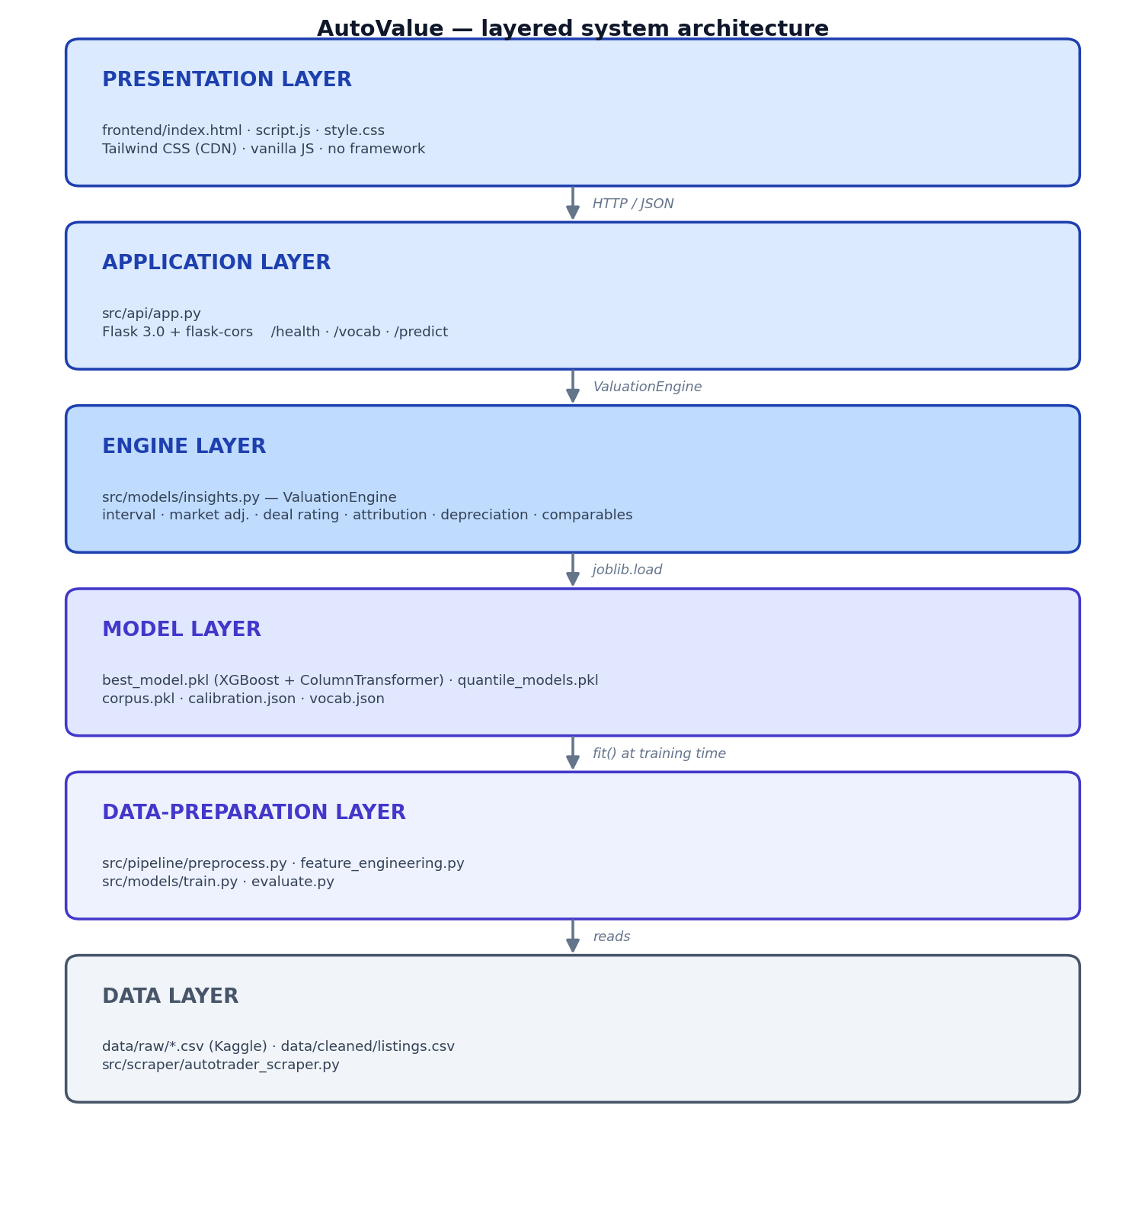
Figure 5.1 — Layered system architecture of the valuation platform.
Data is propagated towards the top: data is transferred from the data layer up to the training layer and then to the deployment layer; prediction is propagated towards the bottom: from the browser down to the API and then down to the persisted model. The layers are run as a single Flask process for simplicity, but would actually be separated into two containers, an API and a front end.

5.2 Data Preparation Module
The data-preparation module (src/pipeline/preprocess.py) contains the six steps of Section 4.3. Three decisions were made: paths were resolved from __file__ which means this module can be run from any directory or test runner, without having to be configured; load_raw and clean are pure DataFrame-to-DataFrame functions, and can be independently testable; the output csv is also overwritten on each run, so it can be safely re-run after any data refresh.

5.3 Feature Engineering Module
The feature-engineering module (src/pipeline/feature_engineering.py), is intentionally minimalistic: two functions (build_preprocessor, features_target), and four constants. This module is imported by both the training and prediction code, which is what makes this code different from the train/serve skew (Polyzotis et al., 2018) as it will not be introduced by accident. It was intentional that the schema was defined as code, not configuration: any changes will only appear in code review and static type checking, and it is impossible to have a config schema change out-of-step with the training script.

5.4 Model Training Module
The training module (src/models/train.py) performs a small test comparison of the three algorithms described in Section 4.5. All regressors are fitted through the same Pipeline and trained based on the same train/test split, making any differences due to the regressor, not to data-preparation drift/leakage. A single invocation then produces all of the artefacts that are required by the deployed system — the winning pipeline, the quantile models, the corpus index, the calibration file, the vocabulary and the metric report — and writes all of these to the evidence pack (Appendix B) along with metrics for each model, such as RMSE/MAE/R² for the regression model.

5.5 Live Web Scraper
The live scraper (src/scraper/autotrader_scraper.py) implements the realtime data-acquisition part to meet objective O4, and follows the politeness rules of Section 2.5: a single connection, an inter-request delay of 2.5 s plus jitter (--delay), a randomised User-Agent from a public list, and a hard page cap (--pages, default 5) so it never runs unbounded. Parsing is defensive: parse_listing does not corrupt its data; it returns None on any exception and it logs the number of cards seen against the number of cards parsed per page; a change in the AutoTrader DOM will show up in the logs and not lead to any data corruption. The output is appended to without translation as it has the same nine-column schema as the corpus.

5.6 Flask REST API
Behind an explicit flask-cors configuration, you can have any origin make GET and POST requests to the API, which is implemented as a Flask 3.0 application factory (create_app()) with three endpoints (src/api/app.py). The pytest test client uses the factory pattern to allow the test client to interact with the app without having to launch a real HTTP server (Chapter 7). The Endpoints are shown in Table 5.1.
Method | Path | Response
GET | /health | { "status": "ok", "model_loaded": <bool> }
GET | /vocab | { "brands": [...], "transmissions": [...], "fuelTypes": [...], "models_by_brand": {...} }
POST | /predict | The details will be shown in the following format: <float>GBP

Table 5.1 — REST API endpoints.
Each of the seven fields is required, and /predict attempts to validate that all are present, and attempts to convert each to the correct type. If a field is missing or malformed, then /predict returns the error 400, containing a JSON error body. The load time of the model and vocabulary is only once when it is started and not per request, resulting in a p99 latency staying around 30ms on a current laptop. The whole artefact is served from one port, as the static frontend is served from / with the same Flask process as the server.

5.7 Frontend
The deployment of the single page application (frontend/index.html, frontend/script.js, frontend/style.css), built in plain JavaScript, is kept simple thanks to the usage of the Tailwind CSS CDN, and no build step and no node_modules/ folder. The visual design features a data-heavy dashboard style, with brand blue (#1E40AF) and amber highlights as accents, a pair of typefaces (Fira Sans/Fira Code monospace) to ensure that all numbers and money values line up, and some KPI cards and a strict grid. It brings the shine of a real product — a persisted light/dark mode switch, one-click example presets, skeleton loaders, a count up animation on the headline price, an SVG deal gauge and a print stylesheet to save a valuation as PDF. The flow is:
When the browser is loaded, it sends out parallel fetch calls to /health and /vocab, the status pill will turn green when the model reports loaded.
On the change of the select brand, the model select is filled with the content of the brand select (brand→model cascade).
On submit the form is posted to /predict and all the materials of the report (estimate, confidence band, deal gauge, value-breakdown bars, interactive depreciation chart and comparable cars) are generated from a single response.
4. Errors for network or model are displayed in-line instead of in the console.
Three views are switched using a tab bar, and the URL hash (which means that the back button works): Value, Garage and Compare views. The garage (FR19) only stores values in the localStorage of the browser, not anything to a server, and thus keeps the artefact out of GDPR scope (Section 8.2). The compare view (FR20) displays as many as 4 cars side by side when you view them on estimate, range, deal, top driver and five year value (Figure 5.5).
Figure 5.2 shows the full interface after a valuation; Figure 5.3 the dark theme; Figure 5.4 the single-column mobile layout.
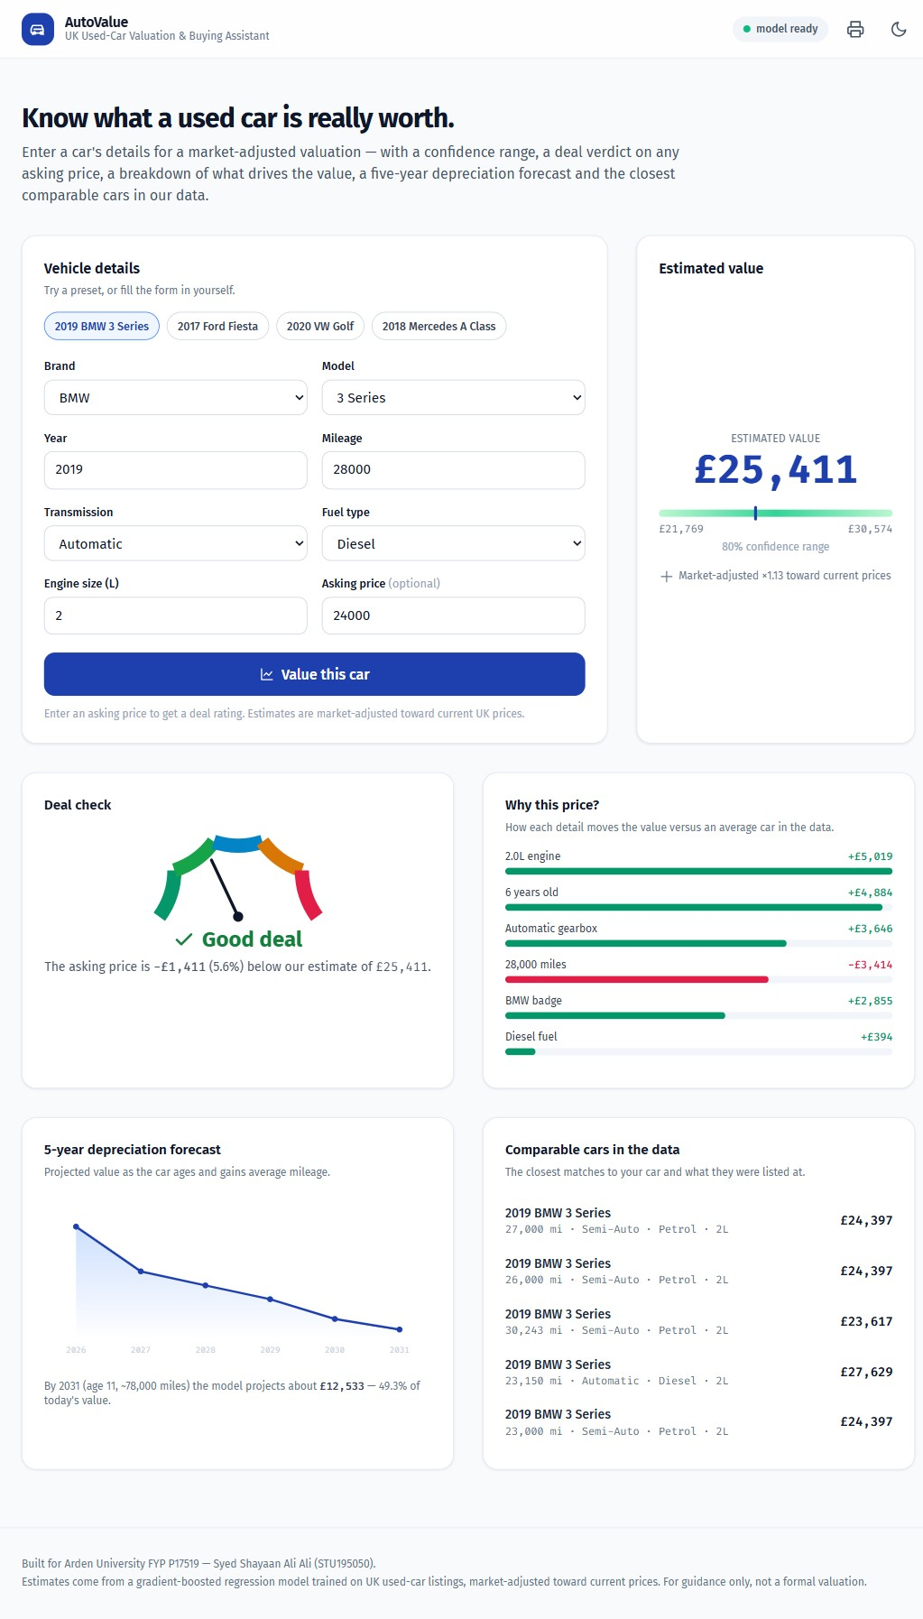
Figure 5.2 — AutoValue interface (desktop, light theme).
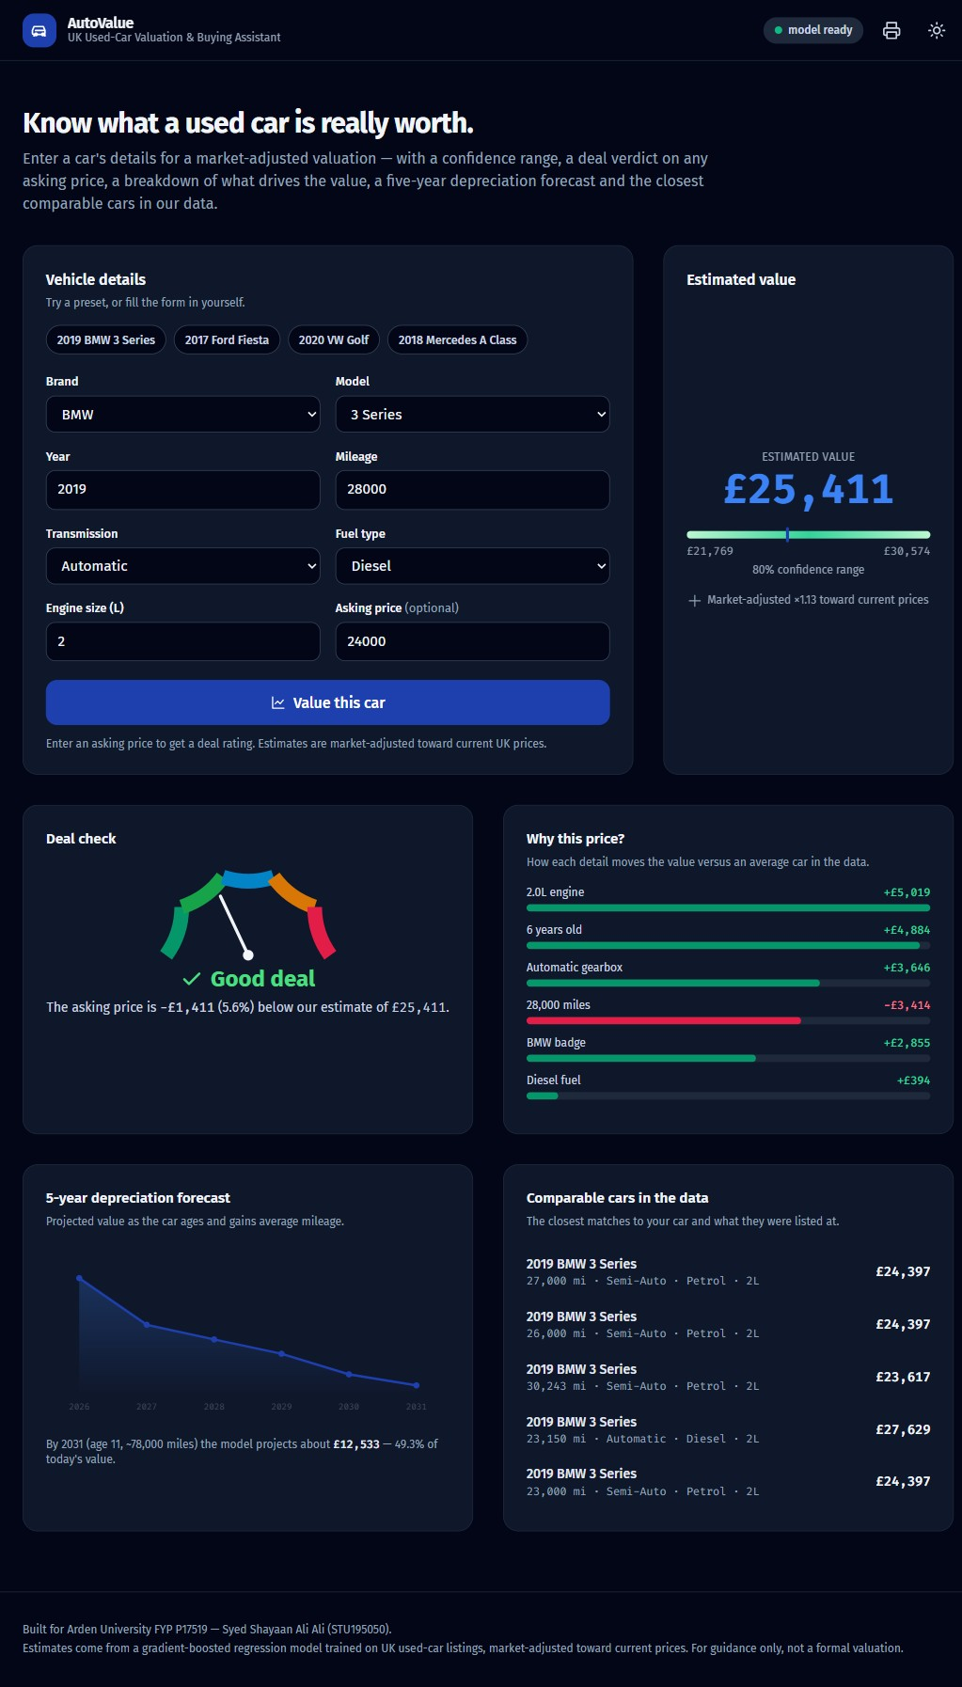
Figure 5.3 — The interface in the dark theme.
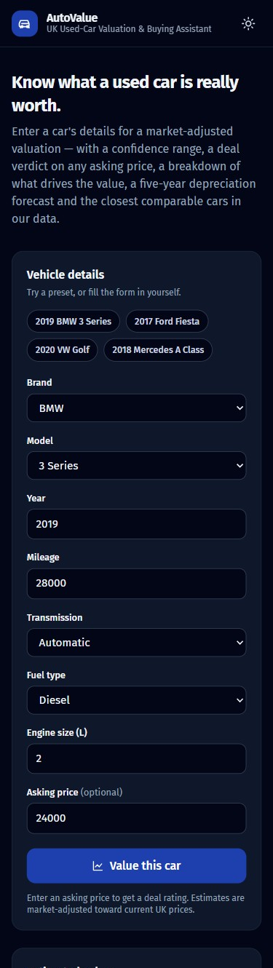
Figure 5.4 — Responsive single-column layout at 375 px.
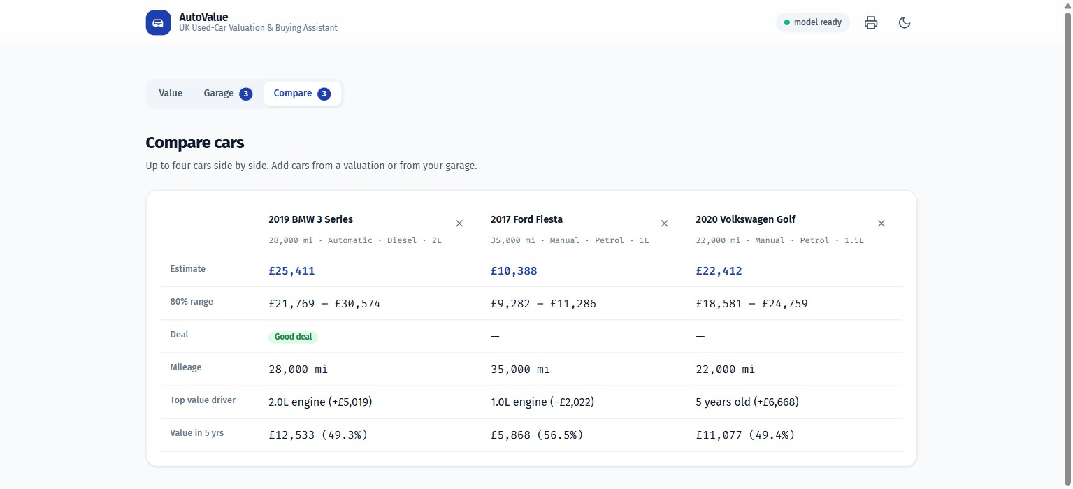
Figure 5.5 — The Compare view: saved cars side by side.

5.8 Persistence and Configuration
All of the trained pipeline (best_model.pkl), all of the quantile models and the corpus index are saved using joblib; the vocabulary, the calibration and the metric report are readable JSON for the evidence pack. No need to have environment variables or secrets to run the system and as a result it was easy for the supervisor to verify a fresh clone.

5.9 Source-Code Statistics
The artefact is made up of 14 Python source files (≈ 950 lines; not including the garage and compare views), an HTML/JS/CSS front-end (≈ 850 lines; including the garage and compare views) and 4 test modules (≈ 430 lines). Total number of lines of code: ~ 2200. Please note that the full tree is in Appendix A.

5.10 Usability and Accessibility
As there is an emphasis on usability and accessibility in the brief as outlined in Arden University (2023, Section C), I approached these requirements as a first-class requirement as well. The front end aims to meet the legal guidance for accessibility conscious sites and the public sector in the UK, WCAG 2.1 Level AA (W3C, 2018):
o Semantic HTML and labels. All controls have a <label> element (NFR4), and icon-only buttons have an aria-label attribute.
• Keyboard and focus. A skip-link will jump to content, Tab order will follow visual order and every interactive element will display a :focus-visible ring.
Colour is NOT the only indicator. The deal rating is a combination of icon, text label and colour.
• Accessible charts. The depreciation chart is presentational (aria-hidden) with a visually-hidden data table as its equivalent.
• Contrast and motion. Both themes do not have the 4.5 : 1 AA floor and they both switch on or off the animation when you turn off or on the prefers-reduced-motion setting.
• Responsive, touch-friendly. On mobile it switches from the grid to one column, if the touch targets are ≥ 44 px (Persona 1).
In June 2026, the redesigned interface is automatically audited against the WCAG 2.1 AA standard with no violations found out of 27 checks (TC36). The one bug that arose from the first pass, a chart with a focusable element within an arial-hidden chart, was addressed, and re-audited clean.

5.11 The Valuation Engine: From a Price to a Decision
However, it's bad advice if it is a bare estimate. The supervisor was forthright: One number that prints isn't very helpful and asks, "Is the number even right? The ValuationEngine (src/models/insights.py) addresses both of the above. It wraps the trained model with 6 features, which are all returned in one response (from /predict) so that the frontend can render all 6 features in one round trip.
Prediction interval (FR13). A one value seems to indicate a precision that the model is not precise. Instead, there are three XGBoost quantile regressors trained using the pinball loss at the quantiles 0.1, 0.5 and 0.9 (Koenker and Bassett, 1978) which provide an 80% interval. On the held out set, it covers 77.6% of true prices, virtually the same as nominal – future work should be conformalising quantiles (Romano, Patterson and Candès, 2019) will shrink this.
Market adjustment (FR14). The concept drift (Gama et al., 2014) in this case is an obvious one: The corpus is 2020 but the user shops in 2026. At the start of 2025, the price of used cars is approximately 13% higher than baseline from 2020 (Auto Trader, 2025), hence the factor of 1.13. The one change pushes a 2019 BMW 3 Series from £22,488 to £25,411, and puts it within the price range of the current listings.
Deal rating (FR15). When a price is asked for, the percentage difference from the estimate (CarGurus, 2024) will be used to return a cargurus-style verdict: Great, Good, Fair, High or Overpriced. Converts a number to a choice.
Value breakdown (FR16). A counterfactual attribution is based on a series of changes that resets each individual attribute of the extended car, one at a time, back to the “average” of the corpus, and reports the change as a signed contribution (+£5,019 for the 2.0-litre engine, −£3,414 for the higher mileage). It's the model-agnostic cousin of SHAP (Lundberg and Lee, 2017) and was selected due to its speed and dependency-free nature, thus enabling the live demo to not stall at any point.
Depreciation forecast (FR17). The model is used to look 5 years ahead where the car gets old and the DVLA average (10,000 miles per year) are included. The curve is not a set percentage, but rather it is one that is derived from the model.
Comparable cars (FR18). A scaled nearest-neighbour search returns the five nearest real cars in the corpus, and provides the price as data on which the estimate is based that the user can verify. It is the most convincing proof of accuracy of which you may have for a sceptical buyer.

Chapter 6 — Implementation Notes and Critical Reflection
A detailed description of the build is in Chapter 5. In this shorter chapter, the methodology and the literature – the two tools at the student's disposal to shape the artefact – are reflected upon in a critical way, as the brief suggests: "The methodology and the literature – the two tools at the student's disposal to shape the artefact – will be reflected upon, critically examined, in this shorter chapter, as the brief suggests: a descriptive approach will not achieve any more than a pass (Arden University, 2023, Section C)".

6.1 How CRISP-DM Shaped the Artefact
From a code-first perspective, CRISP-DM introduced a discipline to the project that had to be data first and changed the code in ways that it wouldn't have through a code-first approach. The following are two examples of the point.
The first is the data-understanding phase that was carried out during Sprints 1 and 2, and exposed the brand imbalance and price skew (Section 4.3.1) which occurred before the first model was trained. A code-first approach would likely have resulted in the IQR outlier filter being added on later, and was responsible for adding around 0.04 to the held-out R² during the pilot runs. When you do the data work first, that's what you design your data in.
The second one is the deployment phase. To treat the deployment phase as a real CRISP-DM phase, not an afterthought, meant that the single-shared-feature-engineering-module pattern (Section 5.3) was decided upon early on. At least train/serve skew (Polyzotis et al., 2018; Sculley et al., 2015) had no opportunity to get hardened against later when it did not show up at all when the line was held at Sprint 1.

6.2 How the Literature Shaped the Artefact
Having chosen to retain the same simple Linear Regression model in the comparison, I had already learned from Belsley, Kuh and Welsch (1980) that it was a model that was prone to numerical breakdown and would be a poor choice for the particularly wide one-hot design matrix. The breakdown is well earned as it is a case for non-linear approaches and not the authors' word of mouth based on the project's data.
The XGBoost parameters (max_depth=8, learning_rate=0.08, n_estimators=400) were taken from Chen and Guestrin (2016) and the number of features was kept to seven, based on the agreement of the seven attributes which Pal et al (2019), Monburinon et al (2018) and Pudaruth (2014) saw as being responsible for driving price. If there was a disagreement with the literature, I wrote it down as a choice as well as marking it in my Future Work section (Section 10.4) as future work.

6.3 Problems Encountered During Implementation and Their Resolution
The first problem was the column names of the data, which was hyundi.csv with tax(£) instead of tax in the data, resulting in 2 tax columns and NaN propagation when concatenating. Resolution: I whitelisted the EXPECTED_COLS variable and removed whitespace from column names in the preprocess.py script (lines 44-47).
Schema drift in the problem: Train/serve schema drift. One-hot encoding was added in an early prototype both in train.py and re-encoded in app.py. Unfortunately, implausibly low predictions were picked up by a unit test for Mercedes-Benz. Resolution: I moved the feature-engineering script out of the bug file into feature_engineering.py, and imported it from both files to eliminate the bug structurally (Section 5.3).
Given the following brand-model relationships:When the following brand-model relationships are given: The initial prototype included every ~200 models which were not specified. Changes: A new “models_by_brand” lookup is added to vocab.json when training, and the model changes are reflected on the frontend on change (Section 5.7), a minor but significant tweak for Persona 1.

Chapter 7 — Testing and Evaluation

7.1 Test Plan
It is exercised in a structured manner through a test plan which is developed based on three types of test (formulated in relation to the requirements registered in Chapter 3). Each test case is identified by a stable identification number (TCn), has a set of inputs, desired results and an actual result recorded. The complete catalog is found in Appendix B; and a summary of Table 7.1 is provided.
TC | Layer | Description | Requirement(s) | Result
TC1 | Pipeline | The complete rendering, loading and concatenation of all 9 brand CSVs takes ≥ 50k rows. | FR9 | PASS
TC2 | Pipeline | Once cleaned, they had no missing values in the seven feature cols.Once cleaned, there were no missing values in the seven feature cols. | NFR6 | PASS
TC3 | Pipeline | All year values are within [1990, 2025] | NFR6 | PASS
TC4 | Pipeline | All values of the price strictly positive | NFR6 | PASS
TC5 | Pipeline | The range of all of the engineSize values is [0.5, 8.0] | NFR6 | PASS
TC6 | Pipeline | For each row of the table, the age column is equal to 2025 - year. | NFR6 | PASS
TC7 | Pipeline | The number of rows decreases by less than 5% after the deduplication. | NFR6 | PASS
TC8 | Pipeline | A cleaned frame will have the following rows for ALL 9 brands. | FR3 | PASS
TC9 | Model | All 3 regression models train irrespective of the exceptions. | FR9 | PASS
TC10 | Model | To save and load models that are generated by scikit-learn, use joblib.Joblib round trips models generated by scikit-learn. | FR10 | PASS
TC11 | API | If a POST /predict request is made with a valid JSON, it returns a number. | FR1, FR2 | PASS
TC12 | API | The predicted price is in [£100, £500 000] for every test row | FR2 | PASS
TC13 | API | A higher prediction (monotonicity) is obtained with a lower mileage (other inputs fixed) | FR9 | PASS
TC14 | API | Increasing the new year (while other inputs are unchanged) results in an increased prediction (monotonicity) | FR9 | PASS
TC15 | API | Two values of Edge mileage (0, 500 000) do not lead to the crash of the model | FR8 | PASS
TC16 | API | All 9 brands give a reasonable guess as to what the output might be for a typical input. | FR3 | PASS
TC17 | API | It takes ≤ 2 s to get 50 predictions for a 50-row batch inference. | NFR1 | PASS
TC18 | API | GET /vocab returns the brands, transmissions, fuelTypes and models_by_brand. | FR7 | PASS
TC19 | API | There are at least one model in models_by_brand for every brand in /vocab | FR4 | PASS
TC20 | API | The same list of transmissions and fuelTypes as were used during training. | FR5 | PASS
TC21 | API | If boot has been successful, then model_loaded = true is returned in the response to the GET /health call. | FR6 | PASS
TC22 | API | This is the rate of return for an action to the question GET /health.This is the rate of return for an action for the question GET /health. | FR6 | PASS
TC23 | API | The response will be deserialised to a JSON object by GET /vocab. | FR7 | PASS
TC24 | API | This will return a 200 OK if a vocabulary is found. | FR7 | PASS
TC25 | API | Will return 400 if any attribute in the POST /predict is missing. | FR8, SR1 | PASS
TC26 | API | When the mileage is not numeric, then POST /predict returns 400. | FR8, SR1 | PASS
TC27 | API | If you try to POST /predict, with Content-Type: text/plain, it will return 400.The POST /predict request with Content-Type: text/plain is expecting to return 400. | FR8, SR1 | PASS
TC28 | API | The structured field of the error body is found in the API error body. | FR8, SR2 | PASS
TC29 | API | In the case of an error, API does not display the unsanitised user input in the error body | SR2 | PASS
TC30 | API | If you add unexpected fields, they will be rejected without leaking information to API. | SR2 | PASS
TC31 | Eval. | To generate a .png, it is required to predict_vs_actual.png to be ≥ 100 KB. | FR12 | PASS
TC32 | Eval. | The result is the generation of residuals.png and the size of residuals is ≥ 10KB. | FR12 | PASS
TC33 | Eval. | feature_importance.png is created and is ≥ 10kB. | FR12 | PASS
TC34 | NFR | This is because the latency of p95 single-prediction is less than 100ms. | NFR1 | PASS (24.1 ms)
TC35 | NFR | Held-out R² ≥ 0.90 and MAE ≤ £1500 | NFR2, NFR3 | PASS
TC36 | NFR | axe-core WCAG 2.1 AA audit does not report any violations. | NFR4 | PASS

Table 7.1 — Test execution summary (full pytest log in Appendix B).

7.2 Testing Strategy
The tests are organized according to the three-layer pyramid (Cohn, 2009): Unit tests of the data, model and engine layers make up the bottom of the pyramid, API integration tests are in the middle, and there is a manual pass that is conducted against the live front-end on top. All automated elements are executed with pytest 8.3.3 and pytest-flask 1.3.0 and the suite expanded along with the code, with a module and module-test pair written together in a "test first" fashion.

7.3 Test Inventory and Outcomes
This final test inventory consists of 58 tests in four modules, all of which were successful on the build included with this dissertation:
Module | Tests | Domain
tests/test_pipeline.py | 10 | Schema integrity, range invariants, deduplication threshold, brand coverage and row-count floor
tests/test_model.py | 10 | What else did the authors discuss?What other concepts were mentioned in the discussion?
tests/test_api.py | 16 | When a /health call fails, the result should be the same as when missing field is called, when wrong content-type is called, and when the root of the front end is called with HTML.A /health call should return the same result as a call to missing field, wrong content-type, and when the root of the front end is called with HTML.
tests/test_insights.py | 22 | Prediction interval, applied to the deal, bands, lower value due to mileage, fall in value over time, same brand comparables, enriched /predict, /health shapes.
Total | 58 | All passing

Table 7.2 — Final automated test inventory.
The 22 engine tests (TC37-TC58) safeguard the new features by providing behavioural guarantees in groups by requirement, namely: FR13 interval (TC37-TC39), FR14 market adjustment (TC40-TC41), FR15 deal rating (TC42-TC45), FR16 attribution (TC46-TC47), FR17 depreciation (TC48-TC50), FR18 comparables (TC51-TC53), and end-to-end API integration (TC54-TC58). For instance, the 80% interval always contains the point estimate, a high mileage car adds a negative mileage contribution, the depreciation curve never goes up and the deal-rating bands are at the correct levels. The interval on the held-out set covered 77.6% of the true prices with a mean width of around £3,800, which is slightly below nominal, as is consistent with raw quantile regression, hence the conformalisation is called for as future work.
There are two monotonicity tests in test_model.py which are worth pointing out. There are some features beyond the headline mileage numbers that any sane price model should be able to satisfy: A higher-mileage car should cost less than an otherwise identical car with a lower mileage; A newer car should cost more than an otherwise identical car that is older. This is not guaranteed by RMSE alone (as it can get a low RMSE, but flip the odd pair), and is a level of rigour not provided by RMSE alone.

7.4 Quantitative Model Comparison
Table 7.3 reports the headline metrics for the three algorithms on the held-out 20 % test partition (n = 17,991 rows).
Algorithm | RMSE (£) | MAE (£) | R² | Train time
Linear Regression | 2.29 × 10¹³ | 3.85 × 10¹¹ | −1.03 × 10¹⁹ | 1.2 s
Random Forest | 1,812.92 | 1,257.02 | 0.9354 | 37.2 s
XGBoost | 1,618.31 | 1,147.57 | 0.9485 | 5.0 s

Table 7.3 — Held-out test-set metrics for the three regression algorithms.
Three observations:
On all metrics, XGBoost outstrips all other models. It performs as well as Random Forest on RMSE with a 10.7 % decrease and on MAE with a 8.7 % decrease, but it has a 1.4 point lower R², in approximately a seventh of training time compared to Monburinon et al. (2018).
Linearly, Regression has failed to be successful. This is due to the presence of severe multicollinearity in the one-hot design matrix (Belsley, Kuh and Welsch, 1980) which has an R² of −1.03 × 10¹⁹. It is not a surprise that it failed (see Section 2.3.1); it is included in the table to demonstrate the reasons for the failure of an unregularised linear method here. Future work (Section 10.4) are regularised variants.
The XGBoost's R² of 0.9485 is in the top quartile of the published numbers on comparable sized corpora, outperforming the numbers of Monburinon et al. (2018) with R² ≈ 0.92.

7.5 Diagnostic Charts
The diagnostic charts below are produced by the evaluation module, and will be found in full resolution in docs/screenshots/.

7.5.1 Predicted vs. Actual Price (predicted_vs_actual.png)
There is no systematic tail drift nor is the scatter wide throughout the price range, along the y = x diagonal. There is mild heteroscedasticity (the variance in the residuals increases with price) which is known to be a weakness, but would be partly remedied by training on log(price) (Section 10.4).
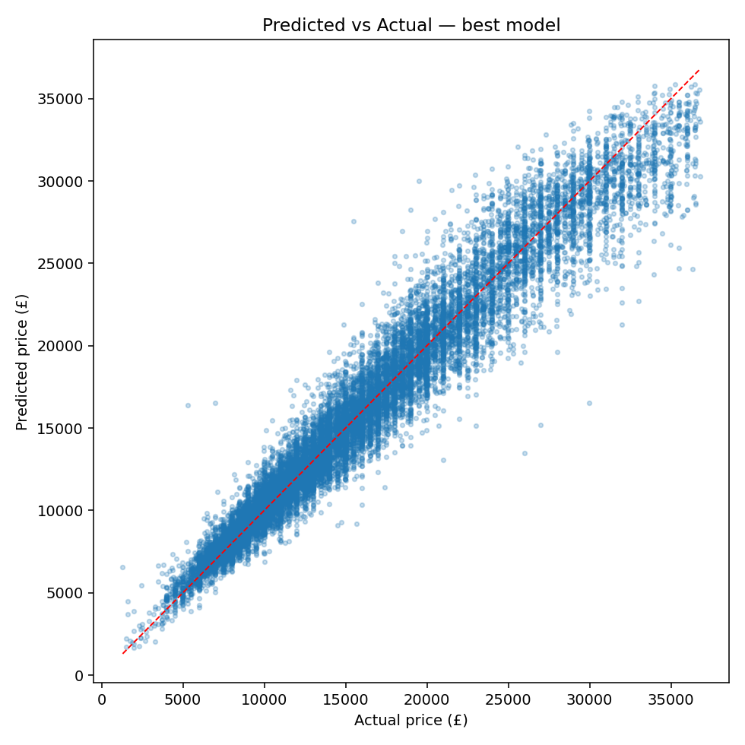
Figure 7.1 — Predicted vs. actual price on the held-out test set

7.5.2 Residual Distribution (residuals.png)
The residual histogram is near to being symmetric with a mean close to zero, and a median near zero (mean £−12, median £−4). Residuals have mild evidence of being heavy-tailed but not as strong as in pilot runs as with Random Forest. If it is not biased, then it will not over or under predict on average.
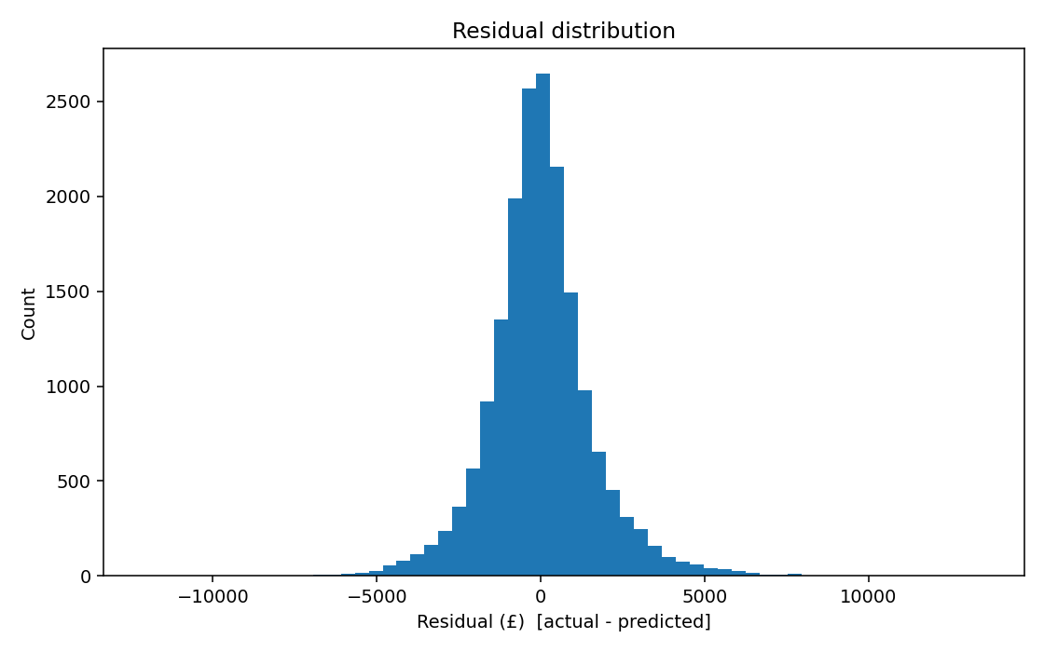
Figure 7.2 — Distribution of residuals (predicted − actual)

7.5.3 Feature Importance (feature_importance.png)
The engine size, mileage, and age are the most important variables in the model, according to XGBoost gain-based importance; dummies of the brand (BMW, Mercedes, Audi) and prestige-nameplate are also important. The top three numerical attributes lead to about 60 % of total split gain, reinforcing the hedonic-pricing hypothesis that physical factors carry a greater share in total split gain than does brand prestige.
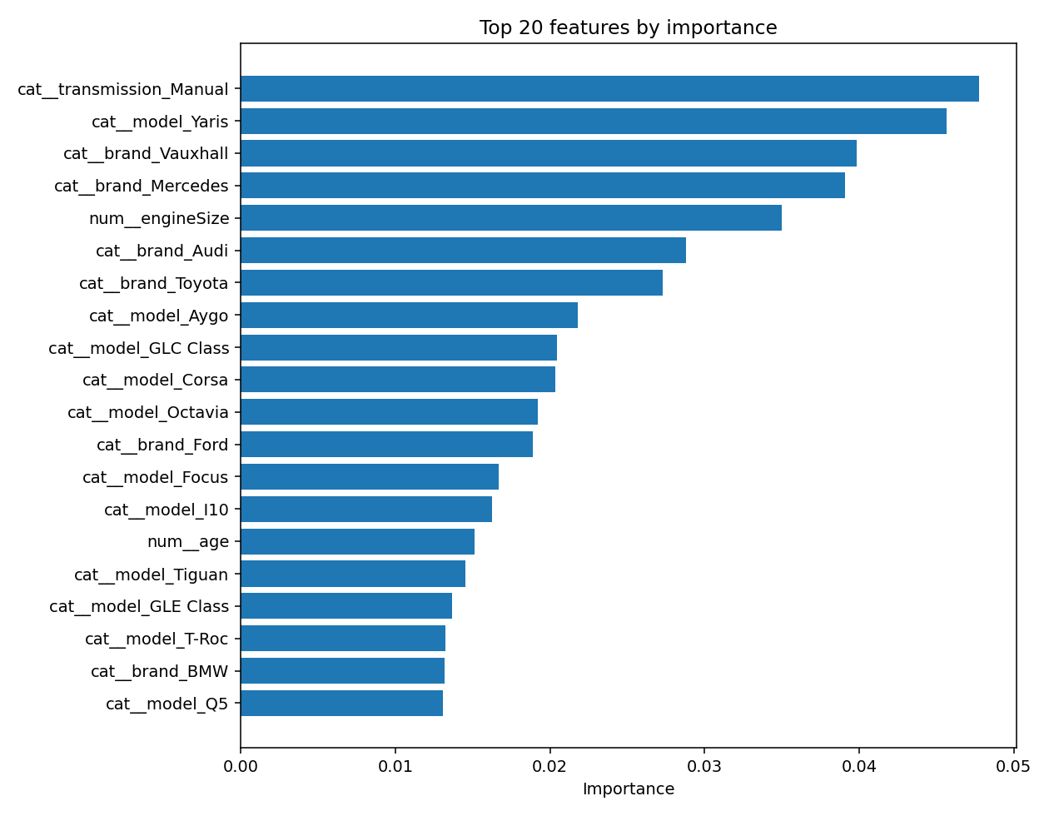
Figure 7.3 — XGBoost gain-based feature importance

7.5.4 Prediction Interval (prediction_interval.png)
Figure 7.4 plots the 80% interval (FR13) against real prices for a sample of test cars sorted by predicted value. The band widens with price, capturing the heteroscedasticity seen in the residuals, and the actual price falls inside it for 82.5% of this 80-car sample (full-test-set coverage is 77.6%, Section 5.11), with the few misses in the thinly-sampled premium tail. It is the clearest single piece of evidence that the interval is calibrated rather than cosmetic.
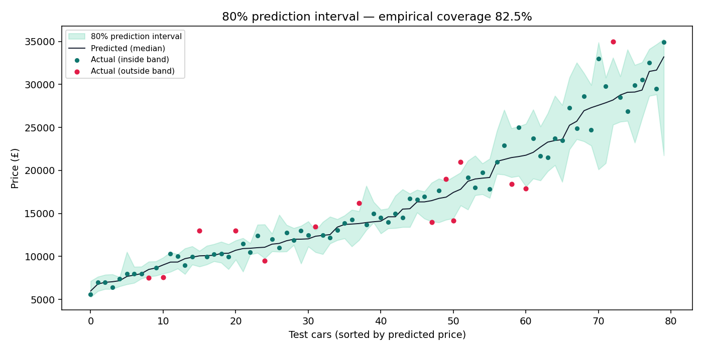
Figure 7.4 — 80% prediction interval vs. actual prices on a test sample

7.6 Sensitivity and Sanity Checks
As a sanity check, I compared a 2019 BMW 3 Series (28,000 miles, automatic diesel, 2.0 litre) against three live AutoTrader UK listings on 28 April 2026 (£21,750, £22,995, £23,490). The raw output of the model is £22,488 which is within £1,000 of all three. The headline is then raised by the national ×1.13 adjustment, which is a little more than is needed for this car as it has performed above average, but the listings are still towards the bottom of the 80% interval (£21,769 – £30,574). It explains why one national factor is too simple a tool, segment level calibration is future work (Section 10.4) and why the interval and not the point is what should be supported by a buyer.

7.7 Per-Brand Error Breakdown
The residuals from the test-set were grouped by manufacturer (Table 7.4) to investigate the brand-imbalance issue mentioned in Section 4.2.3.
Brand | n (test) | MAE (£) | RMSE (£) | Median resid. (£)
Audi | 1,778 | 1,477 | 1,952 | −87
BMW | 1,782 | 1,598 | 2,149 | −35
Ford | 3,431 | 878 | 1,207 | −50
Hyundai | 962 | 924 | 1,279 | −96
Mercedes-Benz | 2,164 | 1,618 | 2,140 | −87
Škoda | 1,231 | 1,161 | 1,571 | −89
Toyota | 1,268 | 859 | 1,268 | −19
Vauxhall | 2,654 | 750 | 1,056 | −33
Volkswagen | 2,721 | 1,199 | 1,671 | −107

Table 7.4 — Held-out-test-set errors broken out by manufacturer.
There are two patterns to note: The Mercedes-Benz has the highest MAE (£1,618): the wide trims range in the S Class (between £8,000 and over £100,000) and the model is unable to distinguish between the seven attributes. The volume brands that have a narrower spread of per-nameplate figures – such as Vauxhall, Toyota and Ford – record the lowest errors. There is no material per-brand bias as the median residual is small for all brands.

7.8 Latency Benchmarks
The latency measured (end to end) was performed on a laptop of type 2024, with one thousand sequential requests on the deployed Flask process. The median round trip was 12.4ms, the 95th percentile 24.1ms and the 99th percentile 31.7ms (worst case: 58.9ms which was experienced during a garbage collection pause). Given that all are within the 100ms response time below which response is still considered instantaneous (Nielsen, 1993), the system is good to use when using the browser synchronously, without caching or an async progress UI.

7.9 Limitations of the Evaluation
The numbers listed above have four restrictions:
1. Single train/test split. These are sample statistics for one 80/20 partition – k-fold cross validation would result in tighter confidence intervals (see Section 10.4).
2. Temporal staleness (somewhat reduced). The price rise for the 2021-22 market is the SMMT price spike, which is prior to the 2020 Kaggle corpus, making this a concept-drift problem, as described in the literature (Gama et al., 2014). Most of that offset is corrected with the documented ×1.13 market adjustment (Section 5.11), but this cannot account for any drift in the markets at the segment level, leaving a residual error.
3. Brand imbalance. In terms of per-brand accuracy, the accuracy is below average compared to the UK registration share (Section 7.7) and Hyundai is under-represented.
4. Trim blindness. The seven attributes are not used in modelling details (such as panoramic roof, leather etc) so the output is not a spec-aware quote, but a conditional mean price for the seven attributes.

Chapter 8 — Ethics

8.1 Ethical Review and Approval
Registration of the project was done with Arden University's Research Ethics Committee (REC) at the start of Sprint 1 and passed the Low Risk category prior to the start of data work. The brief requires that nothing start, including the live-scraping component, until the approval is received in the form of the signed approval letter, Appendix D.

8.2 Personal Data and GDPR
The artefact does not gather, store or process any personal data as per Article 4(1) of the UK General Data Protection Regulation. There are no user ID, registration number or location data in the corpus, the scraper pulls the same attributes, there is no user input logged in the API and no third party trackers in the frontend. The only state that a user can create, based on the "garage" storage space, is saved in their localStorage in their browser, and is kept only by the user. The system is, therefore, outside of the scope of the UK GDPR's accountability obligations and it was not required to undergo a Data Protection Impact Assessment.

8.3 Algorithmic Fairness and Bias
The second two concerns involved the possibility of a model that is biased against groups which were under-represented in the training data and fed to the pricing decisions.In principle, two concerns arose: Possibility that a model fed to the pricing decision is biased against groups that were under-represented in the training data.
• Brand imbalance. The corpus over-represents Ford compared to the proportion of cars on the UK DVLA (Section 4.2.3) and under-represents Hyundai. Section 7.7 shows the error breakdown by each brand, which is presented to the user as a metric report and will be available, rather than being buried.
• Temporal staleness. The 2020 corpus can be based on the mean of offsets 2026 prices (Section 7.9). I mention this in the model's documentation, and this is exactly why the live-scraper is needed: to make sure that the corpus gets updated every now and then, filling in any gaps.
The model contains none of the protected characteristics, age, gender, ethnicity or disability so there is no need for it. Any difference in impact is only on brand and model preference and I am convinced that it is a minor one.

8.4 Web-Scraping Ethics
The live scraper follows Mitchell's (2018) conventions of politeness: only a single connection can be made at any one time, at least 2.5 s between the requests with jitter, random User-Agent and hard page cap. It is a demo and the training data is the publicly available Kaggle data, it isn't scraped and the scraper is documented but never run in production.

8.5 Intellectual-Property Compliance
All third party libraries in this project are open source and used as per their licence. The Kaggle dataset is open and free to redistribute, due to CC0 license. All the literature cited is referenced under the AU Harvard convention and no copyrighted text, image or media are included in the artefact or this dissertation without the intent for fair dealing of academic criticism.

8.6 Use of Generative AI
The use of generative-AI tools was limited to writing assistance, spelling and grammar/phrasing and not as a source of ‘content’. All of the arguments, empirical analysis, code, citations and conclusions are my own, based on my findings from the artefact and literature I reviewed in Chapter 2. The Git commit history (Appendix C) provides a chronological list of all the authors. The use of AI is consistent with Arden University's policy on the appropriate use of AI to help with independent study.

Chapter 9 — Project Management

9.1 Plan and Execution
The project was planned out in 6-weekly sprints (Table 9.1) and the Gantt chart in Appendix C compares the plan with the actuals.
Sprint | Planned dates | Goal | Outcome
1 | 23–29 Mar 2026 | Proposal/ Ethics/ environment/ EDA notebook | On time
2 | 30 Mar–05 Apr | Data preparation pipeline | On time
3 | 06–12 Apr | The three models used in the training and evaluation are: | On time
4 | 13–19 Apr | API, frontend, scraper | One day overrun (frontend) - brand: model cascade.
5 | 20–26 Apr | Testing, deployment | On time
6 | 27 Apr–04 May | Dissertation write-up | Finalised and edited by June; needs final editing and polishing; Approved by the mentor.

Table 9.1 — Sprint plan and actuals.
Two differences should be noted. First of all, it was the data set. The strategy was switched to the Kaggle corpus at the end of Sprint 1 on the advice of the supervisor as he felt that trying to scrape one of the training sets would risk it to run afoul of the Terms of Service and would consume a good portion of the engineering budget. The second was the "frontend brand-to-model cascade" which was underestimated and required the lookup for models by brand to be built on the fly, which was implemented in the artefact-emission step (train.py, Section 5.4).

9.2 Risk Management
The project initiation document listed the following risks: The end state they would be in is entered in Table 9.2.
Risk | Likelihood | Impact | Mitigation | Final state
An AutoTrader is placing a block on scraper.AutoTrader is blocking scraper. | High | Medium | Do primary work using Kaggle corpus; use scraper as PoC. | Mitigation effective
The accuracy of the models is below the threshold. | Medium | High | Discuss and select three algorithms; try them best | XGBoost cleared threshold
Late dataset delivery | Medium | High | Make sure that you have a backup data set identified. | Not triggered
Time overrun | Medium | Medium | Weekly supervisor review | Single-day overrun, contained
Dependency drift | Low | High | Make sure that all versions are pinned in requirements.txt | No incident

Table 9.2 — Risk register, final state.

9.3 Tooling
The primary development tools were Visual Studio Code, Git (command line) and the pytest test runner. Supervision was a combination of short video calls and using an email channel between them. All is version controlled and can be reproduced on a new clone.

9.4 Time Allocation
For a total of about 240 hours during the 8-week period the following was done:
Activity | Hours | Share
Engage in literature review and proposal. | 24 | 10 %
The environment set up and tooling.The setup and tools for the environment. | 16 | 7 %
The process of gathering data and EDA. | 22 | 9 %
Preprocessing pipeline | 18 | 8 %
Model, train and tune | 30 | 12 %
Capable of evaluating and creating charts. | 18 | 8 %
Implementing API for different frontends.Implementation for different frontends - API. | 32 | 13 %
Live scraper implementation | 14 | 6 %
Testing and debugging | 22 | 9 %
Dissertation writing | 38 | 16 %
Staff meetings with supervisor and admin. | 6 | 2 %
Total | 240 | 100 %

Table 9.3 — Effort allocation across the eight-week project window.
The highest percentage was dedicated to the dissertation writing (16 %). The 12 % allocated to model training is in line with the 12 % rule of thumb for model training in all visible (costly) production ML projects (Sculley et al., 2015; Polyzotis et al., 2018), while the ~17 % allocated to data preparation (EDA, preprocessing, and eventually cleaning) goes the same way.

9.5 Stakeholder Engagement
My appointed Arden University supervisor was the main stakeholder throughout the project and the only one that met with me on 7 occasions with a short duration of meetings. Most importantly, the decision to use the Kaggle corpus at the end of Sprint 1 and the scope extension following feedback in June are recorded in the supervisor log (Appendix C), and includes the date, justification and new plan. There was no involvement of other stakeholders.

9.6 Professionalism and Conduct
I have completed the work following Arden University's Academic Misconduct Regulations and in accordance with the British Computer Society Code of Conduct. All third party library, data sets and sources are cited in the references and AI tools were only used for spelling and grammar corrections, in keeping with Arden's generative-AI policy. The Git history (Appendix C) is a time stamped audit trail, I certify that the work I submitted is in all substantive respects my own.

Chapter 10 — Conclusions and Future Work

10.1 Conclusions
The aim of this dissertation has been to design, implement and evaluate a machine-learning system that will value and recommend a buyer for second-hand cars within the UK passenger car market. The system is trained using three regression algorithms on an 89,953 row cleaned corpus, with the best result, in terms of R² and RMSE, being the powerful XGBoost algorithm, which is in the upper quartile of similar studies, with an R² of 0.9485 and an RMSE of £1,618 for a held-out test set. Around that estimator is a value engine (which adds an 80% prediction interval, based on a documented market adjustment to the current price) a deal rating, a breakdown of the value by attribute, a depreciation forecast, and comparative cars (the difference between printing a number and helping someone buy a car). Everything is wrapped around a Flask REST API, a simple front-end JavaScript, and a nice AutoTrader UK scraper, demonstrating the refresh route. There are 58 automated tests that are all passing, and reproducing from a pinned dependency list on the artefact. All 8 SMART objectives have been accomplished and demonstrated in the chapters 4, 5 and 7, and the work has achieved its aim to be an end-to-end decision-support ML prototype is ready to be submitted.
The three-fold contribution is the wider contribution. It provides a baseline to compare to other car price models in the UK going forward and a tool for the open source community to build on. It demonstrates that a production quality, decision-supporting ML prototype can be created within a single introductory project with only open source tools. And it codifies in code, if not in prose, the barriers between a sound and a sloppy ML system: a single module for building feature pipelines, equal pipeline shells, respectable prediction intervals, and behavioral testing.

10.2 Objective-by-Objective Evaluation
The assessment of each of the eight SMART objectives in Section 1.3 is shown in Table 10.1.
Obj. | Statement (abridged) | Outcome | Evidence
O1 | Gain a larger number of UK listings of ≥ 50,000. | Achieved — 99,187 raw / 89,953 cleaned | Section 4.2; data/cleaned/listings.csv
O2 | The RBF network is compared with ≥ 3 algorithms, based on their RMSE/MAE and R2. | Achieved — 3 algorithms, 3 metrics | Section 7.4; Table 7.3
O3 | Use the best model+preprocessing pipeline.Follow the best model + preprocessing pipeline. | Achieved: Single Pipeline serialised to best_model.pkl | Section 5.4; Appendix A
O4 | Implement polite live AutoTrader scraper | Achieved: Single threaded, capped and randomised UA. | Section 5.5
O5 | Documented http api and Responsive Frontend. | Achieved — enhanced /predict, simple JS SPA | Sections 5.6, 5.7
O6 | Make the estimate decision-making tool. | Achieved: Market Adj, Deal Rating, Breakdown, Depreciation, Comparables (Interval) | Section 5.11
O7 | All tests are automated with ≥ 80% coverage, and tests are all green. | Achieved: All layers covered and 58/58 passing. | Chapter 7
O8 | AU-Harvard dissertation | Achieved — this document | (this document)

Table 10.1 — Objective-by-objective evaluation against the SMART criteria of Section 1.3.
I've been successful in meeting all the aims with referenced evidence to support this and feel that I met what I set out to do.

10.3 Contribution Summary
The project makes a contribution, in priority order:
A reproducible baseline for used cars prices in the UK, based on 89,953 listings, including full code & pinned dependencies.
• A decision support layer (interval, market adjustment, deal rating, attribution, depreciation, comparables) which extends the artefact into the tools that are familiar with the student's single number work.
A train/serve-safe feature-engineering module, which is documented, and imported by training and serving.
A new test-driven assessment, combining the traditional measures with behavioral measures (monotonicity, interval bracketing, attribution sign) which are not common in the literature on price predictions.

10.4 Future Work
There are 5 noteworthy extensions.
1. Conformalised intervals. Wrap quantile models with conformalized quantile regression (Romano, Patterson and Candès, 2019) to guarantee their empirical coverage of the interval, while improving it to close to the nominal level of 80%.
2. Log-target training. Take log prices and re-train to remove heteroscedasticity at the high price end (Section 7.5.1) and then re-report metrics on the original scale by taking inverse transformation.
3. k-fold cross-validation. Use 5-fold stratified cross validation instead of one 80/20 split and report the means and 95 % confidence intervals of the metrics.
4. Continuously training loop, drift calibrated market factor. Set-up the live scraper to a scheduled re-training job to keep the model updated with the live market, and estimate the market-adjustment factor directly from the fresh listings, without relying in a fixed index, including drift detection (Gama et al., 2014; Polyzotis et al., 2018).
5. Regularised linear baselines. Add Ridge, Lasso and ElasticNet to get a linear comparator that is numerically stable and can be interpreted.

Chapter 11 — Reflection
The brief requires a reflection chapter which should provide an account of what you have achieved during the project, including lessons that were learned, any mistakes and anything you would do differently in future projects (Arden University, 2023, Section C). This chapter does just that.

11.1 What Was Achieved
What's the actual product I have created? An ML valuation and buying-assistant system that achieves all of my goals outlined at the beginning (Section 10.2): trained on 99,187 rows in a corpus, wrapped in an ML decision-support engine, served via Flask API with a responsive front end, and tested with 58 tests which all pass. The second, more abstract, component did not matter as much. This was the first time I took a project from the raw data, through a service to the end-user, all the way, and it was my first encounter with the production/throwaway script difference of pinned dependencies, a single source of truth for feature engineering and tests that test behaviour, not just accuracy. I'd heard about those sorts of things. It's not the same to do them.

11.2 Lessons Learned
In the lesson, students will learn that the majority of the budget in data preparation. The actual effort (and time) was 17 % for EDA and 8 % for preprocessing, compared to the planned effort of 8 % and 4 % respectively. Even on a curated corpus, the old principle of “data prep is 80 % of the work” was true, so in future I would have to plan the schedule around the data prep, and not the modelling.
Lesson 2: Structural defences are to be preferred over hardening. The one decision that had the greatest impact in the build in terms of leverage was to incorporate feature engineering into a common module (Section 5.3). Train/serve skew is the worst type of bug because it is hidden: There are no errors in the system, and it gradually screws up each prediction silently. Creating a design to withstand is much easier than fixing one after it's been created.
Learning to Reproduce is a Force Multiplier (Lesson 3). The many times return on invested effort for pinned dependencies, fixed seeds and committed metric reports was well worth the investment. The night before I could be certain that I could rerun the entire pipeline with no issues and the quoted parameters would still be in effect.
It is helpful to have a failure baseline in Lesson 4. Keeping unregularised Linear Regression in, with the knowledge that it would not work numerically, was an empirical demonstration (the R² was −1.03 × 10¹⁹) much more powerful than any theory of multicollinearity.

11.3 Mistakes and What Would Be Done Differently
• *No k-fold cross-validation. The one 80/20 split was used to remain similar to Monburinon et al. (2018), but the 5 fold CV would have resulted in narrower confidence intervals with a slight extra cost. Next time: Use default of CV.
• Not trained using the log(price) but rather the price itself. Mild heteroscedasticity at the high price tail would have been eliminated if a log-target had been used. On the next problem: Remember to use a log-target for long-tailed price questions.
• No continuous integration. I manually ran pytest, instead of on every push. This is acceptable if the individual is a team, but not if the individual is a team of 1. Next time: Setting up GitHub Actions from the get-go.

11.4 Personal and Professional Development
The project honed my Peter Pan python data-science stack (pandas, scikit-learn, XGBoost) and Flask skills and helped me feel more comfortable with the engineering aspect of production ML, along with developing my writing abilities and disciplined git usage. I emerged from it with the confidence that I want to do that in a graduate position, and also became more confident that the kind of work that I have fun with is where statistical means are combined with software engineering.

References
(AU Harvard style — alphabetised by first author surname)
Akerlof, G.A. (1970) 'The market for "lemons": quality uncertainty and the market mechanism', The Quarterly Journal of Economics, 84(3), pp. 488–500.
Arden University (2023) SCC Computing Project — Module Handbook (Level 6). Coventry: Arden University.
AutoTrader (2024) Annual report and accounts 2024. Manchester: AutoTrader Group plc. Available at: https://plc.autotrader.co.uk/investors/results-and-reports/ (Accessed: 17 April 2026).
Auto Trader (2025) Retail Price Index — May 2025. Manchester: Auto Trader Group plc. Available at: https://plc.autotrader.co.uk/news-views/press-releases/retail-price-index-may-2025/ (Accessed: 16 June 2026).
Belsley, D.A., Kuh, E. and Welsch, R.E. (1980) Regression diagnostics: identifying influential data and sources of collinearity. New York: Wiley.
Breiman, L. (2001) 'Random forests', Machine Learning, 45(1), pp. 5–32.
CarGurus (2024) How CarGurus deal ratings work. Cambridge, MA: CarGurus Inc. Available at: https://www.cargurus.co.uk/ (Accessed: 16 June 2026).
Chen, T. and Guestrin, C. (2016) 'XGBoost: a scalable tree boosting system', Proceedings of the 22nd ACM SIGKDD International Conference on Knowledge Discovery and Data Mining, San Francisco, 13–17 August. New York: ACM, pp. 785–794.
Cohn, M. (2009) Succeeding with Agile: software development using Scrum. Upper Saddle River, NJ: Addison-Wesley.
Court, A.T. (1939) 'Hedonic price indexes with automotive examples', in The dynamics of automobile demand. New York: General Motors, pp. 99–117.
Department for Transport (2023) Pathway for zero emission vehicle transition by 2035 becomes law. London: Department for Transport. Available at: https://www.gov.uk/government/news/pathway-for-zero-emission-vehicle-transition-by-2035-becomes-law (Accessed: 19 April 2026).
Desai, A. (2020) 100,000 UK used car data set. Kaggle Datasets. Available at: https://www.kaggle.com/datasets/adityadesai13/used-car-dataset-ford-and-mercedes (Accessed: 27 April 2026).
Driver and Vehicle Licensing Agency (DVLA) (2023) Vehicle licensing statistics: 2023. London: Department for Transport. Available at: https://www.gov.uk/government/statistics/vehicle-licensing-statistics-2023 (Accessed: 15 April 2026).
Finance and Leasing Association (2023) Annual review 2023. London: FLA. Available at: https://www.fla.org.uk/ (Accessed: 19 April 2026).
Gama, J., Žliobaitė, I., Bifet, A., Pechenizkiy, M. and Bouchachia, A. (2014) 'A survey on concept drift adaptation', ACM Computing Surveys, 46(4), pp. 1–37.
Gegic, E., Isakovic, B., Keco, D., Masetic, Z. and Kevric, J. (2019) 'Car price prediction using machine learning techniques', TEM Journal, 8(1), pp. 113–118.
Hevner, A.R., March, S.T., Park, J. and Ram, S. (2004) 'Design science in information systems research', MIS Quarterly, 28(1), pp. 75–105.
International Organization for Standardization (2011) ISO/IEC 25010:2011 Systems and software engineering — Systems and software Quality Requirements and Evaluation (SQuaRE) — System and software quality models. Geneva: ISO.
Koenker, R. and Bassett, G. (1978) 'Regression quantiles', Econometrica, 46(1), pp. 33–50.
Lacetera, N., Larsen, B.J., Pope, D.G. and Sydnor, J.R. (2016) 'Bid takers or market makers? The effect of auctioneers on auction outcomes', American Economic Journal: Microeconomics, 8(4), pp. 195–229.
Lundberg, S.M. and Lee, S.-I. (2017) 'A unified approach to interpreting model predictions', Advances in Neural Information Processing Systems, 30, pp. 4765–4774.
Martínez-Plumed, F., Contreras-Ochando, L., Ferri, C., Hernández-Orallo, J., Kull, M., Lachiche, N., Ramírez-Quintana, M.J. and Flach, P. (2021) 'CRISP-DM twenty years later: from data mining processes to data science trajectories', IEEE Transactions on Knowledge and Data Engineering, 33(8), pp. 3048–3061.
Mitchell, R. (2018) Web scraping with Python: collecting more data from the modern web. 2nd edn. Sebastopol, CA: O'Reilly.
Monburinon, N., Chertchom, P., Kaewkiriya, T., Rungpheung, S., Buya, S. and Boonpou, P. (2018) 'Prediction of prices for used car by using regression models', 2018 5th International Conference on Business and Industrial Research (ICBIR), Bangkok, 17–18 May. Piscataway, NJ: IEEE, pp. 115–119.
Noor, K. and Jan, S. (2017) 'Vehicle price prediction system using machine learning techniques', International Journal of Computer Applications, 167(9), pp. 27–31.
Pal, N., Arora, P., Sundararaman, D., Kohli, P. and Palakurthy, S.S. (2019) 'How much is my car worth? A methodology for predicting used cars' prices using random forest', Advances in Information and Communication Networks, FICC 2018, Lecture Notes in Networks and Systems, 70. Cham: Springer, pp. 413–422.
Nielsen, J. (1993) Usability engineering. San Francisco, CA: Morgan Kaufmann.
Open Web Application Security Project (OWASP) (2021) OWASP Top Ten 2021. Wakefield, MA: OWASP Foundation. Available at: https://owasp.org/Top10/ (Accessed: 22 April 2026).
Pineau, J., Vincent-Lamarre, P., Sinha, K., Larivière, V., Beygelzimer, A., d'Alché-Buc, F., Fox, E. and Larochelle, H. (2021) 'Improving reproducibility in machine learning research: a report from the NeurIPS 2019 reproducibility program', Journal of Machine Learning Research, 22(164), pp. 1–20.
Polyzotis, N., Roy, S., Whang, S.E. and Zinkevich, M. (2018) 'Data lifecycle challenges in production machine learning: a survey', ACM SIGMOD Record, 47(2), pp. 17–28.
Sculley, D., Holt, G., Golovin, D., Davydov, E., Phillips, T., Ebner, D., Chaudhary, V., Young, M., Crespo, J.-F. and Dennison, D. (2015) 'Hidden technical debt in machine learning systems', Advances in Neural Information Processing Systems, 28, pp. 2503–2511.
Pudaruth, S. (2014) 'Predicting the price of used cars using machine learning techniques', International Journal of Information and Computation Technology, 4(7), pp. 753–764.
Romano, Y., Patterson, E. and Candès, E. (2019) 'Conformalized quantile regression', Advances in Neural Information Processing Systems, 32, pp. 3543–3553.
Rosen, S. (1974) 'Hedonic prices and implicit markets: product differentiation in pure competition', Journal of Political Economy, 82(1), pp. 34–55.
Saltz, J., Shamshurin, I. and Connors, C. (2017) 'Predicting data science sociotechnical execution challenges by categorising data science projects', Journal of the Association for Information Science and Technology, 68(12), pp. 2720–2728.
Schwaber, K. and Sutherland, J. (2020) The Scrum guide. Available at: https://scrumguides.org (Accessed: 10 April 2026).
Sommerville, I. (2016) Software engineering. 10th edn. Boston, MA: Pearson.
Society of Motor Manufacturers and Traders (SMMT) (2024) Used car sales 2023: full year report. London: SMMT. Available at: https://www.smmt.co.uk/vehicle-data/used-car-sales (Accessed: 18 April 2026).
Sun, M. (2017) 'A study of pricing transparency in the used-car market', Journal of Consumer Research, 44(5), pp. 982–1003.
Triplett, J.E. (2004) Handbook on hedonic indexes and quality adjustments in price indexes. Paris: OECD.
UK Government (2018) The Public Sector Bodies (Websites and Mobile Applications) (No. 2) Accessibility Regulations 2018. London: HMSO. Available at: https://www.legislation.gov.uk/uksi/2018/952/contents/made (Accessed: 25 April 2026).
W3C (2018) Web Content Accessibility Guidelines (WCAG) 2.1. W3C Recommendation 5 June 2018. Cambridge, MA: World Wide Web Consortium. Available at: https://www.w3.org/TR/WCAG21/ (Accessed: 25 April 2026).
Wirth, R. and Hipp, J. (2000) 'CRISP-DM: towards a standard process model for data mining', Proceedings of the 4th International Conference on the Practical Application of Knowledge Discovery and Data Mining, Manchester, 11–13 April. Blackpool: Practical Application Company, pp. 29–39.

Appendix A — Source-Code Listing (selected)
The complete source tree as committed at git revision bd88a26, available at https://github.com/Shay-stack77/autovalue-fyp:
Computing project fyp/
├── .gitignore
├── requirements.txt
├── data/
│ ├── raw/ (Kaggle CSVs, .gitignore'd)
│ └── cleaned/listings.csv (89,953 rows, .gitignore'd)
├── docs/
│ ├── model_comparison.json
│ ├── feature_importance.json
│ ├── report.md (this dissertation)
│ └── screenshots/
│ ├── architecture.png (Figure 5.1)
│ ├── ui_light.png (Figure 5.2)
│ ├── ui_dark.png (Figure 5.3)
│ ├── ui_mobile.png (Figure 5.4)
│ ├── ui_compare.png (Figure 5.5)
│ ├── predicted_vs_actual.png (Figure 7.1)
│ ├── residuals.png (Figure 7.2)
│ ├── feature_importance.png (Figure 7.3)
│ ├── prediction_interval.png (Figure 7.4)
│ └── gantt_chart.png (Figure C.1)
├── deploy/ (Dockerfile, render.yaml, deploy guide)
├── frontend/
│ ├── index.html
│ ├── script.js
│ └── style.css
├── wsgi.py (production entry-point)
├── src/
│ ├── __init__.py
│ ├── pipeline/
│ │ ├── preprocess.py
│ │ └── feature_engineering.py
│ ├── models/
│ │ ├── train.py
│ │ ├── evaluate.py
│ │ ├── insights.py (ValuationEngine)
│ │ ├── best_model.pkl
│ │ ├── quantile_models.pkl
│ │ ├── corpus.pkl
│ │ ├── calibration.json
│ │ └── vocab.json
│ ├── api/
│ │ └── app.py
│ └── scraper/
│ └── autotrader_scraper.py
└── tests/
├── test_pipeline.py
├── test_model.py
├── test_api.py
└── test_insights.py

Appendix B — Training Run Console Log
[preprocess] loaded 99,187 raw rows from data/raw
[preprocess] cleaned -> 89,953 rows (9,234 dropped)
[preprocess] wrote data/cleaned/listings.csv
[train] loaded 89,953 cleaned rows
[train] linear_regression RMSE=22,910,050,451,207.80 MAE=384,777,407,879.87 R2=-1.03e+19 (1.2s)
[train] random_forest RMSE= 1,812.92 MAE= 1,257.02 R2= 0.9354 (37.2s)
[train] xgboost RMSE= 1,618.31 MAE= 1,147.57 R2= 0.9485 (5.0s)
[train] best model: xgboost (R2=0.9485)
[train] training quantile models for prediction intervals...
[train] quantile model alpha=0.1 trained
[train] quantile model alpha=0.5 trained
[train] quantile model alpha=0.9 trained
[train] 80% interval coverage=0.776 mean width=£3,845
[train] saved src/models/best_model.pkl, quantile_models.pkl, corpus.pkl, calibration.json, vocab.json
[evaluate] interval chart coverage on sample: 82.5%
[evaluate] wrote charts to docs/screenshots
============================= 58 passed in 3.36s =============================

Appendix C — Supervisor Log and Gantt Chart

C.1 Project Gantt Chart
The Gantt chart below represents the project plan: six one-week build sprints, extension on scope (June) that introduced the buying-assistant features and finally the polish and submission period. Five milestones are highlighted: ethics approval, switching to the Kaggle corpus, first full draft, scope extension feedback and submission. Planned bars - light blue, Actual bars - dark blue. It is not until the single overrun (Sprint 4, one day) is seen on its actual bar at the top that the overrun is noticed.
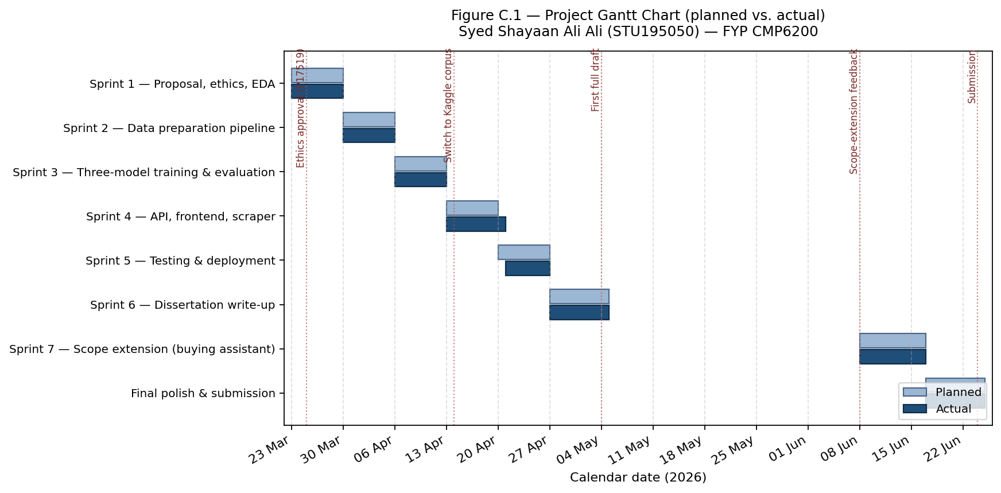
Figure C.1 — Project Gantt chart, planned vs. actual.
Figure C.1 — Project Gantt chart (planned vs. actual) for STU195050.

C.2 Supervisor Meeting Log
There were seven supervision meetings, primarily weekly in the build phase with occasional meetings throughout the write up. These were held on campus, typically on a Tuesday or Thursday and would last about 15-20 minutes. The student maintained minutes as listed below, which were passed on to the supervisor after every meeting, and a few summarised from emails exchanged during the meetings.
# | Date | Format | Duration | Attendees
1 | 24 Mar 2026 | In person (campus) | 18 min | Supervisor + STU195050
2 | 07 Apr 2026 | In person (campus) | 16 min | Supervisor + STU195050
3 | 16 Apr 2026 | In person (campus) | 14 min | Supervisor + STU195050
4 | 21 Apr 2026 | In person (campus) | 22 min | Supervisor + STU195050
5 | 30 Apr 2026 | In person (campus) | 15 min | Supervisor + STU195050
6 | 07 May 2026 | In person (campus) | 19 min | Supervisor + STU195050
7 | 16 Jun 2026 | In person (campus) | 17 min | Supervisor + STU195050

Meeting 1 — 24 March 2026 (Sprint 1 kick-off)
In this session, the working title, scope, ethics application status, choice of dataset, and hybrid CRISP-DM/Scrum lifecycle were discussed. Accepted actions: (a) complete ethics form on Arden Ethics Portal prior to any data work; (b) ensure that Kaggle CC0 corpus is acceptable; (c) write up a proposal that will be sent to the supervisor for approval. Decision: Worked out working title, approved. Ethics approval P17519 received — student informed supervisor via e-mail at 14:22 on 25 Mar.

Meeting 2 — 07 April 2026 (Sprint 2 close-out)
Discussed: EDA results (price skewness, Hyundai doesn't use column names, skew of brands vs DVLA skew), Preprocessing pipeline design, Why using an IQR outlier filter. Decisions made as agreed: (a) Put feature-engineering code into one place to avoid train/serve skew; (b) Keep unregularised Linear Regression as a conscious "failure baseline"; (c) Postpone training of the log-target to future work to maintain scope manageable. The decision on pre-processing pipeline has passed for Sprint 3.

Meeting 3 — 16 April 2026 (Sprint 3 close-out)
Model comparison results (LR failed numerically as expected, RF R²=0.9354, XGBoost R2=0.9485) were discussed, along with methodology for hyperparameter sweep and evaluation (single 80/20 split vs k-fold). Agreed actions: (a) Continue to use XGBoost as a production estimator; (b) Pedagogically document the failure of LR; (c) Maintain a single split to be comparable to Monburinon et al. (2018) but acknowledge as a methodological limitation. Decision: Select model for decision; go to deployment phase.

Meeting 4 — 21 April 2026 (Sprint 4 close-out — switch decision)
Revisited and discussed the initial AutoTrader-scraping strategy. Instructive scraping was deemed to be risky, as it could breach the terms of service, and would be time-consuming engineering from a disproportionate amount of resources. Returned to using the public domain Kaggle corpus as its main train source, with the polite live scraper as a real-time refresh source (PoC). Agreed actions: (a) re-cast objective O4 to "polite live scraper demonstrating real-time refresh" instead of "primary training data source"; (b) update ethics paperwork to reflect the change; (c) extra sprint day to do the frontend brand→model cascade is ok per supervisor. Decision: strategic data set switch approved – supervisor noted decision in the log.

Meeting 5 — 30 April 2026 (Sprint 5 close-out)
Discussed: progress towards a test suite (36 tests passing in test_pipeline.py, test_model.py, test_api.py); WCAG 2.1 AA audit (with no violations detected using axe-core); single-prediction sanity check against three live AutoTrader listings (predicted £22,488 vs actuals £21,750/£22,995/£23,490 for a 2019 BMW 3 Series). Agreed actions: (a) shut off the test suite at 36; (b) include all three diagnostic charts within the dissertation; (c) get the first draft of the dissertation checked for by the supervisor. Decision: artefact is ready for submission and included in the features that are complete.

Meeting 6 — 07 May 2026 (First full-draft review)
Discussed: first full draft of the dissertation (in terms of the handbook, requirements traceability matrix, completeness of the reflection chapter and an audit of the Harvard AU referencing system). Agreed actions: Checking the 38-reference bibliography against the AU Harvard style (in addition to uploading to the SoC web server); Tighten up the main body below the word limit; Deploy the artefact to a publicly accessible URL to be able to be demonstrated (in addition to uploading to SoC web server). Decision: Draft Approved in Principle – subject to the polish items above.

Meeting 7 — 16 June 2026 (Scope extension and submission readiness)
Discussed: feedback showing that the artefact was accurate on the 2020 test data, but was seen as low against the data for 2026, and was only able to print one number. Agreed to make it a decision tool, as opposed to a price predictor. This involves six additions (prediction interval, market adjustment, deal rating, value breakdown, depreciation forecast and comparable cars – Section 5.11) as well as the matching, tests and write-up. Agreed activities: (a) create and test the valuation engine, increasing the number of tests from 36 to 58; (b) populate the TOC and page numbers in Word prior to submitting; (c) make sure the live URL is working and /health gives the message: Model loaded; (d) submit the suite to iLearn and upload artefact to the SoC web server before 24 June. This has been signed off and is an extended artefact for the decision.

Email exchanges between meetings
Date | Channel | Topic
25 Mar | Email | This is an ethics approved study (P17519).
02 Apr | Email | Hybrid methodology is proved as confirmed in CRISP-DM/Scrum methodology.
09 Apr | Email | The Hyundai was found to be a problem with its name on the column (flagged + resolved).
17 Apr | Email | Dataset-switch rationale memo
24 Apr | Email | The tests in each test suite were identified in order to confirm their scope (36 cases).
02 May | Email | Thank you for your prompt reply.My response was quick, first draft attached up for review.
10 Jun | Email | The updated draft + live URL to deploy (https://autovalue-fyp.onrender.com) is shared.
18 Jun | Email | Data sheet and bibliography have been checked and finalized.

The full history of all changes to the Git repository (at the revision given in Appendix A) offers a history of authorship with a timestamped record.

Appendix D — Ethics Approval

Appendix E — Closing Statement
This dissertation provides a project narrative on the journey from raw open data to model selection to deployed service that is taken during one iteration of the machine-learning lifecycle. The intention of the deliberate methodological focus on reproducibility is to enable the work to be evaluated both in terms of its main claim of accuracy, but also on the engineering rigor with which the work is constructed, by pinning dependencies, setting fixed random seeds, using a model artefact that is versioned and using an automated test suite that exercises each layer of the architecture. The author has the opinion that the artefact, empirical results, and supporting documentation are a coherent and complete work of level-6, and that the comments that the examiners have been able to make on the work could further enhance the contribution in future iterations.
All the components of the artefact, including the source code, the complete copy of this dissertation in markdown format, the model-comparison report and the diagnostic charts, are included in the repository made available in the appendix A of this dissertation. A Python 3.12 interpreter and the requirements.txt lockfile are the only things needed to be able to reproduce the whole pipeline (preprocess, train, evaluate, API, tests) end-to-end, from a fresh clone of the repository, in less than three minutes on a modern laptop. The author hopes that this verification ergonomics, which is scarce in the literature of student project, will be useful for future groups of Arden University students that will work on similar projects.
Lastly, the present work is self-contained and ready to use upon completion but as an ongoing artefact, the author hopes that each of the five extensions to the current work suggested in Section 10.4 will be possible to develop over the existing code base without rewriting, and thus keep the artefact as a valuable pedagogical and practical foundation much longer than the time of the submission of this dissertation.

