
A Needle in a Data Haystack



Finding the Needle in Ranked Play
Behavioral and Strategic Patterns in League of Legends
Shay Morad, shay.morad@mail.huji.ac.il, shay.morad
Aminadav Eliyahu, aminadav.eliyahu@mail.huji.ac.il, ami.10122
Amit Itah, amit.itah@mail.huji.ac.il, amit.itah
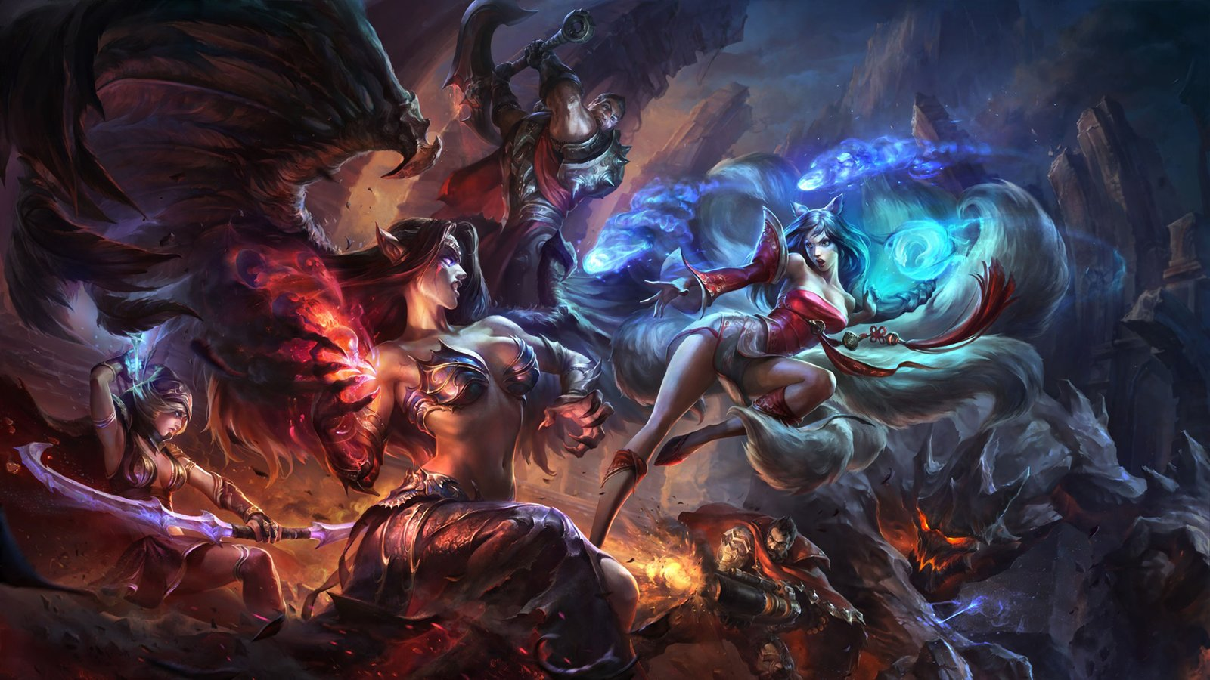


Domain and Motivation
League of Legends (LoL) is a competitive multiplayer game in which two teams of five players compete in repeated matches. Ranked play produces rich longitudinal data: the same players appear across many games, allowing analysis not only of what happens inside a match, but also of behavioral patterns between matches.

Our project uses this temporal structure to study patterns that are difficult to detect from individual games alone. In particular, we distinguish between variables known before a target match and statistics produced during it, preventing target-match information leakage in predictive analyses.
Data
Our primary dataset is a collection of Riot Match-V5-style records covering North America (NA), Korea (KR), and Europe (EU). The raw data occupy approximately 75 GB uncompressed. After streaming extraction and deduplication, the processed corpus contains 497,102 unique matches, 4,971,020 participant rows, and 994,204 team rows.
We converted the raw JSON data to compressed Parquet tables with separate match-, participant-, team-, and champion-ban-level records, allowing efficient analysis of the full corpus. The source dataset is: https://www.kaggle.com/datasets/omaracornejo/matches-raw-euw
A major sampling issue is that matches were collected by crawling the histories of predefined seed players. Thus, many players appearing in a downloaded match are incidental teammates or opponents and should not automatically be treated as longitudinally sampled players. We reconstructed an authoritative tracked-player cohort using the original seed lists together with stable Riot PUUID evidence from the accompanying database. The final cohort contains 11,169 player-region identities and covers 100% of NA matches, 100% of KR matches, and 99.95% of EU matches.

Before analysis, we verified sampled raw PUUID-to-processed-ID mappings, participant counts, duplicate IDs, timestamps, missingness, and chronological ordering. The final longitudinal data contain no duplicate (player, match) observations and no negative inter-match gaps. Remaining limitations are that the data are crawler-based rather than a random sample of all LoL players, histories are limited to the observed crawl window, and very short/remake-like games can distort performance measures. These issues are addressed through explicit filtering and robustness analysis rather than silent removal.


Problem 1 - Temporal Behavior & Next-Match Performance
Problem and Hypotheses
We investigate whether session depth, recent ranked-game volume, and post-loss requeue timing are associated with performance in a player's subsequent Ranked Solo/Duo match. We test whether performance worsens with deeper sessions (H1), rapid requeueing after a loss (H2), and greater recent volume (H3), and whether these behavioral variables add predictive information beyond historical player performance (H4). Because the data contain no psychological measurements, these variables are treated as observable behavioral patterns rather than direct measures of fatigue or “tilt.”

Solution / Method
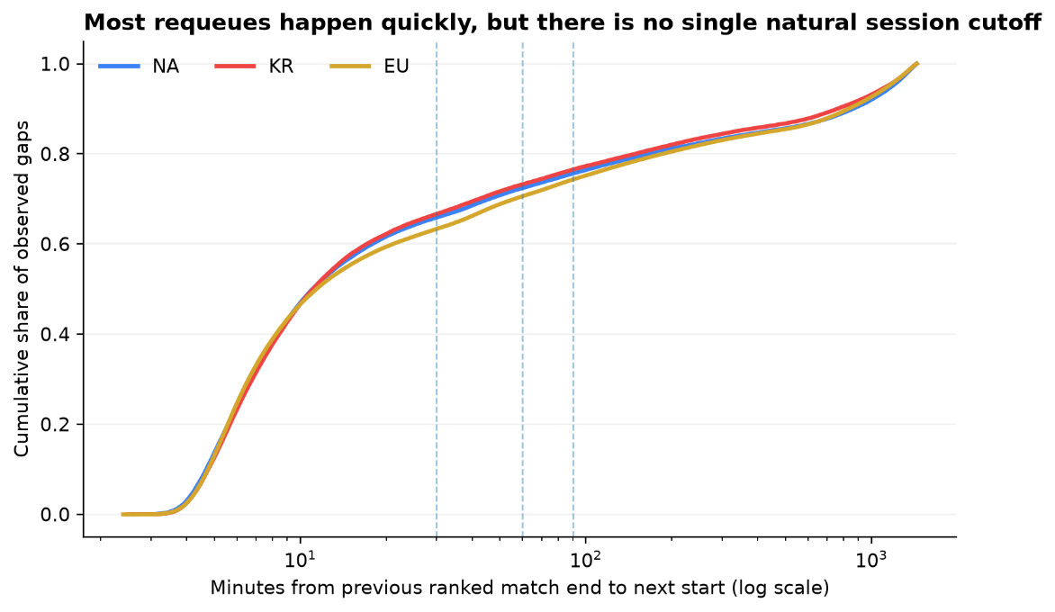
For each authoritative tracked player, matches were ordered chronologically and converted to target-centric observations containing only information available before the target match. The primary sample comprised 1,146,681 Ranked Solo/Duo targets lasting ≥10 minutes across NA, KR, and EU. Inter-match gaps showed a dense short-gap component followed by a long tail (Fig. 1);

Figure 1. Distribution of ranked inter-match gaps across regions. Most observed requeues occur after relatively short gaps, followed by a long tail. We therefore use a conservative 30-minute primary session boundary and test 45-, 60-, and 90-minute alternatives.

Recent volume used a 6-hour primary window with 3/12/24-hour alternatives. We estimated within-player linear probability models with player fixed effects, pre-target history/patch controls, and standard errors clustered by player and physical match. For prediction, we used entropy-based decision trees and selected max_depth and min_samples_leaf on validation data to control overfitting.
Evaluation & Setup
For H1–H3, success required a consistent, practically meaningful, cross-region association, not merely p<.05. We therefore examined effect sizes, 95% CIs, monotonicity, Holm-corrected tests, and sensitivity to alternative thresholds. For H4, Riot's observed target-match win/loss was the ground truth. Data were split chronologically within region into 70% train / 15% validation / 15% test, and we compared majority and historical-win-rate baselines with history-only, behavior-only, and combined trees. Evaluation used accuracy, precision, recall, F1, confusion matrices and ROC-AUC.


Results & Visualization
Raw averages did not show the expected simple fatigue pattern, motivating adjusted within-player analysis:
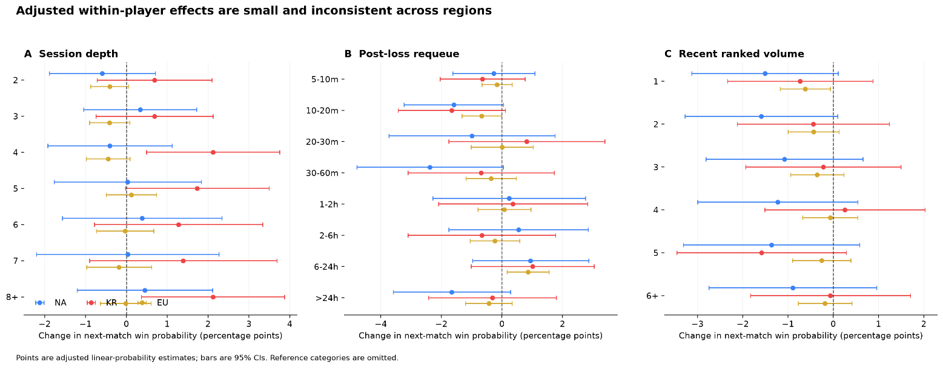
Figure 2. Adjusted within-player associations with subsequent Solo/Duo victory. Points show estimated percentage-point changes in win probability and intervals show 95% CIs. Across session depth, post-loss requeue timing, and recent ranked volume, estimates are small, non-monotonic, and inconsistent across regions.
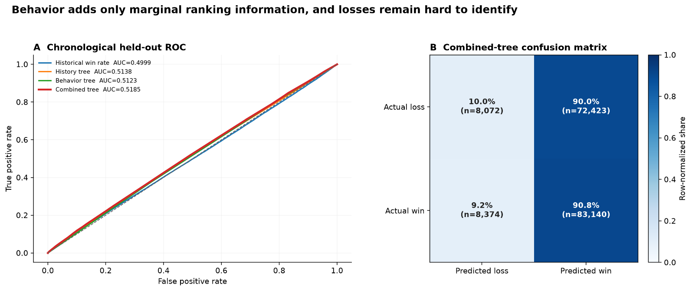
Figure 2 summarizes the primary estimates: session depth, post-loss requeue timing and six-hour volume produced small, non-monotonic, region-dependent effects. In the continuous post-loss model, doubling the requeue gap changed next-match win probability by approximately −0.04 pp (NA), +0.11 pp (KR), and +0.03 pp (EU). No primary behavioral family retained a significant term after Holm correction.

Figure 3. Chronological held-out predictive performance. The combined history + behavior tree improves ROC-AUC only slightly over the history-only model, while the normalized confusion matrix shows that the model identifies wins much more readily than losses.
Prediction was similarly weak (Fig. 3): test AUC was 0.5138 for the history tree, 0.5123 for behavior alone, and 0.5185 for the combined tree, an incremental gain of only 0.0047 over history. Accuracy remained near the majority baseline, while the confusion matrix showed poor loss discrimination.

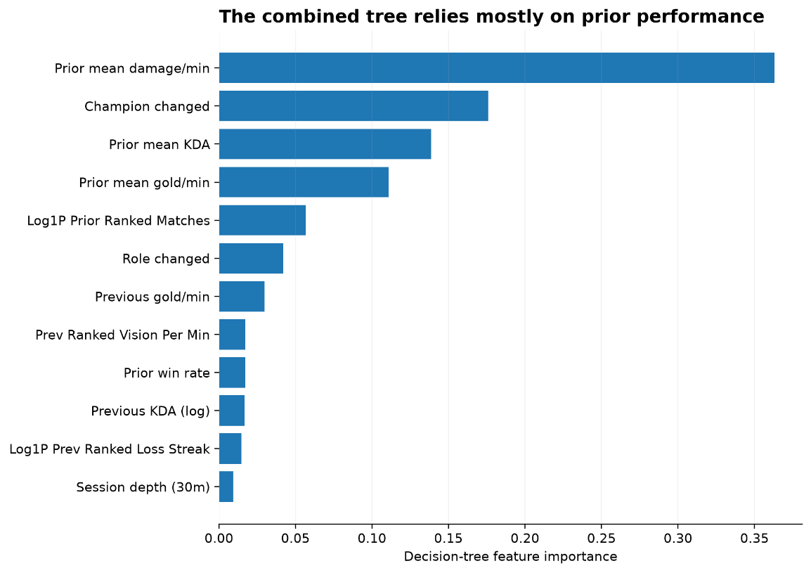

Figure 4. Feature importance of the combined entropy-based decision tree. Historical performance features account for most of the model’s splitting decisions, while session and requeue-related variables contribute comparatively little.
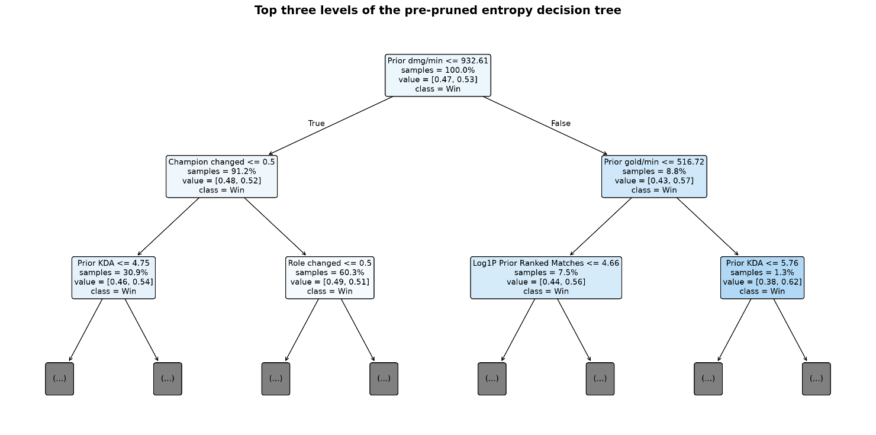
Figure 5. Top three levels of the combined entropy-based decision tree. The first splits are driven mainly by prior performance statistics, illustrating how the model separates observations before incorporating weaker behavioral features.
The entropy tree relied mainly on historical damage, KDA and gold variables; champion/role switching contributed more than session depth or raw gap (Fig. 4).

Impediments & Robustness


The main challenges were crawler-biased player sampling, arbitrary session boundaries, short/remake-like games, repeated player observations, and shared physical matches. We addressed these through PUUID-based tracked-player reconstruction, alternative session/activity thresholds, two-way clustered uncertainty, and robustness samples. Lowering the duration rule from 10 to 5 minutes changed primary effects by at most 0.09 pp, while the stricter alias-confirmed cohort produced no new stable cross-region pattern or Holm-significant primary family.
Conclusion
Overall, we find little evidence for a universal short-term fatigue or post-loss requeue penalty. Session depth, recent ranked volume, and rapid requeueing show small, parameter-sensitive associations rather than a stable cross-region decline in performance. Behavioral timing adds only limited predictive information, and because the data are observational, the results should not be interpreted as causal evidence about fatigue or tilt.

