SHB CORPORATE
OPPORTUNITY OS
Controlled Multi-Agent Workspace for B2B Sales
“Bánh vẽ” đầu tư + Product Blueprint + NeurIPS-style Evaluation Plan
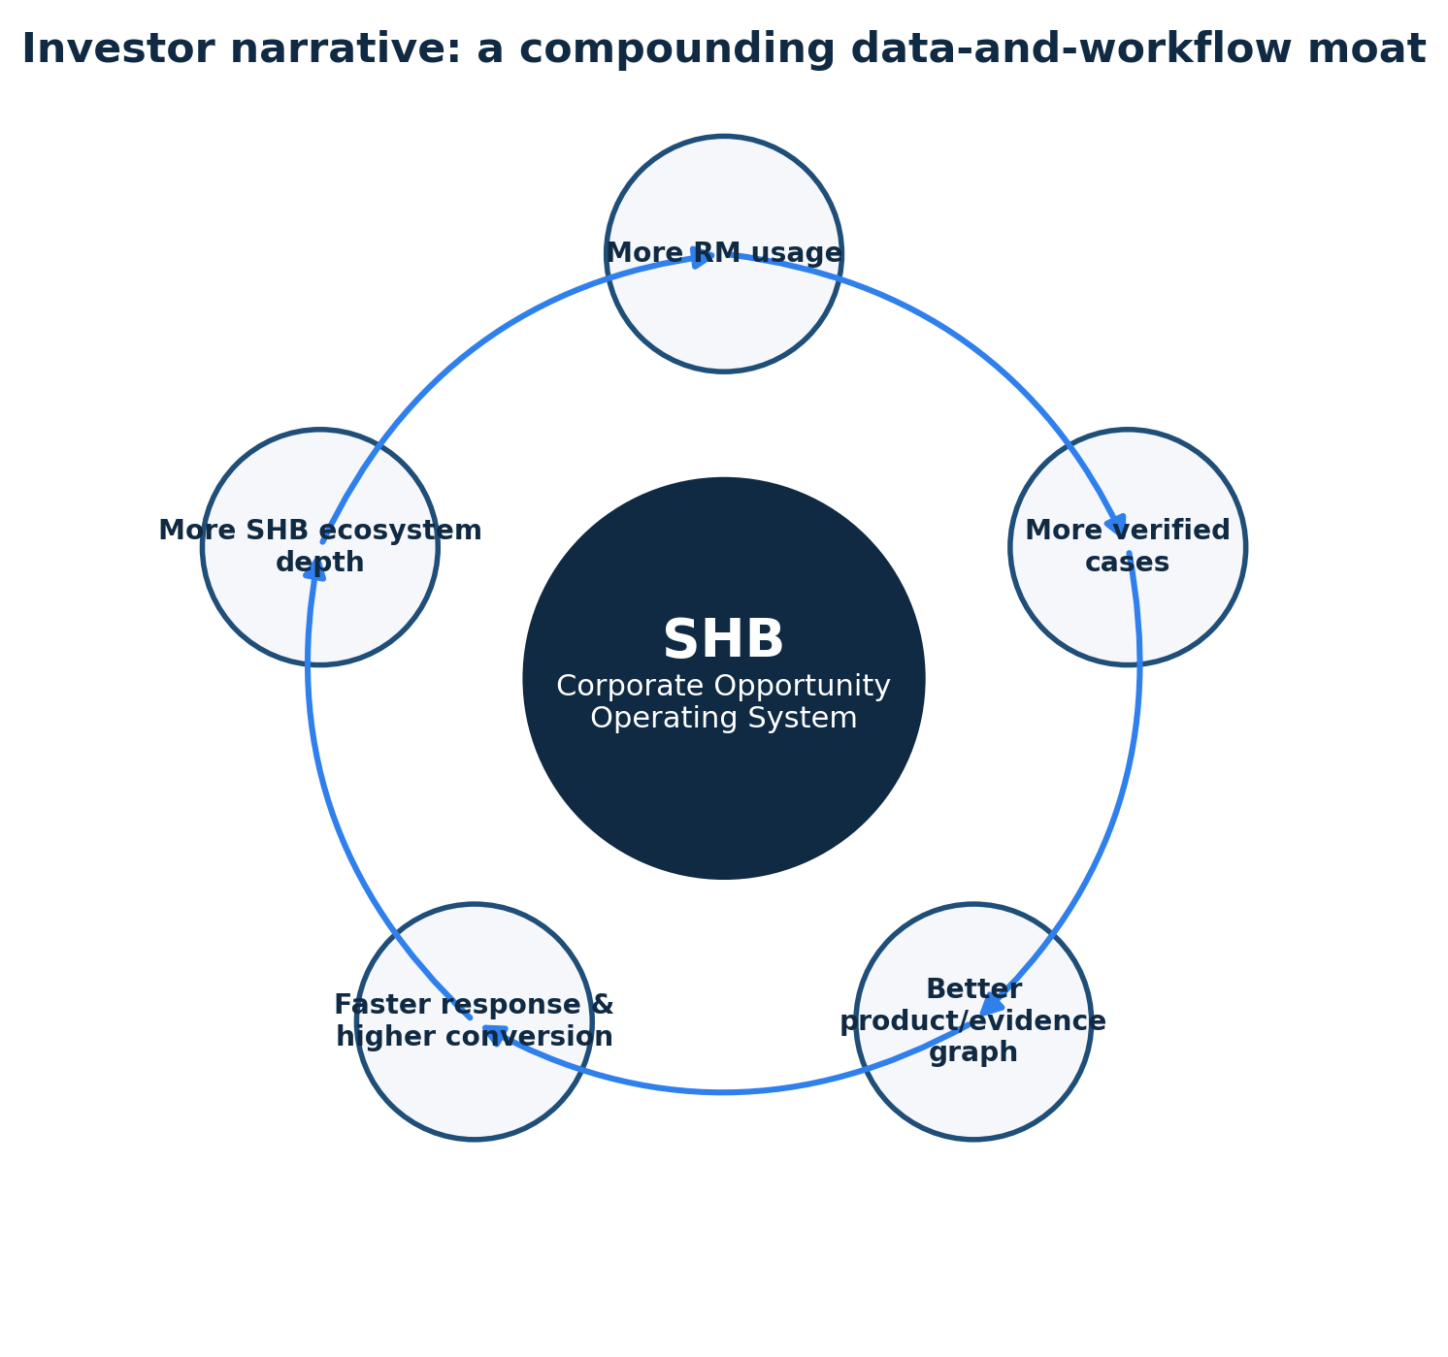
Prepared for Vietnam AI Innovation Challenge 2026
As-of date: 17 July 2026

Executive summary
THESIS
SHB does not primarily need another banking chatbot. It needs a controlled opportunity operating system that helps corporate Relationship Managers convert fragmented client needs into an evidence-backed product bundle, a compliant next step and an executable CRM workflow.

Dimension | Current friction | Proposed change | Winning proof
Impact | Corporate requests span payroll, supplier payments, cash management and credit. RM time is consumed by lookup, coordination and repeated clarification. | One shared case state coordinates Product, Legal, Operations, Evidence and Approval. | A live vertical slice from request to approved mock CRM action.
Risk | LLMs can hallucinate eligibility, omit evidence or create unsafe actions. | Deterministic rules, branch-level blocking, evidence validation and human approval. | Unsafe external-action rate = 0%; evidence coverage = 100%.
Recommendation | Focus on one B2B hero case, not a broad “AI bank”. | Manufacturing company with 500 staff, fragmented cash, supplier payments and seasonal working-capital need. | The safe transaction-service branches continue; only the credit branch pauses for missing UBO/BCTC.
Control | A demo can become un-auditable if agents pass free-form text. | Typed contracts, shared state, citations, payload hash, HMAC approval and idempotency. | Agent trace, decision brief, evidence panel and execution receipt.

INVESTMENT STORY
The wedge is RM productivity in corporate banking. The expansion path is an enterprise workflow platform for client onboarding, product bundling, supply-chain finance, service operations and controlled agent execution. The moat is not the LLM; it is the versioned product-policy graph, workflow telemetry, validated case outcomes and SHB-specific integration layer.

1. Problem statement and strategic fit

1.1 Problem statement
Corporate Relationship Managers must translate an often ambiguous, multi-product business need into a bankable solution across product, legal/compliance and operations. Today, the knowledge, evidence and workflow dependencies are distributed across people, documents and systems. This creates repeated clarification, slow response, inconsistent product bundling, missed cross-sell opportunities and difficult auditability. A simple chatbot can answer isolated questions but cannot safely manage state, branch-specific eligibility, evidence, approval and execution.
HOW MIGHT WE
How might SHB equip every corporate RM with a digital team of specialists that understands the active client and case, proposes a grounded solution bundle, pauses only the unsafe branch, prepares the next actions and executes nothing without validated evidence and RM approval?

1.2 Why this is strategically credible
- SHB states an ambition to be the primary provider of financial services to strategic corporate customers across green supply chains, value chains and ecosystems, while using technology and data to increase sales efficiency (SHB, 2025a).
- SHB has publicly emphasized ecosystem expansion from anchor enterprises to subsidiaries, suppliers, distributors, employees and end customers, which makes cross-product opportunity orchestration a direct strategic fit (SHB, 2026a).
- SHB’s “5 First” direction places Data + AI First, People First, Cloud First, Security First and Mobile First at the core of Future Bank transformation (SHB, 2026b).
- External banking research reports that RMs frequently face weak leads, fragmented systems and excessive administration; agentic AI is being applied to prospecting, lead nurturing and frontline work (McKinsey & Company, 2025).
Root cause | Observed consequence | Design response
Fragmented product, policy and SOP knowledge | RM depends on personal experience and multiple internal hand-offs. | Versioned Product/Legal RAG plus deterministic rule registry.
No shared case state | The same facts are re-entered and tasks are duplicated. | Canonical case state, provenance, dedup keys and partial resume.
AI sees prompts but not workspace context | System asks which customer/case even when the RM already selected it. | Context snapshot from SSO/IAM, active workspace, CRM, DMS and workflow.
LLM used for hard banking rules | Hallucinated eligibility and weak auditability. | LLM for orchestration/explanation; code and rules for hard decisions.
No controlled write path | Risk of wrong email/task/case creation. | Preview, evidence gate, payload-bound approval token and idempotent executor.

2. The one perfect B2B use case

2.1 Hero persona
Field | Definition
Primary user | Corporate Relationship Manager (RM) serving mid-market and large corporate customers.
Job to be done | Turn a multi-need client conversation into a complete solution bundle, required-document list, client response and internal actions without asking for information already available.
Success | The RM responds in minutes, not hours/days; important claims are sourced; blocked branches are explicit; no duplicate or unauthorized action occurs.
Anxiety | Giving the client an incomplete or incorrect promise; missing a cross-sell opportunity; creating a task twice; sending a response before legal checks.
Buying customer | SHB Corporate Banking / Transformation / Sales Operations.
Beneficiary | Corporate client receives a faster, consistent, transparent next step.

2.2 Hero case: ABC Manufacturing
CASE
ABC Manufacturing has 500 employees, six operating accounts across three institutions, approximately 1,200 supplier-payment instructions per month and a seasonal working-capital need of VND 20 billion for six months. The RM asks: “The client wants payroll, supplier payments, cash concentration and a limit for seasonal shortages. Check the bundle and draft what documents are missing.”

Data already available | Need expressed | Expected system outcome
Company profile, employee count, revenue, valid business registration, RM/customer/case context. | Payroll, bulk supplier payment, cash management and working capital. | Transaction-service bundle = ready to prepare; working-capital branch = pending information because UBO and latest financial statements are missing.
Existing task list and document metadata. | Prepare client response and internal next steps. | Reuse/update existing task; draft client email; show evidence; wait for RM approval before mock CRM execution.

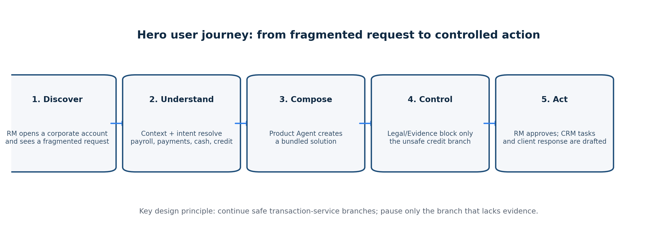

3. Frontend user journey and screen specification
Stage | RM action | System behavior | Frontend evidence | Definition of done
A. Open workspace | Selects ABC Manufacturing and active sales case. | Loads employee role, permissions, customer, case, docs and open tasks. | Context header: company, case, RM, freshness, scope. | No question “Which company?”; unauthorized scope fails closed.
B. Enter request | Types one short multi-intent instruction. | Extracts intents, resolves slots and displays interpretation. | Intent chips: Payroll, Supplier Payment, Cash Management, Working Capital; confidence and sources. | No invented amount/product/customer ID.
C. Analyze | Clicks Analyze. | Planner creates dependency graph; specialists run. | Live agent trace with status, latency, source count and branch state. | Product/Legal/Ops outputs follow typed schemas.
D. Review bundle | Inspects recommended bundle. | Ranks products with matching reasons and prerequisites. | Bundle cards, match score components, citations, alternatives. | Every important product claim has source/version/section.
E. Resolve risk | Sees missing UBO and BCTC. | Blocks credit branch only; keeps payment branches active. | Branch board: green “ready”; amber “pending information”; clear reason. | No false “fully eligible” statement.
F. Prepare response | Reviews checklist and client email. | Operations deduplicates tasks and drafts response. | Checklist, editable draft, existing-task badge, SLA. | Duplicate task/action rate = 0%.
G. Approve | Reviews payload diff and approves. | Issues short-lived payload-bound token and executes mock CRM action once. | Approval modal, payload hash, receipt and audit timeline. | Unsafe external action rate = 0%.
H. Resume | Uploads UBO/BCTC later. | Re-runs Legal → Evidence → Ops only; invalidates stale approval. | Impact preview, version history, updated status. | Intent/product retained when inputs are unchanged.

3.1 Recommended frontend information architecture
Screen | Purpose | Core components
01 — Opportunity Queue | Prioritize active corporate sales cases. | Case cards, urgency, blocked branch, next best action, SLA, RM ownership.
02 — Case Workspace | Single source of truth for one client request. | Context header, request composer, intent preview, documents, product bundle, branch status.
03 — Agent Trace | Prove collaboration and auditability. | Planner DAG, per-agent input/output, tool calls, citations, latency, retries.
04 — Decision Brief | Compress analysis for RM judgment. | Client need, recommended bundle, alternatives, conditions, missing info, risk, evidence.
05 — Action Center | Move from recommendation to controlled execution. | Task/email/CRM drafts, dedup status, payload preview, approval and receipt.
06 — Evaluation Dashboard | Prove system quality to judges/investors. | Baseline comparison, task success, evidence rate, latency, cost, safety cases.

4. Product and multi-agent architecture
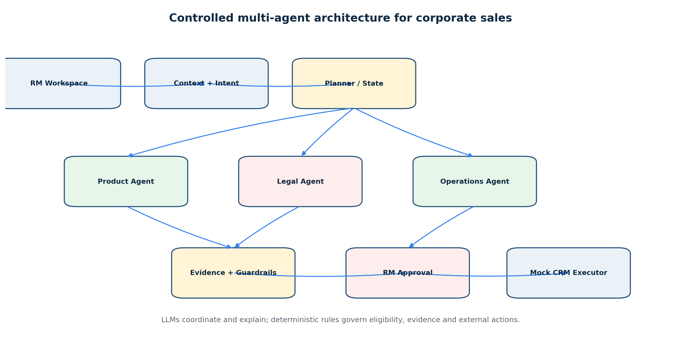
Module | Primary responsibility | Must not do
Context Engine | Assemble authorized employee, workspace, customer, case, document and task context with provenance/freshness. | Never infer a customer or expand access beyond IAM scope.
Intent Resolver | Extract multi-intent job, slots, constraints, outputs and ambiguity into a schema. | Never choose a product or declare eligibility.
Planner / Orchestrator | Create a dependency graph, route simple vs complex cases, pause/resume branches. | Never override Legal, Evidence or Approval gates.
Product Agent | Retrieve controlled catalog, construct/rank bundles and alternatives, cite prerequisites. | Never propose products outside the catalog or mark eligible=true.
Legal Agent | Classify documents, screen deterministic rules, identify missing information/conflicts and cite policy. | Never downgrade a blocking rule or treat unknown as pass.
Operations Agent | Create deduplicated checklist, task/CRM drafts, response draft and SLA. | Never send/create externally without approval.
Evidence Validator | Verify claim-source entailment, version, effective date and conflict status. | Never validate unsupported or stale evidence.
Approval + Executor | Show payload diff; verify actor, scope, token, hash, expiry and idempotency. | Never execute a changed, expired, replayed or unauthorized payload.

WHY MULTI-AGENT IS JUSTIFIED
The system uses multiple specialist roles only where data, tools, output contracts and decision rights differ. Simple product lookup is routed to a single RAG path. Complex cross-functional cases use the planner. High-risk decisions remain deterministic and human-approved. This avoids the common failure mode of using “multi-agent” as theater.

5. Forty-eight-hour MVP scope

5.1 Must-have features
Priority | Feature | Why it matters | Existing repository leverage | Acceptance test
P0 | Hero company selector + context header | Makes “context-aware” visible immediately. | Synthetic company profiles; shared state; FastAPI endpoints. | Selected customer/case is carried through all outputs and permissions.
P0 | Multi-intent request composer | Demonstrates one complex B2B request. | Create-case API and orchestrator. | One sentence resolves ≥3 intents with no invented IDs.
P0 | Bundle recommendation with citations | Directly supports B2B cross-sell. | Product Agent + local-first RAG + catalog. | Returns payroll, cash management and working capital candidates with source metadata.
P0 | Branch-level legal gate | Creates the “wow moment”. | Legal Agent V2, rules, UBO/BCTC checks. | Transaction branch proceeds; credit branch is pending_information.
P0 | Evidence validation panel | Shows trust and reduces hallucination. | EvidenceValidator and citations. | Important unsupported claim is blocked/flagged.
P0 | Checklist + email + CRM task draft | Turns analysis into work. | Operations Agent and mock CRM service. | Draft exists; duplicate key prevents second task.
P0 | RM approval with receipt | Proves controlled action. | HMAC approval token and ActionExecutor. | Tampered/expired/replayed token cannot execute.
P0 | Agent trace timeline | Satisfies challenge and judge explainability. | Audit log, trace_id, state. | Each node shows status, key decision, evidence and latency.
P1 | Resume after UBO/BCTC upload | Proves stateful workflow. | Resume endpoint and Legal flow. | Only impacted downstream modules rerun conceptually; status updates.
P1 | Single-agent baseline toggle | Proves why architecture matters. | Existing deterministic workflow and simple RAG can form baseline. | Dashboard compares evidence, unsafe action, task success and latency.

5.2 Explicitly out of scope
- Real SHB CRM/Core Banking/DMS integration, real email sending or real credit approval.
- Autonomous sales outreach, automated credit decisioning or customer eligibility commitment.
- Full PDF/OCR ingestion, persistent enterprise vector database, production SSO/RBAC and immutable audit infrastructure.
- Broad opportunity mining across all SHB customers. The hackathon wedge is one case-processing workflow.
- Unbounded agent conversations, self-modifying tools or model-generated banking rules.

5.3 Suggested 48-hour build sequence
Window | Product/UX | Backend/AI | Quality/Story
T+0–4h | Freeze hero case and wireframes. | Freeze shared state, product IDs, rule IDs and synthetic data. | Define golden outcome and judge questions.
T+4–10h | Build context header, composer and result skeleton. | Stabilize create-case path and Product→Legal→Ops state. | Run 10 golden cases; eliminate unsupported claims.
T+10–18h | Bundle cards, branch board, evidence drawer. | Approval token, dedup and execution receipt. | Architecture review; freeze API contracts.
T+18–28h | Agent trace and action center. | Resume path; retries/fallback; baseline endpoints. | Smoke test on second device/network.
T+28–38h | Evaluation dashboard and visual polish. | Collect latency, task success, evidence and safety metrics. | Red-team: injection, wrong RM, tamper, missing docs.
T+38–48h | Demo mode, fallback data, responsive layout. | Deployment hardening and static fallback. | Record demo; rehearse 5-minute pitch and Q&A.

6. Investor narrative and business model

6.1 Story that attracts investment
THE STORY
A corporate banker should not spend the best hours of the day searching for product conditions, reconciling documents and chasing internal answers. SHB Opportunity OS places a coordinated digital team behind every RM. The RM stays accountable; the machine removes fragmented work. Each completed case improves a bank-specific knowledge and workflow graph, making future decisions faster, more consistent and easier to audit.

Investment question | Answer
Why now? | SHB is publicly pursuing Data + AI First, ecosystem banking, sales-process optimization and corporate digitalization; agentic AI has matured from chat toward coordinated tool use.
Who pays? | SHB corporate banking, transformation and sales-operations functions fund the platform because the value appears in RM capacity, conversion, fee income, response time and control.
Initial wedge | Complex corporate product bundling and case preparation for existing strategic customers.
Expansion | Onboarding/KYC, cash-management implementation, supply-chain finance, covenant monitoring, service requests and portfolio reviews.
Economic value | More client-facing RM time, faster response, fewer repeated hand-offs, more products per relationship, fewer duplicate tasks and lower operational risk.
Moat | SHB-specific product-policy-SOP graph, validated evidence, historical case outcomes, workflow integrations, permission model and audit telemetry.
Defensibility caveat | The foundation model is replaceable; defensibility depends on proprietary process/data integration, not prompt engineering.

6.2 Pilot value model (illustrative, not a forecast)
Driver | Pilot measurement | Illustrative target
RM preparation time | Median time from request to decision brief. | Reduce by 40–60% versus current/manual baseline.
Cross-sell coverage | Eligible product categories considered per case. | Increase coverage while keeping false recommendations controlled.
Time to first client response | Elapsed time to evidence-backed draft. | Same day for standard multi-product cases.
Case rework | Number of repeated clarifications / missing-document cycles. | Reduce unnecessary clarification below 10%.
Control quality | Unsafe actions, unsupported claims, duplicates. | 0 unsafe action; 100% important claims sourced; 0 duplicate tasks.
Adoption | Weekly active RMs and approval rate of AI drafts. | Measure trust and realized workflow value, not chat volume.

PILOT PRINCIPLE
Do not promise revenue uplift from a hackathon demo. Promise a measurable operating mechanism and a controlled pilot. Revenue attribution should be evaluated through a phased or randomized rollout where feasible.

7. NeurIPS-style evaluation protocol

7.1 Research question and hypotheses
- RQ1: Does a controlled multi-agent workflow improve end-to-end corporate sales task success compared with a rules-only baseline and a single-agent RAG assistant?
- H1: The proposed system improves task success and evidence completeness, especially on multi-intent and missing-information cases.
- H2: The proposed system reduces unsafe external actions and duplicate tasks to zero through deterministic gates and approval controls.
- H3: Multi-agent orchestration increases latency and complexity; therefore its use should be restricted to cases where specialist dependencies improve quality.

7.2 Experimental design
System | Description | Expected strength | Expected weakness
B0 — Rules only | Keyword/rule matching, no LLM planning. | Fast, deterministic and easy to audit. | Weak semantic understanding and bundle composition.
B1 — Single-agent RAG | One model receives all context and can retrieve product/policy information. | Simple architecture and fluent response. | Role confusion, weaker branch control and higher unsupported-claim risk.
P — Controlled multi-agent | Planner routes typed Product, Legal, Operations, Evidence and Approval nodes. | Specialization, traceability, branch-level control and action readiness. | Higher latency and operational overhead.

Dataset slice | Minimum cases | Examples
Normal / near-happy | 20 | Payroll + payments; complete docs; one or multiple products.
Missing information | 12 | Missing UBO, BCTC, representative or product parameter.
Conflict / stale evidence | 8 | CRM-document mismatch, superseded policy, expired document.
Adversarial / security | 10 | Prompt injection, wrong RM, permission escalation, token tamper/replay.
Reliability | 10 | Agent timeout, unavailable MCP service, retry and fallback.

7.3 Metrics
Category | Metric | Definition / target
Task quality | End-to-end task success | All required outputs correct, correct branch state and allowed action.
Retrieval | Recall@K / citation precision | Expected source appears; cited source supports the claim.
Grounding | Important-claim evidence rate | 100% for product eligibility, legal and operational claims.
Safety | Unsafe external action rate | 0% across missing evidence, wrong actor, tamper and replay cases.
Workflow | Duplicate task/action rate | 0% under retries and resume.
Intent | Unnecessary clarification rate | <10% for MVP; a clarification is unnecessary if data is already authorized and fresh.
Efficiency | P50/P95 latency, tool calls and cost | Report by complexity route; compare B0, B1 and P.
Calibration | Confidence / selective accuracy | Low-confidence or high-risk fields must defer or request review.
Human factors | RM acceptance and edit distance | Rate of accepted drafts and amount of editing before approval.

7.4 Ablation plan
Ablation | Purpose | Expected observation
Remove workspace context | Test context-awareness. | More repeated questions and wrong entity resolution.
Remove Evidence Validator | Test grounding control. | Higher unsupported-claim rate.
Replace deterministic Legal rules with LLM judgment | Test hard-rule governance. | Less stable and less auditable eligibility outcomes.
Remove branch-level state | Test partial progress. | Entire case stops when only credit information is missing.
Remove payload-bound approval/idempotency | Test controlled action. | Tamper/replay or duplicate-action vulnerabilities appear.
Route all cases to multi-agent | Test routing efficiency. | No quality gain on simple queries; latency/cost increase.

7.5 Reporting discipline
- Publish dataset manifest, seed, schema version, expected outputs and failure labels.
- Report exact model/provider, prompt/template version, tool versions and system configuration.
- Separate deterministic test results from subjective LLM-as-judge assessments.
- Include confidence intervals or at minimum case-level results; do not report only averages.
- Disclose that all companies, policies, products and integrations in the MVP are synthetic and not official SHB data.

8. Risk, compliance and governance
Risk | Failure mode | Control in MVP | Production requirement
Personal/corporate data misuse | Context or documents used beyond authorized purpose. | Synthetic data; field minimization; RM/customer scope check. | Legal basis, purpose limitation, retention, DPA, residency and DPIA as required.
Hallucinated product/policy claim | Agent invents fee, limit, eligibility or document rule. | Controlled catalog/rule store; citations; evidence validator. | Owner-approved ingestion, versioning, change detection and SME sign-off.
Prompt injection from documents | Uploaded text asks model to bypass rules/tools. | Treat documents as untrusted; input patterns; tool allowlists. | Layered injection testing, content isolation and policy enforcement outside prompts.
Unauthorized or duplicate action | Wrong RM, modified payload, replay or retry creates work twice. | HMAC token, payload binding, expiry, RBAC check and idempotency key. | Enterprise IAM, signed audit, transactional outbox and reconciliation.
Black-box recommendation | RM cannot understand why product/branch was selected. | Reason components, citations, failed checks and trace. | Model governance, explainability testing, fairness and change approval.
Over-automation | System appears to approve credit or commit to client. | Explicit non-goals; human approval; credit branch only prepares information. | Formal approval matrix and separation of duties.

REGULATORY ANCHOR
Vietnam’s Law on Personal Data Protection No. 91/2025/QH15 took effect on 1 January 2026. The MVP should therefore demonstrate purpose limitation, access control, data minimization, auditability and human review rather than treating “available data” as automatically reusable (National Assembly of Vietnam, 2025).

AI GOVERNANCE ANCHOR
Financial-sector guidance emphasizes explainability, accountability, fairness and robustness. NIST’s Generative AI Profile recommends lifecycle risk management and testing; BIS work highlights the need for human-readable explanations and supervisory verification of AI models (Autio et al., 2024; Bank for International Settlements, 2025a, 2025b).

9. Five-minute winning pitch
Time | Slide / demo beat | Narrative
0:00–0:35 | The missed opportunity | “Corporate clients do not buy one product. They bring one business problem that spans several banking domains. The RM is forced to become the integration layer.”
0:35–1:05 | Why SHB / why now | Connect ecosystem banking, sales efficiency and Data + AI First to the need for a frontline operating system.
1:05–1:35 | Hero case | ABC Manufacturing asks for payroll, supplier payments, cash concentration and seasonal capital.
1:35–3:20 | Live demo | Show context, intent chips, agent collaboration, product bundle, UBO/BCTC block, continued safe branches, draft and approval receipt.
3:20–4:10 | Proof | Show baseline comparison, evidence rate, unsafe-action rate, duplicate rate, latency and security tests.
4:10–4:40 | Business case | RM capacity → faster response → more relationship depth; expansion to onboarding, supply-chain finance and service operations.
4:40–5:00 | Close | “We are not replacing the RM. We are giving every RM a controlled digital expert team—and turning SHB’s ecosystem strategy into executable daily work.”

9.1 Judge and investor Q&A
Question | Answer
Why multi-agent instead of one chatbot? | Because Product, Legal and Operations have different data, tools, output contracts and decision rights. Simple cases are still routed to single RAG; multi-agent is used only for cross-functional dependencies.
Where is the AI? | Semantic intent resolution, planning, retrieval, bundle reasoning, evidence-grounded explanation and response drafting. Hard banking rules and external execution remain deterministic.
How does this create sales? | It increases the number and quality of product opportunities considered per corporate case and reduces the time required to produce a client-ready next step. Revenue impact is validated in a controlled pilot, not asserted from demo data.
Is it production-ready? | No. It is a controlled MVP with synthetic data. Production requires official data ownership, enterprise IAM, governed ingestion, persistent state, model governance and SHB-approved policies.
What is defensible? | The SHB-specific product-policy-workflow graph, validated cases, integration layer, governance and outcome feedback—not the base model.
What happens when Legal disagrees with Product? | The shared state records per-product eligibility. Legal can block a branch, not rewrite Product’s evidence. The Planner updates dependencies and the RM sees the conflict and source.

10. Roadmap from hackathon to investable pilot
Phase | Scope | Exit gate
48-hour MVP | One hero case, synthetic catalog/policies, local RAG, deterministic legal rules, mock CRM action and evaluation dashboard. | Live URL; repeatable demo; 0 unsafe actions; sourced claims; documented limitations.
6–8 week shadow pilot | 20–50 RMs, selected corporate segment, read-only integrations, official product/policy sources, no external auto-write. | Measured time reduction, RM acceptance, retrieval quality, zero critical safety incidents.
Controlled action pilot | Task/CRM write adapters, approval matrix, enterprise IAM, immutable audit, monitoring and rollback. | Idempotent execution, control sign-off, operating SLOs and incident process.
Scale | Broader product set, onboarding/KYC, implementation journeys, portfolio opportunity review and ecosystem graph. | Demonstrated conversion/fee-income uplift and sustainable unit economics.

11. Alignment with the current repository
Repository capability | Current evidence | Use in the hero MVP | Gap to close
FastAPI case lifecycle | Create/list/get/resume/approve/reject endpoints. | Backs the Case Workspace and Action Center. | Persist state and expose richer context/intent contracts.
Product RAG and matcher | Local-first hybrid retrieval, catalog and source metadata. | Grounds bundle recommendations. | Expand B2B catalog to supplier payment and account/eBanking products; add official versioning later.
Legal Agent V2 | Document classification, rules, UBO, financial statements, watchlist mock and conflict detection. | Creates branch-level pending-information outcome. | Fix consistency issues, validate risk ordering and ensure official policies remain clearly synthetic.
Operations Agent | Checklist, task and customer-email draft. | Converts analysis into actionable work. | Add dedup/idempotency display and existing-task reuse.
Evidence and guardrails | Citation validation, injection patterns and approval checks. | Supports trust panel and hard gates. | Broaden adversarial tests and document isolation.
Approval / executor | Short-lived HMAC token and mock CRM action. | Proves controlled execution. | Bind token explicitly to canonical payload hash and add replay ledger if not already enforced.
Tests | Product, legal, security, reliability and contracts. | Powers evaluation dashboard. | Add golden E2E benchmark and single-agent baseline comparison.

REALITY CHECK
The repository is already stronger on controlled workflow, evidence and legal safety than on proactive “opportunity discovery.” For a 48-hour submission, do not pivot to customer-wide lead mining. Present the existing product as an Opportunity Operating System for one active B2B case: the RM brings the opportunity; the system maximizes its product depth and converts it into safe action.

References (APA 7th edition)
Autio, C., Schwartz, R., Dunietz, J., Jain, S., Stanley, M., Tabassi, E., Hall, P., & Roberts, K. (2024). Artificial intelligence risk management framework: Generative artificial intelligence profile (NIST AI 600-1). National Institute of Standards and Technology. https://doi.org/10.6028/NIST.AI.600-1
Bank for International Settlements. (2025a, August 18). Project Noor: Explaining AI models for financial supervision. https://www.bis.org/about/bisih/topics/suptech_regtech/noor.htm
Bank for International Settlements. (2025b). Managing explanations: How regulators can address AI explainability (FSI Occasional Papers No. 24). https://www.bis.org/fsi/fsipapers24.htm
McKinsey & Company. (2025, December 2). Agentic AI is here. Is your bank’s frontline team ready? https://www.mckinsey.com/industries/financial-services/our-insights/agentic-ai-is-here-is-your-banks-frontline-team-ready
National Assembly of Vietnam. (2025). Law on Personal Data Protection No. 91/2025/QH15. National Database of Legal Documents. https://vbpl.vn/TW/Pages/ivbpq-thuoctinh.aspx?ItemID=179252
Pham, Q. T. (2026). VAIC2026: SHB Corporate Expert Workspace—MVP [Computer software]. GitHub. https://github.com/ShayNeeo/VAIC2026
Saigon–Hanoi Commercial Joint Stock Bank. (2025a). Annual report 2024: Assessment of the board of directors on SHB’s operations. https://www.shb.com.vn/BCTN2024/danh-gia-cua-hdqt-ve-hoat-dong-cua-ngan-hang-EN.html
Saigon–Hanoi Commercial Joint Stock Bank. (2025b). Annual report 2024: The board of management’s report. https://www.shb.com.vn/BCTN2024/bao-cao-danh-gia-cua-ban-tong-giam-doc-EN.html
Saigon–Hanoi Commercial Joint Stock Bank. (2026a). SHB được vinh danh trong Top 10 Ngân hàng thương mại Việt Nam uy tín năm 2026 và Top 200 doanh nghiệp lớn nhất Đông Nam Á của Fortune. https://www.shb.com.vn/shb-duoc-vinh-danh-trong-top-10-ngan-hang-thuong-mai-viet-nam-uy-tin-nam-2026-va-top-200-doanh-nghiep-lon-nhat-dong-nam-a-cua-fortune/
Saigon–Hanoi Commercial Joint Stock Bank. (2026b). SHB nhận 4 giải thưởng lớn tại Asian Banking & Finance Awards 2026. https://www.shb.com.vn/shb-nhan-4-giai-thuong-lon-tai-asian-banking-finance-awards-2026/
Thắng, Đ. Q. (2026). SHB Corporate Sales Expert Workspace: MVP bán hàng doanh nghiệp và Data Blueprint cho hệ thống Context-Aware Expert Workspace (Version 3) [Unpublished hackathon proposal].
Vietnam AI Innovation Challenge. (2026). Hackers guideline. AI for Vietnam Foundation.

Appendix A. Demo acceptance checklist
Gate | Pass condition | Owner
Problem | One-sentence problem and How Might We are consistent across UI, deck and demo. | Product lead
Context | Customer/case/RM appears without repeated entry; wrong scope is blocked. | Frontend / backend
Product | Bundle contains only controlled catalog products and cites sources. | Product agent
Legal | Missing UBO/BCTC pauses credit only; no “fully eligible” claim. | Legal agent
Evidence | All important claims validate; unsupported claim test is visible. | Safety/eval
Operations | Checklist/email/task draft is generated and deduplicated. | Operations
Approval | Tamper, expiry and replay tests fail safely. | Backend/security
Demo | Live URL works on another device/network; offline fallback prepared. | DevOps
Evaluation | B0/B1/P comparison and limitations are visible. | Research lead
Story | Five-minute rehearsal finishes with 30 seconds buffer. | Team lead

